**831 Final Assembly and Test**

**1.0 PURPOSE AND SCOPE**

The purpose of this document is to provide the detail and instruction necessary to perform the final assembly and test of the 831 the process also serves as a verification that the product continues to meet the specifications and criteria established by Engineering.

**2.0 AFFECTED DEPARTMENTS**

Manufacturing

**3.0 REFERENCE DOCUMENTS**

* D0001.8321 831 Final Checklist template
* D0001.8375 METCAL Procedure Instructions
* D0001.8340 A831.01 Board Test Procedure
* D0001.1126-1 Quality Records Matrix
* A831.01, A831.02, A831.03 Schematics and loading diagrams
* S770.XX Case assembly drawings

**4.0 RESPONSIBILITIES & AUTHORITY**

The technician has the following responsibilities and authority:

* Verify compliance of the product under test to specification.
* Troubleshoot and correct product as required.
* Communicate concerns to Supervisor or Quality Assurance.
* Request management review of product concerns.
* Use proper ESD protective equipment.

**5.0 SAFETY PRECAUTIONS**

* Safety Glasses are required when soldering, lead clipping, or testing power supplies.
* Follow general electrical precautions for working with energized, low voltage circuits.

**6.0 EQUIPMENT & MATERIALS**

* 4 ea - Alkaline and Nickel Metal Hydride (NIMH) AA batteries
* 0621.0095 - USB cable
* ADP090 12pF BNC to Preamplifier Adapter
* ADP092 Low-Pass Filter 75kHz 2nd Order
* Metcal test station equipped with equipment for Electrical and Acoustic testing.
* CBL093 BNC male to 5-pin male Switchcraft cable
* CBL140 Cable 831 power
* Adjustable power supply 0 -12vdc

**7.0 INSPECTION**

Inspect the parts for nonconformities as assembled, and tested.

1. **INSTRUCTIONS**

*Note: Board level tests, are performed by the contract manufacturer (CM) so they are checked “in-house” on an occasional basis to ensure that the CM tests are being done properly. Fully test 1 set of boards from each batch received. This is generally sufficient, unless problems are found.*

1. Case up the unit following the assembly drawing instructions.
2. Install four NIMH batteries into the unit
3. Check the battery operation and charging function.
   1. Press the power key, to turn instrument on. Press power key again to open **Power Control** dialog.
   2. Verify that there is a battery voltage reading, and there is a battery symbol on the screen at the top.
   3. Plug the USB cable into the unit and verify that the battery symbol at the top of the screen changed to a lightning bolt and ‘USB Powered’ came on and reads a voltage.
   4. Press the left or right navigational keys to change the backlight between **Dim**, **Bright** and **Off**. Press **Close** key to exit.
   5. Press the **TOOLS,** key, arrow down twice to **System Properties**, press **ENTER**. Press the right soft key two times to the **Power** tab, highlight the **Battery Type** setting, press **ENTER** and change it to “**NIMH**”. Press Close key, **ENTER** to apply changes, press **Close** soft key twice, turn instrument off.
   6. Check that the (power on key) green LED is on, this indicates the instrument is charging the batteries.
   7. Remove batteries, green LED will go off, remove **NIHM** batteries and install **alkaline**, turn instrument back on, and repeat step 5 and this time select the ”**Alkaline**” setting. Close out of menu and select “**Yes**” to apply changes. Press **Close** key. Turn unit off and this time the green LED will not go on. Remove batteries.
4. Assign a Serial Number, set Manufactured Date and adjust LCD Contrast. Update to current Firmware unless they are agency approved. The METAS approved version is 1.505. The PTB Approved version is 2.301. The LNE approved version is 2.112. Meters coming back for service that are agency approved should not be upgraded from these version. Contact engineering regarding any questions for correct firmware on agency approved meters.
   1. Connect the instrument to the computer through the USB cable.
   2. Run the **LxTTest** program (C:\Program Files\PCB Piezotronics \LxTTest\LxTTest.exe).
   3. Click on **Tools** then **Instrument Setup.**
   4. Select 831 from drop-down list.
   5. Enter the serial number into the **Serial Number** field.
   6. To set the **Manufacture Date**, click the down arrow icon and click on **Today**.

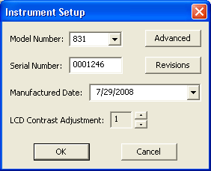*Note:*  Adjust the instrument’s display contrast, view the Live Profile display (as seen below) and adjust the contrast, using the **LCD Contrast Adjustment** buttons, until the background of the banner is dark enough to read the text in the banner and in the tabs, but not so dark that the background is very visible in the white areas.

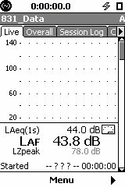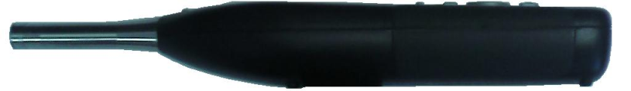

Viewing Angle:

0 to 12°



* 1. Click **OK** to program the unit.

Check firmware version, if needed, open the Firmware Programmer software, check the box “Upgrade firmware using a .ROM file” browse to the current firmware and click on next and finish.

1. Check Control port
   1. Apply 12.0 Vdc. From the adjustable power supply to the CBL140 cable.
   2. Plug the CBL140 cable into the control port on the instrument, the instrument will turn on. If not, check for problems.
   3. Press the 0 power key, the power menu screen will come up. Use the navigation keys to toggle the LCD dim and bright light on and off, observe current draw on adjustable power supply as follows:

|  |  |
| --- | --- |
| **Backlight State** | **Model 831** |
| Off | < 90 mA |
| Dim | < 115 mA |
| Bright | < 135 mA |

* 1. Turn the 831 off and then remove the CBL140 cable.
  2. Connect the instrument to the computer through the USB cable, and power cycle unit. Turn on/off.

1. Install Labels – For LNE approved versions, see step 2.
   1. Place the Calibration label in the recessed location in the battery compartment (print on stock M770.0042), after certification testing. An example shown at the right.
   2. For an LNE approved meter, the LD91 (3255.0056) sticker needs to go into the recessed location in the battery compartment with the calibration label off to the side. This is printed on stock M770.0042. An example is shown below:

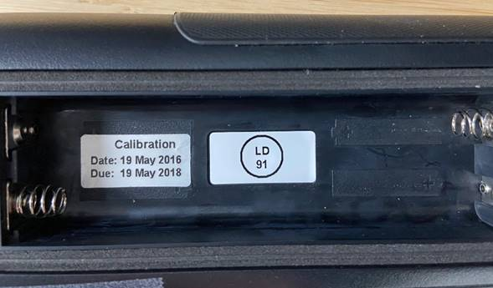

* 1. Place the Battery Warning label in the battery compartment (print on stock M770.0042). Place on the right side wall centered with Calibration label with top even with the top of the sidewall. An example shown at the right.

Create a Final Checklist and an on-line [LD database](http://mypcb.pcb.com/ldproducts/) entry, and an asset in the Metcal database per (D0001.8375) for each 831.

Store instrument until a customer sales order received, then complete procedure.

1. Input Voltage Calibration
2. Connect the output of the Metcal test system to the input of the instrument using the CBL093, connect USB cable to UUT and turn on.
3. On the **LxTTest** program, make sure the “831, Calibrate - No Preamp” control file is loaded. If it is not, click Tests, Select, Control File and Select the file.
4. Run the **Calibrate** and **Gain** tests.
5. Resolve any testing issues.
6. Run the **MET/CAL** tests for this instrument. (D0001.8375, D0001.8378, & D0001.8384)
7. Connect an ADP090 to the PRM831 preamplifier.
8. Connect the output of the test system to an ADP042 and then to the ADP090.
9. Perform **MET/CAL** electrical test (D0001.8378) and verify that they all passed. Resolve any issues.
10. Perform **MET/CAL** acoustical test. (D0001.8384)
11. Print out test results as required by sales order.
12. Program the options ordered into the instrument.
13. Run the **LXTKEYGEN**
14. Enter your **LXTKEYGEN** specific user name and password.
15. Enter the Model and Serial Number of the instrument and press **Lookup**
16. From the sales order determine which options need to be installed. Select the options to be programmed into the instrument.

*(Note: If the customer ordered OB3, OB1 will also be checked. If HSlog is purchased verify that Log is also purchased.)*

1. Make sure **Upload file to connected instrument** is checked.
2. Press **Generate**. This takes a few minutes and the instrument will re-boot.
3. Verify options in the **About** menu match those on the order.
4. Save a copy of the Certification document to R:\Provo\Logistics\ORDERS\ORDERS in a folder named by the order number, complete and enter the customer information on the final checklist, and in the on-line [LD database](http://mypcb.pcb.com/ldproducts/), apply calibration label per step **F, 1**.
5. Deliver completed order to QC for inspection.
6. **RECORDS**

* When the checklist is completed, it is stored in the Production area per the Quality Records Matrix, D0001.1126-1.
* Model and Serial Number information entered into the database.
* Test data is stored electronically in an 831 database or Metrology database, per the Quality Records Matrix.

**10.0 DISTRIBUTION**

This instruction is available to employees electronically via the online Document Control area.

**11.0 REVISION HISTORY**

|  |  |  |  |  |
| --- | --- | --- | --- | --- |
| **DCO #** | **REV** | **DATE** | **INITIALS** | **CHANGES MADE** |
| 1014 | A | 1/26/06 | RH | Initial Release |
|  | B | 28 May 2008 | AJR | Revised to use ADP090 12pF input adapter. |
| 1132 | C | 29 Jul 2008 | AJR | Added LCD contrast calibration for firmware version 1.5 and above |
| ECO 3777 | D | 27 Mar 2009 | AJR | Added Battery Warning Label |
| DCO  1320 | E | 12/13/2010 | RCH | Added Voltage gain calibration |
| ECO  4099 | F | 04/18/2012 | RCH | Changes for turnkey. Removed keypad test. Removed voice recording test. Other clarifications. |
| DCO  1387 | G | 6/1/2012 | RCH | Updates and changes were made to the wording for better understanding. |
| 1621 | H | 04/15/2016 | AJR | Updated to include the 831C. |
| ECO 4550 | I | 4/17/2017 | DWA | Added instructions for label M770.0067 for 831C. |
| DCO  1733 | J | 7/31/2017 | AJR | Added tests for backup battery safe power–off function (TT 6744) and the touchscreen (TT 6755). |
| DCO 1775 | K | 12/21/2017 | RCH | Corrected steps for efficient testing, Corrected grammar, format, and other minor items. |
| ECO  4687 | L | 3/19/2018 | DPW | Changed 831C touch screen inspection process |
| DCO  1860 | M | 10/22/2018 | RCH | Removed 831C instructions per production assembly request (see D0001.8444 for 831C). |
| ECO 4878 | N | 8/19/2019 | DPW | Added instruction to save certification to network |
| DCO 1944 | O | 3/11/2020 | DPW | Added references to MET/CAL tests in section “H”. |
| DCO 2021 | P | 5/20/2021 | DPW | Added notes for agency approved meters and label placement for LNE. |
| DCO 2025 | Q | 8/6/2021 | RH | Remove Tech Inspection requirements. |