A831.21 TEST

- PURPOSE AND SCOPE

The purpose of this document is to provide the detail and instruction necessary to ensure the compliance of the specified product to established specifications. This instruction is applicable to both new product and to customer owned product that has been returned for repair and/or calibration.

2.0 LIMITATIONS

This instruction is limited to the testing of the A831.21 preamp.

3.0 AFFECTED DEPARTMENTS

Manufacturing

4.0 REFERENCE DOCUMENTS

Applicable drawings and instructions for the A831.21 are needed.

5.0 RESPONSIBILITIES & AUTHORITY

The technician has the following responsibilities and authority:
- Verify compliance of the product under test to specification.
- Troubleshoot and correct product as required.
- Communicate concerns to Supervisor or Quality Assurance.
- Request management review of product concerns.
- Use proper ESD protective equipment.

6.0 SAFETY PRECAUTIONS

- Safety Glasses are required when soldering, lead clipping, or testing power supplies.
- Follow general electrical precautions for working with energized, low voltage circuits

7.0 EQUIPMENT & MATERIALS

PRM831 Test Box

EXC006
BNC to BNC cable
2900
Function Generator
Oscilloscope
BNC to test clips

8.0 INSPECTION

Perform a visual check of the board. Check for soldering defects, any shorts or mis-loaded parts.

9.0 INSTRUCTIONS

9.1 Setup

- Connect the EXC006 cable from the 2900 connector of the PRM831 Test Box to the 2900 Preamp 1 input.
- Connect the A831.21 board to be tested to the 831 preamp connector of the 831 Test Box.
- Using the BNC to BNC cable, connect from the PRM831 Test Box PS BNC to the Oscilloscope input.
- Turn on the 2900.
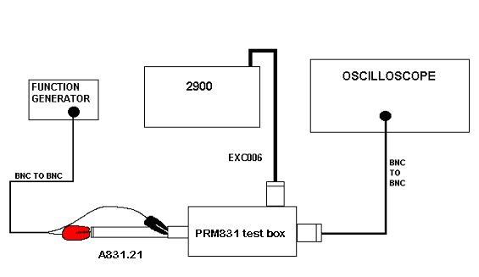

9.2 Check preamp Power Supply current

- Measure the voltage on the Preamp PS using the mutimeter of the O-Scope.
- The voltage should read between 15 mV to 28mV.

9.3 Check the preamp current sink
- Using the O-Scope mutimeter check the voltage from R8 to ground.
- It should be between 14 mV and 32 mV. If the measurement is <14 mV then change R3 from 2.21 k to 2.00 k (4866.2001). If the measurement is >32 mV then change R3 from 2.21 k to 3.16 k (4866.3161). Recheck measurement for 14 mV to 32 mV.

9.4 Signal Check

- Set the function generator to produce 1Vrms @ 1 kHz sine wave.
- Hook the signal cable from the generator - ground lead to the preamp ground and the signal lead to the pogo on the Preamp.
- Change the O-Scope input to see the AC Out of the PRM831 Test Box.
- Check the sine wave on the O-Scope for 1 Vrms out and a uniform (undistorted) signal.

- RECORDS

No records are generated as part of this instruction.

11.0 DISTRIBUTION

Instruction is available online in the “Preamp” folder in the “Technician work instruction” folder in Document Control.

12.0 REVISION HISTORY

DCO # | REV | DATE | INITIALS | CHANGES MADE
1014 | A | 7/11/06 | RH | Initial Release
1081 | B | 5/13/08 | LH | Added options for R3 values when current sink is out of range.

