S831.21 CERTIFICATION TEST

- PURPOSE AND SCOPE

The purpose of this document is to provide the detail and instruction necessary to ensure the compliance of the specified product to established specifications. The instruction applies to both new and customer owned equipment that has been returned for repair and/or calibration.

2.0 LIMITATIONS

The use of this instruction is limited to testing the S831.21

3.0 AFFECTED DEPARTMENTS

Manufacturing

4.0 REFERENCE DOCUMENTS

D0001.1126 Quality Records
Applicable revision drawings for the A831.21

5.0 RESPONSIBILITIES & AUTHORITY

The technician has the following responsibilities and authority:
- Verify compliance of the product under test to specification.
- Troubleshoot and correct product as required.
- Communicate concerns to Supervisor or Quality Assurance.
- Request management review of product concerns.
- Use proper ESD protective equipment.

6.0 SAFETY PRECAUTIONS

- Safety Glasses are required when soldering, lead clipping, or testing power supplies.
- Follow general electrical precautions for working with energized, low voltage circuits

7.0 EQUIPMENT & MATERIALS

PRM831 Test Box
EXC006
Two BNC to BNC cable’s
Function Generator
Voltmeter
ADP005
2900 TEST STATION
Torque Wrench
T831.52 Torque adapter tool PRM831

- INSPECTION

- Examine the cosmetic appearance of the preamplifier
- Verify that the contacts and connectors are properly aligned on the part
- Questions about appearance or quality are to be brought to the attention of the supervisor, manager or QA

- INSTRUCTIONS

9.1 2900 Test Station Test setup

- Using one of the test stations in the technician area, connect the preamp as follows.
- Set the data switch box to the 2900, 2800, 875 position.
- Connect the RS-232 cable to the HP multimeter.
- Connect a BNC to BNC cable from the input of the multimeter to PRM831 Test Box DVM Out.
- Connect a 5-pin Switchcraft cable from the PRM831 Test Box 2900 BNC connector to channel one of the 2900.
- Connect the S831.21 (PRM831) to the PRM831Test Box, 831 Preamp connector.
- Attach an ADP005 onto the S831.21 (PRM831) to be tested.
- Connect the BNC to BNC cable coming from the output of the 2209 to the ADP005.

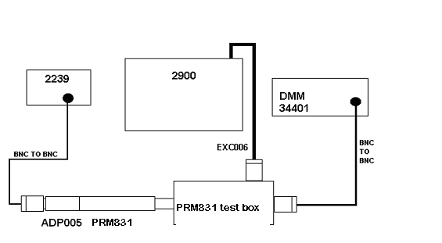

9.2 Run Automated test

- Run the Larson Davis SLM Lab test program.
- Select your name in the Technician field.
- Click on Instrument and select PRM831
- When it asks for the serial number, enter it and press OK.
- Click on the PREAMP SWEEP button.
- Click on the START button.
- If the Preamplifier passes, tighten the connector with the torque wrench to 17 inch pounds.
- Place the black vinyl protective cap on the microphone end of the preamplifier.
- Put the preamplifier into the case.

9.3 Close tested preamplifiers to technician area.

- RECORDS

- Test results are saved per the Quality Records Matrix, D0001.1126-1.
- Enter a new record in the LDL Database for each S/N tested.

11.0 DISTRIBUTION

This instruction is available online in the Technician work instruction folder in the “Preamp” folder in the Document Control area.

12.0 REVISION HISTORY

DCO # | REV | DATE | INITIALS | CHANGES MADE
1014 | A | 7/11/06 | RH | Initial Release
1068 | B | 14 Apr 2008 | LH | Added torque wrench tightening and black vinyl protective cap

