**Spark 705 Battery Wall Subassembly**

*This is a Manufacturer’s Document related to a product that has been approved by a notifying body for use in an explosive environment.  This document shall be reviewed by Engineering and the ISP Manager before it is released or revised.  Any changes to this document could result in modifications to approved design that could result in an unsafe condition.

**1.0 PURPOSE AND SCOPE**

This document outlines the assembly for the Spark 705 Battery Wall Subassembly.

**2.0 AFFECTED DEPARTMENTS**

Manufacturing (Production & Technicians)

**3.0 REFERENCE DOCUMENTS**

* S705.11 and S705.11-ATEX Drawings
* IPC Workmanship Standards

**4.0 RESPONSIBILITIES & AUTHORITY**

The assembler has the following responsibilities and authority:

* Communicate concerns to Supervisor or Quality Assurance
* Follow instructions on engineering drawings
* Follow workmanship procedures
* Ask questions if a drawing, instruction or assembly process is unclear. Questions should be directed to immediate supervisor.

**5.0 DEFINITIONS**

N/A

**6.0 SAFETY PRECAUTIONS**

Safety Glasses are required when soldering, lead clipping, or testing power supplies.

**7.0 EQUIPMENT & MATERIALS**

* Production tool kit
* Any additional tools or equipment required to assemble to specifications
* 0.121” Diameter Eyelet Press.

**8.0 INSTRUCTIONS**

1. Set iron temperature to 750° F.
2. Pre-tin the top of the Positive Battery Clip (Item 5) with solder below the eyelet hole on the outside, see left clip in figure 1.
3. Assemble Positive Battery Clip using Eyelet Press, see drawing.
4. *Quickly* flow the solder from the outside of the Positive Battery Clip to the eyelet for electrical connection, see right clip in figure 1. Ensure that the plastic polarity washer does not get hot so that it does not melt and/or crack.
5. Fasten Positive Clip subassembly and Negative Clip (Item 3) to PCB with Eyelets (Item 4) using Eyelet Press, see drawing.
6. With the PCB secured lengthwise of one edge in a vice, solder the eyelets to the topsides of the clips, see figure 2.
7. Continue heating the top and apply solder to the bottom side of the Eyelets and pad on the back of the PCB.
8. Solder wires into PCB and trim off wire flush with PCB, see drawing.

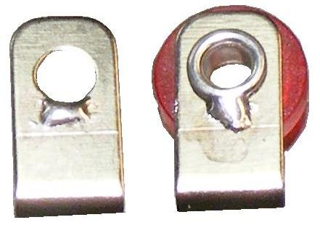

**Figure 1**

1. Clean flux residue from PCB with appropriate flux cleaner avoiding the red polarity washer.
2. Clip off thin flange of Grommets (Item 1) as shown on drawing (Note 2).
3. Glue Grommets into holes of PCB as shown on drawing.

**9.0 INSPECTION**

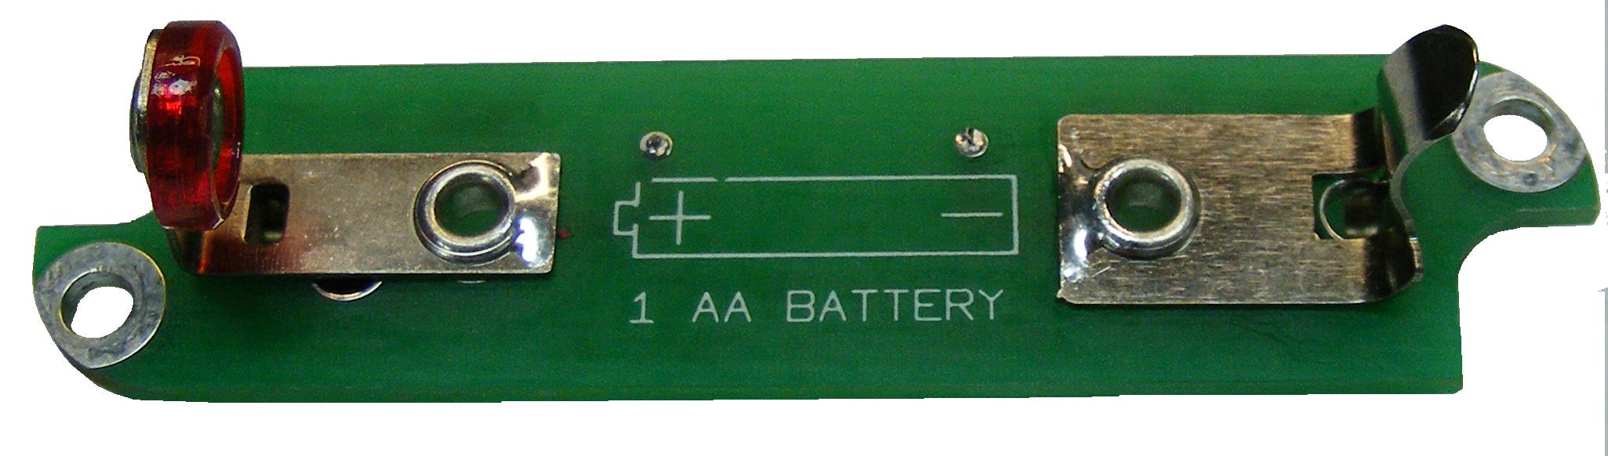

**Figure 2**

* Verify that assembly matches the instructions and drawings for the part number.
* Inspect soldering for joint quality insuring proper fillets that ***gently*** slope from eyelet to clip.
* **Warning: To ensure these solder joints do not puncture the installed battery, ensure solder height does not go above eyelet or have any sharp peaks!**If it does the battery can short out when the battery door is tightened.
* Check that the Polarity washer is not melted or cracked.

**10.0 RECORDS**

No records are generated by this process.

**11.0 DISTRIBUTION**

Distribution of this instruction is via the online Document Control area or by request from Document Control.

**12.0 ATTACHMENTS**

NA

**13.0 REVISION HISTORY**

|  |  |  |  |  |
| --- | --- | --- | --- | --- |
| **DCO #** | **REV** | **DATE** | **INITIALS** | **CHANGES MADE** |
| 1856 | A | 10/09/18 | JGG | Initial release of intrinsic safe procedure. This is an updated version of D0001.8319. Added intrinsic safe note. Added –IS to the end of the document number. |
|  |  |  |  |  |
|  |  |  |  |  |
|  |  |  |  |  |
|  |  |  |  |  |