S912.01 1/4" PREAMPLIFIER PRETEST

- PURPOSE AND SCOPE

The purpose of this document is to provide the detail and instruction necessary to ensure the compliance of the specified product to established specifications. This instruction is applicable to both new product and to customer owned product that has been returned for repair and/or calibration.

2.0 LIMITATIONS

This instruction is limited to the pre-testing of the S912.01 1/4" microphone preamplifier.

3.0 AFFECTED DEPARTMENTS

Manufacturing

4.0 REFERENCE DOCUMENTS

Applicable drawings and instructions for the S912.01.
- S912.01 - S912.01 1/4" Preamplifier Assembly document.
- D0001.8325 - S912.01 Preamplifier Final Test Document.

5.0 RESPONSIBILITIES & AUTHORITY

The technician has the following responsibilities and authority:
- Verify compliance of the product under test to specification.
- Troubleshoot and correct product as required.
- Communicate concerns to Supervisor or Quality Assurance.
- Request management review of product concerns.
- Use proper ESD protective equipment.

6.0 SAFETY PRECAUTIONS

- Safety Glasses are required when soldering, lead clipping, or testing power supplies.
- Follow general electrical precautions for working with energized, low voltage circuits

7.0 EQUIPMENT & MATERIALS

- 2200B/C
- Function Generator
- Oscilloscope
- BNC to BNC cable
- BNC to Aligator Clips Cable
- CBL071 - CABLE MIC 5FT SW TO 7-PIN LEMO
- ADP040 - Mic Signal Tee 7-Pin Lemo

8.0 INSPECTION

- Perform a visual check of the board. Check for any shorts or mis-loaded parts.
- Visually check wires in LEMO connector at end of preamp's cable.

9.0 INSTRUCTIONS

9.1 Setup

- Configure test cables as shown below.
- Setup 2200B for a 0V BIAS and 0dB of GAIN.
- Turn on the function generator, 2200, and O-scope.

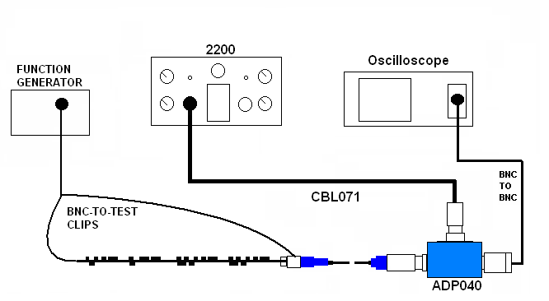

9.2 Check DC Offset

- Switch O-scope to read DC and after waiting for voltage to stabilize, verify that the DC voltage is around 1.2 ± 0.5VDC.

9.3 Signal Check

- Set the function generator output to produce a 1.0 Vrms at 1 kHz sine wave.
- Set the O-Scope to read AC voltages.
- Check the sine wave on the O-Scope for about 1.0 Vrms.
- Turn off function generator, 2200, and O-scope.
Return Preamp board to production for final assembly.

- RECORDS

No records are generated as part of this instruction.

11.0 DISTRIBUTION

Instruction is available online in the “Preamp” folder in the “Technician work instruction” folder in Document Control.

12.0 REVISION HISTORY

DCO # | REV | DATE | INITIALS | CHANGES MADE
 | A | 03/16/2007 | JLD | Initial Release
ECO  3569 | B | 04/20/2007 | JLD | Step 9.3, changed resulting voltage to 1.0 Vrms.

