S912.01 1/4" PREAMPLIFIER FINAL TEST

- PURPOSE AND SCOPE

The purpose of this document is to provide the detail and instruction necessary to ensure the compliance of the specified product to established specifications. The instruction applies to both new and customer owned equipment that has been returned for repair and/or calibration.

2.0 LIMITATIONS

The use of this instruction is limited to testing the S912.01 1/4" preamplifier.

3.0 AFFECTED DEPARTMENTS

Manufacturing

4.0 REFERENCE DOCUMENTS

- D0001.1126 Quality Records
- Applicable revision drawings for the S912.01
- D0001.8324 - S912.01 Preamplifier Pretest

5.0 RESPONSIBILITIES & AUTHORITY

The technician has the following responsibilities and authority:
- Verify compliance of the product under test to specification.
- Troubleshoot and correct product as required.
- Communicate concerns to Supervisor or Quality Assurance.
- Request management review of product concerns.
- Use proper ESD protective equipment.

6.0 SAFETY PRECAUTIONS

- Safety Glasses are required when soldering, lead clipping, or testing power supplies.
- Follow general electrical precautions for working with energized, low voltage circuits

7.0 EQUIPMENT & MATERIALS

2200B/C
2900 Real Time Analyzer
Function Generator
Oscilloscope
TWO BNC to BNC cable’s
CBL071 - CABLE MIC 5FT SW TO 7-PIN LEMO
CAL200 - Microphone Calibrator
ADP024 - 1/4" Microphone-to-1/2" Calibrator Adaptor
2530 - ¼ Externally Polarized Microphone
ADP040 - Mic Signal Tee 7-Pin Lemo
ADP077 - Mic Adaptor Guarded 6.8pF 1/4" EQUIV
ADP009 - 1/2" Microphone to 1/4" Preamp Adaptor
DB9-to-7-pin LEMO TEDS Programming Cable

- INSPECTION

- Examine the cosmetic appearance of the preamplifier
- Verify that the contacts and connectors are properly aligned on the part
- Questions about appearance or quality are to be brought to the attention of the supervisor, manager or QA

- INSTRUCTIONS

9.1 Setup

- Configure test cables as shown below.

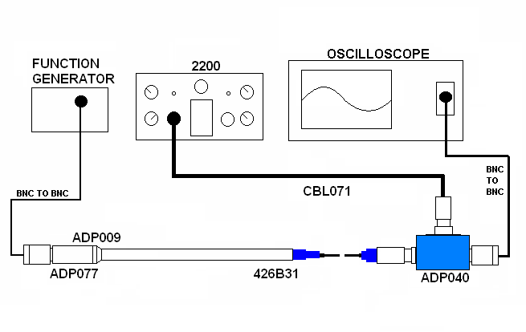

- Set up 2200 for a 200V BIAS and 0dB of GAIN.

9.2 Dummy Load Test

- Setup 2200B for a 200V BIAS and 0dB of GAIN.
- Turn on the 2200, the overload light may turn on for a few seconds but it should not remain on.
- The DC level should settle to 1.2 Vdc ± 0.5 Vdc.
- Connect a 1Vrms sin wave to ADP077.
- Monitor the output of the S912.01 on the scope.
- The AC signal should be ≅ 980 mVrms.
- Turn off 2200.
- Remove the ADP009 and ADP077.

9.3 Microphone Test

- Connect ¼" 2530 microphone to the S912.01. (Any ¼" externally polarized microphone should work).
- Turn on the 2200.
- Ensure 2200 bias is set to 200 VDC.
- Attach an active CAL200 (114 dB re. 20 µPa) to the microphone.
- Wait a few seconds for the overload light to go out,
- Monitor the output of the S912.01 on the scope.
- The signal should be ≅ 15 mVrms and undistorted.
(This level is dependent on the microphone used; it is best to note this level and always use the same microphone for this test).
- Disconnect preamp from equipment and remove microphone from preamp.

9.4 2900 Test Station Test setup

- Using a test station, connect the preamp as follows.
- Set the data switch box to the 2900, 2800, 875 position.
- Connect other computer RS-232 port to the HP multimeter.
- Connect a BNC to BNC cable from the input of the multimeter to the ADP040.
- Connect a CBL071 cable from the ADP040 to channel one of the 2900.
- Screw ADP009 and ADP077 onto the S912.01 to be tested.
- Connect the BNC to BNC cable coming from the output of the 2209 to the ADP077.

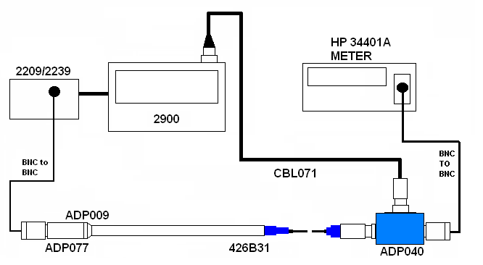

9.5 Run Automated test

- Run the Larson Davis LAB.EXE test program.
- Select your name in the TECHNICIAN field.
- Click on Instrument and select 426B31 preamp.
- In the EQUIPMENT SETUP, ensure that the ADP005 box is set to GUARDED.
- When it asks for the serial number, enter it and press OK.
- Click on the ALL TESTS button.
- Click on the START button.

9.6 Return tested preamplifiers to Production.

10.0 TEDS TEST

10.1 PROCEDURE

- Test on-board TEDS chip by using TEDS_RW.EXE program.
- Load the following settings for each preamplifier in the TEDS_RW.EXE program:

- Manufacturer: PCB
- Model: 426B31
- Description: Microphone Preamplifier

- Ensure that data is retrievable.

11.0 RECORDS

- Test results are saved per the Quality Records Matrix, D0001.1126-1.
- Enter a new record in the LDL Database for each S/N tested.

12.0 DISTRIBUTION

This instruction is available online in the Technician work instruction folder in the “Preamp” folder in the Document Control area.

13.0 REVISION HISTORY
DCO # | REV | DATE | INITIALS | CHANGES MADE
 | A | 03/16/2007 | JLD | Document Created
 | B | 04/20/2007 | JLD | Step 9.2, mic bias changed to 200 V.
ECO 3569 | C | 05/14/2007 | JLD | Added testing of TEDS.

