
CER-831-E
Model 831 Environmental Test

1.0 PURPOSE AND SCOPE

The purpose of this document is to provide the detail and instruction necessary to ensure the compliance of the Model 831 with preamp to established specifications for temperature and humidity. The procedure is written to apply to any technician that is given the responsibility and authority to test and / or certify this product.

2.0 AFFECTED DEPARTMENTS

Manufacturing

3.0 REFERENCE DOCUMENTS

Operation and Specifications as found in I831.01 Model 831 Reference Manual
Operating manual for all test equipment used.
A831.01, A831.02, A831.03 and S831.01 Schematic and Assembly Drawings may be needed.
A831.21 Schematic and Assembly Drawings may be needed.

4.0 RESPONSIBILITIES & AUTHORITY

The technician has the following responsibilities and authority:

- Verify compliance of the product under test to specifications.
- Troubleshoot and correct product as required.
- Communicate concerns to the Supervisor of Quality Assurance.
- Request management review of product concerns.
- Follow established ESD standards.

5.0 DEFINITIONS

None applicable to this procedure.

6.0 SAFETY PRECAUTIONS

- This procedure will expose the equipment under test to extreme cold and hot conditions. Use caution and wear gloves when handling equipment that may be very cold or hot to avoid burns.
- Safety glasses are required when soldering, lead clipping, or testing power supplies.

- EQUIPMENT AND MATERIALS

The “unit under test” is one or more Model 831 and one PRM831 or 426A12 Microphone Preamplifier and microphone for each Model 831
- One ADP090 for each unit under test if no microphone is included
- One CBL138 (or other length USB cable) for each unit under test
- One EXC006 or EXC010 Signal Cable for each PRM831
- One CBL152 Signal Cable for each 426A12
- One CBL154 Control Cable for each 426A12
- 12 Volt DC power source for 426A12, SLA battery with 2.5mm power plugs
- Automated Environmental Test System with Signal Generator
- Modified LD 2201 and EA when mic is included with PRM831
- USB Hub(s) with one port for each unit under test

8.0 INSPECTION

Equipment to be environmentally tested should already have been bench certified and thus needs no further inspection at this point. Microphones need to have certification first. If the system includes a 426A12, then it should receive CER-426A12 certification first.

9.0 INSTRUCTIONS

The purpose of this test is to ensure that the Model 831 and the preamplifier with microphone will meet the requirements of published sound level meter standards. Most of these standards only specify operation over a -10 to +50°C range. Since this equipment, when used for environmental noise monitoring, will be subject to conditions beyond those required by standards, we have instigated self imposed limits. These limits are programmed into the ReportGen program and listed in the tables below.

Model 831 and Preamplifier Relative SPL vs. Temperature Limits
Tested Temperature Range: -40°C to +70°C
Frequency (Hz) | Lower Limit (dB) | Upper Limit (dB) | Uncertainty (dB)
6.3 | -0.3 | +0.3 | 0.1
20 | -0.3 | +0.3 | 0.1
1000 | -0.3 | +0.3 | 0.1
20,000 | -0.3 | +0.3 | 0.1

Model 831 and Preamplifier Relative SPL vs. Humidity Limits
Tested Relative Humidity Range: 50% to 95%
Frequency (Hz) | Lower Limit (dB) | Upper Limit (dB) | Uncertainty (dB)
6.3 Hz | -0.3 | +0.3 | 0.1
20 Hz | -0.3 | +0.3 | 0.1
1000 Hz | -0.3 | +0.3 | 0.1
20,000 Hz | -0.3 | +0.3 | 0.1

Model 831 and Preamplifier Relative SPL vs. Humidity Endurance Limits
Tested Relative Humidity 95% at 40°C for 2 hours
Frequency (Hz) | Lower Limit (dB) | Upper Limit (dB) | Uncertainty (dB)
6.3 Hz | -0.3 | +0.3 | 0.1
20 Hz | -0.3 | +0.3 | 0.1
1000 Hz | -0.3 | +0.3 | 0.1
20,000 Hz | -0.3 | +0.3 | 0.1

9.1 Connect the units for testing.

- Place an ADP090 on each PRM831 preamplifier when no mic is included.
- When a mic is included support the preamp vertically and put the EA on the mic.
- Connect the preamplifier to the Model 831. The PRM831 connects into the Model 831 using an EXC006 if needed. The 426A12 is connected to the Model 831 using the CBL152.
- Connect the control cable of any 426A12 preamplifiers, to the Model 831 and to a 12 Volt battery power via the 2.5mm power jack
- Connect a USB cable from each Model 831 to a USB Hub. Do not daisy-chain hubs, each one must connect directly to the computer for them to work properly. Each hub must be a “powered hub”
- Connect the output of the signal generator to each ADP090 using BNC cables or to the input of the 2201. Connect the output of the 2201 to the EA.

9.2 Environmental Chamber operation

- Start the Chamber test program “LD Environmental Chamber Control Software” by invoking chamber.exe.
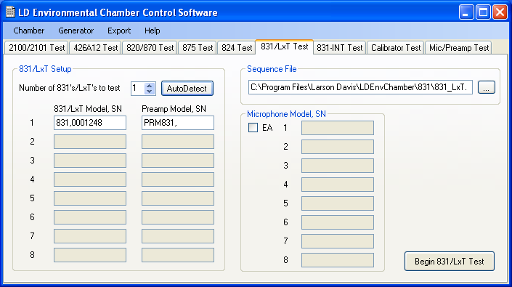

- Click on 831/LxT Test tab .
- Enter the number of Model 831 instruments attached and then click on the “Auto Detect” button . This will fill in the LxT/831 model and serial numbers as well as the preamplifier model number(s). Enter the serial number(s) for the attached PRM831 preamplifier(s). This will be automatically done if the preamplifier is a model 426A12. Verify all entries.
- If a mic is included with the PRM831 or 426A12 then check the EA box and fill in the mic model and serial number.
- Select the 831_LxT.seq sequence file for 831s with PRM831s, the 831_LxTea.seq file for 831s with mic and the 831_426A12.seq file for 831s that have a 426A12 attached.
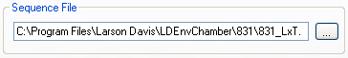
- Click Begin 831/LxT test.
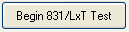

9.3 Completion of Environmental Chamber Test

- Once the test is completed the equipment can be removed from the chamber.

9.4 Plot Test Results
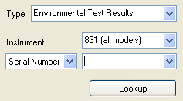
- Start the Report Generator program
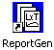.
- Select Environmental Test Results as the test type.
- Select the Instrument field to be 831 (all models).
- Select Serial Number and enter the serial number in the adjacent field and press Lookup or drop down the field and choose the serial number of the unit to generate reports for.
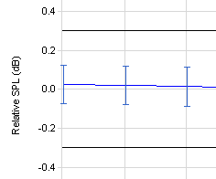
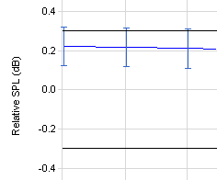
- Locate and view the test results. Verify that the “uncertainty flags” are within the limit lines. The left example below shows a passed condition. Blue flags above or below the limit lines represents a failed condition as shown in the right example below.
Passed Example
Failed Example
- Print the test documentation to be provided to the user by pressing the button and selecting the reports from the list provided.

9.5 Unit Failure

If any units did not pass the chamber tests, then troubleshoot the failures, make repairs and repeat the test process.

10.0 RECORDS

- Chamber results are maintained electronically for a minimum of two years in the ReportGen database.

11.0 DISTRIBUTION

Manufacturing

12.0 ATTACHMENTS

Not applicable to this procedure.

13.0 REVISION HISTORY

DCO # | REV | DATE | INITIALS | CHANGES MADE
1085 | A | 29 May 2008 | AJR | Created work instruction
1179 | B | 25 Mar 2009 | LWH | Changed temperature range from "-30°C to 60 °C" to "-40°C to 70 °C". Changed Humidity endurance from 45 °C to 40 °C. Added optional 831_LxTea.seq and 831_426A12.seq file selections for testing with a PRM831 and mic or 426A12 with its mic.

