
MDMUSB-E
Configuration Instructions

1.0 PURPOSE AND SCOPE

The purpose of this document is to provide the detail and instruction necessary to configure the baud rate and other settings of this product to work with the Model 831.

2.0 AFFECTED DEPARTMENTS

Manufacturing

3.0 REFERENCE DOCUMENTS

Operation Instructions found in I831.01 Model 831 Reference Manual

4.0 RESPONSIBILITIES & AUTHORITY

The technician has the following responsibilities and authority:

- Verify compliance of the product under test to specifications.
- Troubleshoot and correct product as required.
- Communicate concerns to the Supervisor of Quality Assurance.
- Request management review of product concerns.
- Follow established ESD standards.

5.0 DEFINITIONS

None applicable to this procedure.

6.0 SAFETY PRECAUTIONS

- Follow all standard safety precautions.

- EQUIPMENT AND MATERIALS

A PC with Windows XP or other OS compatible with the MultiTech Driver
- The MDMUSB-E to be configured

8.0 INSPECTION

Verify that you have the items on the BOM for MDMUSB-E. The firmware version number of the modem must be 2.0 or greater; otherwise it cannot be used outside of the USA. The version number can be read electronically in the procedures below.

9.0 INSTRUCTIONS

Installing the MultiModem USB Driver:

1) Connect one end of the USB cable to the modem and the other end to the PC.
2) Place the MultiModem CD into the PC’s CD-ROM drive and plug the USB cable into the PC. The Add New Hardware Wizard will display. Please follow the installation prompts.

MultiModem USB Baud Rate Setup:

1) After Installation go to Control Panel > System > Hardware tab > Device Manager
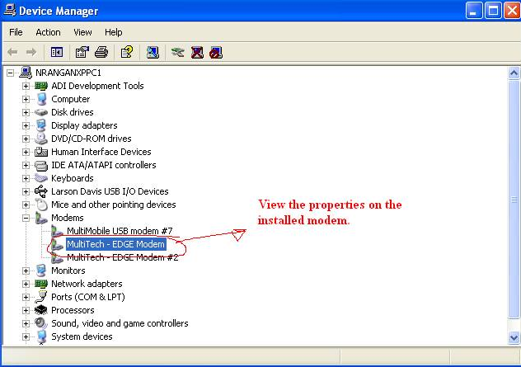

2) In the Edge modem properties page. Look at the Port number the device has been assigned (Com38 in this example). This is used when connecting with HyperTerminal below.
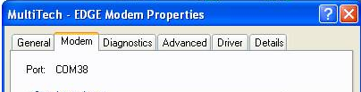

3) Navigate to the HyperTerminal program. On Windows XP machine the navigation path would be Start -> Accessories -> Communication -> HyperTerminal
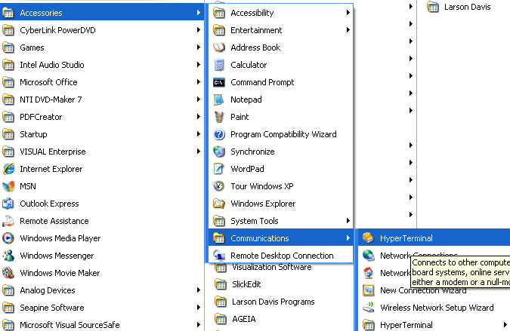

4) This would open up the HyperTerminal window and prompt for a new connection.
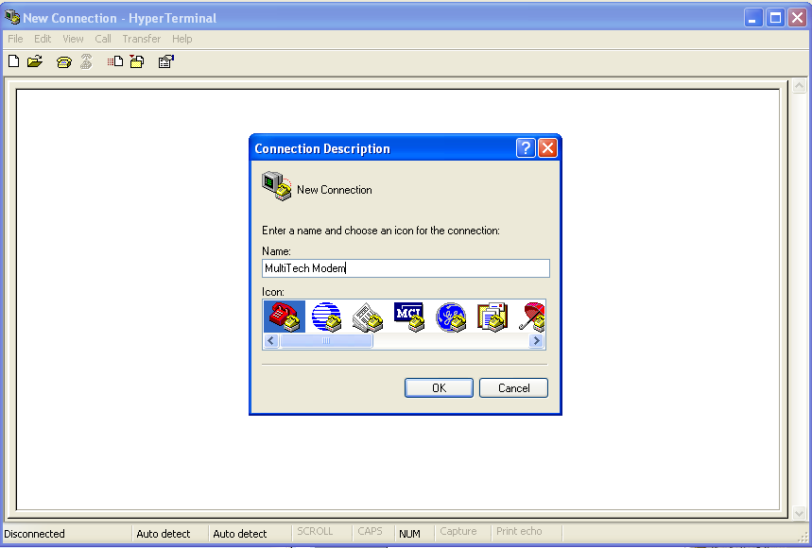
5) In the Connection Description window fill in an appropriate name and click Ok.
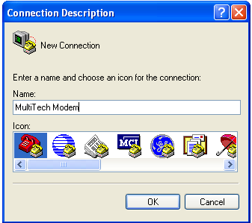

6) When you select OK the Connect To dialog will be displayed. In the Connect Using drop down menu select the com port to which the Modem is connected (this was discovered in step 2 above using device manager). Select OK when done.
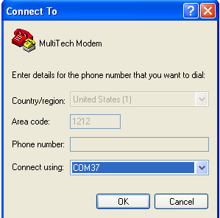

7) In the Properties set to the following: Bits per second -> 230400, Data bits -> 8, Parity ->None, Stop bits 1, Flow control -> Hardware.
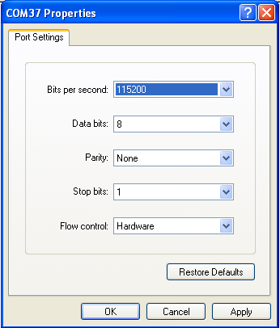
Select 230400 bps
Note: There is a possibility that the modem is currently configured for a bit rate other than 230400 pbs. In this event, try other rates until you find the correct one and then proceed.

8) In the Modem Properties -> Settings tab -> ASCII Setup
a) Enable Send line ends with line feeds
b) Enable Echo typed characters locally (if the characters you type in the next step are duplicated, return to this step and uncheck this box.)
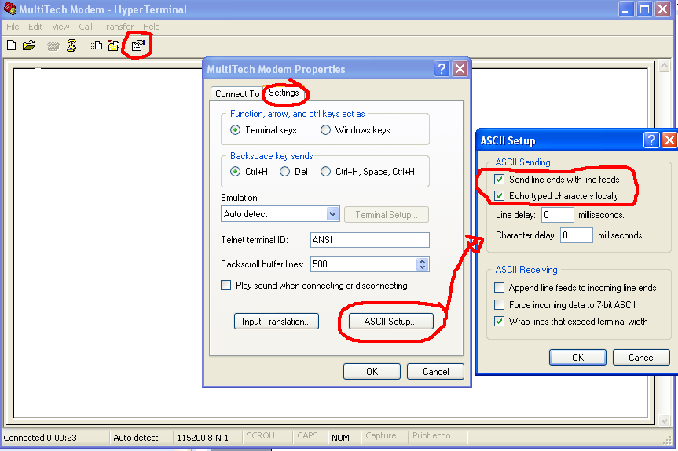

9) Now type in AT in the window and press Enter. Check that it responds with OK. If it does proceed to step 11 else proceed to step 10.

10) If it didn’t respond with an Ok go to modem properties and change the bits per second to 115200 rate and retry step 9.

11) Now type in AT+IPR? This should be respond with 230400. Type in AT+IPR=115200

This change will cause communication with the modem to cease.
Return to the location identified in step 7 and set the baud rate to 115200.
Reconnect to the modem.

12) Now type in AT in the window and verify that it responds with OK.
13) Now type in AT+IPR? and verify that it responds with 115200.
Your HyperTerminal session should look something like this:
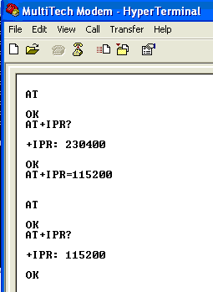
The Bits per second rate was changed to 115200 here.

14) Return to the device manager, right click on the Edge modem and select Uninstall from the menu.
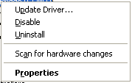
This will remove this instance of the Edge modem so that other Edge modems can be installed without consuming additional COMM Port numbers.

10.0 RECORDS

None

11.0 DISTRIBUTION

Manufacturing

12.0 ATTACHMENTS

Not applicable to this procedure.

13.0 REVISION HISTORY

DCO # | REV | DATE | INITIALS | CHANGES MADE
1086 | A | 29 May 2008 | AJR | Created work instruction

