A831.03 Board Test Procedure

- PURPOSE AND SCOPE

The purpose of this document is to provide the detail and instruction necessary to ensure the compliance of the 831 product to established specifications.

- AFFECTED DEPARTMENTS

Manufacturing

3.0 REFERENCE DOCUMENTS

A831.03 Schematics and loading diagram

4.0 RESPONSIBILITIES & AUTHORITY

The technician has the following responsibilities and authority:
Verify compliance of the product under test to specification.
Troubleshoot and correct product as required.
Communicate concerns to Supervisor or Quality Assurance.
Request management review of product concerns.
Use proper ESD protective equipment.

5.0 SAFETY PRECAUTIONS

Safety Glasses are required when soldering, lead clipping, or testing power supplies.
Follow general electrical precautions for working with energized, low voltage circuits

6.0 EQUIPMENT & MATERIALS

Adjustable DC power supply 0-15 Vdc
Modified CBL140 (bare wire leads into banana plug for + and – power in)
Digital Voltmeter, 4.5 digits
A831.03 board test fixture

7.0 INSPECTION

Before testing the board, look at the components to verify polarity and that, parts are not missing, also note and repair obvious solder defects.

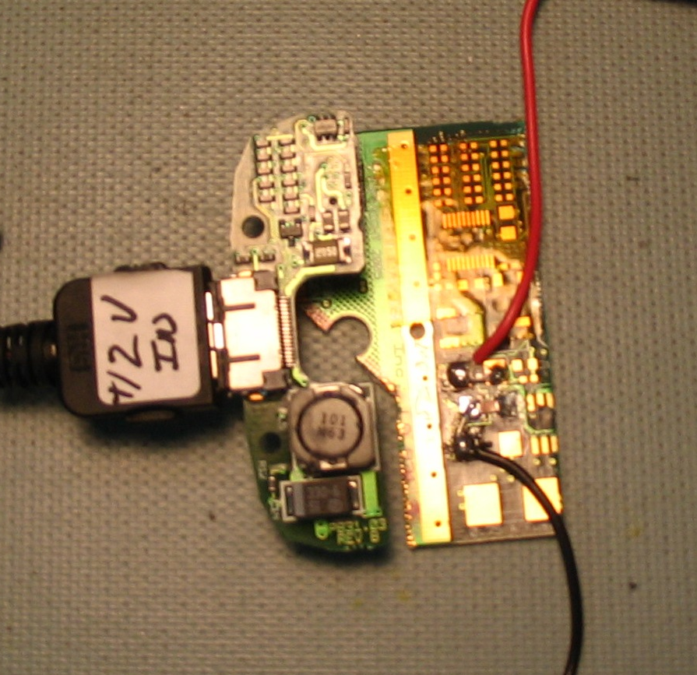
9.0 INSTRUCTIONS
A831.03
Device Under Test
Test Fixture
Wires to + and – of Voltmeter
(Modified from P831.01)
+12 Volt Power
(Modified CBL140)
The photo at the below shows the A831.03 being tested.

- Adjust power supply to 12 Volts dc and then turn power supply OFF.
- Connect the A831.03 board to Test Fixture.
- Connect digital voltmeter to Red and Black wires of the fixture to measure the Vext+5.5 output (see photo of fixture).
- Connect power via the modified CBL140 to the control port input of the A831.03 board.
- Turn power supply ON.
- Red LED will light up on the test fixture.
- Check for current draw of < 25mA on power supply.
- Verify the reading on the voltmeter; limits are 5.3 Vdc to 5.7 Vdc. Troubleshoot non-functional units.
- Turn power supply OFF and disconnect board under test.

- RECORDS

Complete and turn in the technician inspection and rework report.

11.0 DISTRIBUTION

Manufacturing

12.0 ATTACHMENTS

13.0 REVISION HISTORY

ECO # | REV | DATE | INITIALS | CHANGES MADE
1153 | A | 27Oct2008 | AJR | Initial Release

