A831.01 Test Procedure

PURPOSE AND SCOPE
The purpose of this document is to provide the detail and instruction necessary to ensure the compliance of the 831 product to established specifications by the contract manufacturer. Please become familiar with the entire document before attempting to test the product.

REFERENCE DOCUMENTS
- A831.01 Schematic, Assembly Drawing and Bill of Manufacturing
- A831.02 Schematic, Assembly Drawing and Bill of Manufacturing
- A831.03 Schematic, Assembly Drawing and Bill of Manufacturing

EQUIPMENT & MATERIALS
- Adjustable DC power supply 0-12vdc with built in current meter
- PSA029 5.0 volt power supply with Type-A USB output port. A Type A to mini-B USB cable is used in conjunction with this power supply, with a 0.1 ohm, 1% resistor inserted in-line with this cable to perform current measurements.
- Oscilloscope with probe
- Precision frequency counter.
- Test LCD (1895.0021)
- CBL093 signal cable
- USB-A to mini USB-B cable
- CBL139 AC/DC output cable
- Function Generator
- Keypad emulator tool
- Fixture, Control port test
- Personal Computer capable of running LXT_Test.exe test software
- USB flash memory drive
- Modified CBL140 831 control port power cable
- Test A831.02 board
- Test A831.03 board

INSPECTION
Before testing the board, visually inspect and correct component loading, polarity and missing parts. Note and repair obvious solder defects.

INSTRUCTIONS
- The PSA029 power supply output voltage is regulated to +5.0 volts. An in-line 0.1 ohm, 1% resistor is installed in the cable for measuring the current consumption.

Note: If you are not using a power supply to mini USB with a voltage regulator, do not put in more than 5.5 Volts into the board.

- Connect the test LCD to the A831.01 board.
- Turn the switch on the bottom of the A831.01 board to the off position – towards the large USB connector.
- Plug the PSA029 USB power cable into the A831.01 board.
- Turn the switch to the “ON” position – towards the small USB connector.
- Turn the board “ON” by pressing the ‘PWR’ pad using the keypad emulator.
- Verify that the 831 logo is displayed on the LCD.
- Verify that the board is drawing less than 175 mA (<17.5 mV if measuring across in-line 0.1 ohm current-measurement resistor).
- Carefully turn unit over and check the following voltages,

Test Point | Power Supply Name | Low Limit | High Limit
TP 34 | V+3.3 | 3.00 Volts | 3.33 Volts
TP 40 | Vrtc | 2.40 Volts | 2.60 Volts
TP 18 | USB_V+ 3.3 | 3.00 Volts | 3.33 Volts
TP 35 | DSP_Vint | 0.90 Volts | 1.80 Volts
TP 30 | Vlcd | 12.7 Volts | 20.4 Volts
TP 36 * | DSP Clock | 9.8295 MHz | 9.8313 MHz
TP 37 * | RTC Clock | 32.7664 KHz | 32.7696 KHz
TP 37 $ | RTC_Xout | 32.76784 KHz | 32.76816 KHz
Notes:
* Rev C and prior revisions
$ Rev D revision, RTC_Xout tolerance is 2 ppm plus measurement uncertainty (included in limits). At this point in the test procedure, the DSP oscillator is not be controlled by firmware. When loaded, firmware will control RTC_Xout with VCXO via the DAC (U19, see TP5) and will change after power-on every several minutes. This brings the DSP oscillator into sync with the very accurate RTC oscillator inside U20.
- Turn the board off by turning the switch to the “OFF” position.
- Remove the PSA029 USB power supply cable.
- Connect the A831.01 board to the computer’s USB port using USB cable.
- Turn the unit on by switching the power switch to the “ON” position and pressing the ‘PWR’ pad on the board using the keypad emulator, computer will give a tone.
- Activate the Model 831 & LxT test software. LxTTest.exe.
- Load Firmware and Instrument Setup
  - Select Tools, then Load Firmware/Options… menu item. Select Next, then select Upgrade the firmware using a .Rom file and deselect the Change installed options using an .OPT file.
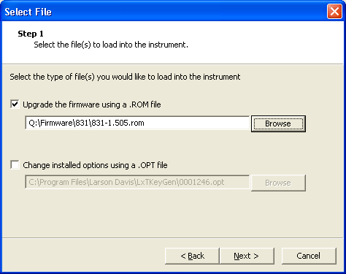
  - Select the released version of firmware 831-vvvv.ROM, where vvvv is the version number.
  - Click Next, then Finish.
  - After the firmware has been loaded, select OK, then CLOSE on the computer screen, instrument will remain in the load state.
  - Open the Tools menu, select Instrument setup, information box will open, go to Manufacture date window, and select date by clicking on Today (by the red circle), Highlight the serial number and change it to, 000100, select OK. The instrument will now program the Manufactured Date and go through a memory check. This will take a few minutes.
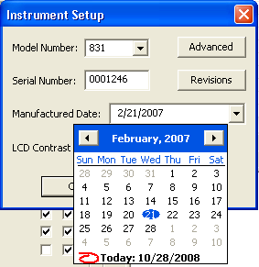
- Turn instrument off by pressing the S4C pad with the emulator, and holding on it until power turns off (≈2s). Unplug the USB cable.
- Attach tested A831.02 and A831.03 boards to the A831.01 board.
- Plug USB cable back into A831.01 board and turn instrument back on.
- Verify the following voltages, carefully turn unit over when needed.

Test Point | Power Supply Name | Low Limit | High Limit
TP 16 | Va+1.5 (Formerly Va+1.8) | 1.47 Volts | 1.53 Volts
TP 13 | Va+5 | 4.87 Volts | 5.13 Volts
TP 15 | Va+3.3 | 3.26 Volts | 3.34 Volts
TP 41 | Vpreamp | 34.3 Volts | 36 Volts
TP 42 | Va+18 | 17 Volts | 18.0 Volts
TP 43 | Va-14.5 | -14 Volts | -15.0 Volts
TP x8f1 | Clock frequency | 19,660,570 Hz | 19,663,590 Hz

Key Pad operation
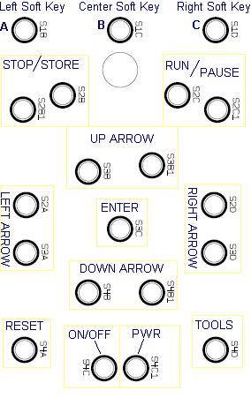
The figure below indicates the key reference designators, names and positions for each of the key pads. Note that there are two pads for the Stop/Store, Run/Pause and the four arrow keys.
Verify keypad operation, using keypad emulator tool to press all pads as follows:

- Press the ENTER pad twice. A menu opens and closes.

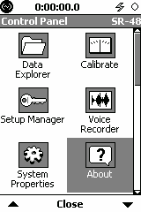
- Press TOOLS pad, Control Panel appears, press left and right arrow pads and up and down arrow pads to verify that the highlighted icon changes with the key presses.
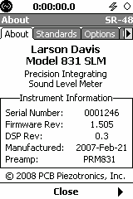
- Highlight the About icon and press ENTER. The About display is shown.

- Press S1D pad to change the selected tab over right and S1B to go left. Press S1C pad twice to Close out.

- Press S2C1 pad to RUN and S2C to PAUSE.

- Press S2B1 twice to STOP and STORE followed by the ENTER key; the icon on top right of screen will change to a folder. Press S4A pad to RESET and then ENTER, folder goes away and an open box is shown.

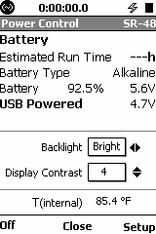
- Press S4C pad POWER display opens. Press right and left arrow keys twice each to toggle backlight on and off. The blue keypad backlight LED’s will also turn on and off.

- Press up and down arrow keys to change the display contrast.

- Press S1B pad to turn unit off.

Check the AC/DC out, Calibration and Voice functions.

- Input 0.5 Vrms 1 kHz sine wave directly into the input of the 831 using the CBL093, BNC male to 5-pin male Switchcraft cable. Turn unit on.
- Calibrate the unit
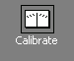
  - Press the TOOLS key, highlight the Calibrate icon and press ENTER.
  - Arrow down and select the line 114.0 dB 1 kHz and press ENTER. Move back up and highlight the Calibrate button to perform the calibration.
  - Press ENTER for Yes and to save the results. If the message “Out of normal range” appears, then there is an error and the board will need to be repaired. Select Close to exit dialog.
- Enable AC/DC Output

  - Highlight the System Properties and press ENTER.
  - Press S1D pad three times to highlight the Preferences tab, arrow down two times and press ENTER, select AC/DC and press ENTER.
  - Press S1C to Close the System Properties dialog. The Apply Changes prompt will be shown, press ENTER for Yes and then press S1C to exit Control Panel.
- Check AC/DC Output
  - Plug the CBL139 AC/DC output cable into the signal out jack and press RUN key.
  - Verify that the DC output (Black cable) is 1.12VDC to 1.16VDC.
  - Measure A/C output waveform with oscilloscope.
  - Verify that the A/C output (Red cable) is about 2.2 Vrms with a clipped sine wave.
  - Change the function generator to 200 mVrms.
  - Verify that the AC output (Red cable) is 1.60 to 1.74 Vrms with an undistorted sine wave.
  - Press STOP key.
  - Remove CBL093 from the input and remove CBL139 from the headphone jack.
- Check Voice Recorder
  - Plug the headphones into the signal out jack.

  - Press the Tools key, highlight the Voice Recorder icon and press ENTER key.
  - Press S1B pad to start recording (record short message). Press the ENTER pad twice to stop and save message.
  - Press S1D pad to hear playback. Press ENTER to stop. Press S1C to exit voice.
  - Remove the headphones.

USB Flash Drive Test
- Enable USB Port and USB Storage
  - Press TOOLS key, highlight System Properties and press ENTER. Press S1D pad 3 times to highlight the Preferences tab.
  - Press down arrow to highlight USB Host Port, press ENTER, and select ON. . Press ENTER key.
  - Down arrow once and edit USB storage, select AUTO, and press ENTER.
  - Press S1C to Close the System Properties dialog and the Apply Changes prompt will be shown, press ENTER for a Yes and then press S1C to exit Control Panel.
- Plug a USB flash drive that contains a pre-saved 831 data file into the 831’s USB-2 host port.

- Press TOOLS key, and press ENTER to open Data Explorer.
- The pre-saved 831 data file on the USB flash drive will show on the file list, with an LD logo and a small USB stick symbol, before the file number, and the light on your USB flash drive will blink.
- Close window twice and remove Flash drive. Turn unit off and remove USB cable.

Check Control Port
  - Apply 12 Vdc from Adjustable DC power supply to the CBL140 cable.
  - Plug CBL140 cable into the control port on the A831.03 board. Unit will automatically power on. Current draw on the power supply’s current meter should be less than 85 mA on the power supply.
  - Press the on/off key and toggle the Dim and Bright lights on, observing current draw, should be less than 115 mA when dim, and less than 135 mA when bright.
  - Close dialog box and turn off.

Loading 831 Data File Into USB Flash Drive
Skip this step except as needed. This step is only performed once, to load an 831 data file into a USB flash drive, to be used in a previous section of this document.
- Enable USB Port and USB Storage
  - Press TOOLS key, highlight System Properties and press ENTER. Press S1D pad 3 times to highlight the Preferences tab.
  - Press down arrow to highlight USB Host Port, press ENTER, and select ON. . Press ENTER key.
  - Down arrow once and edit USB storage, select AUTO, and press ENTER.
  - Press S1C to Close the System Properties dialog and the Apply Changes prompt will be shown, press ENTER for a Yes and then press S1C to exit Control Panel.
- Plug a blank USB Flash Drive into USB-2 host port.
- Run unit for 10 seconds, press stop twice, to STOP and STORE data. The “Save File?” message comes up, press ENTER for Yes. The light on the USB flash drive should light up. Wait until the light goes off to continue.
- Press TOOLS key, and press ENTER to open Data Explorer.
- The saved 831 data file on the USB flash drive will show on the file list, with an LD logo and a small USB stick symbol, before the file number, and the light on your USB flash drive will blink.
- Close window twice and remove Flash drive.
- Turn unit off and remove USB cable.

RECORDS

- Complete and turn in the technician inspection and rework report.

DISTRIBUTION

- Manufacturing and contract manufacturer.

FIXTURES

Construction of Fixture, Test LCD (1895.0021)
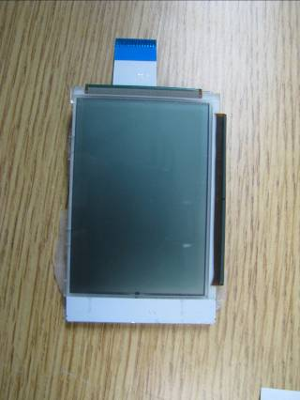
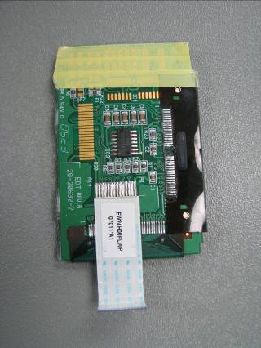
A test display is used to determine the instrument’s user interface functionality. Care should be taken when handling the display to protect it from ESD (Electro–static Discharge) and to prevent damage to the FFC (flat flexible cable).

The backside is also insulated with Mylar (or equivalent) tape so that there are not short circuits between the display and the A831.01 board circuitry.

Construction of Fixture, Keypad emulator tool

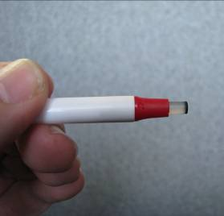
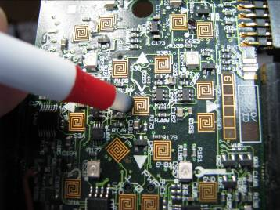
A keypad emulator tool will be provided that is used to “push” the buttons on the keypad. When the A831.01 board is not in a case with an elastomeric keypad, a substitute tool must be used to make electrical connection between the two serpentine circuits of each key.

The pictures at the right show the tool and its operation.

The tool can be manufactured by cutting off a button element that contains a conductive carbon pad from a keypad, and pushing it into modified stick pen as shown above.

REVISION HISTORY
DCO # | REV | DATE | INITIALS | CHANGES MADE
ECO 4099 | A | 04/23/2012 | JLD | Initial release.
DCO  1411 | B | 10/29/2012 | RCH | The accuracy of the voltage at DC out (TP14) and consequently the DC voltage out of the AC/DC connector is dependent upon the accuracy of the U10 voltage regulator. This regulator is 3.3V ±1.21%. This change to step 7.D.2. Makes the passing voltage range reflect this accuracy range better.
DCO  1425 | C | 1/11/13 | RCH | Update voltage table (5.0 I) to reflect new test point voltages for revision E boards.

See Section FIXTURES for LCD construction details.
See Section FIXTURES for Keypad tool construction details.
Ensure to replace entire serial number field when entering this serial number, as the 831 unloaded with firmware sends back a default serial number with leading spaces in front of it. If left, these leading spaces will cause serial number writing operation to fail.
After an hour of operation, Clock frequency (TP x8f1) will be 19.6608 MHz ±200 Hz (19.6606 to 19.6610 MHz).
Go to section “Loading 831 Data File Into USB Flash Drive” if a USB flash drive is available that does not yet contain an 831 data file.

