831-INT-ET Configuration and Testing Work Instructions

PURPOSE AND SCOPE
The purpose of this document is to provide the detail and instruction necessary to ensure the compliance of the specified product to established specifications. This instruction is applicable to both new product and to customer owned product that has been returned for repair and/or calibration.

LIMITATIONS
This instruction is limited to the deployment of the 831-INT-ET.

AFFECTED DEPARTMENTS
Manufacturing

REFERENCE DOCUMENTS
- Cisco Linksys E2000 Configuration Guide.ppt
- Applicable drawings and instructions for the 831-INT-ET are needed.
- S831.04 ASSY 831-INT INTERFACE UNIT DRAWING.

RESPONSIBILITIES & AUTHORITY
The technician has the following responsibilities and authority:
- Verify compliance of the product under test to specification.
- Troubleshoot and correct product as required.
- Communicate concerns to Supervisor or Quality Assurance.
- Request management review of product concerns.
- Use proper ESD protective equipment.

SAFETY PRECAUTIONS
- Follow general electrical precautions for working with energized, low voltage circuits

EQUIPMENT & MATERIALS
- 831 SLM.
- PRM831, 831 Microphone Preamplifier.
- 377B02 or equivalent, ½” pre-polarized microphone.
- R-Drive Image Software.
- Windows Computer.
- USB SD card reader.
- Cisco Linksys E2000 router.

INSPECTION
Perform a visual check of the board. Check for soldering defects, any shorts or mis-loaded parts.

831-INT-ET HARDWARE SETUP
- If not already done, remove 831-INT M831.41 top enclosure case.
- Install SBC onto the A831.04 assembly.
- Secure with QTY 4.0 5290.0187 #4-40 screws.
- Apply Loc-Tite 222 before installing these screws.

- Torque screws to 50±2 IN-OZ (3.1±0.1 IN-LB).
- Apply the QTY 2.0 1132.0036 contact strips to the SBC. One on the USB connector shield and one on the Ethernet shield. Refer to S831.04 drawing for placement and orientation.
- Configure A831.04 P2 jumpers so that it is configured for both SBC and Watchdog Enabled (see figure or refer to A831.04 drawing).
- If there is any USB cable connected to the 831-INT-ET’s USB host port, disconnect it. The SBC should still remain powered.
Note: If SBC powers off when connection to 831-INT-ET USB host port is disconnected P2 is configured incorrectly.

CONFIGURATION AND TESTING INSTRUCTIONS

Writing SD Flash Card
- Place a blank 3045.0105 2 GB SD Chip in the USB card reader.
- Insert the USB card reader into an available USB slot on the Windows machine.
- Run R-DriveImage.exe
- Click ‘Next’ See Figure 1.

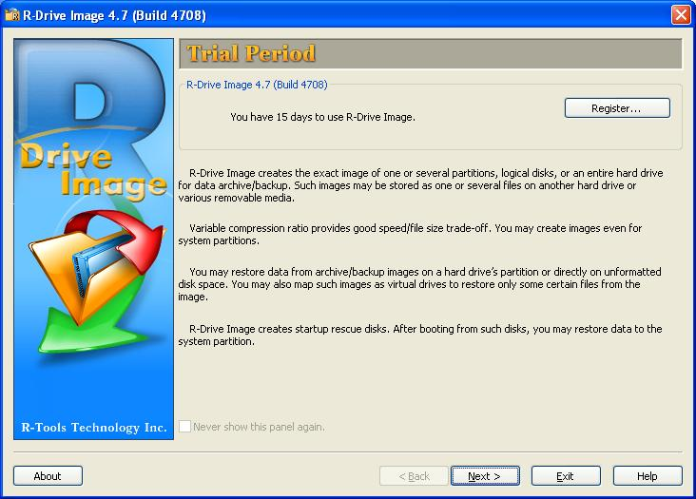
Figure 1

- Click ‘Restore from an Image’ See Figure 2.

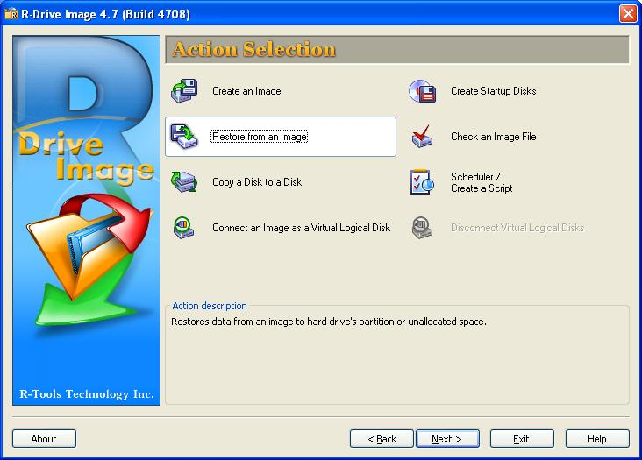
Figure 2

- Browse to the current SBC_x_x.arc 831-INT-ET image file, found in the path \\Nydfs01\Shared\Provo\Engineering\Firmware\831-INT-ET\ and select it.
- Click ‘Next’. See Figure 3.

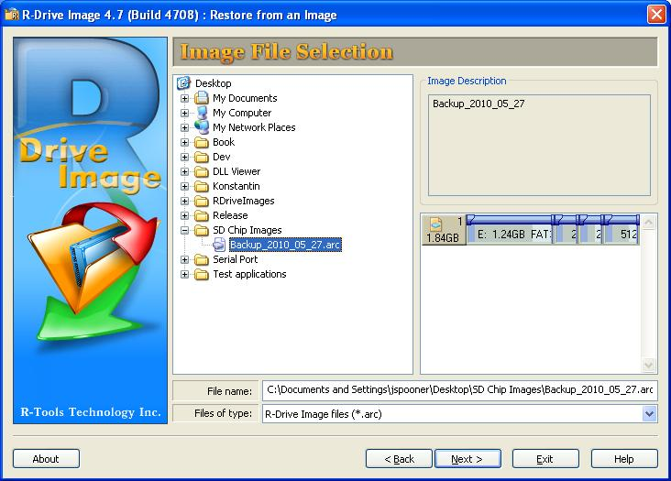
Figure 3

- Select the current SBC_x_x.arc as the image you want to copy.
- Select the destination you want to copy the image to. This should be USB device with the SD card in it.
- Click ‘Next’. See Figure 4.

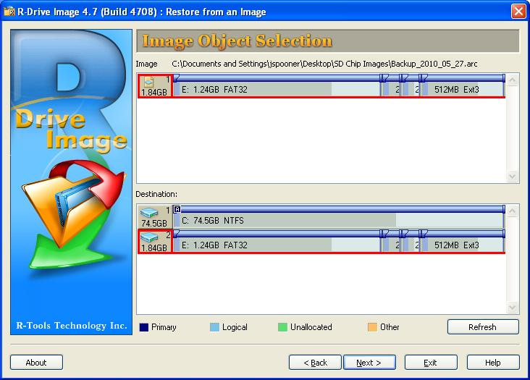
Figure 4

- Click ‘OK’ if the warning comes up that says the destination will lose all data. See Figure 5.

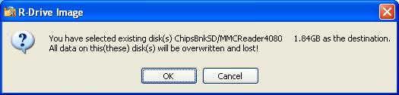
Figure 5

- Select ‘Raw disk copy (disk will be shown after rebooting)’.
- Click ‘Next’. See Figure 6.

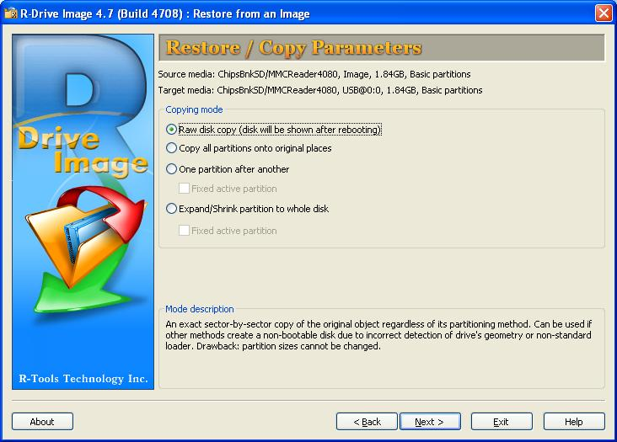
Figure 6

- Review the processing information. Select ‘Start processing immediately’.
- Click ‘Start’. See Figure 7.

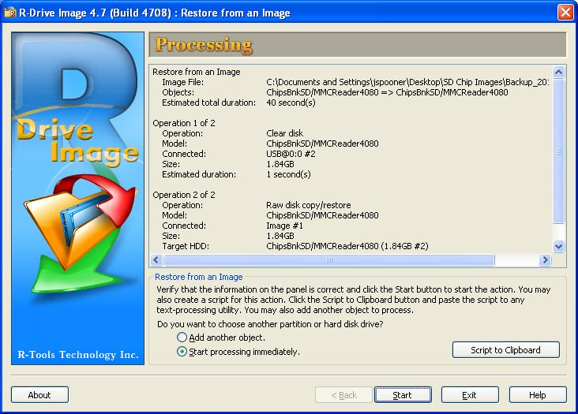
Figure 7

- Wait until the deployment image is fully copied to the 2 GB SD chip. See Figure 8.

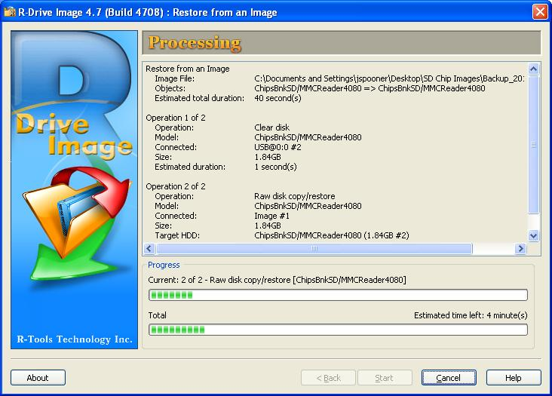
Figure 8

- Click ‘OK’ on the disk image restored successfully. Redo previous steps if the restore fails. See Figure 9.

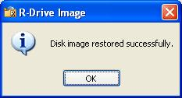
Figure 9

- Click ‘Exit’. See Figure 10.

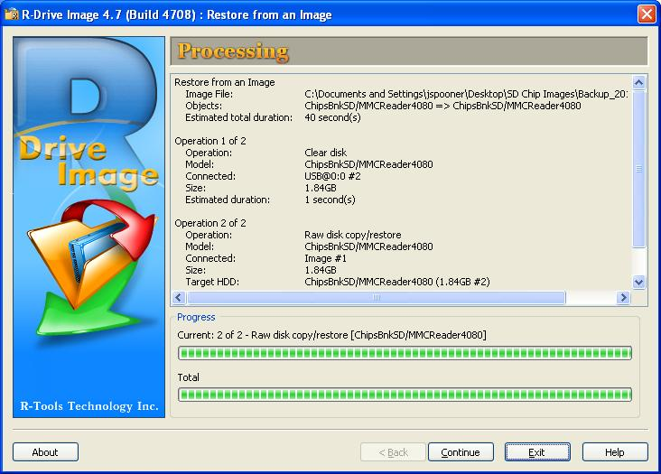
Figure 10

- Remove the 2 GB SD Chip from the USB card reader.

Setup to Determining IP address and MAC address of 831-INT-ET
- If the configuration has not yet been done for this test station, perform the set up test computer’s network interface card for DCHP connection. See Section 10.4.
- If you haven’t setup your Cisco Linksys E2000 router, following the instructions in Cisco Linksys E2000 Configuration Guide.ppt.
- Place the programmed 2 GB SD Chip in the 831-INT-ET SBC SD Chip holder and lock it down.
- Assemble the rest of the 831-INT-ET (see S831.04 drawing).
- Install the 831 (with preamp and microphone) in the 831-INT-ET.
- Connect the USB cable from the 831’s mini USB to the USB port B on the
831-INT-ET.
- Insert an Ethernet cable into the Cisco Linksys E2000 DHCP router on one of the open blue ports.
- Insert the other end of the Ethernet cable into the 831-INT-ET Ethernet port.
- Power up the 831-INT-ET with 831.
- Start Cisco Connect All Programs → Cisco Connect. Figure 11
- Select change in the router settings box.
- Select advanced settings. Figure 12
- Select OK. Figure 13
- Select DHCP Reservation. Figure 14
- Copy the IP address and MAC address. The 831-INT-ET will be the entry without a client name. The other entry should be for your windows box. Figure 15
- Ensure to annotate this MAC address on the 831-INT-ET back label and also in the Larson Davis data base. (See Records in Section 11.0).

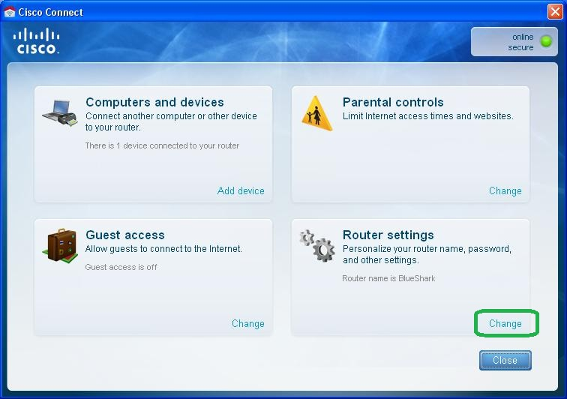
Figure 11

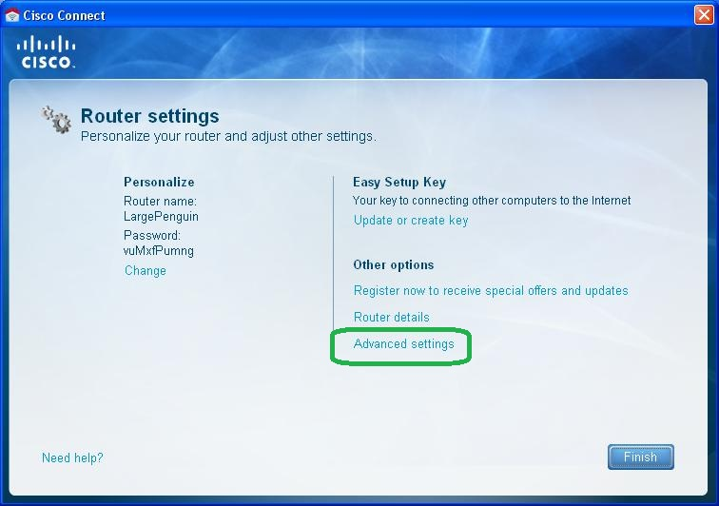
Figure 12

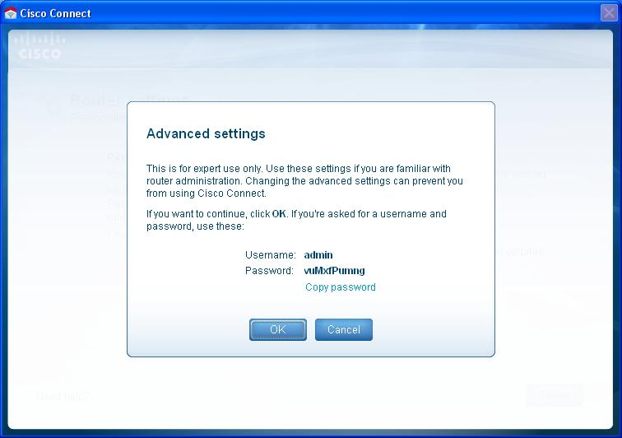
Figure 13

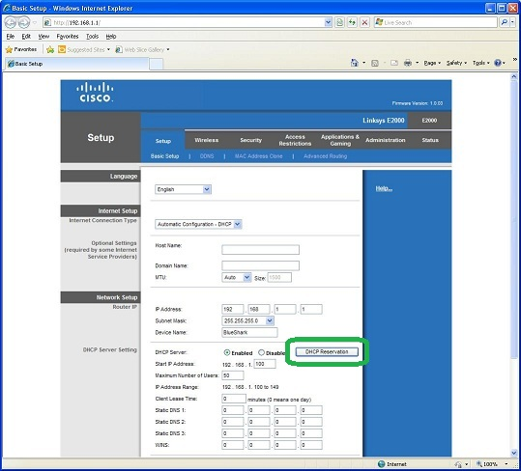
Figure 14

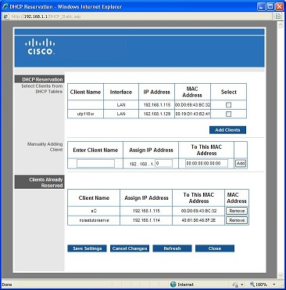
Figure 15

831-INT-ET Ethernet Functionality Testing
- If already done, then power up the 831 and 831-INT-ET.
- Wait for approximately 3 minutes for 831-INT-ET SBC to fully boot.
- Connect to the 831 via G-3.
  - Open G-3
  - Select the menu option Connection → Remote → Internet.
  - Type in the IP address for the 831-INT-ET that was previously found in section 10.2.
  - Type in the port number for the 831-INT-ET. Default port is 2001.
  - Select the ‘Manual Control’ tab in Instrument Manager.
  - Click ‘ScreenGrabber’ button.
  - Verify that ScreenGrabber works.
  - Close the ScreenGrabber dialog.
  - Click ‘Start Live Stream’ button
  - Verify that the Live Stream works.
  - Close the Live Stream dialog.
  - Select the ‘Download’ tab
  - Select a file to download and click ‘Download’ button.
  - Verify the file downloads correctly.
  - Do any additional spot checks you want.
- Close G-3.
- DHCP is the default configuration for the SD chip image. No further testing required; skip to section 11.0.

Setting up test computer’s network interface card for DCHP
- If it has not been done yet, configure the test computer’s network connections as described below. If you don’t have this configuration, skip this section.

Example setup on the test computer using the default 831-INT-ET configuration:
  - Plug Ethernet cable from the Ethernet network to the yellow port on the Cisco Linksys E2000 router.
  - Plug Ethernet cable from the computer’s Ethernet port to one of the blue ports of the E2000 router.
  - Open network connections and select the Local Area Connection. See Figure 16.

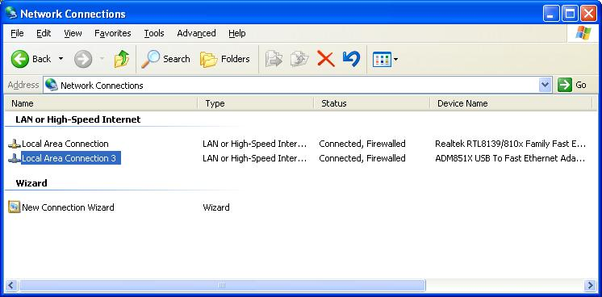
Figure 16

  - Right click on the connection and select ‘Properties’
  - Select Internet Protocol (TCP / IP). Click ‘Properties’ button. See Figure 17.

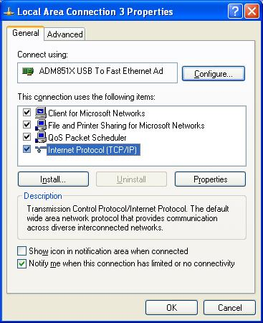
Figure 17

  - Select ‘Obtain an IP address automatically’
  - Select ‘Obtain DNS server address automatically’
  - Click ‘OK’ button to save the changes. See Figure 18.

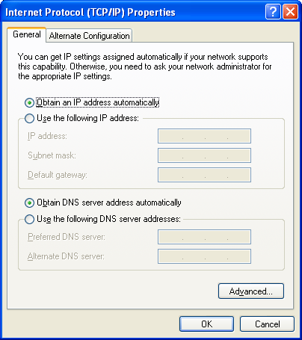
Figure 18

  - Click ‘OK’ button on the ‘Local Area Connection Properties’ dialog. See Figure 17.

Records
Figure 17
- Create label using label M770.0042, that includes unique MAC address for 831-INT-ET, and place it as shown in Figure 17. The MAC address will be six sets of hex numbers separated by colons (i.e. 12:34:56:78:90:AB). To eliminate errors, copy and paste this MAC address from UsbToUsb.exe program (see Section 10.2) to the printing program.
- Also copy and paste this MAC address into the 831-INT-ET’s record notes field in the Larson Davis Data Base.

DISTRIBUTION
Instruction is available online in the “831” folder in the “Technician work instruction” folder in Document Control.

REVISION HISTORY
DCO # | REV | DATE | INITIALS | CHANGES MADE
 | A | 04/19/10 | JS | Initial Release
 | B | 05/27/10 | JS | Add more details on the SD chip restore operation. Detail steps for Static and DHCP IP configuration.
 | C | 06/23/10 | JS | Added clarification and minor bug fixes. SerialPort.exe is now SerialNetworkProgrammer.exe
 | D | 11/10/10 | JD / JS | Added equipment list and steps to convert 831-INT to 831-INT-ET.  SerialNetworkProgrammer.exe is now obsolete.  UsbToUsb.exe is replacing SerialNetworkProgrammer.exe
 | E | 11/16/10 | JD / JS | Reorganized sections by production request.
ECO  3899 | F | 01/10/2011 | JLD | Updated 9.0 to ensure that both SBC and watchdog are configured for 831-INT-ET version. Added applying thread lock to four SBC screws.
 | G | 07/01/2011 | JLD | Removed replacement of SBC’s crystal. Renamed document.  Other very minor updates to document.
ECO  3995 | H | 08/16/2011 | JS | Replaced UsbToUsb with Cisco Linksys E2000 router.

