AEC201 Ear Simulator Tuning Instructions

1.0 PURPOSE AND SCOPE

This is the document for calibrating and tuning the AEC201 Ear Simulator.

2.0 AFFECTED DEPARTMENTS

- Production
- Repair and Calibration
- Engineering

3.0 REFERENCE DOCUMENTS

- AEC201 Assembly drawing (S201.1)

4.0 RESPONSIBILITIES & AUTHORITY

The technician has the following responsibilities and authority:
- Verify compliance of the product under test to specification.
- Troubleshoot and correct product as required.
- Communicate concerns to Supervisor or Quality Assurance.
- Request management review of product concerns.
- Use proper ESD protective equipment.

5.0 DEFINITIONS

AEC201 Ear Simulator
Is a mechanical acoustical device which simulates the response of the human ear to audio frequencies and used for measurement of earphones.

6.0 SAFETY PRECAUTIONS

Follow general electrical precautions for working with energized, low voltage (200V maximum) circuits. All other standard safety procedures should be followed.

7.0 EQUIPMENT & MATERIALS

- AEC201 Ear Simulator to be tested
- Two 377A13 Microphones one as the driver mic and one as the receiver mic in the AEC201
- PRM915 Hardware with 18 nF capacitor for driver mic
- MAEC101.52 (Driver) and MAEC101.54 (Driver Bottom) assembled together
- 831 with PRM831
- CBL092, CBL173 and CBL190
- MTS001 Base and Chamber with additional 7-pin LEMO connector thru base
- NI USB 4431
- Air pressure solenoids mounted on a board with Sealevel 8115 USB controller and NI USB 6008 A/D converter
- PCB 1502 B01GC15PSIA pressure sensor
- Two PSA027 12 Volt AC to DC Adaptors
- Liquid thread lock (Loctite 271 “red” or equivalent)
- 5/64” allen wrench
- Computer with the AECTest software and with 4 USB ports or a USB hub
- CAL250 Acoustic Calibrator
- Compressed Air

8.0 INSTRUCTIONS

Before beginning this procedure, the Ear Simulator subassembly should be put together. Detailed assembly instructions are included in the S201.1 assembly drawing.

Verify that the small, stainless steel port tube (7035.0007) is securely mounted in the coupler housing (MAEC101.01) and its hole is open and free of blockages through its entire bore. Make sure the Tuning plate (MAEC101.03) is centered in the coupler (MAEC201.01) and that there is loctite under the heads of the three screws but no loctite in any of the four small holes. The tuning procedure should be done within a day since the loctite will get hard if left too long.

8.1 TUNE

- Using the 5/64” allen wrench, adjust the three #2 socket head cap screws to lightly hold the tuning cavity. The tuning plate must remain centered in the coupler.

- Connect the Test Setup as shown in Figure 1. The MAEC101.52 (Driver) and MAEC101.54 (Driver Bottom) are attached with the 377A13 driver mic on the PRM915. These will stay with the PRM915 throughout these tests.

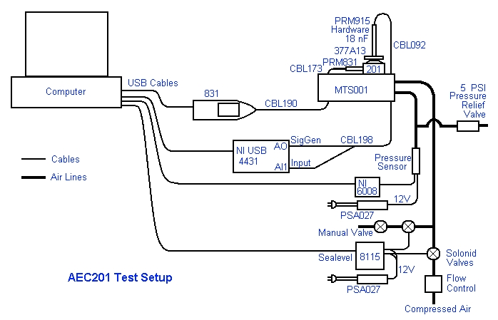

Figure 1. Ear Simulator Test Setup.

- Start the AECTest program.
- Steps E through I can be preformed as often as needed to make sure the microphone with preamp and 831 are in calibration. This could be at the start of a group of AEC201s to be tested but for sure when an different mic is used in the ear.
- Set the PRM915 off to the side, remove the top of the AEC201 leaving the 377A13 mic on.
- Gently put the CAL250 on the mic and attach the CAL250 run cable to the CAL250.
- Place the pressure vessel on top and latch down.
- Select Calibrate in the program then select OK.
- When finished, accept and remove the pressure vessel then the CAL250.
- Place the AEC201 top on the base and set the PRM915 on the top of the AEC201.
- The program can be run at normal static pressure (about 87 kPa) or can be pressurized to reference static pressure (101.3 kPa). If running at the reference static pressure, place the pressure vessel on top and latch down.
- Select Tune or Start. Tune tests at two frequencies while Start tests all required frequencies.
- Once the test sweep is finished, check the tuning level difference for 10.3 dB when run at reference static pressure or 9.67 dB when run at ambient static pressure.
- If the level difference is too much then tighten the tuning screws. If the level difference is too little then loosen the tuning screws. Equally tighten or loosen the screws a small amount (5° to 15°) each time. Experience will determine how much.
- Remove the PRM915 and the AEC201 top and adjust the screws.
- Replace the top and the PRM915.
- Rerun the AECTest program until the test passes with a full sweep at the reference static pressure.
- When tuning more than one AEC201 the receiver mic can be reused without recalibrating. Put on the next AEC201, reinstall the PRM831 and 377A13 mic then the tuning process can be started at I above.
- Customer service AEC201s can be run with the customers microphone (must be a 377A13), their PRM831 and 831 if they have sent these to us.

9.0 INSPECTION

None

10.0 RECORDS

The test results are stored in R:\Provo\Data\CertData\AEC201.

11.0 DISTRIBUTION

Production
Repair and Calibration
Engineering

12.0 ATTACHMENTS

None

13.0 REVISION HISTORY

DCO # | REV | DATE | INITIALS | CHANGES MADE
ECO 3982 | A | Jan 2011 | LH | Initial release

