PSA030 Power Supply Assembly Instruction

PURPOSE AND SCOPE
Instruction on the fabrication of the PSA030 power supply, so that it is compatible for use with the 831-INT and 831-INT-ET 831 Docking Stations.

AFFECTED DEPARTMENTS
Manufacturing

REFERENCE DOCUMENTS
N/A

RESPONSIBILITIES & AUTHORITY
The technician has the following responsibilities and authority:
- Verify compliance of the product under test to specification.
- Troubleshoot and correct product as required.
- Communicate concerns to Supervisor or Quality Assurance.
- Request management review of product concerns.
- Use proper ESD protective equipment.

SAFETY PRECAUTIONS
- Safety Glasses are required when soldering, lead clipping, or testing power supplies.
- Follow general electrical precautions for working with energized, low voltage circuits.

EQUIPMENT & MATERIALS
- Digital Multi-Meter, HP 34401A or equivalent.
- Soldering iron.
- 0195.0059, Power Supply, 90-264 VAC, 15V, 3.2A, 2.5x5.5 mm.
- 1145.0069, Connector, power plug 2.1x5.5 mm.
- Vice.

ASSEMBLY INSTRUCTIONS
- Cut 2.5 x 5.5 mm plug connector off end of 0195.0059 power supply right at end.
- Slide on 1145.0069 back shell.
- Strip back wires to the dimensions as shown in Figure 1.0 below.
- Plug in power supply and measure for polarity:

Wire with white striping = (+).

Solid black wire=(-).

If polarity is reversed, please reverse instructions below accordingly.
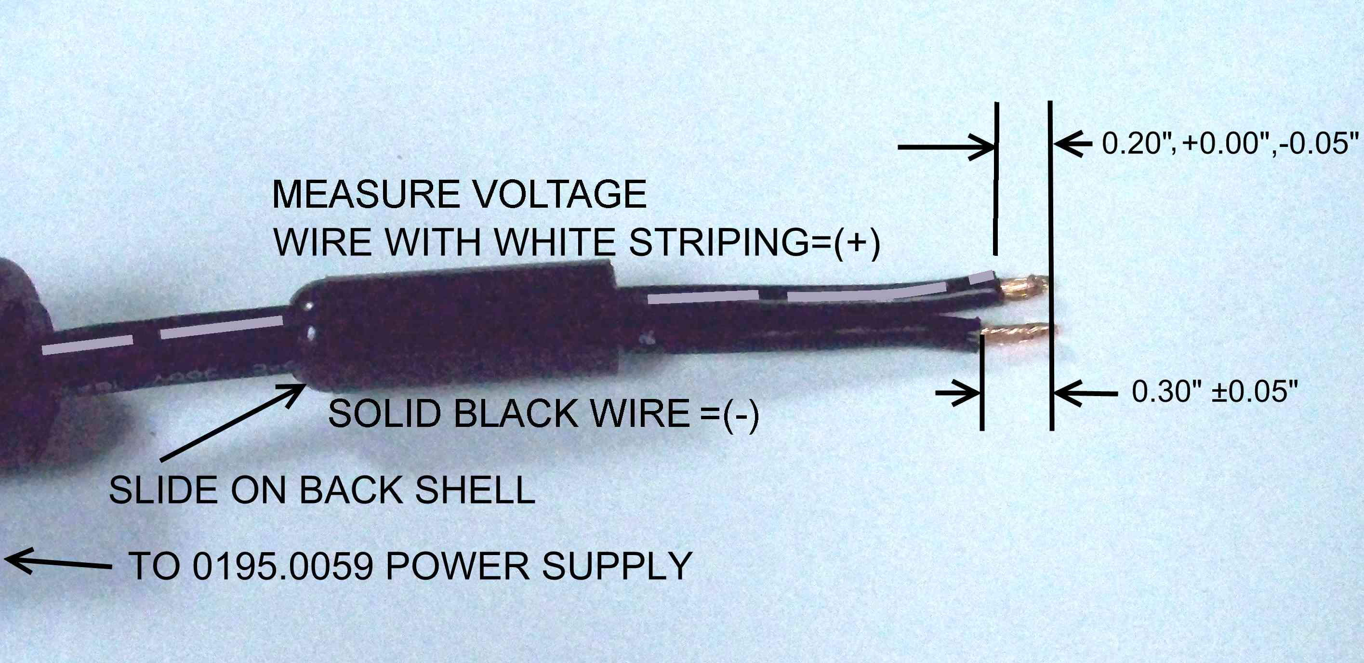
Figure 1.0 Cut cable, insert back shell, and strip wires

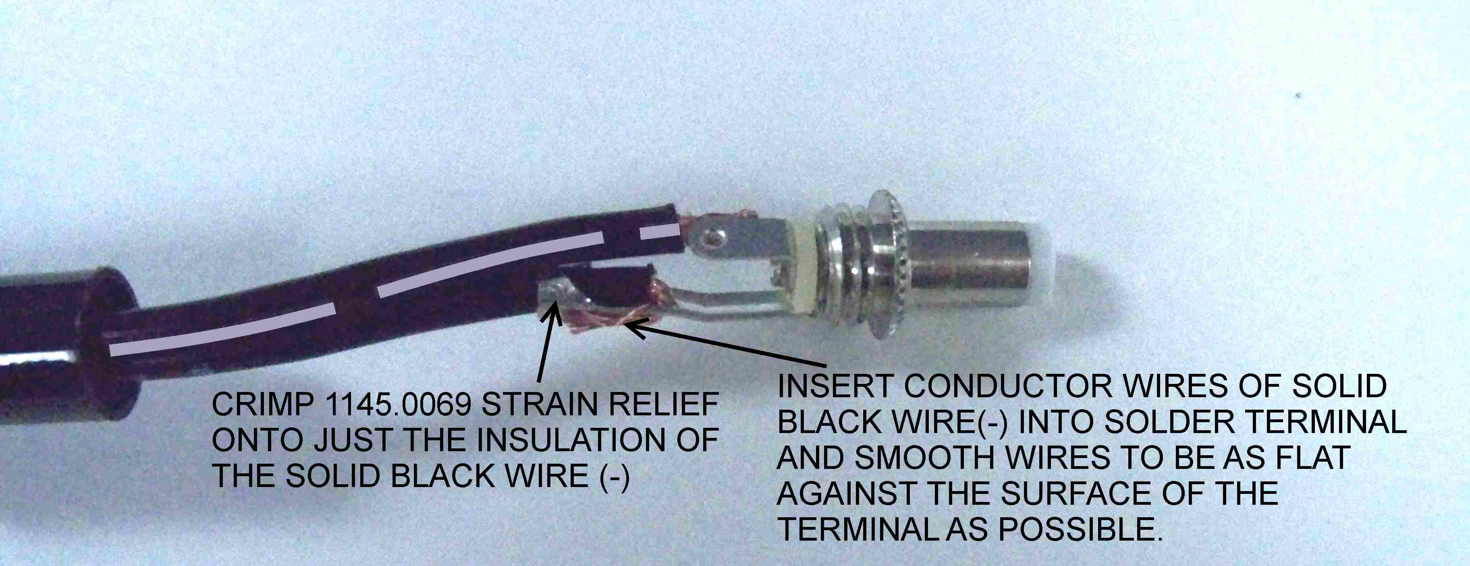
Figure 2.0 Insert and flatten negative wire.

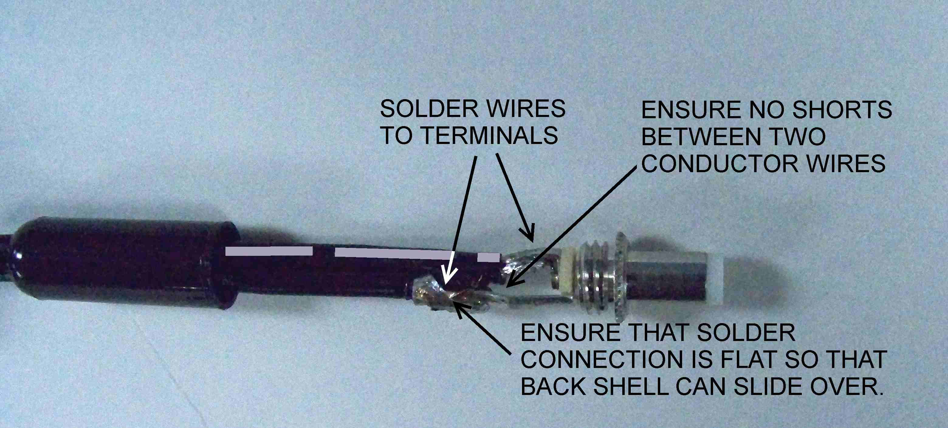
Figure 3.0. Solder wires to solder terminals

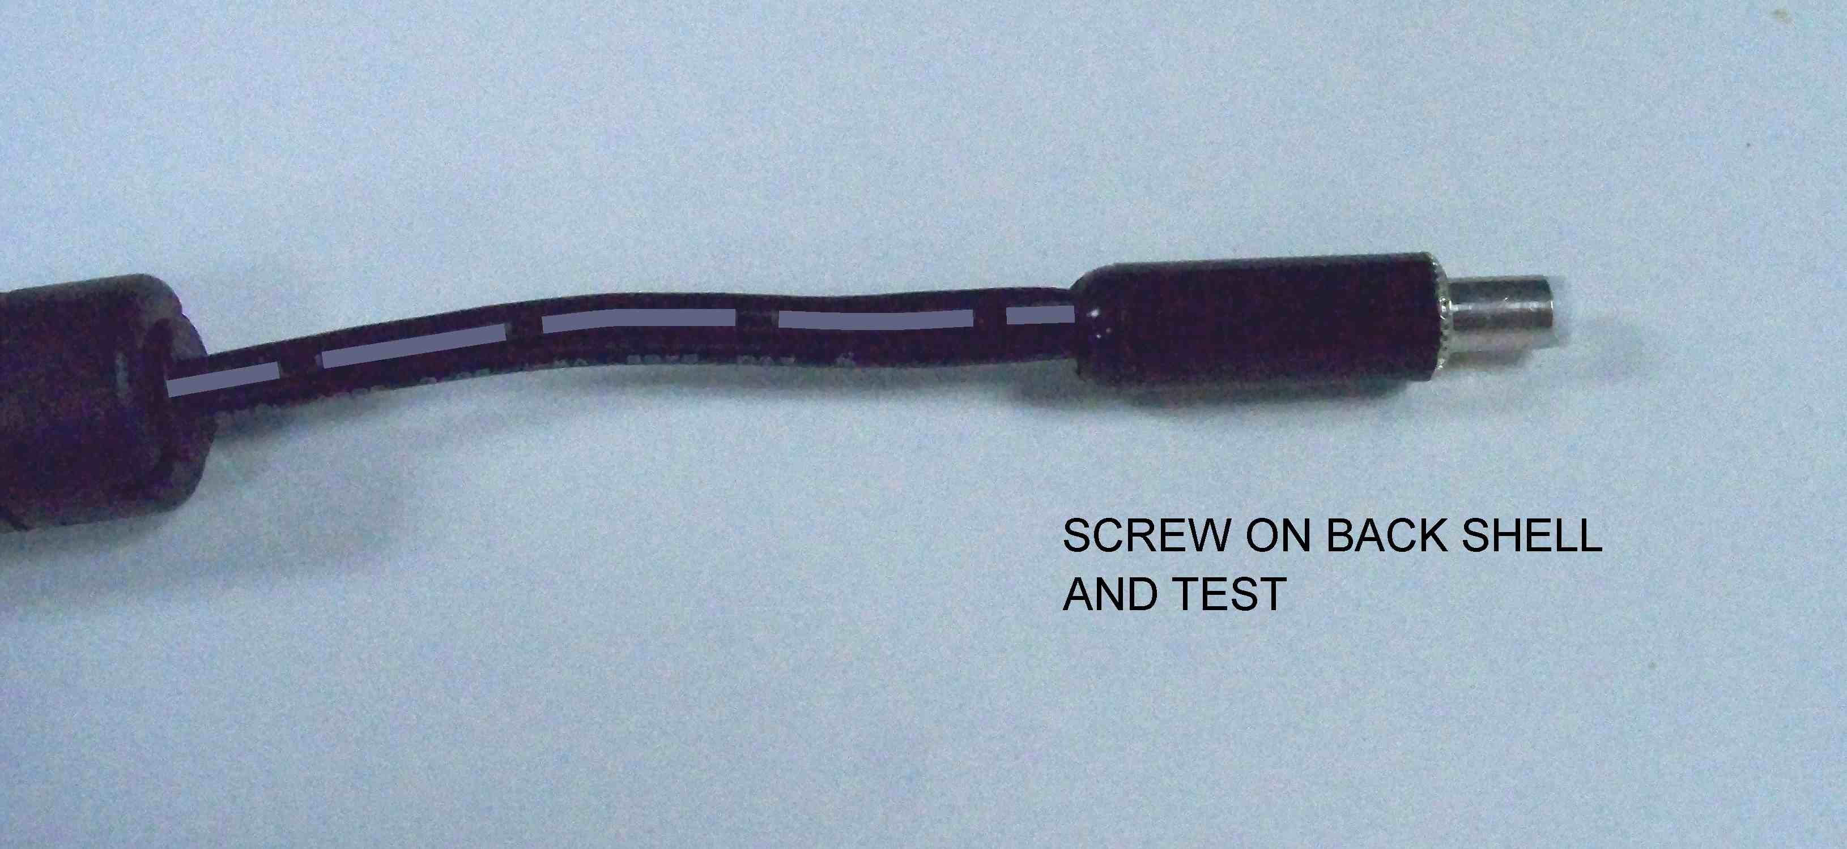
Figure 4.0. Screw on back shell

TESTING INSTRUCTIONS
- Plug in the 0195.0059 power supply into AC mains power.
- Measure voltage/polarity on output of newly soldered connector. Ensure the following:
- Output voltage is 14.25 to 15.75 VDC.
- Polarity is correct on output of connector as shown in Figure 5.0 below.
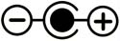
Figure 5.0. Polarity of power
supply after finishing.

RECORDS
N/A.

DISTRIBUTION
This instruction is available to employees and can be accessed through the online Document Control area.

REVISION HISTORY
DCO # | REV | DATE | INITIALS | CHANGES MADE
3899 | A | 02 MAY 2011 | J. DAVIS | Initial release.

