Raven to 831-INT-ET Cable Assembly Instruction

PURPOSE AND SCOPE
This work instruction documents the modification of the cable that comes with the DC version of the Sierra Wireless Raven Modem (COM-RAVEN-DC) such that the cable and modem can be connected and used with the 831-INT-ET.

This instruction is applicable to no other product than the COM-RAVEN-DC.

AFFECTED DEPARTMENTS
- Manufacturing

REFERENCE DOCUMENTS
- None

RESPONSIBILITIES & AUTHORITY
The technician has the following responsibilities and authority:

- Verify compliance of the product under test to specification.

- Troubleshoot and correct product as required.

- Communicate concerns to Supervisor or Quality Assurance.

- Request management review of product concerns.

- Use proper safety precautions and equipment

SAFETY PRECAUTIONS
- Safety Glasses are required when soldering, lead clipping, or testing power supplies.

- Follow general electrical precautions for working with cable stripping/cutting tools.

EQUIPMENT & MATERIALS

- Digital Multi-Meter, HP 34401A or equivalent.

- Heat Gun or equivalent

- 20 Wire Strippers for 20AWG wire

- Wire Cutters or Diagonal Cutters

- 2.0mm x 0.5mm flat head screw driver

- All materials specified on the COM-RAVEN-DC BOM

ASSEMBLY INSTRUCTIONS

- Acquire the various components, materials, documents and tools required for the COM-RAVEN-DC per the COM-RAVEN-DC Bill of Materials as listed in the ERP system and the equipment list given above.

- Cut the DC power cable contained with the Sierra Wireless Raven Modem to 24” ± 0.5” as shown in Figure 1.

- Strip jacket back 1.00” ± 0.25” and cut-off white conductor at jacket as shown in Figure 1.

- Strip black and red conductors 0.25” ± 0.125” as shown in Figure 1.

- Cut a piece of heat shrink to 0.75” ± 0.25” in length, center on jacket termination, and shrink in place with heat gun as shown in Figure 1.

- Twist bare cable on red and black conductors, insert conductors into terminal block per pin-out given in Table 1, and lock screw terminals to conductors with screw driver.

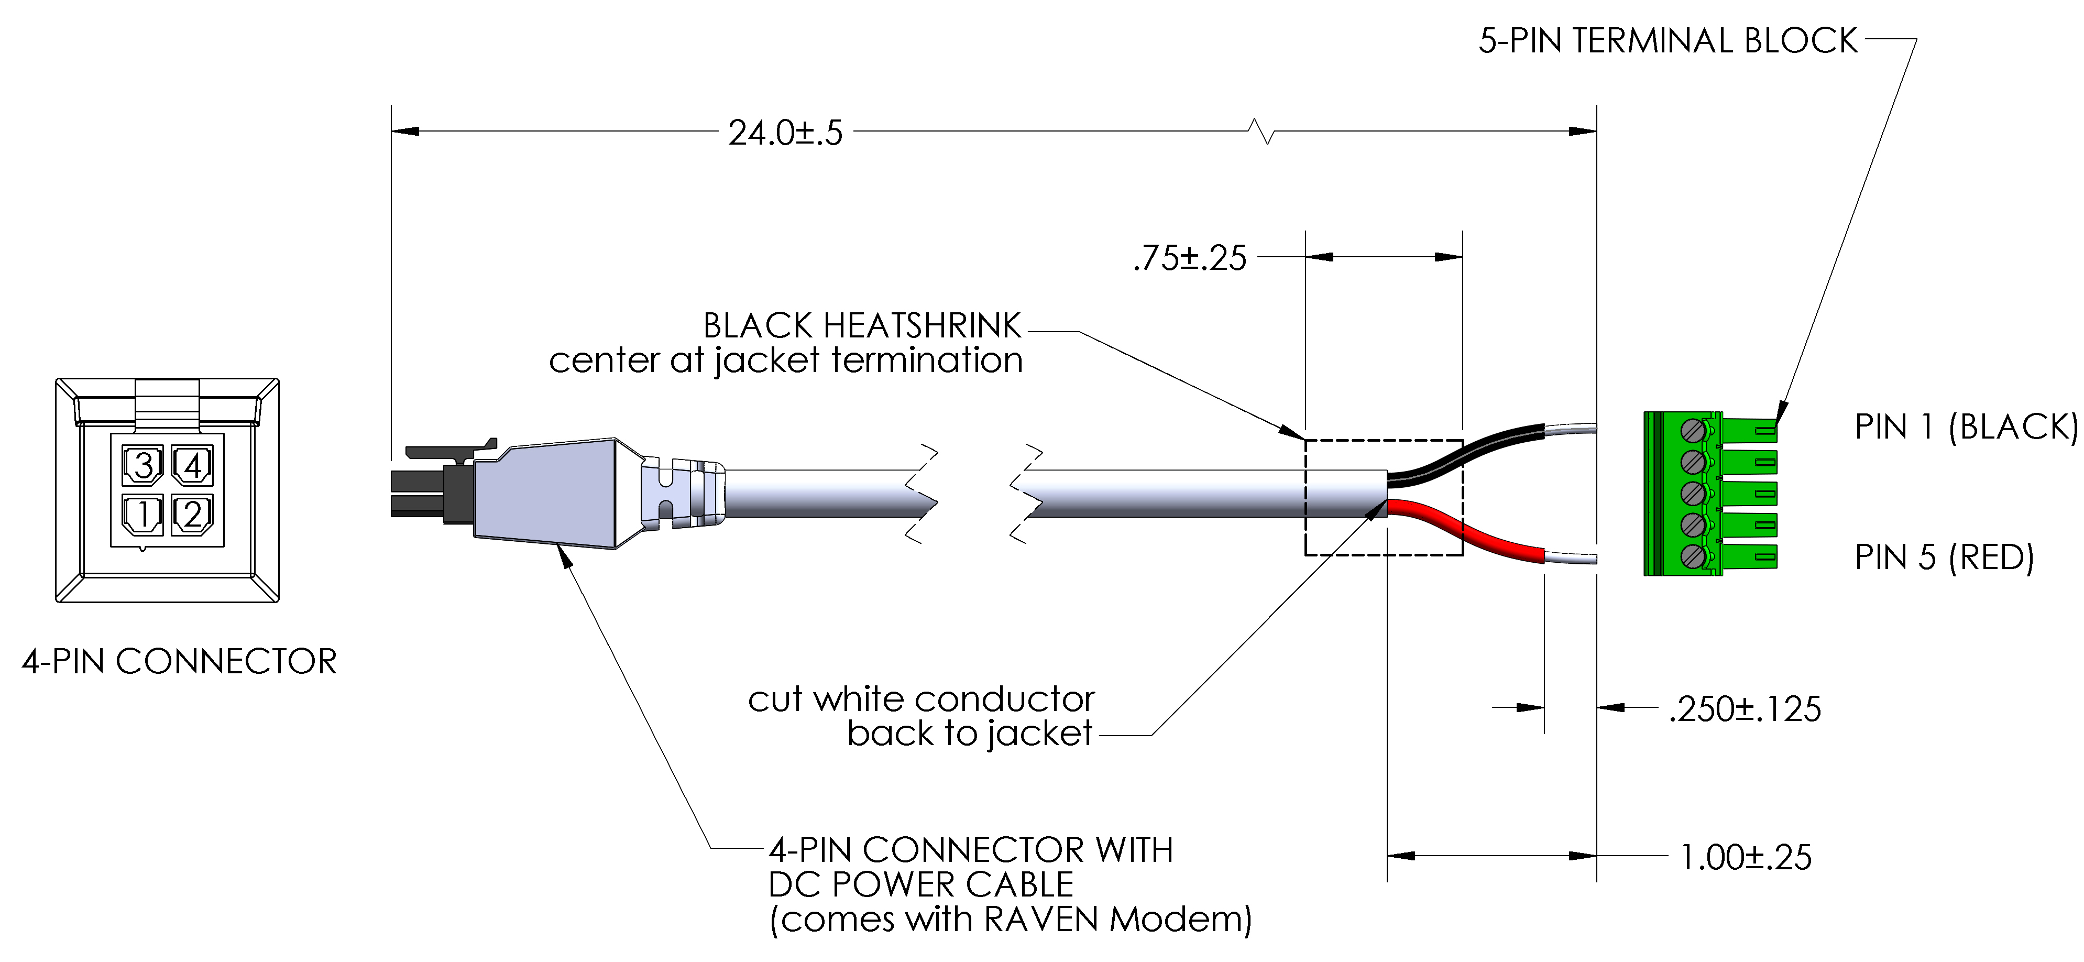

Figure 1.0 DC power cable assembly
Table 1. DC power cable assembly pin-out

4-PIN CONNECTOR / DC POWER CABLE | 5-PIN TERMINAL BLOCK
PIN 1 / RED | PIN 5
PIN 2 / BLACK | PIN 1

TESTING INSTRUCTIONS

- Test finished cable for shorts and opens using the pin-out in Table 1 using a Digital Multi-meter or other continuity sensing device.

DISTRIBUTION

This instruction is available to employees and can be accessed through the Work Instructions directory online.

REVISION HISTORY

DCO # | REV | DATE | INITIALS | CHANGES MADE
N/A | -1 | 01 MAY 2013 | K. MARETT | Release for Production Review.
4179 | A | 03 MAY 2013 | K. MARETT | Initial Release

