NoiseTutor Software Installation Instructions

PURPOSE AND SCOPE
This document provides the detail and instruction necessary to ensure the compliance of the SEPS041 to established design and market specifications. This instruction is applicable to both new product and to customer owned product that has been returned for repair and/or calibration.

LIMITATIONS
This instruction is limited to the FITPC-NT.1.

AFFECTED DEPARTMENTS
Manufacturing

REFERENCE DOCUMENTS
None

RESPONSIBILITIES & AUTHORITY
The technician has the following responsibilities and authority:

- Installation of the NoiseTutor License File

- Verification of License File Functionality if 831 is provided (NMS021 systems only)

- Creating and System Restore Point

SAFETY PRECAUTIONS
Follow the Larson Davis ESD procedure when handling unprotected/ungrounded electrical circuits.

EQUIPMENT & MATERIALS

- A NoiseTutor PC, possibly installed into a NoiseTutor station

- NoiseTutor license file

PROCEDURES

Noise Tutor License File Installation

- If applicable, receive license file from Purchasing.

- Copy license file to C:\ProgramData\Lake-view Software\NoiseTutor

This folder can be accessed from NoiseTutor client by selecting View → NoiseTutor Folder

Noise Tutor Client Verification (If 831 is included)

- Start up NoiseTutor client.

- Verify the license is listed from the Help → About dialog.

- Verify the 831 is connecting to PC through the following instructions.

  - In the NoiseTutor Toolbar, select Commands → Start

  - Ignoring any error messages, the NoiseTutor Log should state that the 831 is connected as in Figure 1.

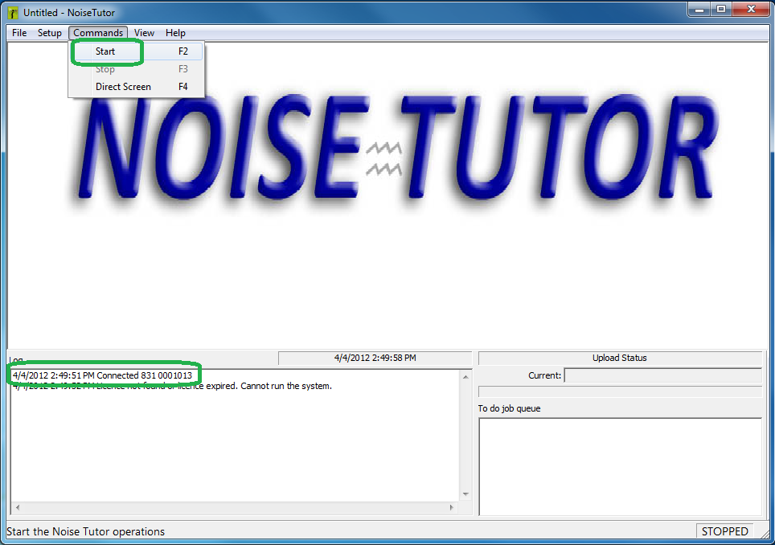

Figure 21. ensure 831 is connecting to PC through NoiseTutor client

- Close the NoiseTutor client.

Create Windows System Restore Point

- Select Start, right-click (My) Computer, and then click Properties as shown in Figure 2.

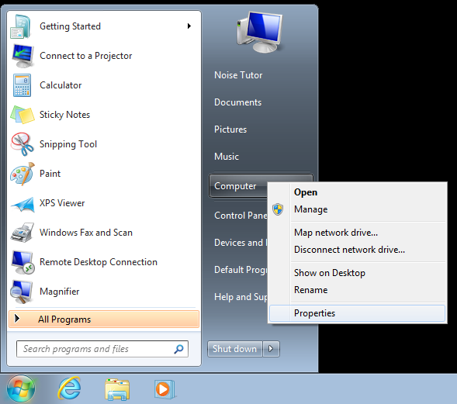

Figure 2. select properties from (my) Computer

- Select System Protection as in Figure 23.

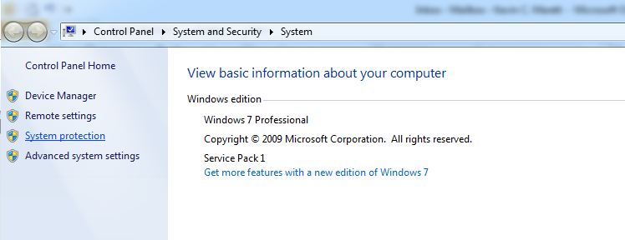

Figure 3. select System Protection in System Window

- Select Create … as shown in in Figure 24.

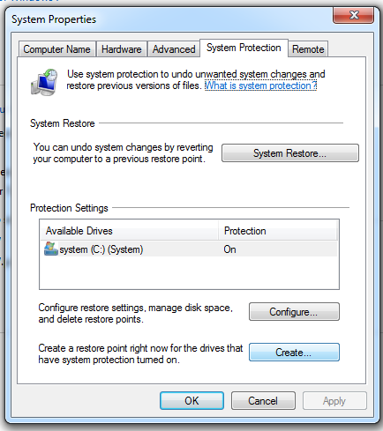

Figure 4. select Create in System Properties

- Enter “Original Factory Configuration” in the Restore Point dialog as shown in Figure 5 and select Create.

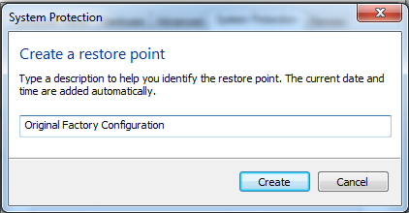

Figure 5. select Create in System Protection

- Select Close to the successful creation message as in Figure 6.

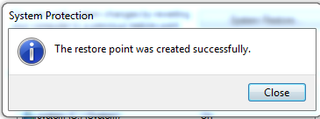

Figure 6. Successful Restore Point Creation message

- Close System Protection Window.

- Close System Window.

- Shut down the PC

RECORDS

- Store the license file/s received from Spectra in the Data\CertData\NoiseTutor network folder.

- Burn the appropriate license file/s onto a NoiseTutor CD and record the 831’s serial number (if applicable) on the relevant NoiseTutor CD label.

DISTRIBUTION
Instruction is available online in the “NoiseTutor” folder in the “Technician work instruction” folder in Document Control.

REVISION HISTORY
DCO # | REV | DATE | INITIALS | CHANGES MADE
 | A | 08/15/11 | JS | Initial Release.
 | B | 09/20/11 | JS | UAC → user access control  Tell how to show and hide hidden directories.
 | C | 04/16/2012 | KCM | Added steps, Wireless Watcher, and TeamViewer Install.
4219 | D | 7/23/2013 | KCM | Changed modem utility to ACE Viewer .  Called out source location of necessary files.  Removed Verification of Microsoft registration.
4219 | E | 7/23/2013 | KCM | Incorrect Revision in MRP
N/A | F | 9/3/2014 | KCM | Reduced to License File Install & System Restore Creation

