FitPC-2I Receiving Instructions

PURPOSE AND SCOPE
This document provides the detail and instruction necessary to ensure the compliance of the FIT-PC2I, used in the NoiseTutor systems, to established configuration specifications.

LIMITATIONS
This instruction is limited to the FIT-PC2I.

AFFECTED DEPARTMENTS
Receiving
Quality Assurance

REFERENCE DOCUMENTS
- None

RESPONSIBILITIES & AUTHORITY
The Quality Assurance inspector has the following responsibilities and authority:

- Activating Windows 7,

- Verifying the Intel S3500 SSD is installed in the PC, and

- Verifying the correct PC image has been used

SAFETY PRECAUTIONS
- Follow general electrical precautions for working with energized, low voltage circuits

EQUIPMENT & MATERIALS

- USB Keyboard

- USB Mouse

- Monitor with DVI connection

- Internet connection (LAN preferred)

- FIT-PC2I under inspection

PHYSICAL INSPECTION INSTRUCTIONS

- Perform a visual check of the FitPC-2I under inspection to ensure no physical damage has come to the unit.

- Return the PC for nonconformity if it has undertaken any physical damage.

WINDOWS 7 ACTIVATION INSTRUCTIONS
Windows 7 may have been activated by the distributor and/or the PC has been booted prior to the activation of Windows 7 and the FIT-PC2I will boot to the Windows desktop. In this case, certain steps of this work instruction are skipped, as noted in the following instructions.

Prepare the FITPC2 for first-time use.

- Record the Window 7 product key from Windows license sticker on PC, shown in Figure 1 or on the Windows license given in CD case for use later.

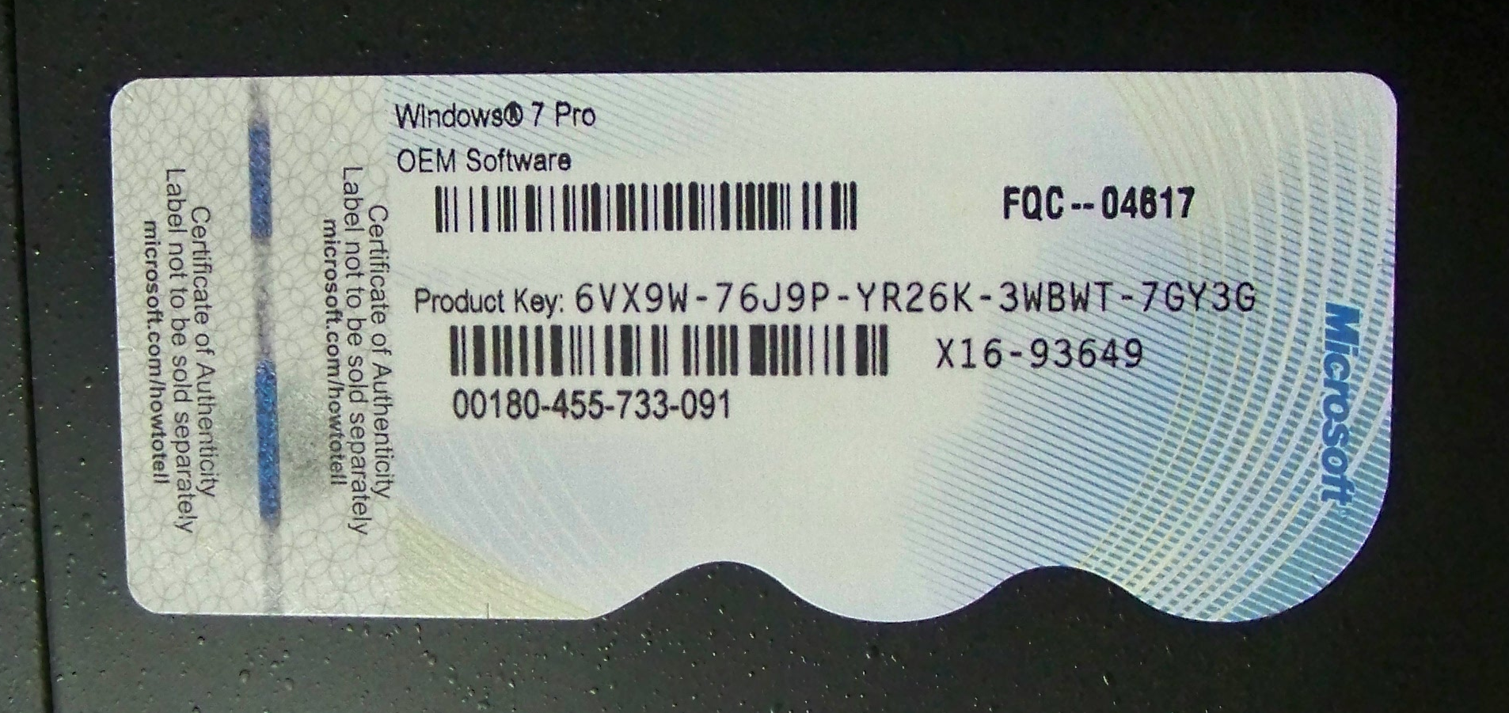

Figure 1. Windows license sticker

- Plug USB keyboard, USB mouse, monitor, and Ethernet internet connection, and PC power into PC as shown in Figure 2.

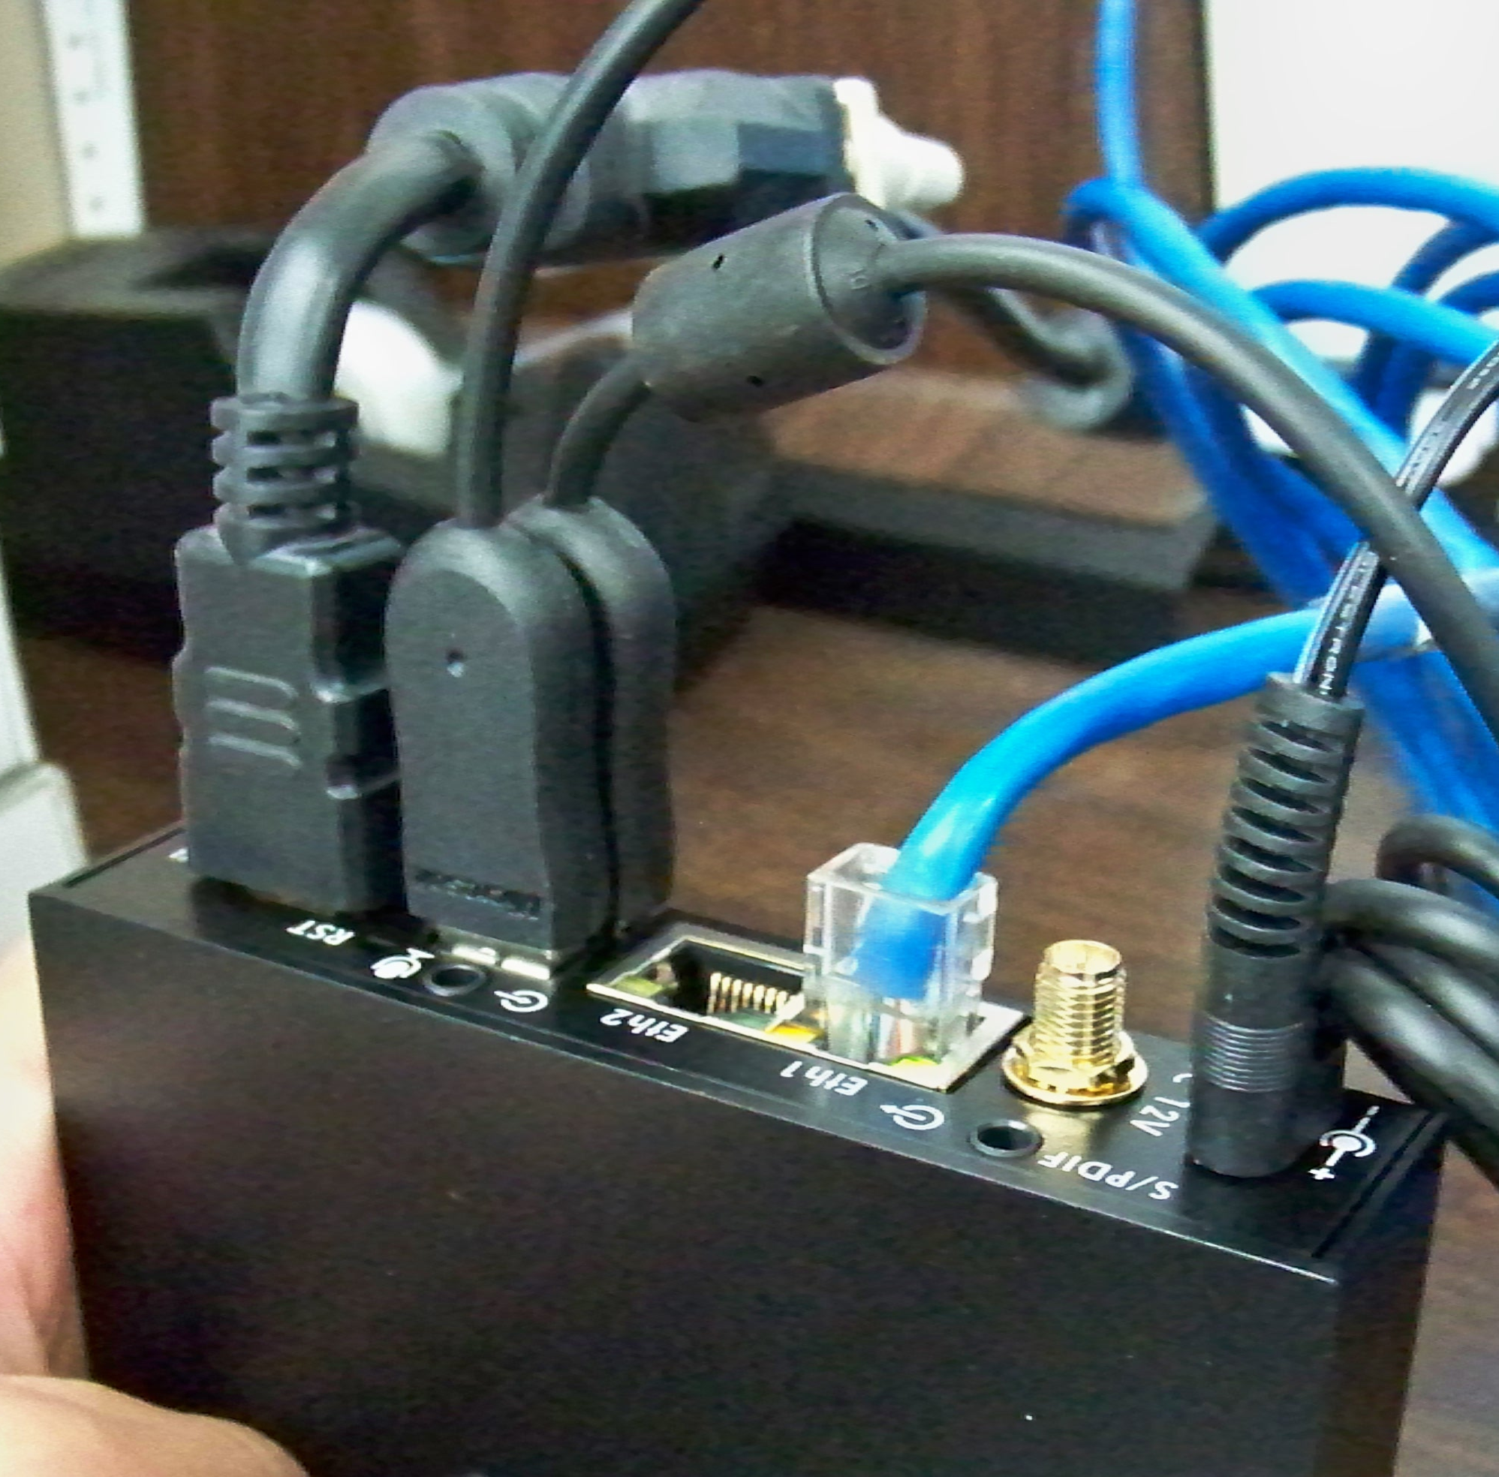

Figure 2. PC peripheral and power connections

- Turn on monitor if not powered. Turn on PC power by pressing power button shown in Figure 3 if it does not automatically boot.

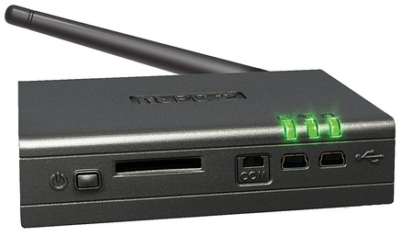
Power Button
Power Indication Lights

Figure 3. PC power button and power indication lights

Step through the automated activation of Windows 7.

- If Windows boots to the desktop, skip to Section 9.3.

If Windows is not activated, you will be prompted for input. Continue with Step 5.

- Select country, time and currency, and keyboard layout

- Select Next.

- Enter NoiseTutor for the user name and enter NoiseTutorFit for the computer name.

- Select Next.

- Leave password blank.

  - Leave retype password blank.

  - Leave password hint blank.

- Enter product key recorded in Step 1 of Section 9.1.

  - Select Automatically activate Windows when I’m online.

- Select Next.

- Select I accept the license terms.

- Select Next.

- Select Ask me later.

- Select your time zone.

  - Select Automatically adjust clock for Daylight Saving Time.

- Select Home Network.

- Select today’s date.

  - Select today’s current time.

- Select Next.

- Select Skip to join a wireless network.

- Restart PC now. Wait for Windows 7 to boot up.

- Verify that the Windows 7 is activated. You should receive a message that the activation process has completed.

If an error occurs with registration, verify internet connection with internet explorer and with PC connected to internet, try registration again by following the instructions in Section 9.3

Verify Windows Activation and/or Activate Windows 7 manually

- Select Start, right-click (My) Computer, and then click Properties as shown in Figure 4.

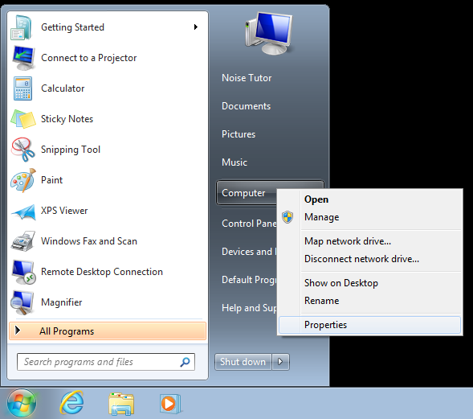

Figure 4. select properties from (my) Computer

- Verify under Windows Activation if Windows 7 has been activated.

If Windows 7 has been activated under Windows activation, Windows will state that Windows is activated as in Figure 5.

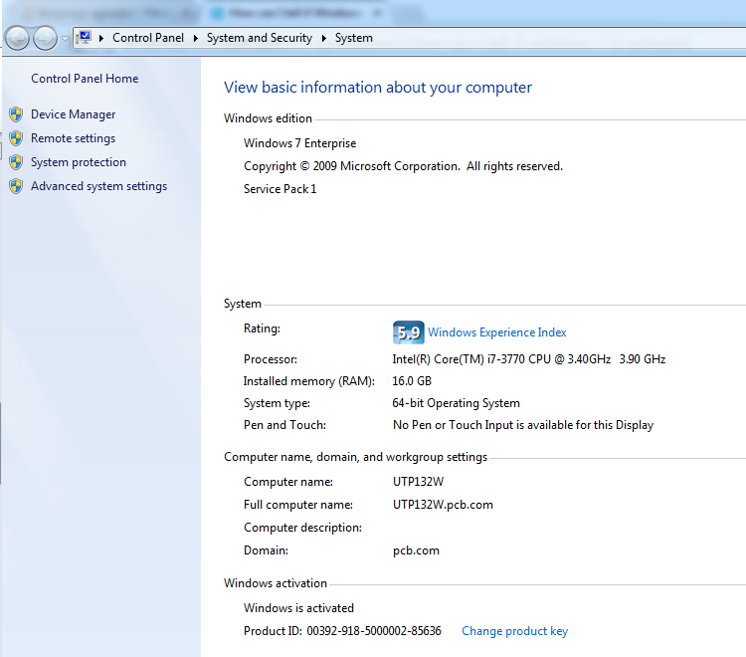

Figure 5. Windows 7 is Activated

If Windows 7 has not been activated under Windows activation, Windows will request Activate Windows now as in Figure 6.

In this case, select Change Product Key

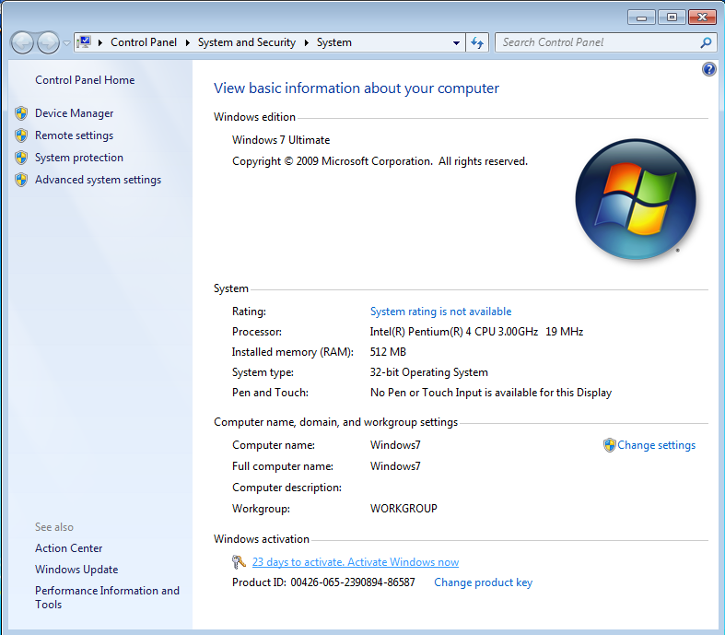

Figure 6. Windows 7 is not activated

- Enter the Product Key from Step 1 of Section 9.1 in the Windows Activation window shown in Figure 7 and select Next.

If Windows continues to not activation, notify the Logistics Manager.

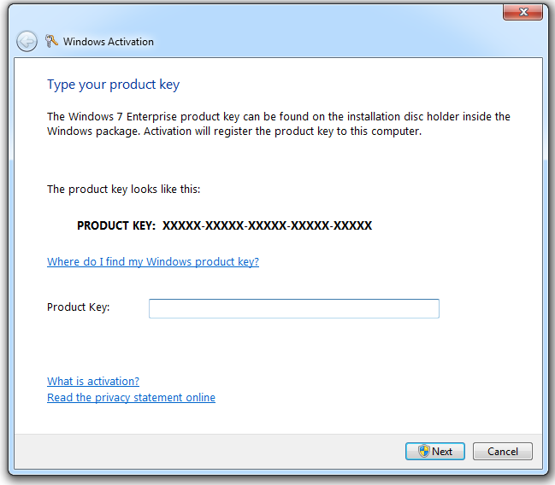

Figure 7. Windows Activation Window

SSD MAKE/MODEL VERIFICATION INSTRUCTIONS

Verify the correct SSD is installed in the PC

- Select Start, right-click (My) Computer, and then click Properties as shown in Figure 8.

Figure 8. select properties from (my) Computer

- Select Device Manager as shown in Figure 9.

Figure 9. Select Device Manager
- Select the Disk Drives drop-down and verify that INTEL is the installed SSD, as in Figure 10.

If any other Make is Displayed under the Disk Drive drop-down, return the PC to the distributor.

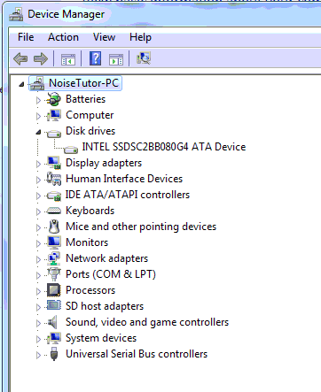

Figure 10. Select Device Manager

PC IMAGE REVISION VERIFICATION INSTRUCTIONS

Verify the PC image revision is that of the most current release

- Navigate to the C:\ directory either through opening (my) Computer or through Windows Explorer

- Verify that the file: 5499.0035 (“”) NoiseTutor PC Image.txt is located at this directory.

If this .txt file is not located at this directory, the PC image is not that controlled by Larson Davis and should either be returned to the distributor for nonconformity or reimaged with that controlled by LD. Inform the Logistics Manager of this issue.

If this file does exist at the given directory continue to Step 3.

- Verify that the revision in parenthesis denoted above by “”is that listed in the MRP tool under the item: 5499.0035.

For example if the revision in MRP tool is given as C, the file name should read: 5499.0035 (C) NoiseTutor PC Image.txt

If the revision of the .txt file does not match that of the MRP listing, the PC image is not that controlled by Larson Davis and should either be returned to the distributor for nonconformity or reimaged with that controlled by LD. Inform the Logistics Manager of this issue.

Shut-down PC and Disconnect peripherals

- Shut-down the FITPC-2I from the Start menu.

- Once the PC lights go dark, disconnect all peripherals including power and return it to its original packaging for stock.

RECORDS
Place Windows 7 product key in the Larson Davis database spreadsheet located at Provo/Shared/QC LD/FitPC along with the date of inspection and the PC serial number.

DISTRIBUTION
Instruction is available online in the “NoiseTutor” folder in the “QA Inspection” folder in Document Control.

REVISION HISTORY
DCO # | REV | DATE | INITIALS | CHANGES MADE
 | A | 09/16/11 | JS | Initial Release
 | B | 12/1/2011 | JS | Removed 831 serial number reference
 | C | 12/7/2011 | JS | Added error conditions for Windows 7 registration process.
 | D | 4/10/2012 | KCM | Added setting power options, steps, and QA responsibility
 | E | 4/10/2012 | KCM | Released at Wrong Revision
N/A | F | 9/3/2014 | KCM | Retained only Windows Activation & PC image rev check

