**A2103.01 Assembly Test & S2103.01 Final Test Instruction**

# PURPOSE AND SCOPE

This document provides the necessary details and instructions to perform the testing for the A2103.01 assembly and the S2103.01 final test. This process also serves as verification that the product continues to meet the specifications and criteria established by Engineering and the requirements created by Product Management.

# LIMITATIONS

This instruction applies to the A2103.01 and S2103.01 subassemblies.

# AFFECTED DEPARTMENTS

Manufacturing

# REFERENCE DOCUMENTS

* S2103.01 Preamplifier Assembly Drawing
* A2103.01 Preamplifier Schematic
* D0001.7038 High Impedance Circuit Cleaning Procedure
* D0001.8375 METCAL Procedure Instructions

# RESPONSIBILITIES & AUTHORITY

The technician has the following responsibilities and authority:

* Assemble the S2103.01 subassembly according to the PRM2103 drawing.
* Verify compliance of the subassembly to the defined PRM2103 tests.
* Troubleshoot and correct subassembly as required.
* Communicate any concerns with subassembly design or manufacture to Supervisor or Quality Assurance.
* Request management review of any concerns with subassembly design or manufacture.
* Use proper ESD equipment when testing or assembling this subassembly.
* Ensure RoHS compliance of the product as designed.

# SAFETY PRECAUTIONS

* Safety glasses are required when soldering, lead clipping, or testing power supplies.
* Follow general electrical precautions for working with energized, low voltage circuits.

# EQUIPMENT & MATERIALS

* All materials specified on S2103.01 Bill of Materials as listed in the MRP system
* Test station with: Computer equipped with the PreampTest, ReportGen program, signal generator (SRS DS360 with SeaLevel 8111 or 2900 with 2209/2239).
* Agilent / HP 34401A Multi-meter
* Oscilloscope
* Model 831 (certified)
* ADP090, 12 pF BNC to ½” Microphone Preamplifier Adapter
* 0195.0057 (PSA027) 12V 1.6A power supply or Bench Power Supply
* T2103.02 PRM2103 test cable
* CBL117 RS232 cable
* CBL180 LxT/831 AC out to BNC cable
* CBL138 USB cable (or 0621.0095)
* T2013.01 S2103.01 solder fixture
* Preamp-connector wrench
* Current no clean Lead-Free Solder

# ASSEMBLE PREAMP

## Assembly (Reference PRM2103 Assembly Drawing)

Assemble preamp per PRM2103 drawing. Note that preliminary electrical tests contained in section 9.1 of this document are performed in step 7 in the drawing.

# Preliminary Electrical TEST INSTRUCTIONS

## Board Level Signal Test

### Setup Board Level Test Configuration

1. Configure the test setup of the Model 831, PC, Function Generator, Multi-meter, Oscilloscope and cables as shown in Figure 9.1 – Board Test Configuration below.

*Do not connect the A2103.01 at this step; the board to test will be connected later.*

1. Turn on the Model 831 and navigate to the **Live** > **Preamp** page; **Direct** will be shown as the preamplifier type.

Figure 9.1 – Board Test Configuration

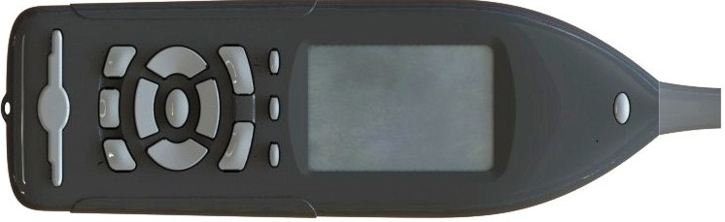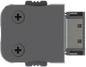

**A2103.01**



***To 0195.0057 or Bench Supply***

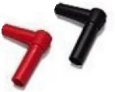

***To Multi-meter Volts In, Red 🡺 HI, Black 🡺 LO***

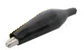

***From***

***Function Generator***



***CBL138***

***USB to PC***

***T2103.02***

***Test Cable***



Settings: OBA Range should be Normal ,

OBA Bandwidth should be 1/3 Octave using Z-weighted filter.

1. Set the function generator to produce 1Vrms @ 1 kHz sine wave.
2. Set the oscilloscope input to see the signal out of the preamp (500 mV/div vertical, AC coupled, 250 μs/div horizontal time base).

### Connect S2103.01 BOARD

1. Carefully plug in the Lemo connector of the T2103.02 Test Cable to the S2103.01 pcba, observing the pin-1 location. Also, ensure that the key on the 10-pin connector on the pcba is aligned with the red dot on the T2103.02 Test Cable.
2. Attach the signal generator output lead to the pcba’s front pogo.
3. Attach the oscilloscope lead to the signal out of the pcba (J6, pin-5), as shown in Figure 9.2, below.

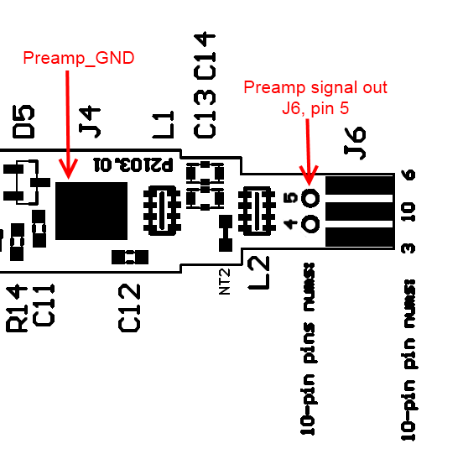

**FIGURE 9.2** – A2103.01 Board Connection Locations

1. Verify that the output sine wave at J6, pin-5 viewed with the oscilloscope is uniform and undistorted.
2. Verify that the level measured on the 831 is between: 119.5 to 120.5 dB.

*Note: 831 should be calibrated for 1 Vrms = 120 dB*

### Verify Electrical Functionality

*Note: The following voltage tests in this subsection only need to be performed as a sample test on 5% or five of the boards out of the batch, whichever quantity is greater.*

1. On the 831 preamp screen, verify that preamp voltage is:
   * Between 15.7 to 18.0 VDC.
2. Verify in the 831 Live > Preamp page the following results are observed:
   * Preamp type: PRM2103.
   * Should not see “<Comm Error>” or “<Fault 101>” message.

**Warning:** Disconnect the signal generator clip from the microphone input pogo for the next test.

1. Set 831 settings to the following:
   * 0 dB gain, Normal OBA, and Z-weighted OBA.
2. Go to the **Preamp** page on the 831 and verify the multi-tone spectrum of the Cal Check function by pressing the ENTER key (🗷 Calibrator On). View the multi-tone spectrum on the 1/3 Octave page (press up arrow twice). Verify that the levels found at the frequencies listed below are correct.

* 31.5 Hz: 113 to 118 dB.
* 250 Hz: 114 to 119 dB.
* 1 kHz: 114 to 119 dB.
* 4 kHz: 114 to 119 dB.
* 8 kHz: 114 to 119 dB.

1. Go back to the **Preamp** page and press ENTER to turn the multi-tone Cal Check generator off.
2. Return to finish PRM2103 assembly per drawing, Step 8.

## Hook-up Bench Test Software

1. Connect the Model 831 and S2103.01 using T2103.02 Test Cable as illustrated in Figure 9.3.

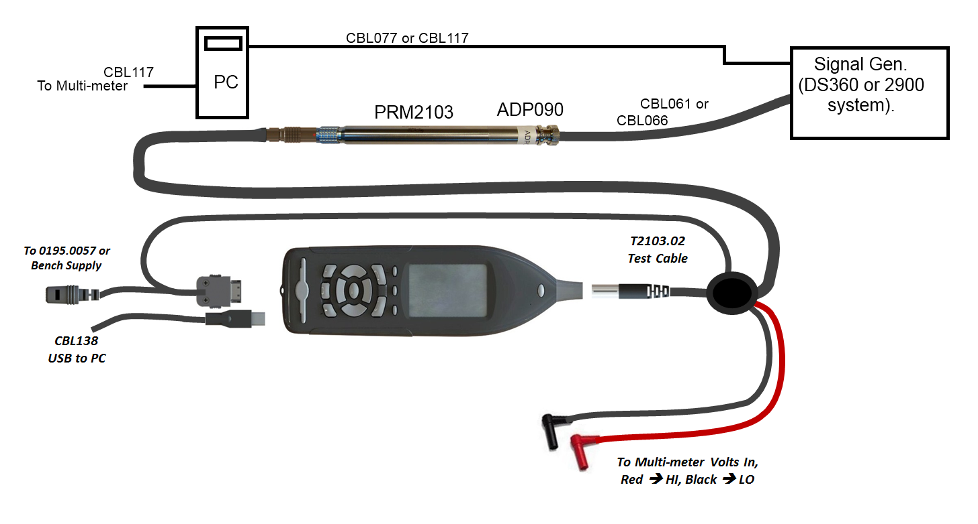**Figure 9.3 – Bench Test Software Connection Diagram**

## Program Preamp Serial Number

1. View the **Live** > **Preamp** page on the 831.
2. Start the **PreampTest** software on the computer.
3. Select **Write PRM2103 Serial Number** from the **Tools** drop-down on the menu bar.
4. Enter the serial number of the S2103.01 in the dialog box and select **OK**. Verify on the Model 831 **Live** > **Preamp** page that the serial number is correct and matches the serial number on the outer tube of the S2103.01.

## Run Bench Test Software

1. Follow D0001.8375 METCAL test procedure to test preamplifier with METCAL software.

# Environmental Testing

All environmental testing on the S2103.01 is done per customer request (CER-PRM2103-E).

## Equipment

* Environmental chamber.
* Windows Computer.
* Model 831 sound level meter (certified).
* Agilent 33220A Signal Generator.
* Agilent 34401A Digital Volt Meter.
* ½” Microphone electrostatic actuator (B&K Model UA-0033 or GRAS Model RA0014).
* LD Model 2201X10 Electrostatic actuator power amplifier (with Model 2201 modifications). (EA Amplifier).
* Microphone/preamp stand (custom).
* Custom microphone/preamp/EA connector clamp (larger alligator clamp with banana jack and BNC connector attached).
* T2103.02 PRM2103 testing cable, 20 ft.
* PSA027, 12 VDC power supply.
* USB Cable, type USB A to USB mini-B, 6 ft.
* 20 ft. BNC cables.
* 3 ft. high temperature Teflon BNC cable.
* Larson Davis environmental test program.

## Initial Chamber Software Configuring

Ensure the LD chamber software is set up with the following system configuration settings:

Chamber Setup:

* Chamber Selection: Select which chamber being used (i.e. Thermotron, etc.).
* IP address: Enter the IP address of the environmental chamber being used.

Generator Setup:

* Agilent 33220A function generator.
* IP Address: Enter the IP address of the Agilent 33220A function generator being used.

Data base Setup:

* Server: UTPDB01.
* Database: envtest.
* SQL Authentication.
* User: TestSoftware.

## Environmental Equipment Test Setup

Warning%20logo **Warning!!! Output of EA amplifier is a high voltage shock hazard. Ensure EA amplifier’s power switch is in ‘OFF’ position before setting up of test system.**

1. Set EA amplifier microphone bias knob to ‘0 V’ position.
2. Set up the test system as shown in Figure 10.1 below.

***Important: Use the microphone that is being sold/sent with customer’s PRM2103.***

***Warning: When installing the E.A. be careful not to damage the microphone’s diaphragm.***

1. Close the chamber door.
2. Turn EA amplifier power switch to ‘ON’ position.
3. Set EA amplifier microphone bias knob to 300 V.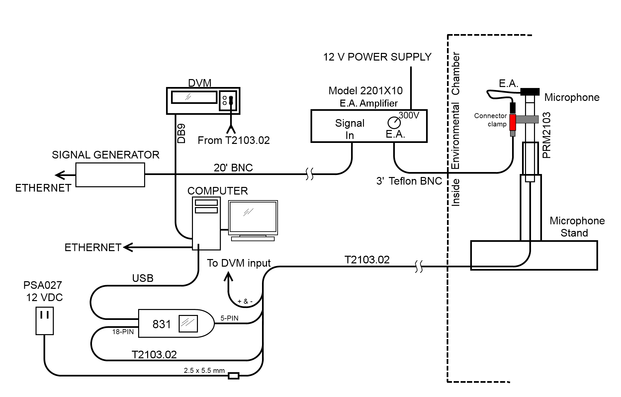 **Figure 10.1.** Environmental Test Connection Diagram (using Electrostatic Actuator).

## Environmental Chamber Test Software Setup

1. Open the LD environmental chamber testing program.

Select the 426A12/PRM2103 tab.

1. Select the number of units and select ‘Auto Detect’.
   * The ‘Preamp’ field should populate with PRM2103 and also the preamp’s serial number.
2. Enter the full microphone serial number in the ‘Mic Serial Number’ field.
3. Click the ‘Use 34401A’ check box.
   * Ensure that the correct serial comm port is selected and that the comm settings are 9600 baud, 8 bit data size, none (parity), 2 (stop bits).
4. In the Generator>Setup menu, select the Agilent 33220A function generator.

## Test Precheck

1. Verify that the total test system is operating correctly by doing the following:
   * In the LD environmental chamber testing program, open the ‘PRM2103-EA-Precheck.seq’ test script.
   * Click on the ‘Begin Test’ button.
   * As the test runs, verify that the measured levels in the Program Output box in the right hand of the chamber test program are within the limits shown in Figure 10.2.
2. Pre-check test will stop automatically.

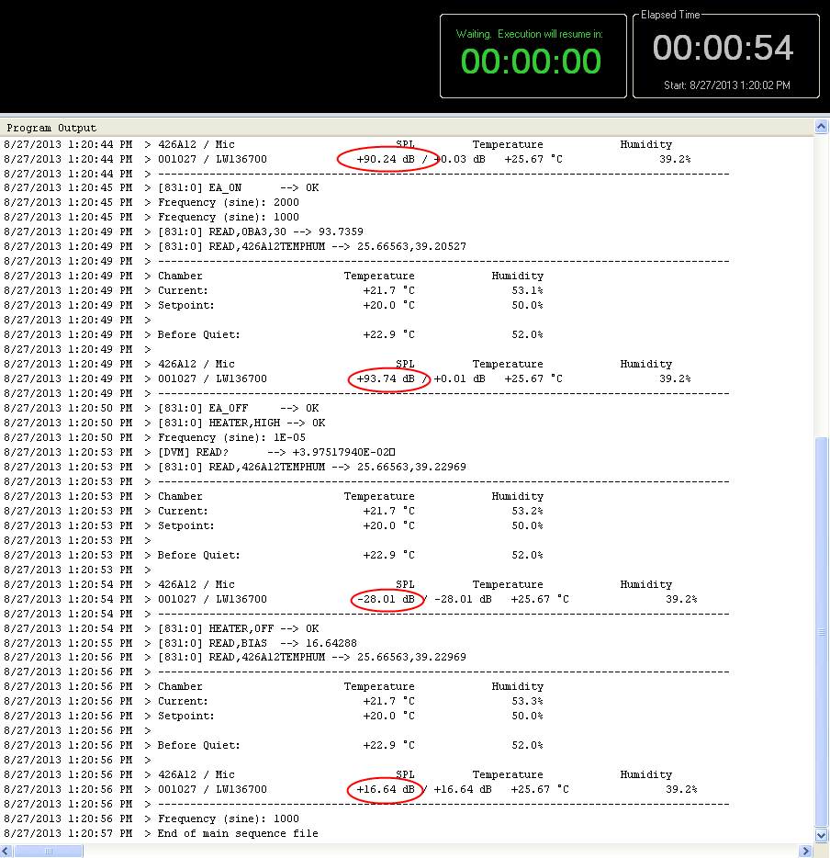

82 to 89 dB (E.A. test level)

92 to 96 dB (cal check level)

16.0 to 18.0 dB (preamp output DC voltage)

-28.5 to -26.0 dB (heater current in dB amps)

**Figure 10.2.** PRM2103 environmental test precheck values.

*Note: If the results above are not seen:*

* + - *Verify all cabling is set up correctly, according to Figure 11.1.*
    - *Verify that E.A. is installed in correct orientation.*
    - *EA Amplifier power switch is in ‘ON’ position.*
    - *EA Amplifier microphone bias switch is set to 300 volts.*
    - *Voltage at ‘DC Out’ port of EA amplifier is ~306 VDC.*

*Voltages at ‘Amp Out’ port of EA amplifier are ~70 VAC.*

## Run Test

1. In the ‘Sequence File’ area, navigate to and choose the chamber test script file PRM2103-EA.seq.
2. Click on the ‘Begin Test’ button.

## Verify Environmental Testing Passed.

1. Look up the tested unit/s in the **ReportGen** software.
2. Verify that all tests passed when completed.
3. If customer has ordered a CER-PRM2103-E then click Print and collect print-outs to be shipped with the Preamp.

## Test Disassembly

Warning%20logo **Warning!!! Output of EA amplifier is a high voltage shock hazard. Ensure EA amplifier’s power switch is in ‘OFF’ position.**

1. Switch the EA amplifier microphone bias switch from 300 volts to 0 volts.
2. Switch EA amplifier power switch to ‘OFF’ position.
3. Disassemble the rest of the test.
4. Carefully re-install the microphone’s grid cap back onto the microphone.

# RECORDS

**Final Step:** Record inspection results in Larson Davis database for the PRM2103 system (by serial number).

# DISTRIBUTION

Instruction is available online in the “PRM2103” folder in the “Technician work instruction” folder in Document Control.

# REVISION HISTORY

|  |  |  |  |  |
| --- | --- | --- | --- | --- |
| **DCO #** | **REV** | **DATE** | **INITIALS** | **CHANGES MADE** |
| ECO  4070 | A | 09/06/2013 | JLD | Initial release |
| DCO 1773 | B | 12/05/2017 | AJR | Changed lower limit for test 9.1.3 Step 1 to 15.7 from 16.3 V to account for a diode drop ignored in original bias voltage calculations. TT 6824 |
| ECO 5073 | C | 12/28/2020 | DPW | Updated assembly instructions to reference PRM2103 drawing. |