PSA032 Battery Charger Work Instructions

PURPOSE AND SCOPE
The purpose of this document is to provide the detail and instruction necessary to build up a PSA032 rev C battery charger.

AFFECTED DEPARTMENTS
- Production

REFERENCE DOCUMENTS
- NA

RESPONSIBILITIES & AUTHORITY
The technician has the following responsibilities and authority:
- Verify compliance of the product under test to specification.
- Troubleshoot and correct product as required.
- Communicate concerns to Supervisor or Quality Assurance.
- Request management review of product concerns.
- Use proper ESD protective equipment.

SAFETY PRECAUTIONS
- Follow general electrical precautions for working with energized, low voltage circuits

EQUIPMENT & MATERIALS
- Digital volt-ohm meter.
- Soldering iron on a LEAD FREE station.
- Heat gun
- Engineering ruler with 0.1” increments.
- Safety glasses.
- QTY 1.0, 0195.0061, Battery charger, lead acid, 12V 3A (Soneil MFR #: 1205SR).
- QTY 1.0, 1145.0071, Barrel connector, 2.5 x 5.5 mm (Switchcraft MFR #: 706).
- QTY 0, 7050.0003, Heat shrink, 1/4” shrinks to 1/8” (3/16”) BLK
- QTY 0, 7050.0004, Heat shrink tubing & sleeves 3/8” BLK

INSPECTION
- Inspect battery charger body and cabling to ensure there is no damage to it.

Assembly Instructions
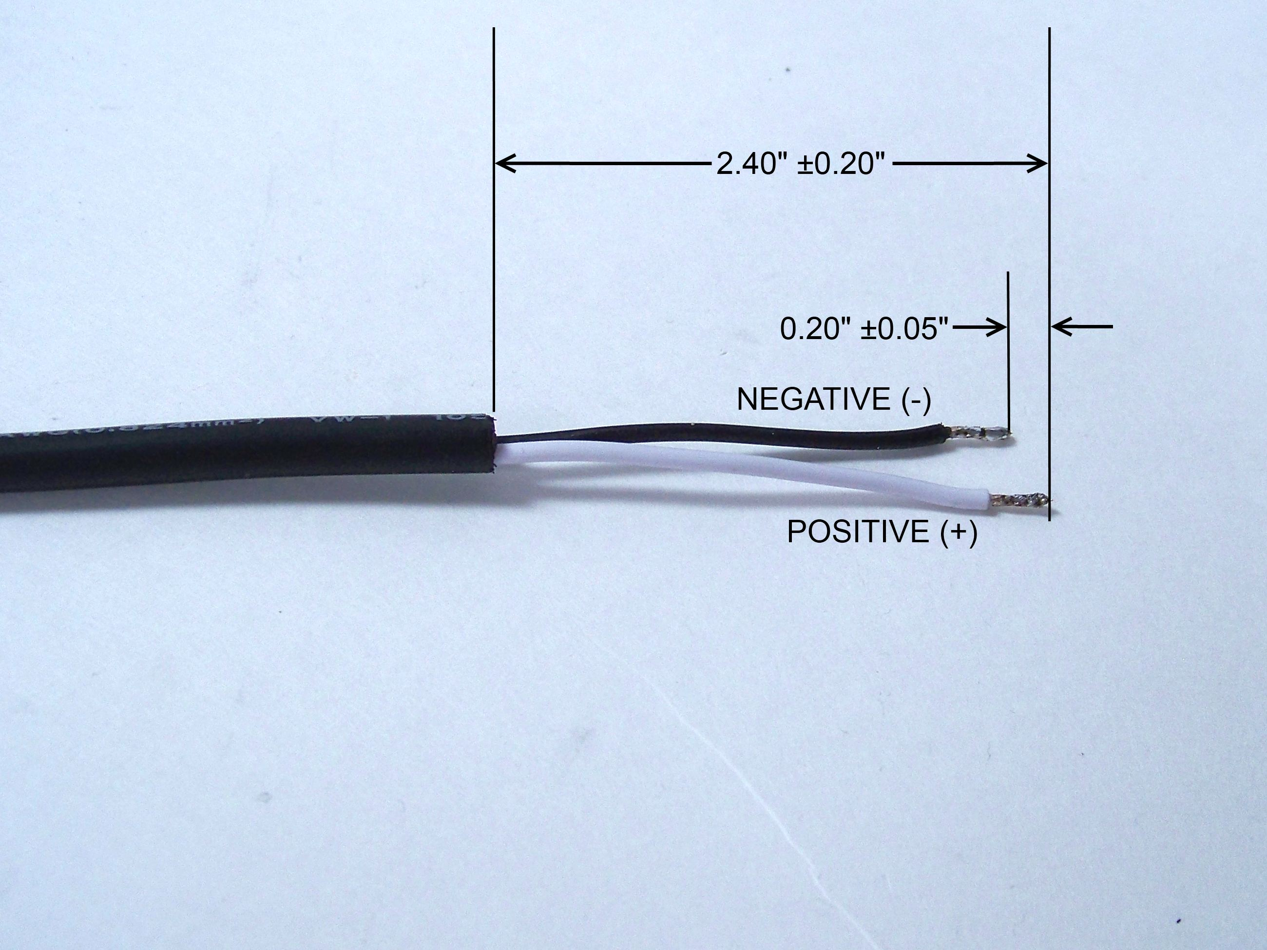
Figure 1. Cut 0195.0061 battery charger wires to length. Cut green wire off (will not be used)

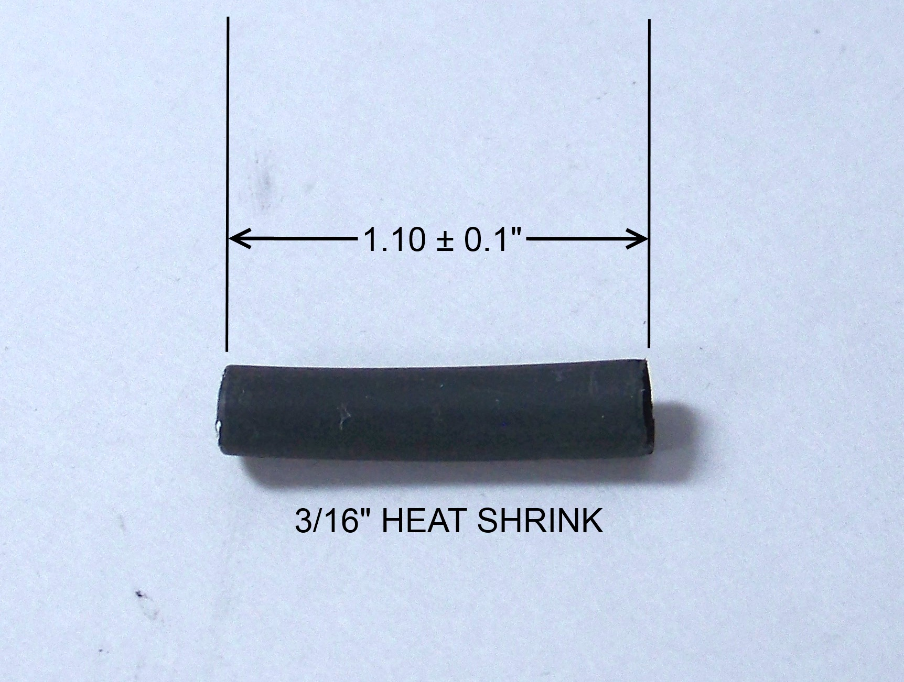
Figure 2. Cut 3/16” black heat shrink (7050.0003)

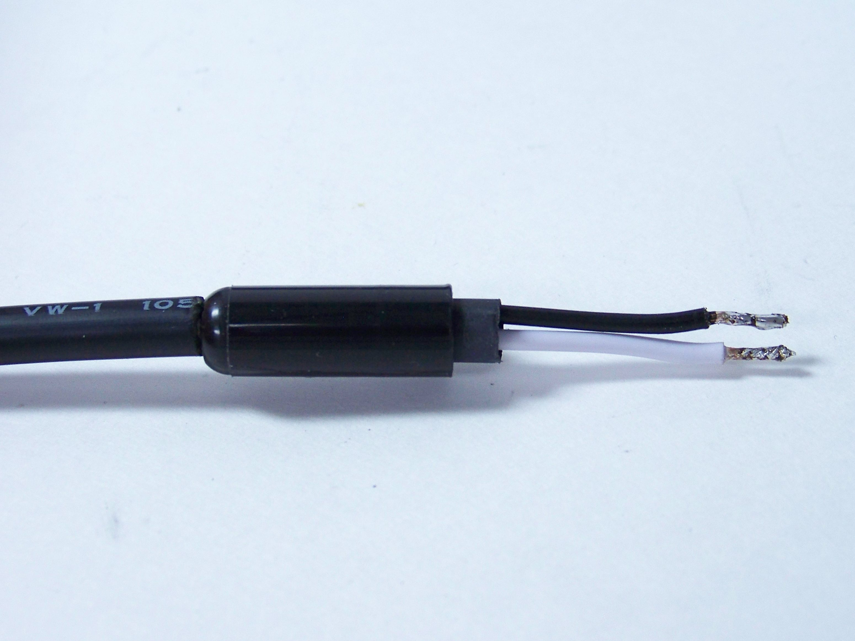
Figure 3. Slide on 1145.0071 connector back shell and then 3/16” heat shrink (7050.0003)
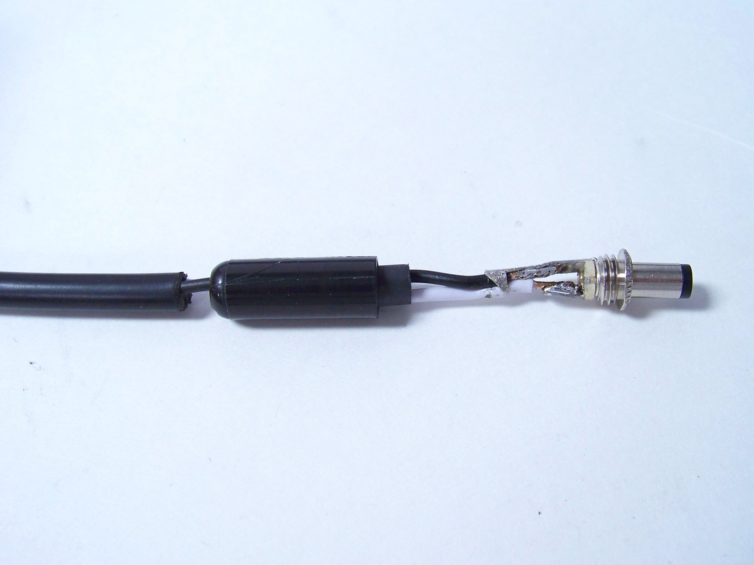
Figure 4. Solder on 1145.0071 barrel connector
and crimp strain reliefs onto wires.
Important: White (+) wire soldered to center conductor of connector. Black (-) wire soldered to outer conductor of connector.
- Perform electrical pretest as described in Section 9 of this document, to verify that connections are good, with no shorts, opens or reverse polarity problems.

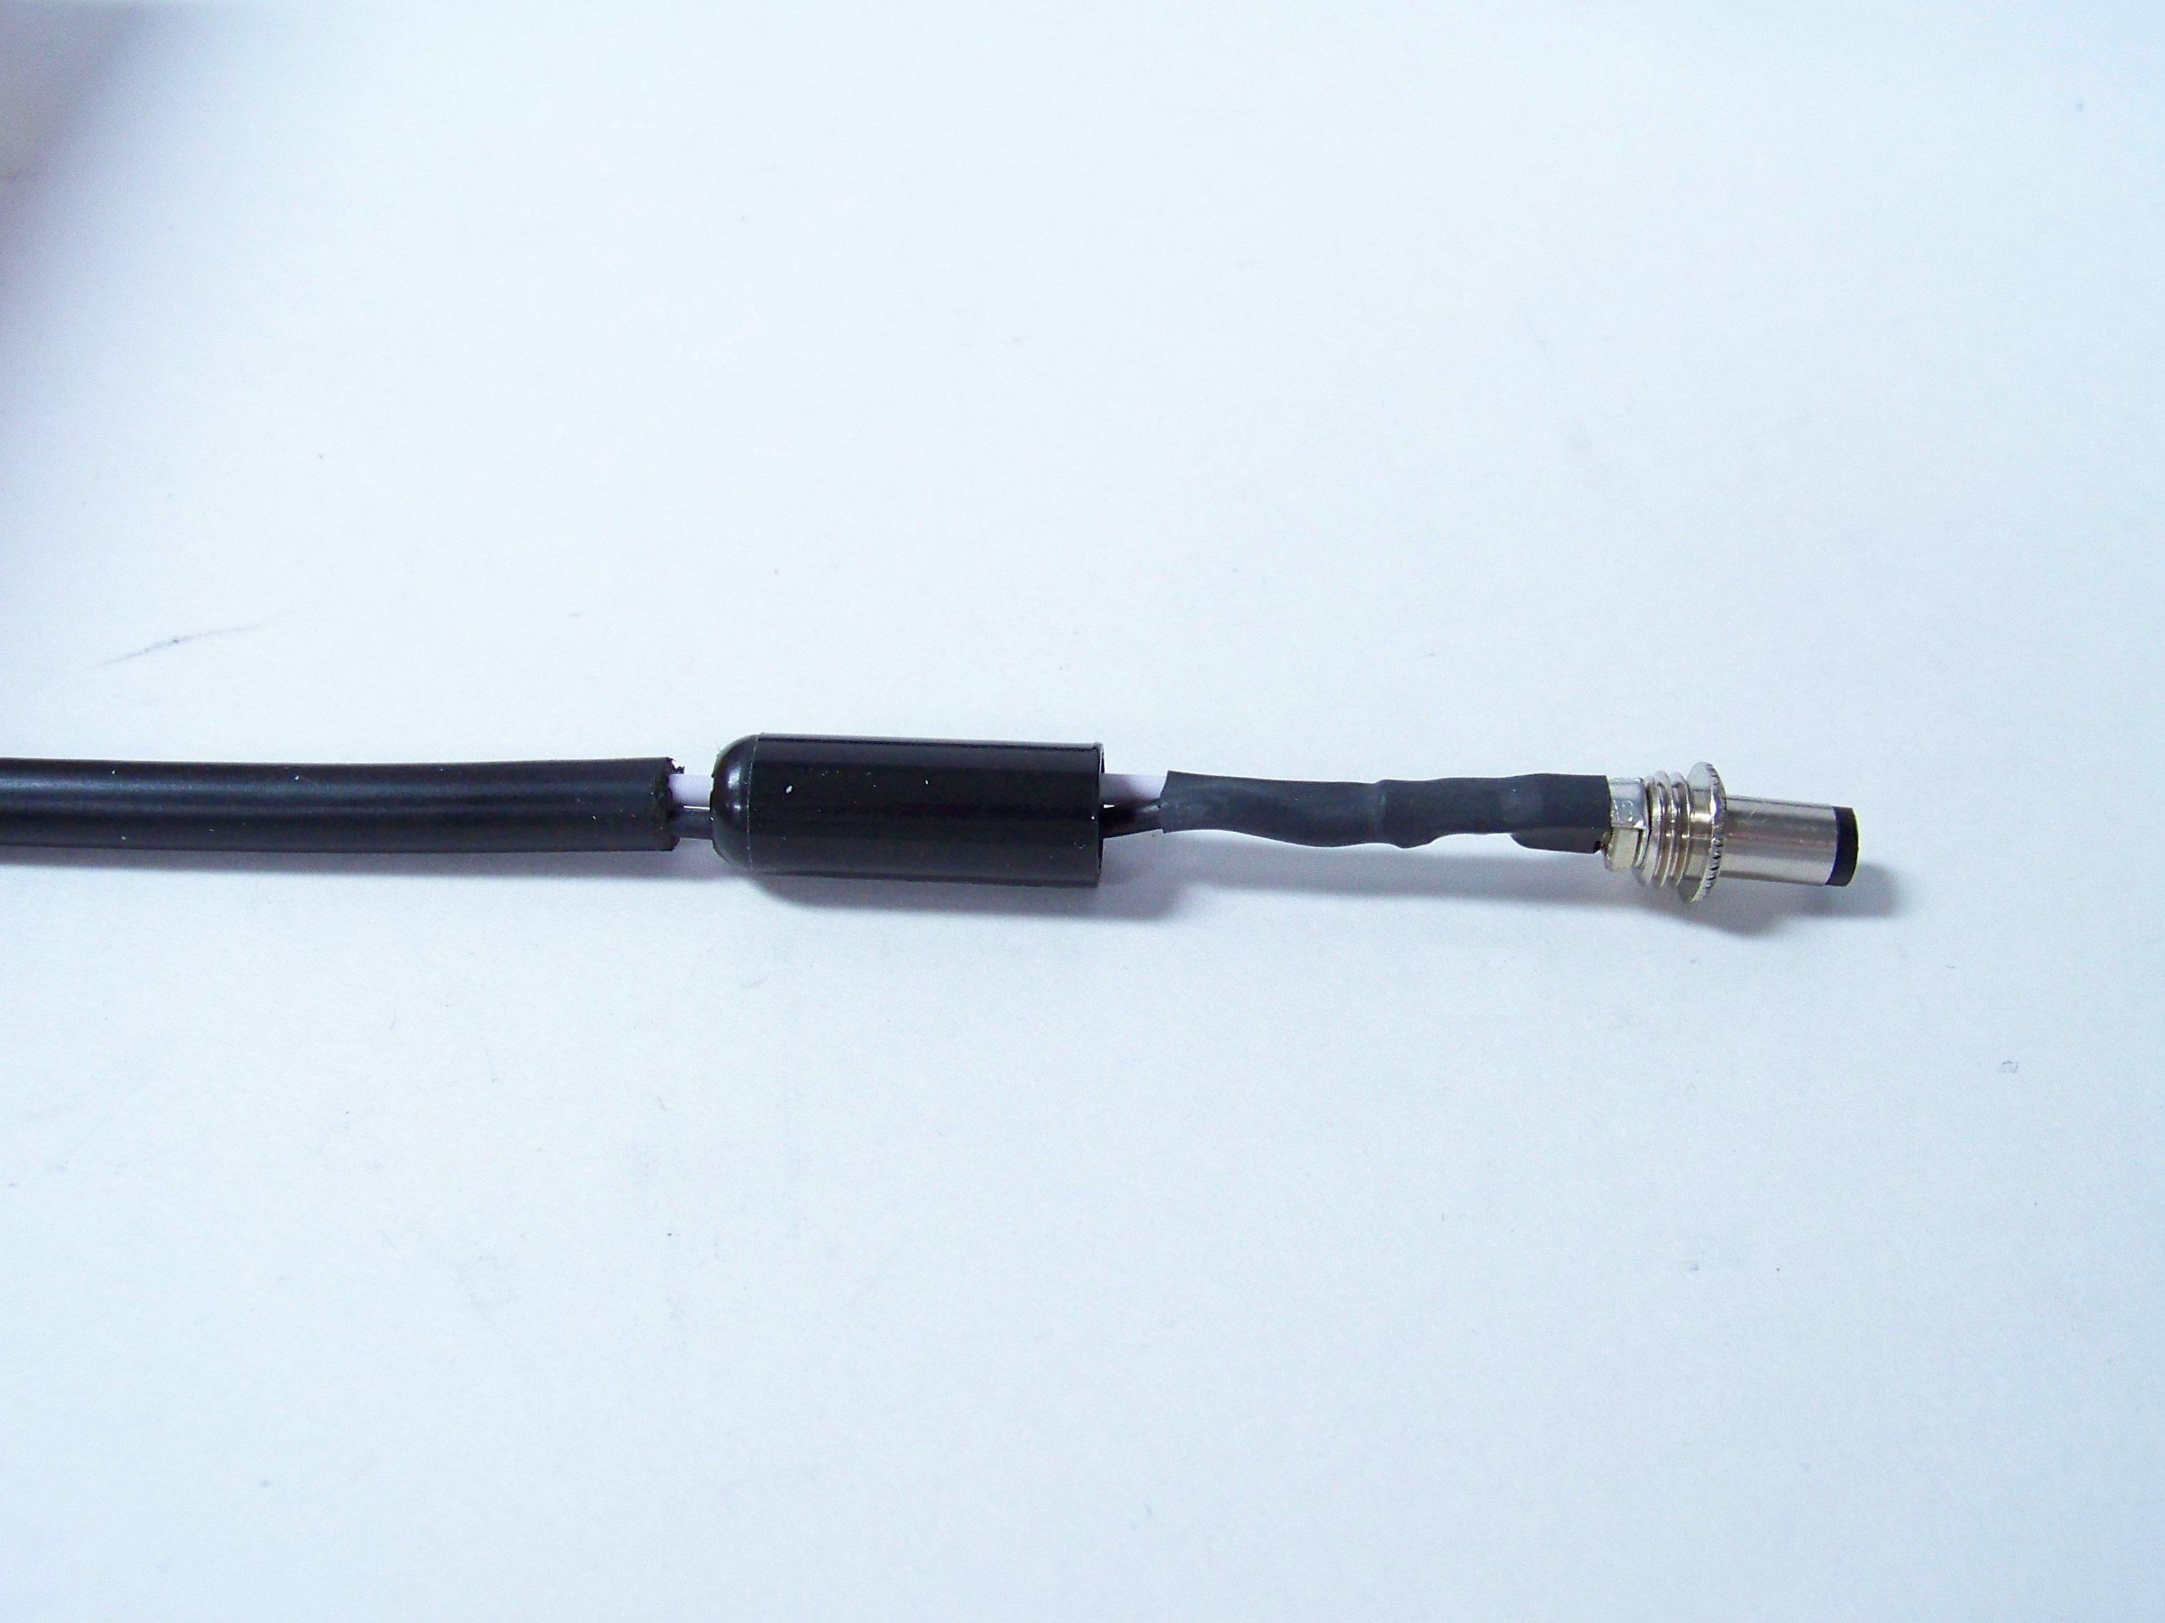
Figure 5. Shrink on 3/16” heat shrink (7050.0003) over
connector strain relief and wires.

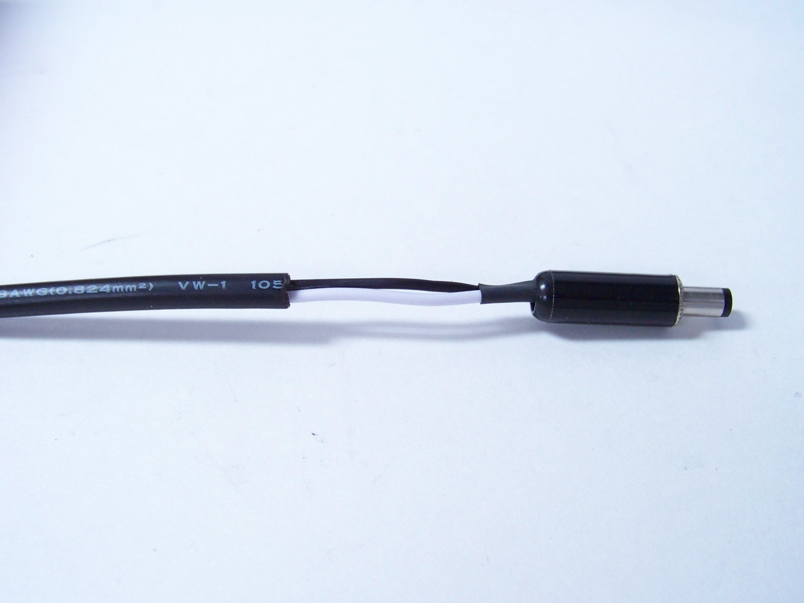
Figure 6. Screw on connector back shell

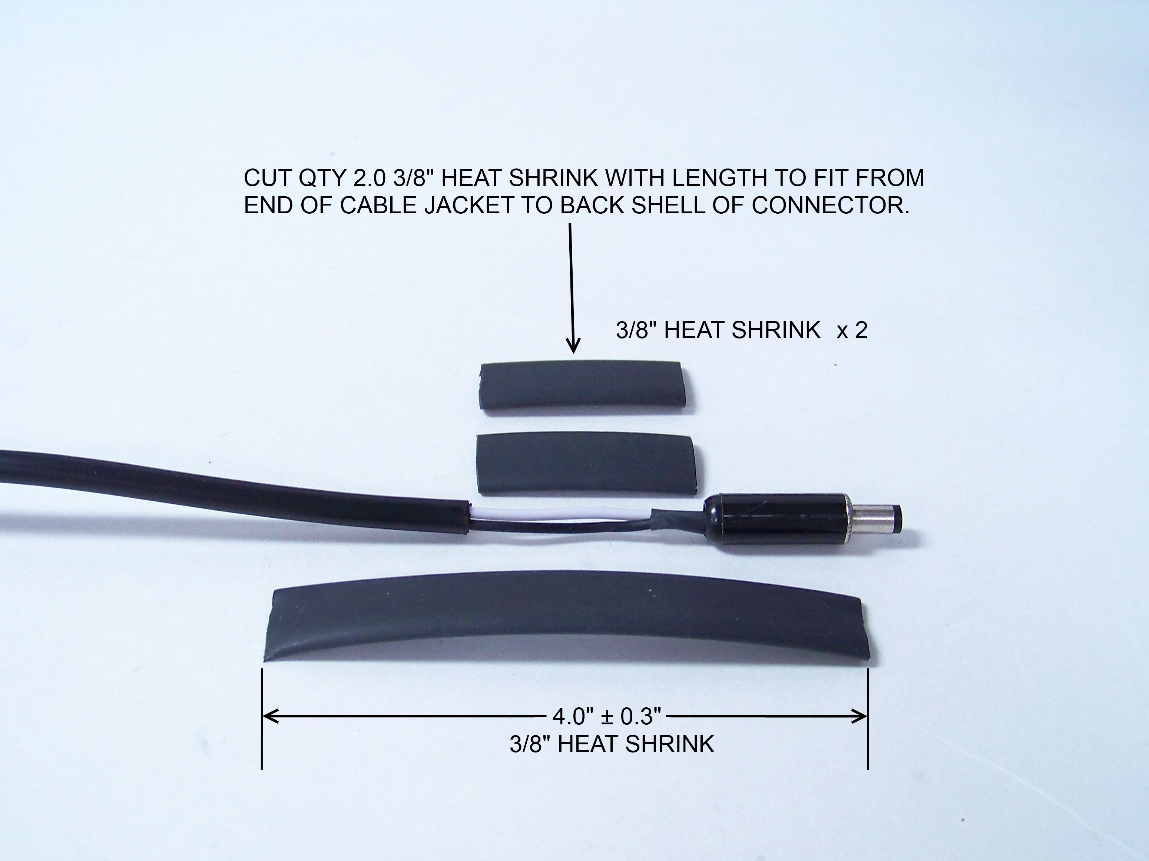
Figure 7. Cut 3 pieces of 3/8” black heat shrink (7050.0004), one 4” and the other two the length from the end of the cable jacket to the connector shell.

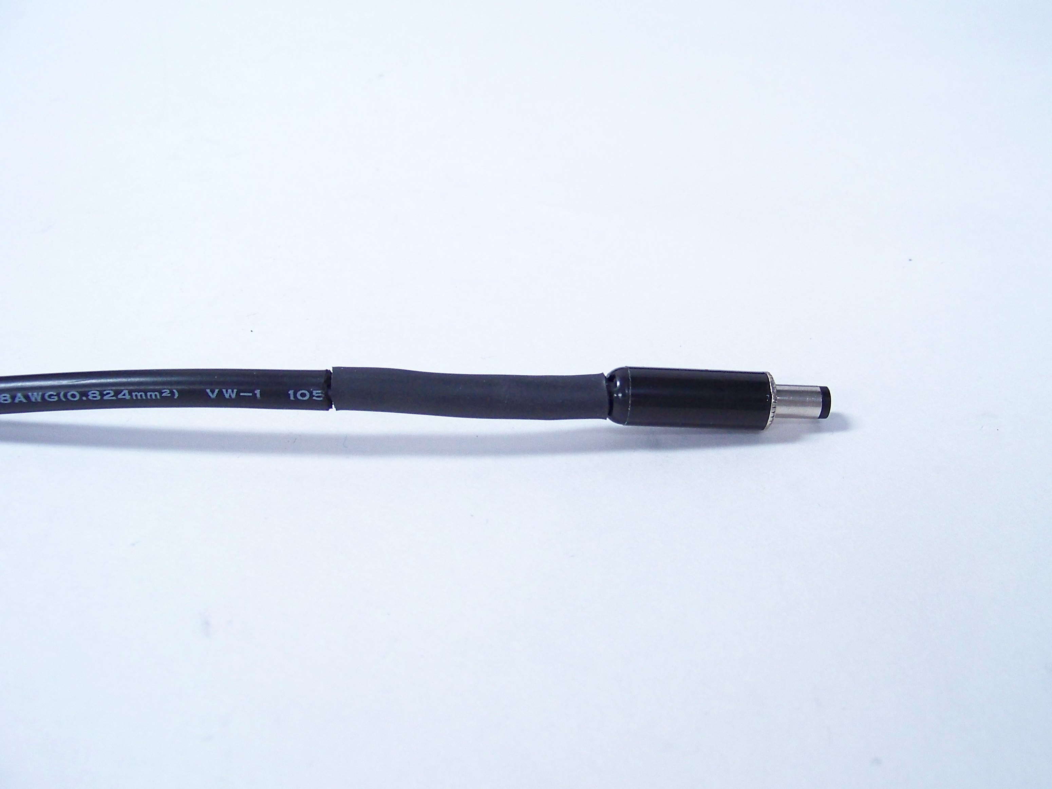
Figure 8. Shrink on both of the shorter pieces of
3/8” heat shrink (7050.0004), to build up thickness of cable.

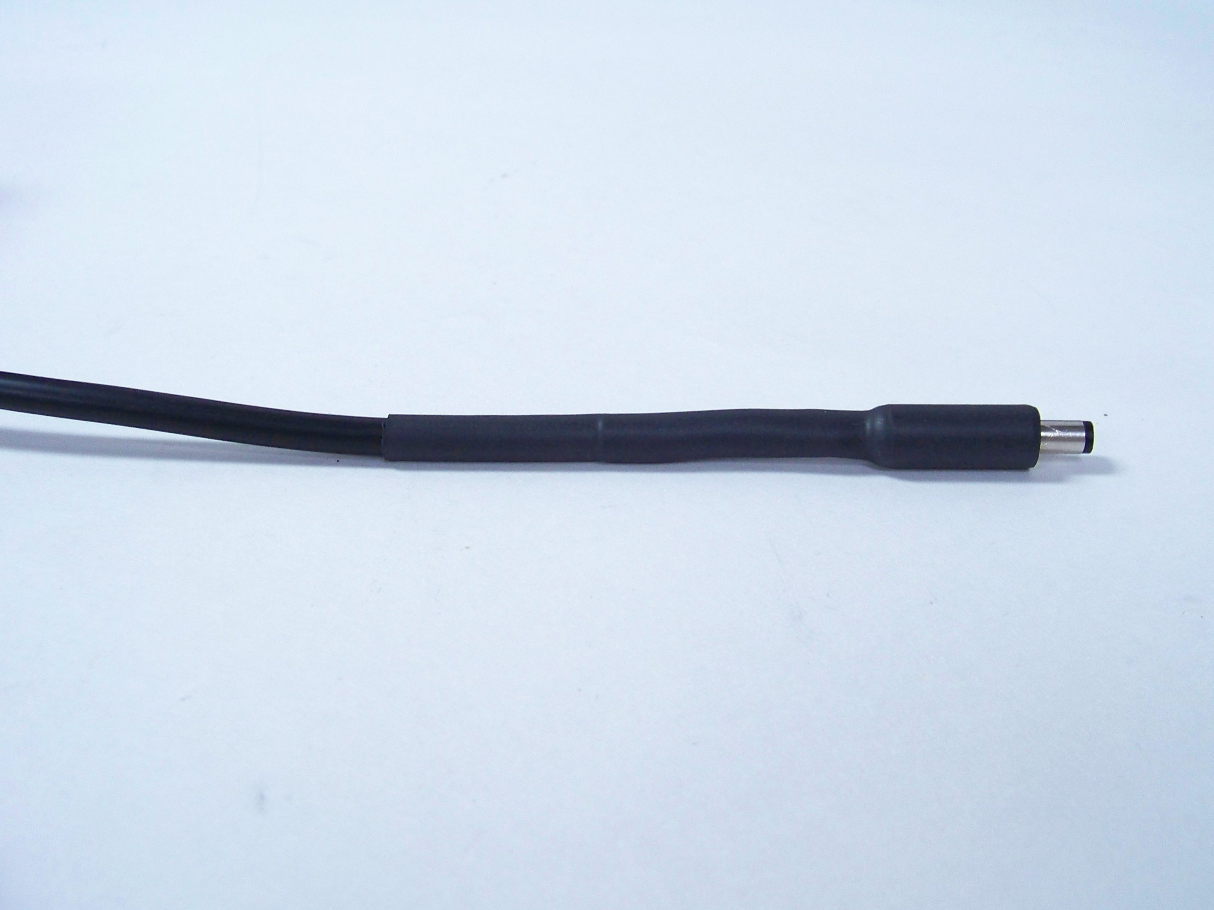
Figure 9. Shrink on 4.0” piece of 3/8” heat shrink (7050.0004) over the cable and connector shell.

Electrical Testing
- Power up battery charger.
- With volt meter, verify that output polarity is correct (see Figure 10) and that voltage is approximately 13.8 ±0.2 volts DC.
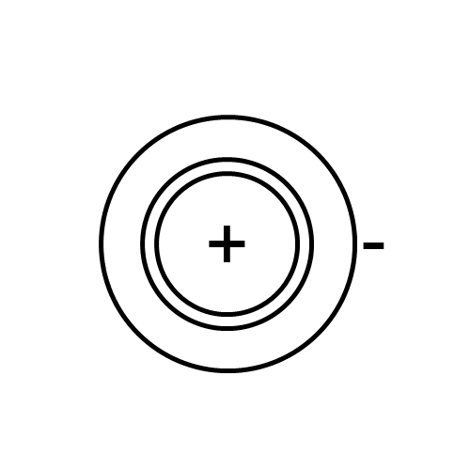
Figure 10. Output polarity of new connector.

Records
- NA

DISTRIBUTION
Instruction is available online in the “Power Supplies” folder in the “Technician” work instruction folder in Document Control.

REVISION HISTORY
DCO # | REV | DATE | INITIALS | CHANGES MADE
ECO  4090 | A | 03/06/2012 | JLD | Initial Release
ECO 4620 | B | 8/22/2017 | DWA | Changed from 0195.0007 to PSA032
ECO 4772 | C | 1/14/2019 | DCW | Added part numbers for heat shrinks

