Custom Cable Plug Work Instruction

PURPOSE AND SCOPE
This document provides the detail necessary to create cable gland stoppers with custom hole patterns in-house.

LIMITATIONS
This instruction applies only to the machining of rubber cable gland plugs.

AFFECTED DEPARTMENTS
Production

REFERENCE DOCUMENTS
- ACC007 drawing

RESPONSIBILITIES & AUTHORITY
The technician has the following responsibilities and authority:
- Selecting the proper hole layout per customer request
- Marking the proper layout on the un-drilled stopper
- Drilling the proper holes in the stopper

SAFETY PRECAUTIONS
- Lock-out, tag-out precautions are to be taken when changing drill press belt-speeds
- Proper protective eyewear should be worn at all times during this process

EQUIPMENT & MATERIALS
- Rubber Stopper to be drilled
- Drill Press
- Drill Bits of desired hole size
- Cable Gland housing used as fixture
- Ballpoint pen or colored Sharpie marker
- Straight Edge Ruler
- Exacto knife or utility knife

MANUFACTURE PROCEDURE

Create hole layout and mark on blank stopper

Step 1: Receive customer order for ACC007. This should document what cables are to be entering the NoiseTutor system.

Step 2: Select the number of holes necessary to accommodate requested number of cables and select the appropriate hole pattern layout as given in the ACC007 drawing.

Step 3: Select the appropriate drill sizes to accommodate hole pattern and assign each size to the hole layout selected prior.

Step 4: With a ballpoint pen or colored sharpie and straight edge ruler, draw the layout onto the large diameter side of the blank stopper as in Figure 1, below.

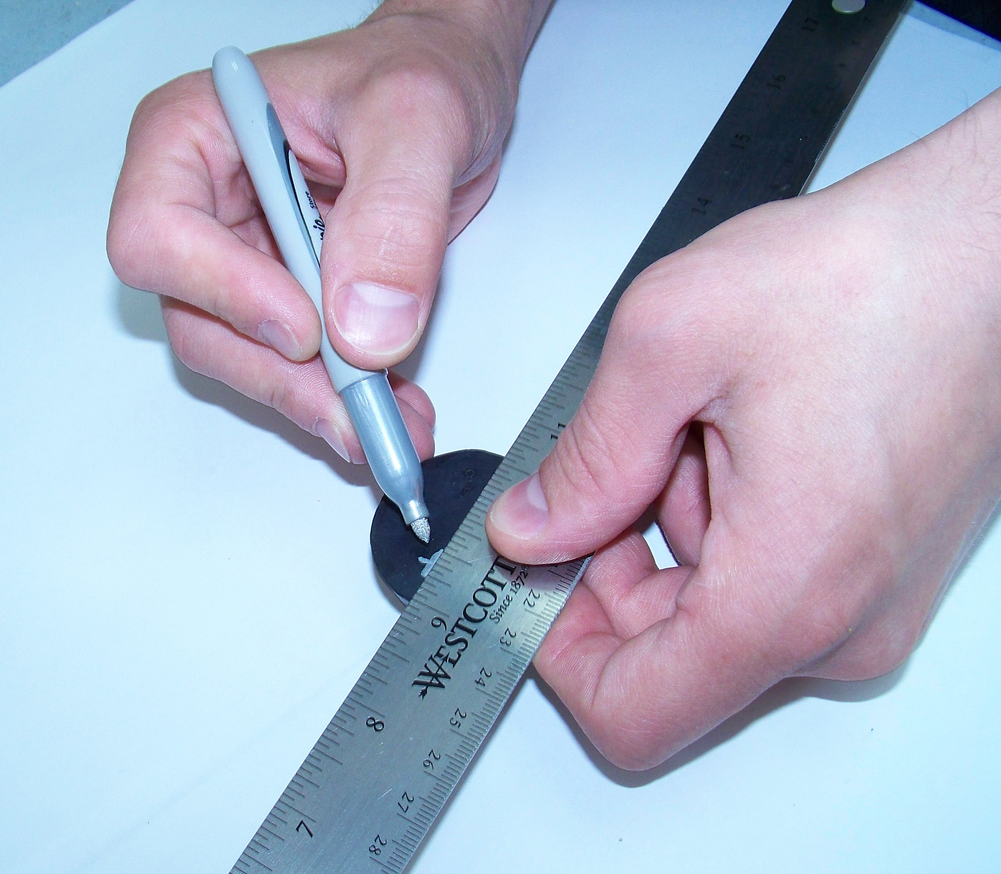

Figure 1. Draw hole layout onto stopper

Install marked-up stopper into fixture and mount to drill press

Step 5: Install marked-up stopper into associated 1 ¼” cable gland housing. Do not over-tighten. The stopper should only be held securely in place.

Step 6: Mount the cable gland with stopper into vice

Step 7: Install appropriate size drill bit to create hole into drill press.

Step 8: Align vice under drill and clamp vice to drill press drill plate using a C-clamp (multiple preferred for safety) as shown in Figure 2, below.

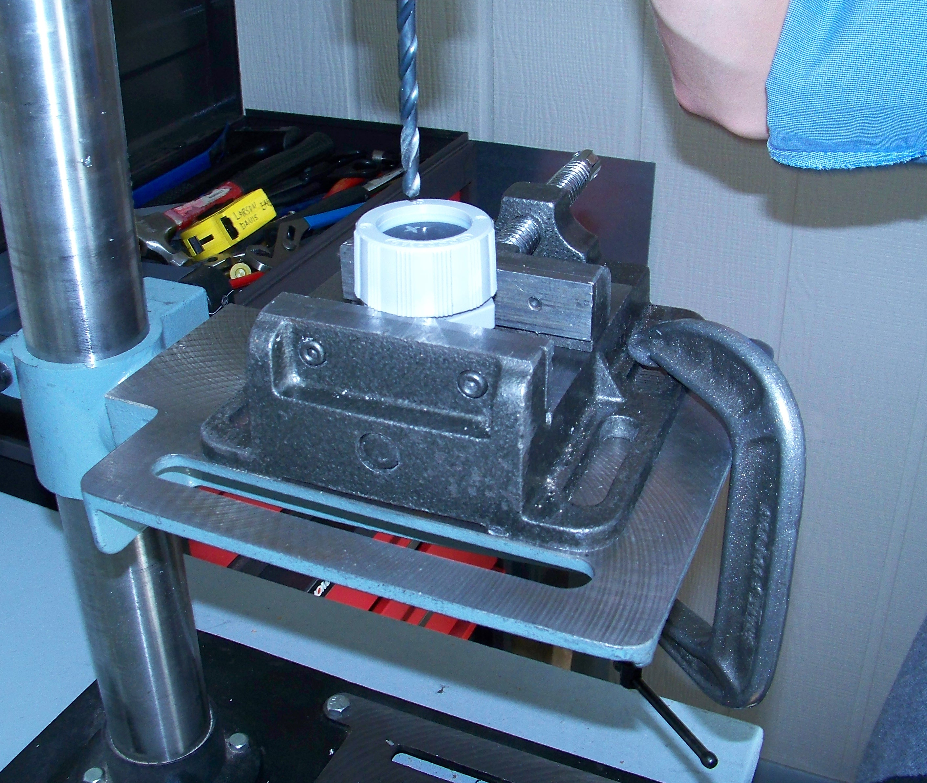

Figure 2. Mount stopper into cable gland in vice
Step 9: Set drill press transmission to run at fastest speed possible. UNPLUG DRILL PRESS PRIOR TO ADJUSTING TRANSMISSION BELT!

Step 10: Verify that the drill will create the hole in the stopper at the correct location.

Drill hole in stopper

Step 11: PUT SAFETY GLASSES ON BEFORE TURNING DRILL ON!

Step 12: Slowly plunge the drill bit into the plug approximately 1/4” as in Figure 4, below, and remove. Repeat as long as solid rubber chips are created until through hole is created.

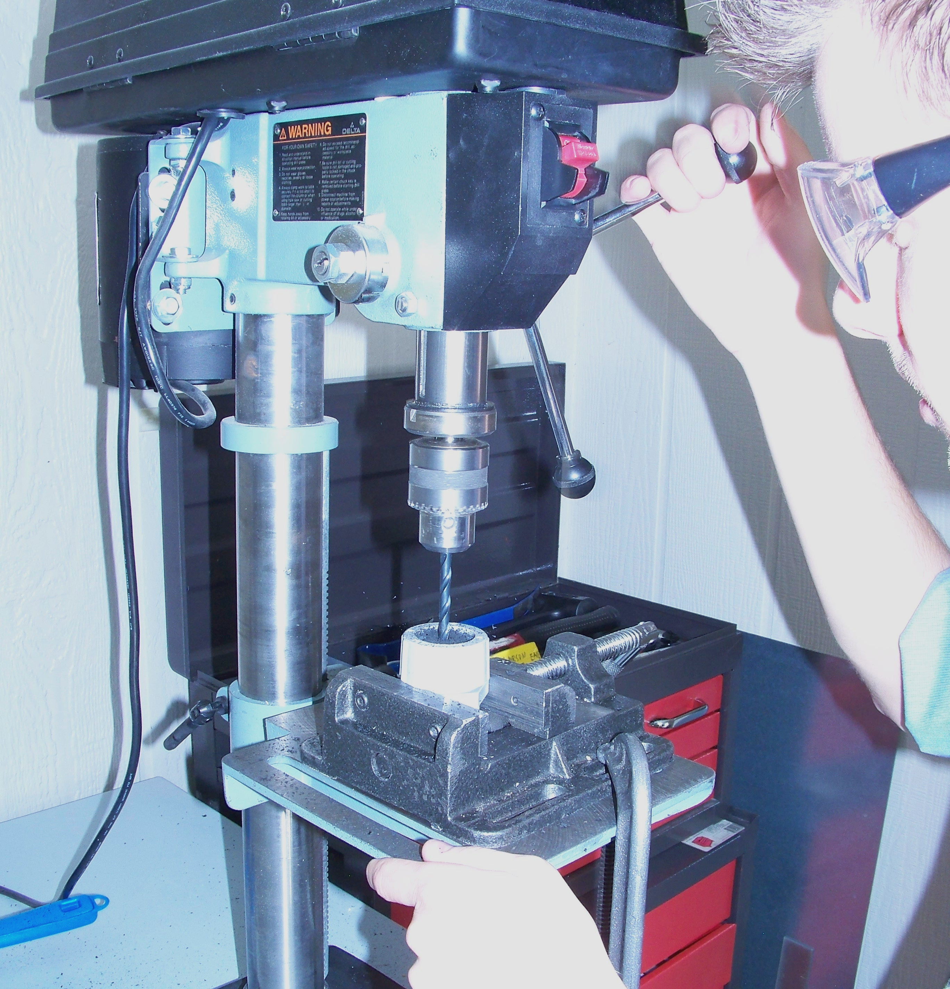

Figure 3. Drill hole in stopper

Step 13: If smoke is created during drilling, remove drill bit from stopper until reasonably cool and restart plunging process.

Step 14: Change drill bits as needed, realign stopper layout, and repeat drilling process until required holes are created.

Step 15: Once all necessary holes are created, remove stopper from cable gland housing, return drill bits to proper location, and clean rubber chips.

Step 16: Create radial slits in outer portion of plug for each hole using Exacto or utility knife as shown in Figure 4, below.

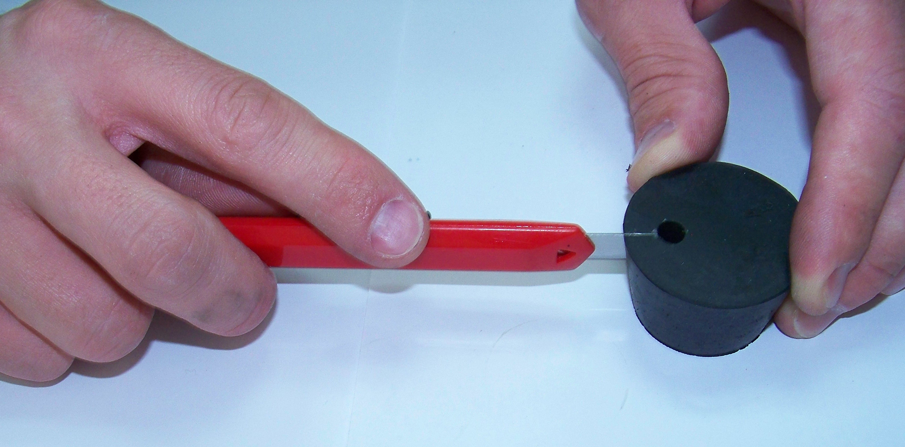

Figure 4. Create slits in drilled stopper

DISTRIBUTION
Instruction is available online in the “NoiseTutor” folder in the “Technician work instruction” folder in Document Control.

REVISION HISTORY
DCO # | REV | DATE | INITIALS | CHANGES MADE
 | A | 3/15/12 | KCM | Initial release for review

