MICROPHONE Environmental Verification TEsting procedure

PURPOSE AND SCOPE
The purpose of this document is to provide the details and instructions to perform the periodic environmental verification testing on microphones.

affected departments
Manufacturing and Engineering

REFERENCE DOCUMENTS
- IEC 61094-4: Measurement Microphones. Part 4 – Specifications for working standard microphones.

RESPONSIBILITIES & AUTHORITY
The technician has the following responsibilities and authority:
- Verify compliance of the product to specification.
- Communicate concerns to Supervisor or Quality Assurance.
- Request Management review of product concerns.

SAFETY PRECAUTIONS
 Warning!!! Output of EA amplifier is a shock hazard at over 400 volts. Ensure EA amplifier’s power switch is in ‘OFF’ position before setting up test system.

EQUIPMENT and MATERIALS
- Environmental chamber.
- Windows Computer.
- Model 831 sound level meter.
- LD 2900 real-time sound level meter/analyzer.
- Model 2209 or 2239 signal isolation/gain/attenuation box.
- GRAS RA0014 ½” microphone electrostatic actuator (modified with shorter cable).
- PRM900C ½” microphone preamplifier (with hole drilled in front end for faster humidity soak).
- Electrostatic actuator power amplifier (custom LD equipment). (EA Amplifier).
- Microphone/preamp stand (custom).
- Custom microphone/preamp/EA connector clamp (larger alligator clamp with banana jack and BNC connector attached).
- ADP015, microphone signal splitter box, 5-pin Switchcraft with BNC.
- EXC003 5-pin microphone cable.
- EXC020 5-pin microphone cable.
- CBL061, BNC to mini phone adapter test cable.
- CBL135, BNC to 5-pin SW cable.
- USB Cable, type USB A to USB mini-B, 6 ft.
- Serial cable, DB9 to DB9, 6 ft.
- Parallel cable, DB25 to DB 25, 6 ft.
- BNC cables, 20 ft. and 6 ft.
- Larson Davis environmental test program.

DEFINITIONS
LD - Larson Davis
Mic - Microphone
Preamp – Preamplifier
EA –Electrostatic actuator (for microphone).

Initial chamber software setup
Set up LD chamber software with the following setups:
Chamber>Setup:
- Whichever chamber is being used (i.e. Thermotron, etc.).
- IP address.
Generator>Setup:
- LD 2900.
- COM Port 1.
Data base>Setup:
- Server: UTPDB01.
- Database: envtest.
- SQL Authentication.
- User: TestSoftware.

Test equipment setup
Warning!!! Output of EA amplifier is a shock hazard at over 400 volts. Ensure EA amplifier’s power switch is in ‘OFF’ position before setting up test system.
- Switch EA amplifier power switch to ‘OFF’ position.
- Set EA amplifier microphone bias knob to ‘0 V’ position.
- Set up the test system as shown in Figure 1.0 below.
- Close the chamber door.
- Verify all chamber cable gland holes are plugged with foam (grey surface of foam faces inside of chamber).
- Turn EA amplifier power switch to ‘ON’ position.
- Set EA amplifier microphone bias knob to 300 V.
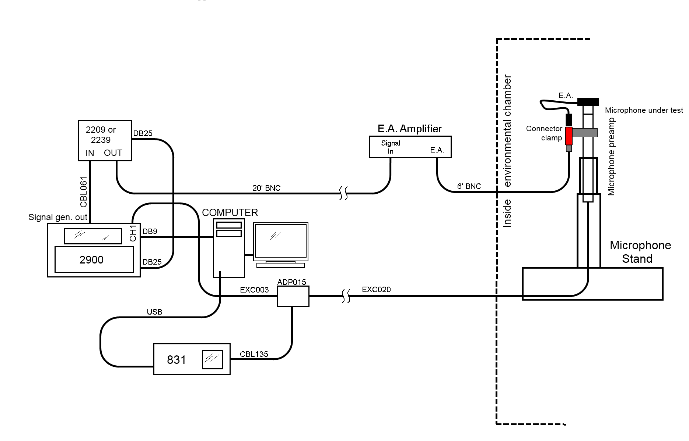
Figure 1.0 Microphone Environmental Test Setup

Test precheck
- Verify that the total test system is operating correctly by doing the following:
  - Open LD SigGen program.
  - Check the ‘Connect’ check box.
  - Set SigGen output signal to 1 kHz at 140 dBµV, and click ‘Send Setup’.
  - Viewing the 1/3 OBA on the 831, the levels should be approximately:
    - ~95 dB SPL at 1 kHz.
    - ~76 dB SPL at 2 kHz.
Note: Above values are for microphones with sensitivity of between 45 to 50 mV/Pa (i.e. 377B02, 377B20, 377B11, LD 2560, LD 2570, LD 2575).
For microphones with sensitivities of between 12 to 14.5 mV/Pa (377A13, LD 2540, LD 2559), these values will be lower by about 12 dB.
Note: If results above are not seen:
    - Verify all cabling is set up correctly, according to Figure 1.0.
    - Go into 2900 settings and ensure that microphone bias setting is set correctly (0 volts for pre-polarized microphones or 200 volts for externally polarized microphones).
      - Press ‘System’ button on 2900.
      - Press ‘Input’ soft key on screen (the ‘K’ key).
      - Mic bias setting is shown in upper right of 2900 screen (as ‘0 or 200 Volts bias’).
    - Voltage at ‘DC Out’ port of EA amplifier is ~300 VDC.
    - Voltages at ‘Amp Out’ port of EA amplifier are ~100 VAC and 153 VDC.
- Close LD SigGen program (without changing the levels).

procedures
- Open the LD environmental chamber testing program.
- Select ‘Mic/Preamp Test’ tab.
- Click ‘1’ and then the microphone model in the ‘Model’ pull-down field.
- Enter the full microphone serial number in the ‘Serial Number’ field.
- Enter the manufacturer name in the ‘Manufacturer’ field.
- Select the ‘LxT/831’ radio button in the ‘Measurement Setup’ area.
- Uncheck the ‘200 V bias’ check box if the microphone is a pre-polarized microphone. Check the ‘200 V bias’ checkbox if the microphone is externally polarized.
Note: If you are unable to change the setting on this checkbox, temporarily switch analyzer mode to ‘2900’ to enable this checkbox, check (or uncheck) the ‘200 V bias’ checkbox to the desired setting, and then switch the analyzer mode back to ‘LxT/831’.
Note: Select analyzer mode by selecting menus Generator>Setup>
- In the ‘Sequence File’ area, navigate to and choose the chamber test script file MICEASS.seq.
Note: MICEASS.SEQ chamber test script tests temperature range from -10 to +50 °C and the humidity range from 50 to 95% R.H. If other environmental testing conditions are being requested use another test script.
Note: MICEASS.SEQ works for most microphones (i.e. 1”, ½”, externally polarized vs. pre-polarized). If testing ¼” externally polarized microphone, check with Engineering to use another test script, as they require a lower humidity test range.
- Run the chamber software sequence file.
  - Chamber sequence test runs the following tests:
    - Temperature sweep (-10 to +50 °C, held at 50% R.H.).
    - Humidity sweep (up to 95% R.H, held at 50 °C).
    - Humidity endurance test (held at 95% R.H. at 50 °C).

Test results evaluation
- Open the ReportGen software.
- In the ‘Type’ pull-down box, select ‘Env. (Mic/Preamp) Test Results’.
- In the ‘Instrument’ pull-down box, select which microphone was tested.
- Select the serial number of the microphone that was tested, in the serial number pull-down box.
- Click on the ‘Lookup’ button
  - This will bring up a list of all of the tests that have been performed on this microphone.
- Select the latest test date/time on that microphone (in the left hand lower panel).
  - The list of all of the various tests that were performed on that date/time will show in the right panel.
- Click on and view all of the ‘Relative SPL vs. Temperature’ test results at the various frequencies. Verify that the ‘Relative SPL’ levels pass the limits listed in Table 1. ^{1,2}
- Go through all of the ‘Relative SPL vs. Humidity’ tests at the various frequencies. Verify that the results pass the limits listed in Table 1. ^{1,3}
- Go through the ‘Humidity Endurance’ tests at the various frequencies and inspect the test results of these tests. Verify the results pass the limits listed in Table 1. ^{1,3}

Environmental Test Type | SPL Deviation Limits
Environmental Test Type | 1 kHz test results | Test results for  frequencies other  than 1 kHz
Allowed Deviations in  SPL vs. Temperatures tests | ±0.5 dB ^{1,2} | ±0.9 dB ^{1,2}
Allowed Deviations  in SPL vs. Humidity tests  (differences from levels taken at 50 °C, 50% RH) | ±0.1 dB ^{1,3} | ±0.1 dB ^{1,3}
Allowed Deviations in  SPL vs. Humidity endurance tests.  (differences from levels taken at 50 °C, 50% RH) | ±0.1 dB ^{1,3} | ±0.1 dB ^{1,3}
Table 1
Notes:
- Test limits in Table 1 are for the 377B02 ½” pre-polarized microphone. If testing any other microphone besides the 377B02, please do not use Table 1, but instead compare the testing results to the microphone’s specification sheet.
- Deviations for SPL vs. Temperature reported by the ReportGen software are relative to the various recorded reference SPL levels of each frequency at reference conditions (23 °C, 50% R.H.). The SPL errors viewed in the test result graphs (relative SPL) and also raw data (‘Errors’ column) can be used as is to determine if their deviations are acceptable in Table 1. If the results in the ‘SPL vs. Temperature’ graphs are not obvious, use the results in the ‘Error’ field in the ‘Raw Data’ pages to obtain the higher resolution data.
- Reported deviations for SPL vs. Humidity are relative to the recorded reference SPL levels of each frequency at the reference conditions (23 °C, 50% R.H.). However, please note that all humidity sweep and endurance testing is done at 50 °C. The pass/fail deviations should be determined from the differences compared to the SPL deviations measured at 50 °C, 50% R.H, not 23 °, 50% R.H.. You might have to go into the ‘Raw Data’ to determine the SPL deviations for each frequency and humidity level from those taken at 50 °C, 50% R.H.
An example of this would be, in looking in the Raw Data of the test, if the 1 kHz test point measurement level was 94.400 dB at 50 °C, 50% RH and changed to 94.450 dB at 50 °C, 95% RH, the SPL deviation at 95% RH would be 94.450 – 94.400 = -0.050 dB. This -0.050 dB would be what is used to determine if it passes the pass/fail requirements of Table 1.

RECORDS

This instruction is for the periodic test of a microphone. Test data and Certificates of Compliance are required records that are retained and maintained (as a minimum) for the life of the microphone warranty (typically two years) or if this is a yearly re-calibration for one year.

Records are maintained electronically or as hard copies in the technician area or electronically as designated by the IT Department.

DISTRIBUTION

This work-instruction is available in the online Document Control area.

ATTACHMENTS

None

REVISION HISTORY
DCO # | REV | DATE | INITIALS | CHANGES MADE
1427 | A | 06/17/2013 | JLD | Initial release.

