TRP020 & TRP020-KIT Work Instruction

PURPOSE AND SCOPE

This document provides the detail necessary to create the following:

- The guy wire, STRP020-KITXX,

- the guy wire kit, TRP020-KITXX and,

- the portable tripod assemblies, TRP020-XX.

LIMITATIONS

This instruction applies only to the TRP020 and related equipment.

AFFECTED DEPARTMENTS

Production

REFERENCE DOCUMENTS

- TRP020-XX assembly drawing

- ITRP020-XX portable tripod instructions

RESPONSIBILITIES & AUTHORITY

The technician has the following responsibilities and authority:

- Kitting the correct components to the BOM and customer order,

- Assembling the Guy wires when necessary,

- Printing the ITRP020-XX document and verifying the print job and,

- Verifying the selected TRP020-XX configuration will work with other components (SLM systems, preamps, and cables) ordered by the customer.

SAFETY PRECAUTIONS

- Follow general precautions when handling equipment above the head.

- Follow general precautions when cutting and crimping metal wires.

- Proper protective eyewear should be worn at all times during this process.

EQUIPMENT & MATERIALS

- All components called out on TRP020-XX, TRP020-KITXX, or STRP020-KITXX BOM depending on assembly ordered.

- TTRP020.1 Crimping Tool for 1/8” Wire Rope

- TTRP020.2 Wire Rope Cutters

- Protective eyewear

MANUFACTURE PROCEDURE

Depending on which assembly and configuration requested, certain instructions must be followed. These instructions are specified as follows.

- Instruction 8.1

If an STRP020-KITXX is ordered, follow only Instructions 8.1.

- Instruction 8.2

If an TRP020-KITXX is ordered, Instruction 8.1 must be followed to create the needed Guy Wire assemblies, followed by Instruction 8.2

- Instruction 8.2

If an TRP020-XX is ordered, Instruction 8.2 must be followed to create the needed guy wire kit, including the creation of the necessary guy wire assemblies of Instruction 8.2.

Note that the guy wire assembly is not needed for the TRP020-06 configuration.

STRP020-KITXX Guy Wire Rope Assembly Instructions

- Verify that all the components on the BOM have been provided.

- Cut the wire rope according to the size specified in Table 1 based on which assembly is needed.

Table 1. guy wire rope size by assembly

Assembly Part Number | Size of Wire Rope
TRP020-10  TRP020-KIT10 | 3X 8.5 feet
TRP020-15  TRP020-KIT15 | 3X 13 feet
TRP020-20  TRP020-KIT20 | 3X 19 feet
- Thread the one end of the wire rope through two compression sleeves, around a wire rope thimble and back through the compression sleeves to create the assembly shown in Figure 1.

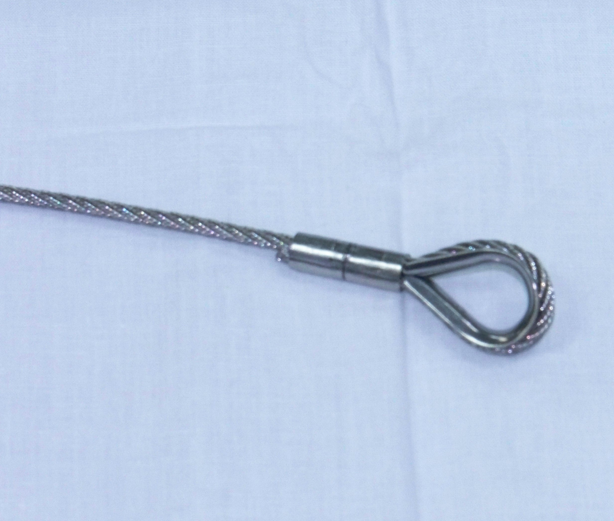

Figure 1. guy wire thimble eyelet assembly

- Trim any wire rope threads flush with the compression sleeve at the wire rope termination.
- Crimp both compression sleeves using crimp tool as shown in Figure 2.

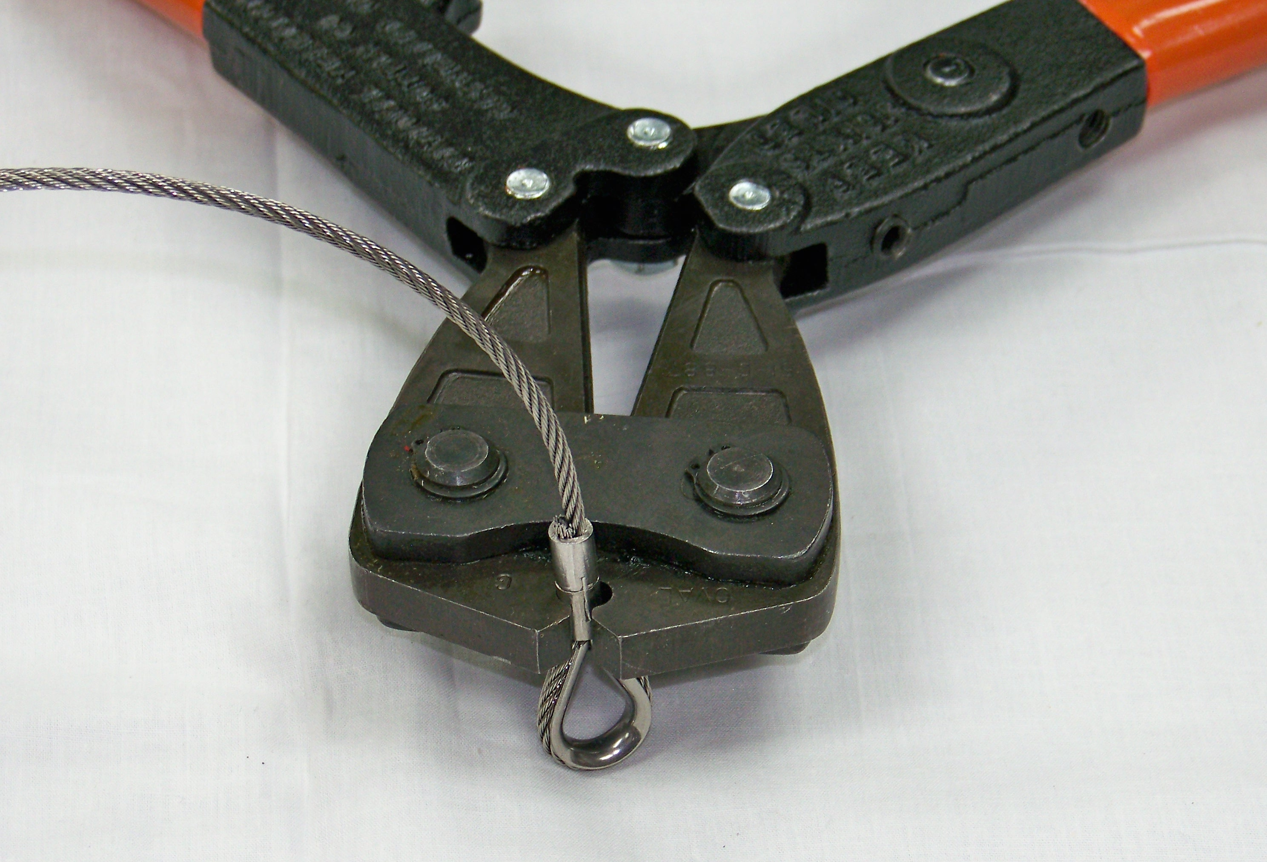

Figure 2. compression sleeve crimping

- Repeat Step 2 and Step 3 on the opposing end of the wire rope to complete the guy wire assembly.

- Wrap the finished assembly into a 7±1 inch diameter coil and zip-tie in a single location as shown in Figure 3.

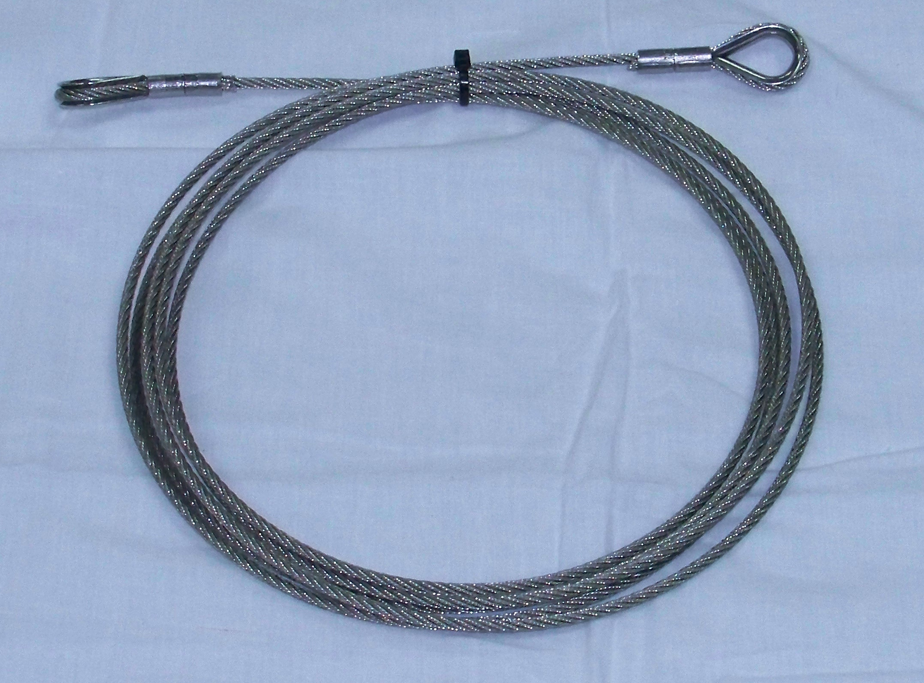

Figure 3. guy wire assembly coil

TRP020-KITXX Guy Wire Kit Assembly Instructions

- Verify that all the components on the BOM have been provided.

- Assembly guy wire assembly/s according to Instruction 8.1.

- Place all components in the provided zip-lock bag.

TRP020-XX Portable Tripod Assembly Instructions

- Verify that all the components on the BOM have been provided.

- Assembly guy wire kit assembly according to Instruction 8.2. Note that the guy wire rope assembly of Instruction 8.1 will be created in Instruction 8.2.

- Discard the following components from the Tripod Kit:

1. aluminum lightning rod

2. aluminum bell reducer

3. 12 AWG cable

4. aluminum non-threaded mast

5, aluminum mast extension

- Print the current released revision of the ITRP020-XX Portable Tripod Instructions if not provided. Verify that ITRP020-XX Portable Tripod Instructions printed correctly.

- Roll up ITRP020-XX and place in shipping tube.

- Place plastic caps on all male threads of aluminum pipes as shown in Figure 4.

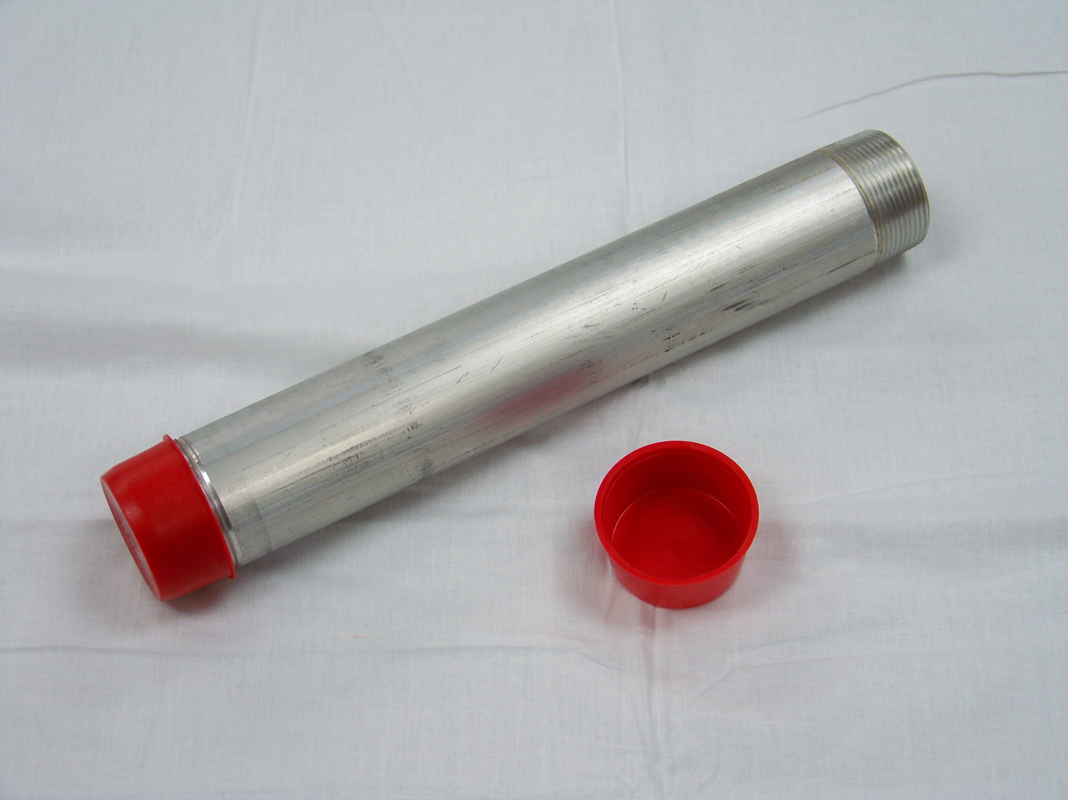

Figure 4. cap threaded ends of aluminum pipes

- Provided all components to Shipping.

DISTRIBUTION
Instruction is available in the “Technician Work Instruction” folder in Document Control.

REVISION HISTORY
DCO # | REV | DATE | INITIALS | CHANGES MADE
 | A | 7/19/2013 | KCM | Initial Release.

