**CUSTOM-111 Work Instruction**

# PURPOSE AND SCOPE

This document provides the detail and instruction necessary to re-work NoiseTutor systems (NMS021 and EPS041) to include a LFP battery.

# LIMITATIONS

This re-work instruction is limited to the NMS021 and EPS041 systems sold without a self-contained battery or that were re-worked prior to be run solely on AC power.

# AFFECTED DEPARTMENTS

Production

# REFERENCE DOCUMENTS

* SEPS041 assembly drawing
* D0001.8361 NoiseTutor Outgoing Inspection

# RESPONSIBILITIES & AUTHORITY

The assembly technician has the following responsibilities and authority:

1. Remove components from existing NoiseTutor system.
2. Install updated NoiseTutor design components.
3. Verify reworked NoiseTutor meets inspection criteria.

# SAFETY PRECAUTIONS

* Follow general safety precautions when working with power tools, possibly sharp sheet metal components, and low voltage circuits.

# EQUIPMENT & MATERIALS

* All the components on the CUSTOM-111 Bill Of Materials
* SEPS041 assembly drawing
* D0001.8361 NoiseTutor Outgoing Inspection Procedure
* Stiff putty knife

# REMOVE OLD COMPONENTS

1. Remove and retain all components from the NoiseTutor station except the following as given in Figure 1:
   1. Cable glands

* 1. Cable tie on case exterior (not shown)
  2. Foam on inside case top
  3. Velcro on inside case top
  4. Sheet metal and foam adhered to case bottom

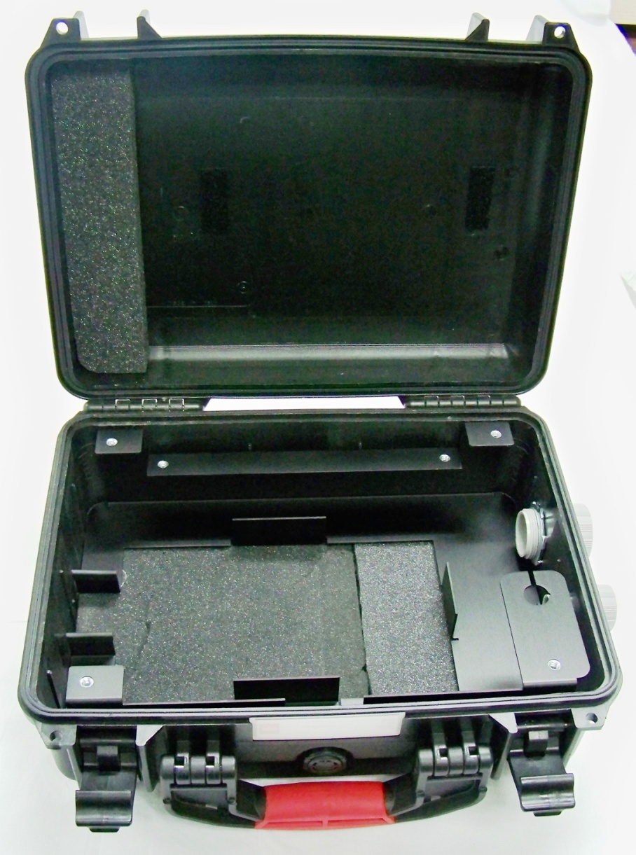

Cable Glands

Sheet Metal/Foam

Inside Case Velcro

Inside Case Foam

**Figure 1.** NoiseTutor station with components removed

1. Separate the sheet metal base from the case bottom as shown in Figure 2. This may require significant effort as flexing the bottom of the case to break glue may be needed.

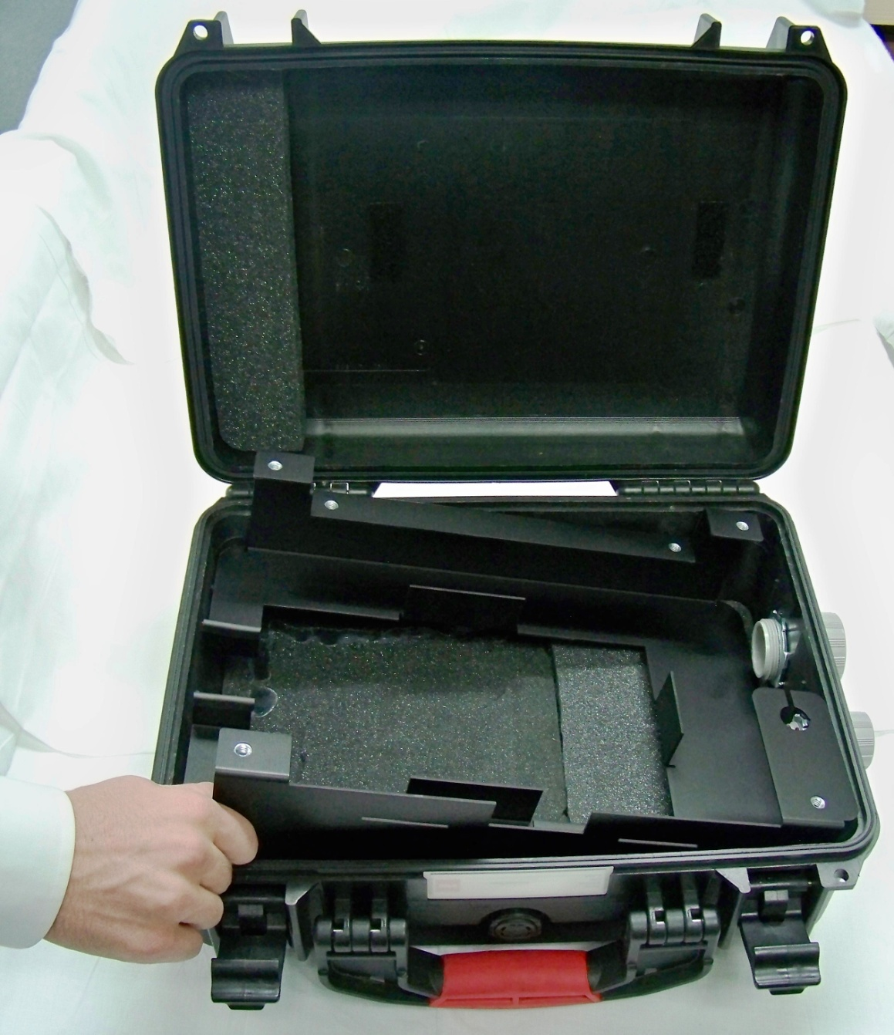

**Figure 2.** Removal of sheet metal base inNoiseTutor station

1. Remove remaining adhesive and foam with the help of a putty knife as in Figure 3.

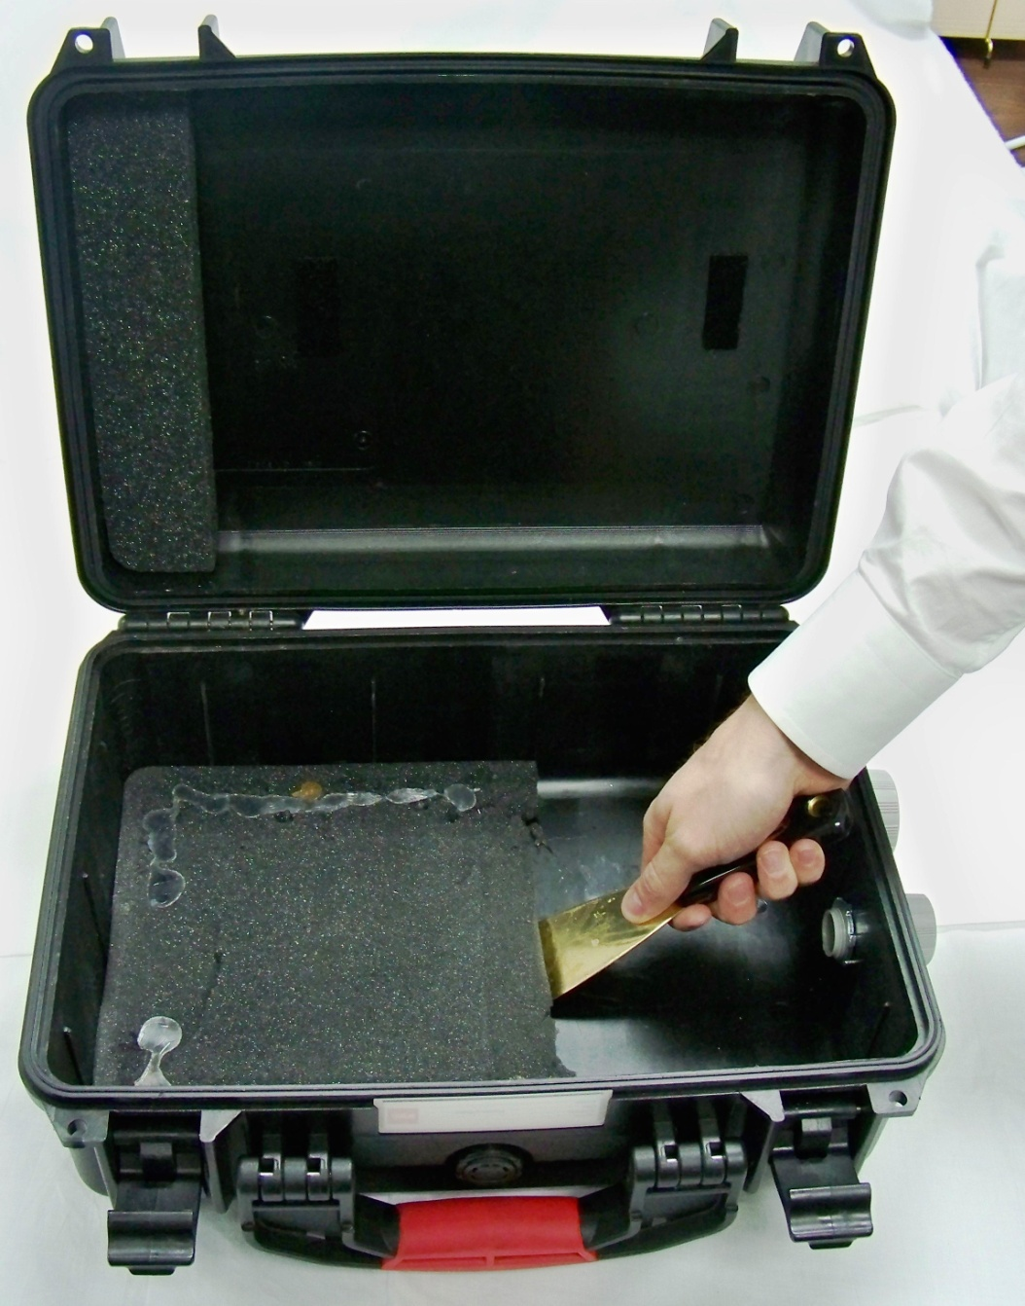

**Figure 3.** Removal of sheet metal base inNoiseTutor station

1. Once the bottom case is clean of adhesive, rebuild the NoiseTutor system using the components removed prior and the components kitted from the CUSTOM-111 BOM. Reference the SEPS041 assembly drawing and associated documents for this task.
2. Discard remaining components not used in the re-assembly process.
3. Inspect the re-built NoiseTutor system according to the NoiseTutor inspection procedure, updating software and settings as needed.

DO NOT CHANGE USER SETTINGS IN THE NOISETUTOR CLIENT

# DISTRIBUTION

This Instruction will be located in the “Technician” directory of the “Work Instruction” folder.

# REVISION HISTORY

|  |  |  |  |  |
| --- | --- | --- | --- | --- |
| **DCO #** | **REV** | **DATE** | **INITIALS** | **CHANGES MADE** |
| N/A | A | 8/20/2013 | KCM | Initial release. |