MET/CAL Procedure Instructions

1.0 SCOPE & APPLICABILITY

This instruction covers running published MET/CAL procedures for new devices and customer device re-certification tests.

2.0 RESPONSIBILITY

The Technician who will test and certify the Unit Under Test (UUT) has the responsibility to follow the applicable instructions and references to produce a quality product.

3.0 MATERIALS, TOOLS, & EQUIPMENT

New or customer UUT
SRS DS360 Low Distortion Function Generator
Sea Level 8111 USB switch
LD ADP093 Fixed 40dB Attenuator
HP 34401A Digital Multimeter
Computer with MET/CAL Runtime installed
Larson Davis Model 831

Note: Some UUT’s will require additional hardware to complete the tests. The procedures associated with each UUT will list all of the additional hardware required.

3.1 Adding instruments to MET/CAL Runtime
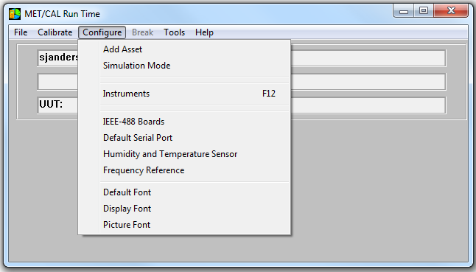
All instruments to be used as standards for a procedure must be added to the MET/CAL Runtime and referenced to the MET/TEAM database.

Select “Configure”, “Instruments”
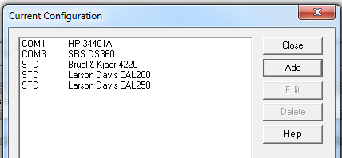
Select “Add” and Enter Larson Davis Tracking number. Enter the interface information and the alias used in the Procedure
Aliases will be: “34401”, “DS360”, “2900”, “831” etc.

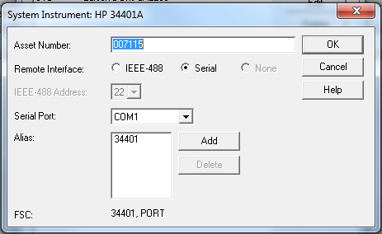

4.0 PROCEDURE
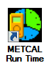
4.1 Prep for Certification
Open the MET/CAL Runtime Executable found on the desktop.

If the UUT is new, select “Add Asset” from the “Configure” Menu.

Enter the serial number of the asset in the appropriate field.

Select the Type (Manufacturer/Model). This will populate the remaining fields with the UUT’s information.

Save the changes and Close the window.

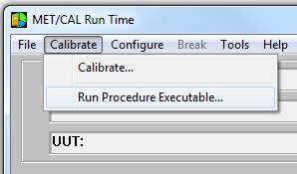
Select “Calibrate” on the Run Time window.

Select “Run Procedure Executable…”
A dialog box will open.
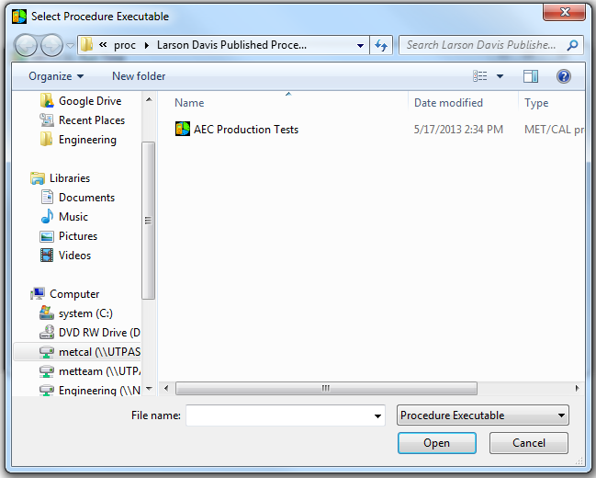
The procedures are organized by product family.
Select the procedure for the UUT

A prompt will verify the details of the test to be run. Click OK
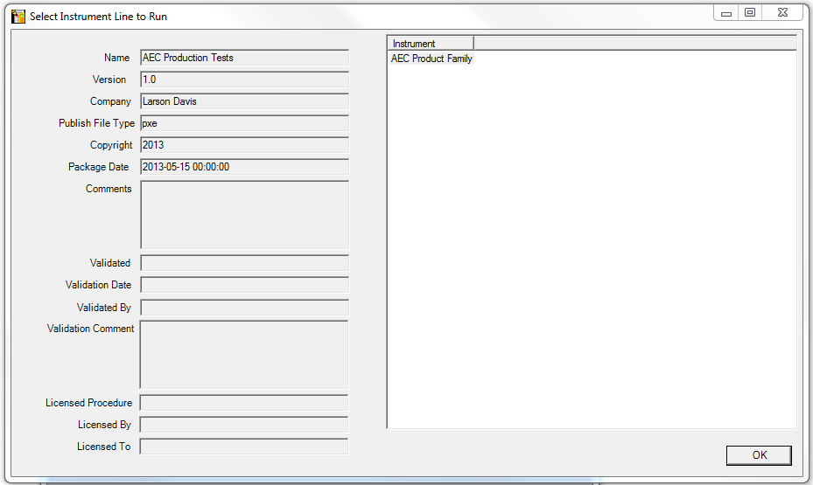

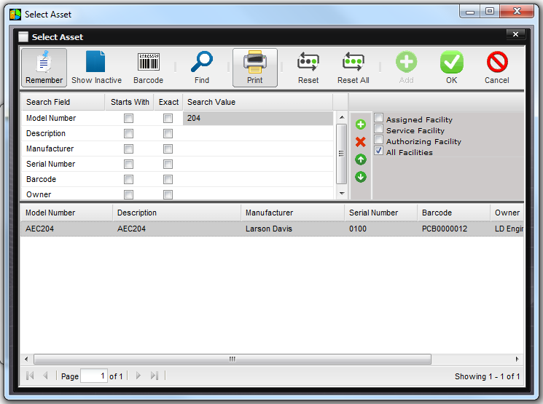
The program will prompt the technician to select the Asset that will be the UUT. Customer devices should be present in the database, and new assets were created

previously for new devices. Select the appropriate Asset and click OK.

The Fluke DewK will populate the Relative Humidity and Temperature. A remote pressure sensor will log the atmospheric pressure during the test.

A dialog will open if the test software determines that the standards required for the test need to be verified. A barcode scanner can be used to correctly associate the standards with the configuration for the workstation.

A prompt will ask the technician which tests are to be performed for the UUT. A button allows the technician to select all tests, or the technician can multi-select only the tests desired, such as for troubleshooting purposes.

A dialog will indicate the total time the series of selected tests will require to complete.

A dialog will prompt the technician to connect the UUT and standards, along with any other required hardware, as indicated by written instruction and/or illustrations. When everything is connected as indicated, click OK.

4.2 Begin Automated Test
A window will show the tests being performed and the individual results of each test. Fail conditions will not pause or stop the procedure, but will be reported at the end of the tests.

If any hardware connection changes are required, the test will pause and prompt the technician to change the necessary connections. It will be very uncommon for this action to be required in any procedures.

4.3 Document Certification Results
Upon completion of the tests, the results are written to the database. The MET/TEAM browser window will open. The technician can enter notes about the asset/tests. The cert can be printed immediately or at a later time. When all of the notes have been entered, the technician sets the Status to “Tested”, and Saves the Work Order.

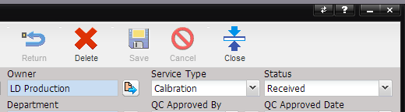
Note that the “Return” button is disabled.
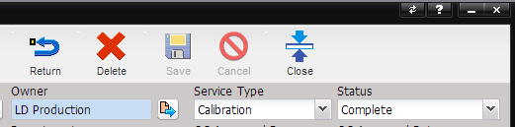

On new products, the owner is unknown, and the Work Order cannot be marked “Complete” and Returned until the product has been purchased.

When the Status is set to “Complete” a prompt will ask if the User would like to update the owner from the database. This permits the Cert to display the owner at the time of purchase.

For customer products, when the unit is ready to ship, the status is set to “Complete”, the Work order can be Returned.

Once the Work Order is “Returned”, it cannot be modified.

5.0 EVALUATION

The test process detailed includes evaluation.

6.0 RECORDS

Test data generated from this process is stored in the test software’s database called MET/TEAM.

7.0 SIGNATORY

The test data and certificate information must be reviewed for the following items before the signatory can sign the calibration certificate.

- Correct Work Instruction used to perform calibration
- Deviations from standard calibration procedure agreed upon with customer
- Indication of limited calibration if applicable
- Accredited symbol appears on certificate when required by customer
- Check document D0001.3033 for approved accredited products
- Non-accredited results are clearly marked
- Before and After data is included when the instrument requires adjustment or repair
- Sub-contracted work is identified
- The measurement uncertainty is not smaller than the CMC claim on the scope of accreditation (D0002.0002)

Once the signatory has confirmed that the certificate complies with these requirements, he or she can approve the certificate by entering his or her name in the “QC Approved By” field in the Work Order, as shown below. MET/TEAM will prompt the signatory for his or her password, ensuring that the signatory’s signature has not been forged. The signatory should also ensure that the QC Approved Date is entered.

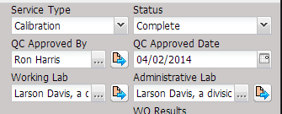

When the “QC Approved By” field has been filled in by the signatory, his or her digital signature is placed at the end of the calibration certificate.

8.0 REVISION HISTORY

DCO # | REV | DATE | INITIALS | CHANGES MADE
XXX | A | 3/26/13 | SA | Initial Release
1493 | B | 5/6/2014 | SJA | Added section 7 regarding signatories
1574 | C | 7/29/15 | DSM | Added D0001.3031 to section 7
1575 | D | 8-18-15 | DSM | Update D001.3031 to D0001.3033
1845 | E | 6-18-18 | DSM | Update material, tools and equipment list

