**A831.13 CM Board Test Procedure**

# PURPOSE AND SCOPE

These instructions provide the detail necessary to ensure compliance of the 831C to established specifications. Please become familiar with the entire document before attempting to test the product. The A831.11 and A831.13 boards being tested in combination will be referred to hereafter as the “instrument.”

Note: This procedure is used to test the A831.13 individually and a known good A831.11 is used as the test fixture

# REFERENCE DOCUMENTS

* A831.13 Interface Board Schematic, Assembly and Bill of Manufacturing
* A831.11 Main Board Assembly Drawing and Bill of Manufacturing
* A831.98 Assembly Drawing
* D0001.8495 A831.11 CM Board Test Procedure
* D0001.8499 A831.11 & A831.13 Board Test Procedure

# EQUIPMENT & MATERIALS

* Adjustable DC power supply with built in current meter capable of 12 Vdc & >0.5 A
* DC power cable with 2.5mm power jack, center positive, and connection to power supply
* A831.11 main board customized with firmware for this test
* A831.98 Control Port Test Fixture
* CBL138, USB cable, A to mini-B
* T831.1103 USB Debug Cable (instructions and driver at [www.ftdichip.com/drivers/VCP.htm](http://www.ftdichip.com/drivers/VCP.htm) )
* Serial terminal program such as [PUTTY](http://www.putty.org/) or [HyperTerminal](https://en.wikipedia.org/wiki/List_of_terminal_emulators#Microsoft_Windows), referred to as “Debug Terminal” hereafter, 115200 Baud, 8-bit, no parity, 1 stop bit, no handshaking.
* Optional: Test LCD color TFT (1895.0024)

# INSPECTION

1. Before testing the A831.13 board, visually inspect and correct component loading, part polarity and missing parts issues. Note and repair obvious solder defects.

# INSTRUCTIONS

1. Setup test equipment
   * Set the power supply output voltage to 12.0 volts and turn it off.
   * Connect T831.1103 to debug connector P8 (observe the pin-1 location/markings) and to the computer’s USB port.
   * Activate the Debug Terminal program.
   * Plug the 2.5mm power plug into the A831.98 test fixture board and to the power supply; observe proper polarity (center positive on the power plug).
   * Position the A831.11 so that the keypad and LEDs are facing down and P1 is accessible (see image below).
   * Connect the USB cable (CBL138) between the A831.11 and the computer.
   * Connect the first A831.13 interface board to be tested to the A831.98 test fixture.
   * Connect this A831.13 to the A831.11 (P1).
   * Turn the A831.01 S1 switch to the “ON” position (towards the small USB connector).
   * Turn on the power supply. The instrument will power on automatically.
2. Verify power up
   * Verify that the board is drawing less than 250 mA.
   * Note that the green power key LED is flashing (DS59).
   * The LCD will show the 831C logo and finally the Live SLM display.
3. Prepare for Automated Test
   * Once the unit has “booted”, press ENTER on the Debug Terminal program to obtain the login prompt.
   * Login in using the confidential credentials provided by Larson Davis:

Login name: _________ password: _________

* + Execute Linux commands to run the test programs (you can copy and paste **commands** from this document to the Debug Terminal or use shortcuts**[1]**)
  + Change to the folder where the automated test programs are located (this will be needed following any login):

**cd /opt/ld/bin/**↵

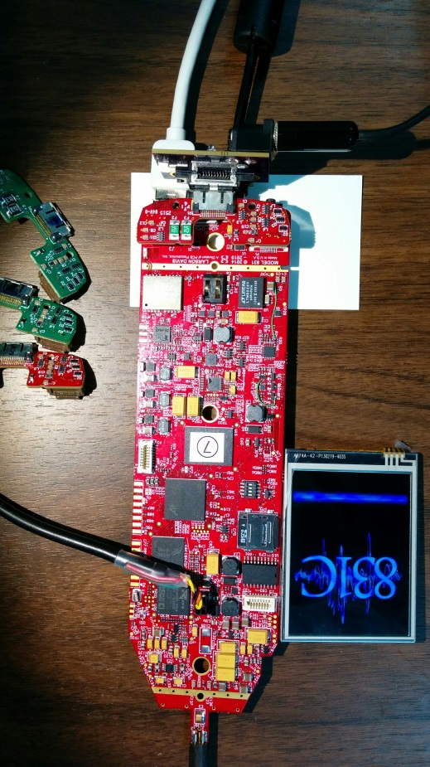

A831.13 under test

A831.11 test fixture

A831.98 fixture

1. Run the **test_831_13.sh** script

* Enter this command:

**./test_831_13.sh**↵

* This menu will be displayed:

|  |
| --- |
| **\*\*\*\*\*\*\*\*\*\*\*\*\*\*\*\*\*\*\*\*\*\*\*\*\*\*\*\*\*\*\*\*\*\*\*\*\*\*\*\*\*\*\*\*\*\*\*\*\*\*\***  **Press key to select test then press [ENTER]**  **\*\*\*\*\*\*\*\*\*\*\*\*\*\*\*\*\*\*\*\*\*\*\*\*\*\*\*\*\*\*\*\*\*\*\*\*\*\*\*\*\*\*\*\*\*\*\*\*\*\*\***  **Key Action**  **--- --------------------------------------------**  **' ' A831.13 Board Test (just press ENTER)**  **X Exit test**  **Z Power Off Instrument** |

1. Test the A831.13 board

* Press **ENTER** to perform the A831.13 Board Test
* Observe that:
  + The RED LED on the A831.98 test fixture blinks
  + Both GREEN LEDs are on
  + The test should end with “**No faults detected.**”
  + If there are issues with the A831.13 board it will indicate the signal lines that have faults as shown in this example:

|  |
| --- |
| **\*\*\* Aux I/O and ADC test started. \*\*\***  **Fault: MainsOk=0 (i=3)**  **Fault: MainsOk=0 (i=7)**  **Fault: MainsOk=0 (i=17)**  **Fault: MainsOk=0 (i=21)**  **Fault: MainsOk=0 (i=25)**  **WARNING: 5 faults detected!** |

* + Repair and retest any with a fault.
* Remove the tested A831.13 (power does not have to be turned off, the USB connection provides power for the A831.11)
* Connect the next board to be tested and press **ENTER** to repeat the tests above, or
* Press **Z**↵ to end and **Power Off Instrument**

*Please do not remove power before the unit has full turned off as an improper shutdown can corrupt the program flash and make the test board unusable!*

# RECORDS

* Complete and turn in the technician inspection and rework report.

# DISTRIBUTION

* Manufacturing and contract manufacturer.

# REVISION HISTORY

|  |  |  |  |  |
| --- | --- | --- | --- | --- |
| DCO # | REV | DATE | INITIALS | CHANGES MADE |
| 1701 | A | 04/27/2017 | AJR | Initial version, a simplification of D0001.8399 for use by Contract Manufacturer for the A831.13 only. |
|  |  |  |  |  |
|  |  |  |  |  |
|  |  |  |  |  |
|  |  |  |  |  |

1. Linux shortcuts: **Autocomplete**– type the first few characters and press the Tab key

   **Recall**– press up–arrow to recall previous commands