**A831.11 CM Board Test Procedure**

# PURPOSE AND SCOPE

These instructions provide the detail necessary to ensure compliance of the 831C to established specifications. Please become familiar with the entire document before attempting to test the product. The A831.11 board being tested with an A831.13 interface board attached will be referred to hereafter as the “instrument.”

# REFERENCE DOCUMENTS

* A831.11 Main Board Schematic, Assembly Drawing and Bill of Manufacturing
* A831.13 Interface Board Schematic, Assembly and Bill of Manufacturing
* A831.98 Assembly Drawing
* D0001.8494 A831.13 CM Board Test Procedure
* D0001.8499 A831.11 & A831.13 Board Test Procedure

# EQUIPMENT & MATERIALS

* Adjustable DC power supply with built in current meter capable of 12 Vdc & >1 A
* DC Power Cable with 2.5mm power jack, center positive, to connect to power supply
* Oscilloscope
* Function Generator
* Multi-Meter with 4 ½ digits, 0.1% DC accuracy
* CBL093, Input Signal Cable
* CBL138, USB cable, A to mini-B
* CBL139, AC/DC Output Cable
* CBL140, Cable, 831 Power, 2.5mm Jack, +Center
* Test LCD color TFT (1895.0024) [1]
* Keypad emulator tool [2]
* Computer running **G4 LD Utility**, referred to as “**G4**”hereafter
* USB flash memory drive with 831C data file[3]
* Battery fixture for charger testing [4]
* A831.13, known good interface board
* Any additional cables or adapters that may be needed (i.e. BNC to dual Banana for voltmeter)
* Optional: T831.1103, USB Debug Cable (instructions and driver at [www.ftdichip.com/drivers/VCP.htm](http://www.ftdichip.com/drivers/VCP.htm) ) and serial terminal program such as [PUTTY](http://www.putty.org/) or [HyperTerminal](https://en.wikipedia.org/wiki/List_of_terminal_emulators#Microsoft_Windows), referred to as “Debug Terminal” hereafter, 115200 Baud, 8-bit, no parity, 1 stop bit, no handshaking.

# INSPECTION

1. Before testing the board, visually inspect and correct component loading, polarity and missing parts. Note and repair obvious solder defects.

# INSTRUCTIONS

1. Setup test equipment
   1. Before connecting to the instrument, set the power supply output voltage to 12.0 volts and turn it OFF.
   2. Connect T831.1103 to debug connector P8 (observe the pin-1 location/markings) and to the computer’s USB port. Activate the Debug Terminal program[5].
   3. Turn the switch on the bottom of the A831.11 (S1) board to the “OFF” position – towards the large USB connector.
   4. Plug the 2.5mm power plug from the power supply into the CBL140; ensure proper polarity (center positive on the power plug).
   5. Connect CBL140 to the A831.13 interface board.
   6. Connect the A831.13 to the A831.11 (P1).
   7. Connect the test LCD to the A831.11 (J53).
   8. Turn the power switch S1 to the “ON” position – towards the small USB connector.
   9. Turn on the power supply. The instrument will power ON automatically.
2. Verify power up
   1. Verify that the board is drawing less than 150 mA.
   2. Note that the green power key LED is flashing (DS59).
   3. Note that the logo shows on the LCD.
3. Verify power supply voltages
   1. Carefully turn unit over so that the keypad and LEDs are facing down.
   2. With the keyboard side of the board facing down, check the following A831.11 voltages (use the component list and assembly drawing to locate test points):

|  |  |  |  |
| --- | --- | --- | --- |
| **Test Point** | **Supply Name** | **Low Limit (V)** | **High Limit (V)** |
| TP29 | V+5ext | +4.78 | +5.21 |
| TP31 | V+3cont | +2.94 | +3.06 |
| TP3 | V+3.3 | +3.11 | +3.21 |
| TP4 | V+1.8 | +1.77 | +1.82 |
| TP5 | V+1.2 | +1.20 | +1.24 |
| TP12 | Vrtc | +2.40 | +2.60 |

*Warning: Use care while probing test point so that the probe does not short out to adjacent components (especially TP3, 4 and 5 as the capacitor terminals near them are GND).*

1. Check the following A831.11 voltages (use the component list and assembly drawing to locate test points):

|  |  |  |  |  |
| --- | --- | --- | --- | --- |
| **Test Point** | **Supply** | **Low Limit (V)** | **High Limit (V)** | **AQL\*** |
| TP13 | V+3.3DSP | +3.10 | +3.21 | * |
| TP15 | DSP_Vint | +0.80 | +1.20 | * |
| TP20 | Va+3.3 | +3.10 | +3.21 |  |
| TP23 | Va+5 | +4.80 | +5.20 |  |
| TP22 | Vq+2.5 | +2.40 | +2.60 |  |
| TP14 | V+19d | +18.90 | +20.50 | * |
| TP18 | Va+18 | +17.40 | +18.80 |  |
| TP16 | V-15d | -16.30 | -14.40 | * |
| TP19 | Va-13 | -13.80 | -12.40 |  |
| TP11 | V+38d | +36.70 | +39.80 | * |
| TP51 or C142 | Vp+36 | +33.50 | +39.30 |  |

*Notes:*

*\* These Test Points to be checked as needed to guarantee an acceptable quality limit (AQL) of 1% (see AQL definition* [*here*](https://en.wikipedia.org/wiki/Acceptable_quality_limit)*). All others points must be verified on every board.*

1. Format the microSD flash memory using either of these two methods:
   1. Format the microSD Card manually with the following commands

|  |
| --- |
| **umount /dev/mmcblk1p1↵**  **mkfs.ext2 /dev/mmcblk1p1↵**  **mount /dev/mmcblk1p1 /mnt/user-flash↵** |

* 1. Format the microSD Card with the script commands

|  |
| --- |
| **cd /opt/ld/bin**  **./production_test.sh↵**  Then execute the V and X commands:  V Format the microSD Card  X Exit test |

1. Carefully turn unit over so that the keypad and LEDs are facing up.
2. Testing by Observation While Operating Instrument
   1. During the testing of the instrument ensure that these LEDs illuminate properly:

RED **Stop** Key backlight, illuminated when measurement stopped

GREEN **Run** Key backlight, illuminated when measurement running

BLUE **Keypad** **backlights** (6 lights), illuminated when key is pressed

GREEN **Power** key backlight will blink while powering on/off

RED **Debug 0** and **Debug 1**, not on, visually inspect installation

* 1. During the testing of the instrument ensure that every key works properly:

Left Softkey Performs the function indicated on the LCD

Center Softkey Performs the function indicated on the LCD

Right Softkey Performs the function indicated on the LCD

RUN/PAUSE Will run a measurement ( RUN LED will illuminate) from stop

STOP/STORE Will stop a measurement (STOP LED will illuminate) from run

RESET Will reset the run time to 

TOOLS Will activate the  menu

ON/OFF Will activate the  dialog

PWR Will power–on the instrument

UP ARROW Will move up through display pages or items on a dialog

DOWN ARROW Will move down through display pages or items on a dialog

LEFT ARROW Will move cursor left in OBA graphs or data entry

RIGHT ARROW Will move cursor right in OBA graphs or data entry

ENTER Will activate items from menus or data entry

1. Instrument Display and Keypad
   1. Use the following Keyboard Layout and Display image to locate display features and keys. Use the Keypad emulator to press buttons.

Page selection

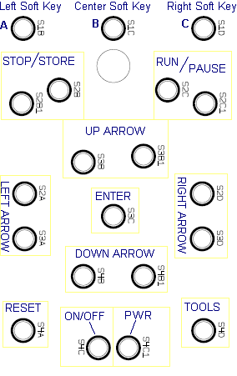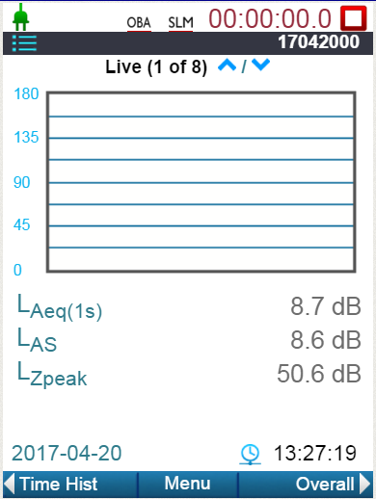

Run/Stop icon & button

TOOLS Menu

Soft-key icon & buttons

1. G4 – 831C Key Mapping and Display
   1. Use the following Keyboard Layout to simulate key actions on G4.
   2. Press **Cntl–Shift–K** to activate/deactivate the key actions (left and center images below).
   3. View the instrument’s display on the G4 Live panel (right image below).

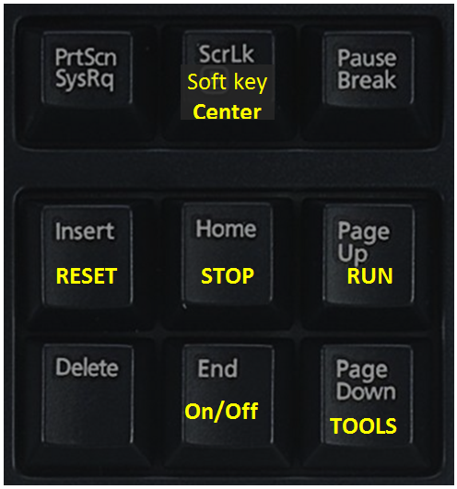 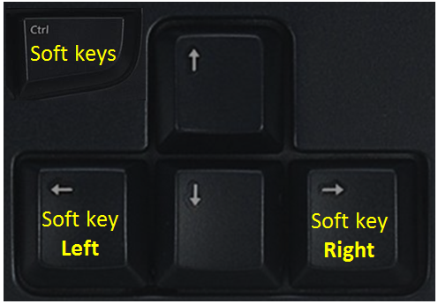 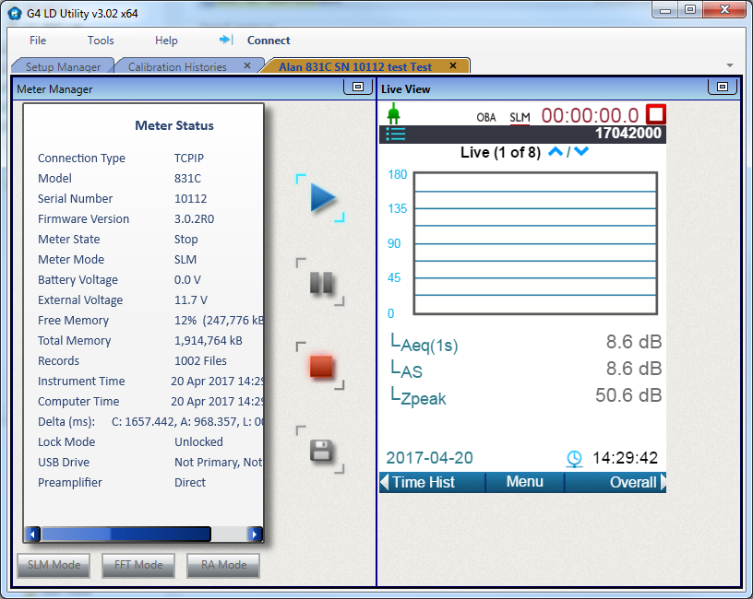

1. Signal Path Test Setup
   1. Function generator:
      * Set the function to SINE
      * Set the frequency to 1000 Hz
      * Set the amplitude to 0.5 volts rms, no dc offset
      * Connect CBL093 from the function generator to the input connector J51
   2. AC/DC Output cable connections:
      * Connect CBL139 sub-miniature phone plug to the AC/DC jack J1
      * Connect Red BNC to oscilloscope channel 1 (AC out)
      * Connect White BNC to DC Voltmeter (DC out)
   3. Configure the oscilloscope:
      * 0.5 volt per division vertical sensitivity channel 1,
      * 0.5 ms per division horizontal time base,
      * trigger on channel 1, rising edge, with a
      * trigger level of 0 volts
   4. Configure the voltmeter:
      * DC on a range with maximum resolution for 1.14 volt reading
   5. Computer control connection:
      * Attach CBL138 USB cable between the computer and the instrument
      * Activate G4 and connect via USB to the instrument (see the G4 manual for operating information)
      * Set the time if prompted, else select the  tab and click on  and sync the time with the PC’s time.
   6. Adjust the AC Output setting to **Preamp 10V** (use G4 or the keyboard):
      * Activate **TOOLS** key (or  system menu on G4)
      * Activate **System Properties**
      * Navigate to **Preferences**
      * Select **Preamp 10V** as the option for **AC Output**
2. 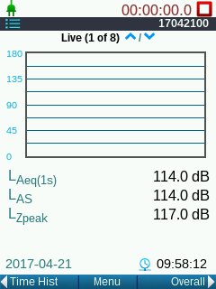Signal Path Test Verification Steps
   1. Run measurement, press **RUN** or click on  icon (needed to activate output on the AC/DC Output).
   2. Verify signal levels on **Live (1 of 8)**[6] with a tolerance ±1 dB:
      * LAeq(1s) = 114.0 dB
      * LAS = 114.0 dB
      * LZpeak = 117.0 dB
   3. Verify on the instrument’s LCD and on G4.
   4. Verify that the DC Output reading on the voltmeter a voltage of 1.140 V, ±0.03 (1.110 to 1.170 Vdc)
   5. 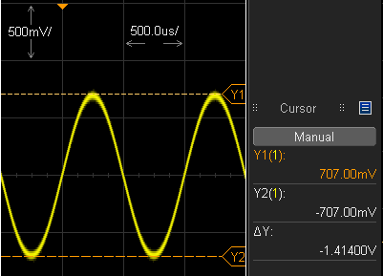Verify that the waveform on the oscilloscope has these characteristics:
      * The AC output will have
        + a sine wave with no clipping
        + DC offset less than ±0.1 V
        + a period of 1 ms
        + a peak-to-peak amplitude of 1.41 volts ±15% (1.6 to 1.2 Vpp)
   6. 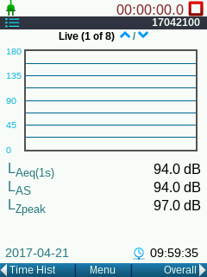Set the function generator amplitude to 0.05 volts rms
   7. Verify signal levels on **Live (1 of 8)** with a tolerance ±1 dB:
      * LAeq(1s) = 94.0 dB
      * LAS = 94.0 dB
      * LZpeak = 97.0 dB
   8. Verify that the DC Output reading on the voltmeter a voltage of 0.94V, ±0.01 (0.950 to 0.930 Vdc)
   9. Setup for **+20dB Gain** signal chain test
      * 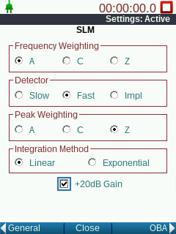Press **TOOLS** key
      * Highlight **Setup Manager,** press **ENTER**
      * Press **RIGHT SOFT** key twice
      * Use the touchscreen[7] to check **+20 dB Gain**
      * Press the **Center SOFT** key to close
      * Press **ENTER** to confirm changes
      * Press **MIDDLE SOFT** key to close settings (after label has changed back to “Close”)
   10. Adjust the AC Output setting to **Out +20 dB** (use G4 or the keyboard):
       * Activate **TOOLS** key (or  system menu on G4)
       * Activate **System Properties**
       * Navigate to **Preferences**
       * Select **Out +20dB** as the option for **AC Output**
   11. Verify signal levels on **Live (1 of 8)** with a tolerance ±1 dB:
       * LAeq(1s) = 94.0 dB
       * LAS = 94.0 dB
       * LZpeak = 97.0 dB
   12. Verify that the waveform on the oscilloscope has these characteristics: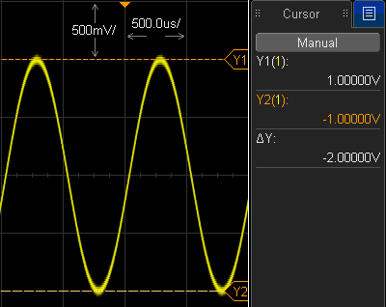
       * The AC output will have
         + a sine wave with no clipping
         + a peak-to-peak amplitude of 1.98 volts ±15% (1.68 to 2.28 Vpp)
3. USB Flash Drive Test
   1. Plug the USB flash drive into the instrument’s USB host.
   2. Press **TOOLS** key, highlight **Data File Manager** and press **ENTER**.
   3. Verify that the pre-saved data file on the USB flash drive is shown in the file list with “**USB**” shown on the right side of the line similar to the image here:

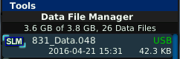

* 1. Press **Close** and remove the flash drive.

1. 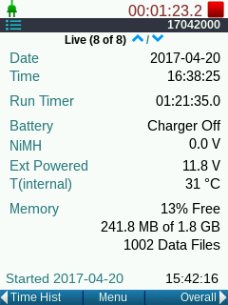Power and Temperature Verification Tests
   1. Navigate to the **Live (8 of 8)** status page
   2. Verify the following:
      * Shows Date *Current date*
      * Shows Time *Current time*
      * Shows Battery **Charger Off**
      * Shows **NiMH 0.0 V**
      * Shows (see below) **Ext Powered 11.8 V**
      * Shows (see below) T(internal) **31 °C**
   3. Verify expected values:
      * Power supply voltage 12.0 V ±4% (11.5 to 12.5 V)
      * Board temperature displayed is

+20 dg C (+68 dg F) to +35 dg C (+93 dg F)[8]

1. Verify battery charging and USB power functionality
   1. Connect leads from 831C Battery Test Pack to battery terminals of J4 observing the polarity shown
   2. Ensure test fixture contains 4 NiMH rechargeable batteries (0277.0004)

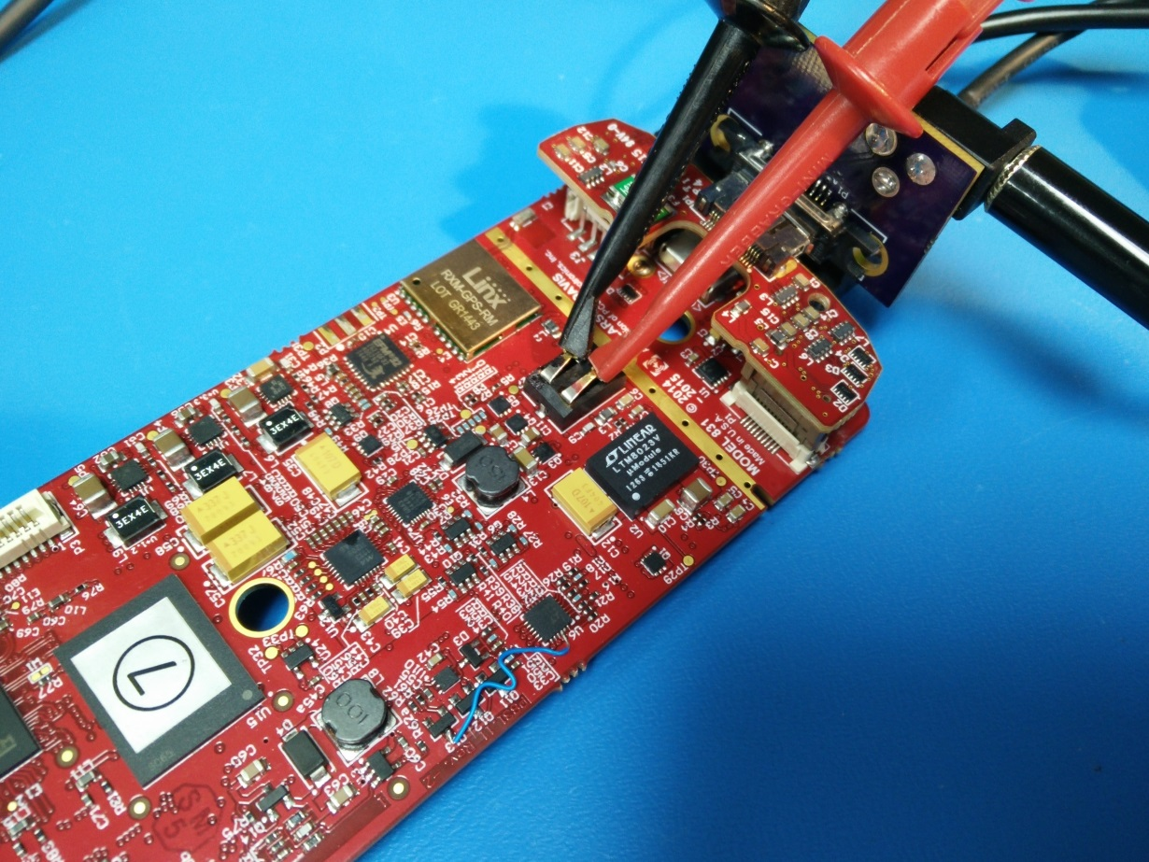

* 1. 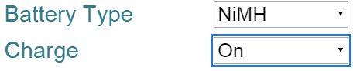Turn ON charger (default may be NiMH & ON)
     + Navigate to:
       - TOOLS 
       - System Properties 
       - Power dialog
     + Ensure **Battery Type** is set to **NiMH**
     + Ensure **Charge** is set to **On**
     + **Close** and **Save** the **System Properties**
  2. Verify that the power supply current increases to about 500mA
  3. Verify that the charger is **Charging** as shown on the Live Status page as shown at the right

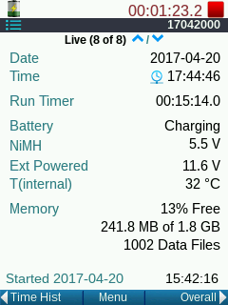

* 1. Connect USB mini cable to PC to supply USB power
  2. Turn OFF the bench supply and verify that the charger is still **Charging** and is now **USB Powered** as shown at the right

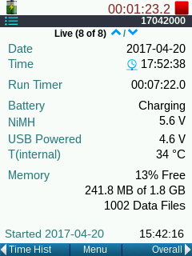

* 1. Disconnect the USB mini cable and verify that the unit continues to run using only battery power and is now **Batt Powered** as shown at the right

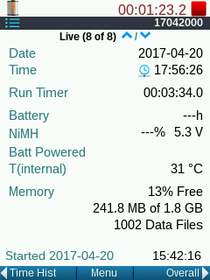

* 1. Turn instrument OFF by holding the **ON/OFF** key pressed for 3 seconds
  2. Disconnect the 831C Battery Test Pack from the unit

# RECORDS

* Complete and turn in the technician inspection and rework report.

# DISTRIBUTION

* Manufacturing and contract manufacturer.

# FIXTURES and TOOLS

## Construction of 831C Display for Test

A test display is used to determine the instrument’s user interface functionality. Care should be taken when handling the display to protect it from ESD (Electro–static Discharge) and to prevent damage to the FFC (flat flexible cable).

The display is EDT p/n ET028003DHU or Larson Davis p/n 1895.0024.

Cover the back of LCD with polyimide film or polyester film insulating tape so that all exposed conductive items are covered and will not short to components on the bare board.

## Construction of Keypad emulator tool

A keypad emulator tool will be provided that is used to “push” the buttons on the keypad. When the A831.11 board is not in a case with an elastomeric keypad, a substitute tool must be used to make electrical connection between the two serpentine circuits of each key.

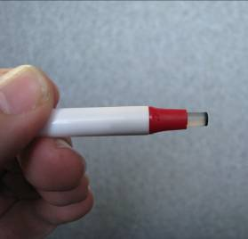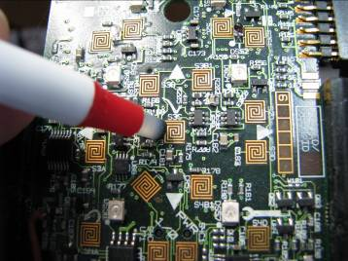

The pictures at the right show the tool and its operation.

The tool can be manufactured by cutting off a button element that contains a conductive carbon pad from a keypad, and pushing it into modified stick pen as shown above.

## Configuring USB Flash Drive with Data File

* 1. This step is only performed once, to load an instrument data file onto a USB flash drive as used in **USB Flash Drive Test** above.
  2. Plug a blank FAT formatted USB Flash Drive into the 831C’s USB host port.
  3. **RUN** unit for 10 seconds, press **STOP** twice to STOP and STORE data. The “Save File?” message comes up, press **ENTER** for Yes.
  4. Press **TOOLS** , highlight **Data File Manager** , press the right soft key for **Menu**, highlight **Copy File to USB** and press **ENTER**.
  5. The light on the USB flash drive should light up. Wait until the light goes off to continue.
  6. Close out by pressing the center soft key **Close**.
  7. Verify that the data file was recorded using instruction in **USB Flash Drive Test** above.
  8. Press **Close** and remove flash drive.

## Construction of 831C Battery Test Pack

**Caution:**

**Do not short battery leads. Damage or fire can occur due to high current potential.**

Be extra careful when storing this pack and when attaching to the instrument’s connector.

Construct a battery pack like shown this photo:

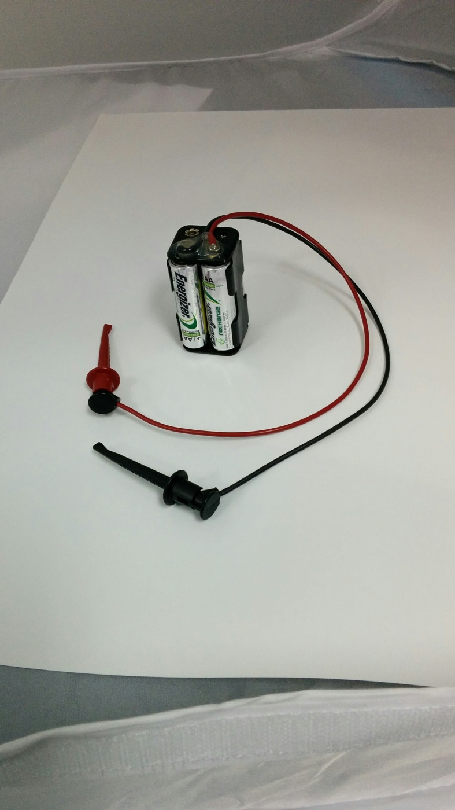

Suggested Parts:

|  |  |  |
| --- | --- | --- |
| Part Number | Manufacturer | Description |
| [3781-24-0](http://www.digikey.com/product-detail/en/pomona-electronics/3781-24-0/501-1064-ND/603372) | [Pomona Electronics](http://www.digikey.com/en/supplier-centers/p/pomona-electronics) | PATCH CORD MINGRABBR TST CLP 24" BLACK (USE ½) |
| [3781-24-2](http://www.digikey.com/product-detail/en/pomona-electronics/3781-24-2/501-1065-ND/603373) | [Pomona Electronics](http://www.digikey.com/en/supplier-centers/p/pomona-electronics) | PATCH CORD MINGRABBR TST CLP 24" RED (USE ½) |
| [BH24AAL](https://www.digikey.com/product-detail/en/mpd-memory-protection-devices/BH24AAL/BH24AAL-ND/66753) | [MPD (Memory Protection Devices)](https://www.digikey.com/en/supplier-centers/m/memory-protection-devices) | HOLDER BATT 4-AA CELLS SLDR LUGS |

# REVISION HISTORY

|  |  |  |  |  |
| --- | --- | --- | --- | --- |
| DCO # | REV | DATE | INITIALS | CHANGES MADE |
| 1701 | A | 04/27/2017 | AJR | Initial version, a simplification of D0001.8399 for use by Contract Manufacturer. |
|  | B | 06/23/2017 | AJR | Fixed Ctrl+Shift+K command.  Added section E to format microSD flash card.  Increased AC output voltage tolerance to ±15%. |
| 1741 | C | 08/08/2017 | AJR | Changed section K.4. limit to 1.140 V, ±0.03 from 1.140 V, ±0.01 to account for DAC and output tolerances. |
| 1922 | C1 | 09/16/2019 | AJR | Graphic format and positioning corrected in section N |
|  |  |  |  |  |

1. See Construction of 831C Display for Test for LCD construction details.
2. See [Construction of Keypad emulator tool](#Construction of Keypad emulator tool) for Keypad tool construction details.
3. See [Configuring USB Flash Drive with Data File](#Configuring USB Flash Drive with Data File) for Keypad tool construction details.
4. See [Construction of 831C Battery Test Pack](#Construction of Fixture, 831C Battery Test Pack) for Keypad tool construction details.
5. The debug cable and terminal program are optional but are helpful in seeing error messages and troubleshooting boot-up issues.
6. The number of display pages, i.e. the “8” in the example “Live (1 of 8)”, can vary based on settings and enabled options so the total pages may be different than illustrated.
7. Use the touchscreen to set this option and to verify that the touchscreen is functional.
8. To observe a change in sensor readings, spray U75 briefly with “Freeze Mist”.