MET/TEAM Receiving and Job Creation

1.0 SCOPE & APPLICABILITY

This instruction covers receiving equipment that is calibrated externally or outside of the MET/CAL test environment. This process enables the use of traceable standards within the MET/CAL system, and ensures that their calibration certificates and calibration dates are tracked by MET/TEAM.

2.0 RESPONSIBILITY

Logistics has the primary responsibility to receive equipment and update the calibration information in MET/TEAM when equipment is delivered to Larson Davis from an external laboratory. Occasionally, Production personnel will perform this procedure for internally calibrated equipment that do not use MET/CAL Procedures (i.e. LD 2900, CAL291, etc.).

3.0 MATERIALS, TOOLS, & EQUIPMENT

Computer with connection to MET/TAM server

4.0 PROCEDURE

4.1 Receiving Equipment into MET/TEAM
Log in to MET/TEAM: http:\\metteam.larsondavis.com:35853

In the Workflow menu, select “Receiving”

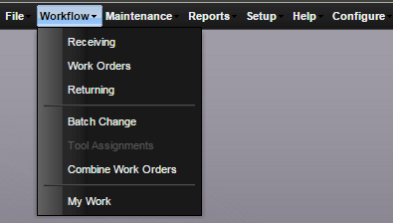

Enter the search parameters to find the asset you wish to receive. Double click on the asset you wish to receive to add it to the receive list.

Note: An asset cannot be received if there are any open work orders for it. All work orders must be returned prior to receiving an asset again.

Note: This process allows you to receive multiple assets simultaneously, e.g. an HP 3458A and a BK Precision 1856D can be added to the receive list at the same time.

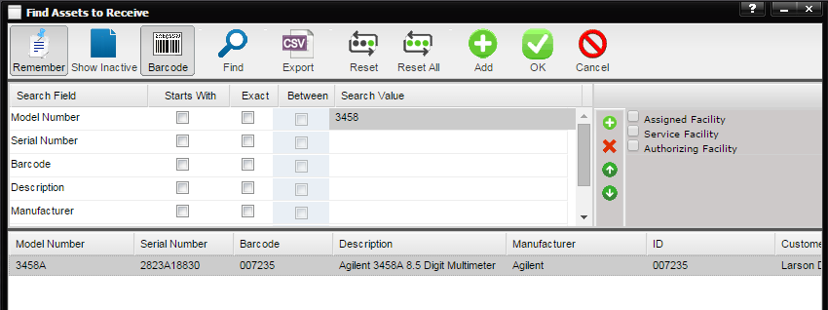

Once all of the assets you wish to receive are added to the list at the bottom of the window, click “OK”.

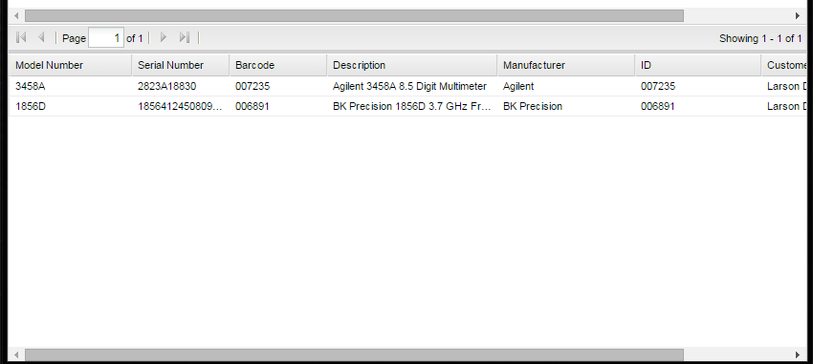

A new window will appear with the information that will be inserted into a new work order. There is generally no need to make any changes to the information in this window. Click the “Process” icon to continue.

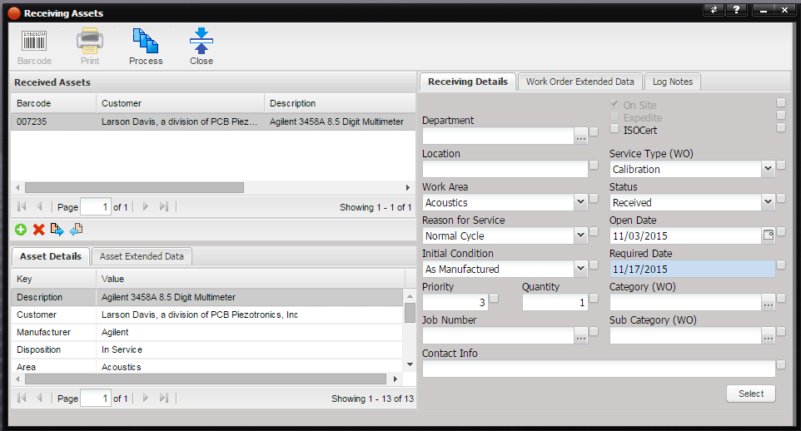

Once MET/TEAM has successfully processed the work orders, click “Close” on the window.

4.2 Returning the open Work Order.
Find the newly created Work Order for the equipment you are updating. The Work Order Status should be “Received”

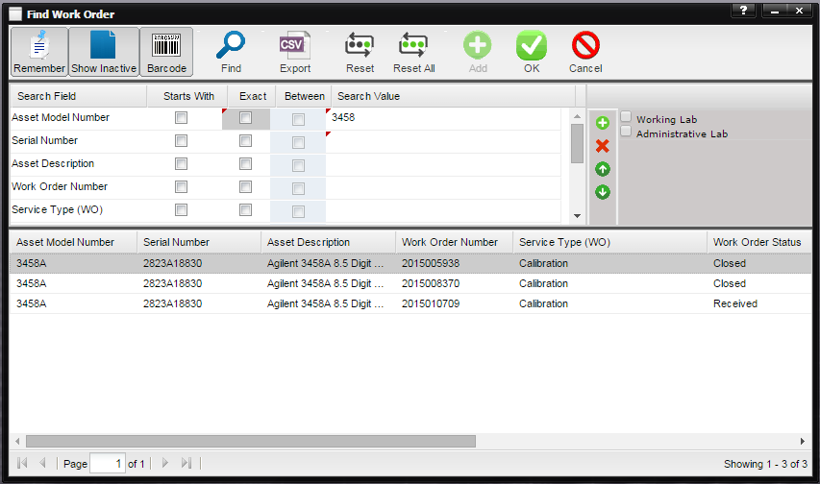

Double-click on the open Work Order to bring up a new window to edit the Work Order.

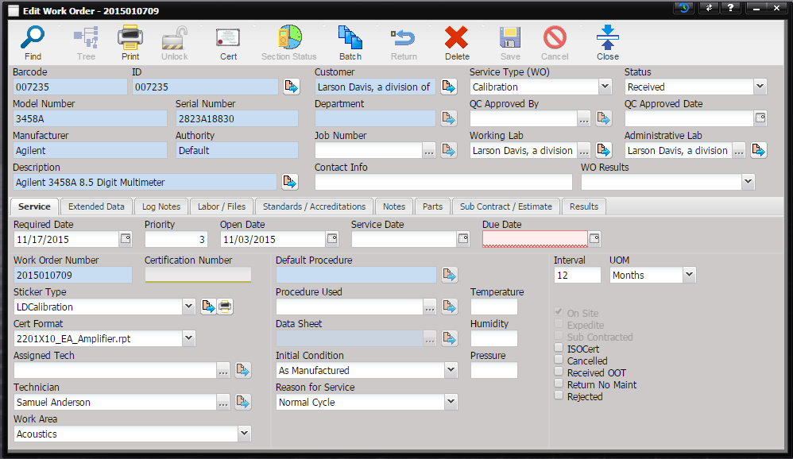

The “Due Date” field will be marked in Red. Update this field with the calibration due date on the calibration certificate provided by the external laboratory. Also enter the “Service Date” with the date the calibration was performed by the external laboratory.

Change the Status on the Work Order to “Complete” and click “Save”.

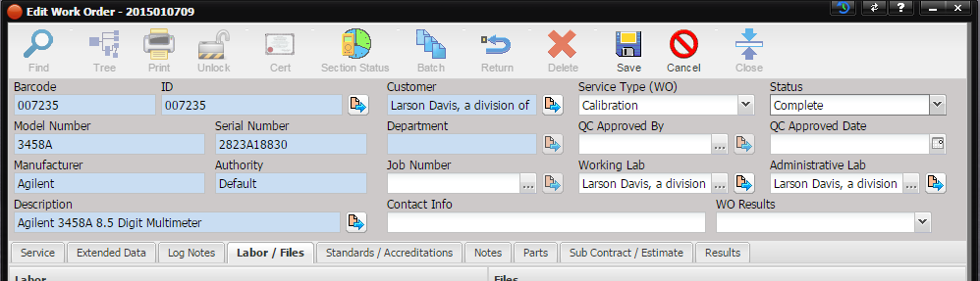

Click “Return”.

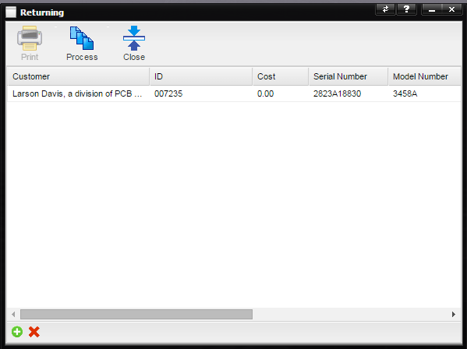

The Work Order window will be closed, and a new “Returning” window will open. You can return multiple Work Orders at once. To add a Work Order, simply click on the green plus sign on the bottom left of the window. Once all of the Work Orders you wish to close are in the list, click “Process”.

4.3 Updating Scheduled Services
Search for the Asset you just received in MET/TEAM.

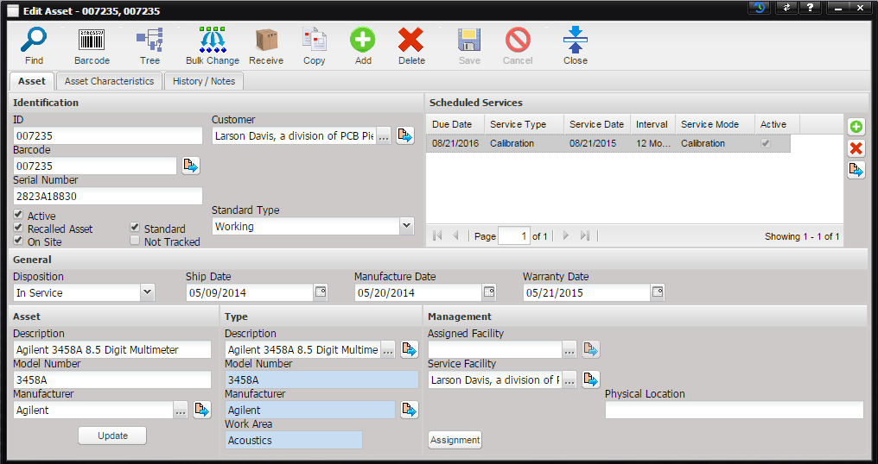

When the work order is returned it should update the Scheduled Services dates. Verify that the dates have been updated.
If they haven’t, double-click on the item in the “Scheduled Services” field that is marked “Calibration” under “Service Type”.

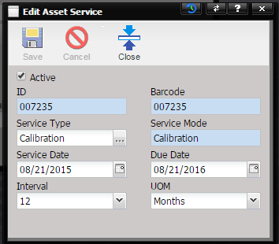

A new window will appear. Update the Service Date and Due Date to match the calibration certificate. Click “Save”.

5.0 EVALUATION

If any adjustments were made to the instrument by the external calibration laboratory, it is beneficial to make note of these adjustments. Please notify the Metrology Engineer, who will add appropriate notes to the Work Order and other records as needed.

6.0 RECORDS

QC maintains an electronic copy of all test data and certificates.

7.0 REVISION HISTORY

DCO # | REV | DATE | INITIALS | CHANGES MADE
1585 | A | 11/3/15 | SJA | Initial Release
1854 | B | 7/27/18 | JGG | Removed attaching electronic copies of the certs

