Sierra Wireless Gateway Configuration Instructions

PURPOSE AND SCOPE
This document provides the detail and instruction necessary to configure a Sierra Wireless cellular gateway for use in a NoiseTutor system.

LIMITATIONS
This instruction is limited to the Sierra Wireless cellular gateways.

AFFECTED DEPARTMENTS
Manufacturing

REFERENCE DOCUMENTS
D0001.6074 Sierra Wireless Bulletin Mirai Malware notice

RESPONSIBILITIES & AUTHORITY
The technician has the following responsibilities and authority:

- Configure a Sierra Wireless cellular gateway to be used with a NoiseTutor, EPS043, etc.

SAFETY PRECAUTIONS
Follow general electrical precautions for working with energized, low voltage circuits.

EQUIPMENT & MATERIALS

- A PC with a web browser, possibly the FitPC-NT installed into a NoiseTutor station.

- A Network cable, possibly already installed in the NoiseTutor station.

- A 12V DC power supply, possibly the battery and power supply in the NoiseTutor station.

- A cellular antenna, possibly already installed in the NoiseTutor station.

PROCEDURES

Connect the gateway

Attach an antenna to each SMA port on the gateway with an antenna symbol. The cellular modem can be damaged if operated without an antenna.

Attach the network cable from the PC to the gateway.

Power cable options:

Attach the already incorporated cable of the CBL201 NoiseTutor power harness.

Adjust a DC power supply to 13V and connect the supplied power cable’s red and white wires to positive and the black wire to negative.

Turn on the power supply and allow the gateway to boot, approx. 1 to 2 minutes, until the Signal light is no longer blinking red.

Login to the gateway

Open a web browser.

Enter http://192.168.13.31:9191 into the address bar.

Login as “user” with default password “12345”, see figure 1.

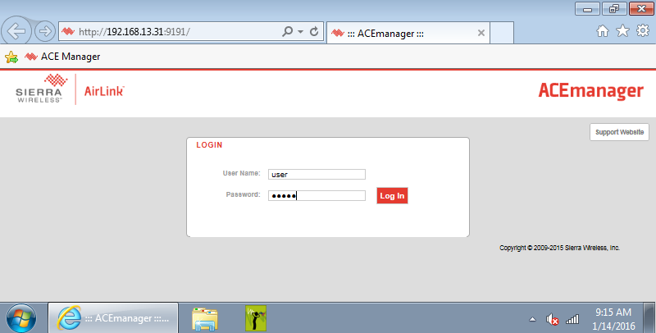

Verify current gateway firmware

Take note of the version of firmware currently on the device.

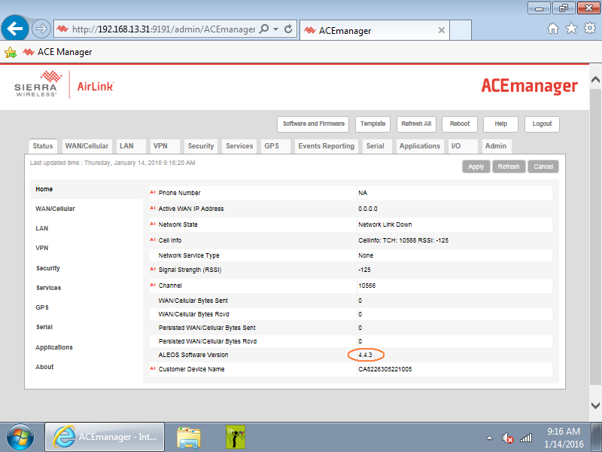

Check for the latest firmware version at http://source.sierrawireless.com/ select the proper device and follow the link Firmware Package.

If needed, download and update the firmware according to the manufacturer’s instructions and log back in when it has rebooted.

Set User Password

Only change the password of devices sent as part of a system.
For devices sent alone include D0001.6074 Sierra Wireless Bulletin Mirai Malware notice with the device. Otherwise include the bulletin with the system documentation.

Click on the Admin tab.

Enter the default “12345” password in Old Password.

Enter “LD_NMSystem16” in both New Password and Retype Password.

Click Change Password.

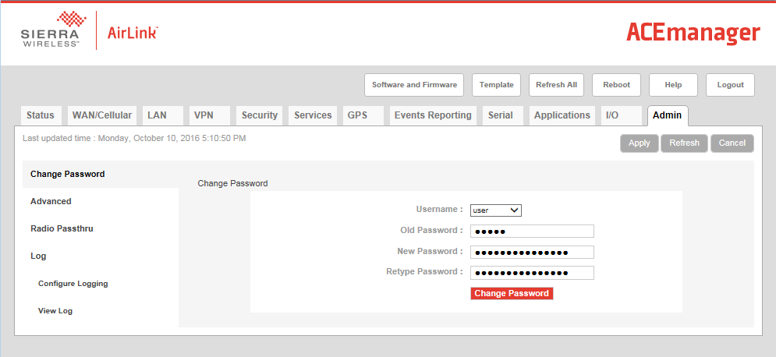

Set WAN/Cellular settings

Click on the WAN/Cellular tab.

On a single antenna configured gateways set RX Diversity to Disable. This disables the device from using a second antenna port that is not connected.

Expand the Advanced section and set Response to incoming Ping to Pass to Host.

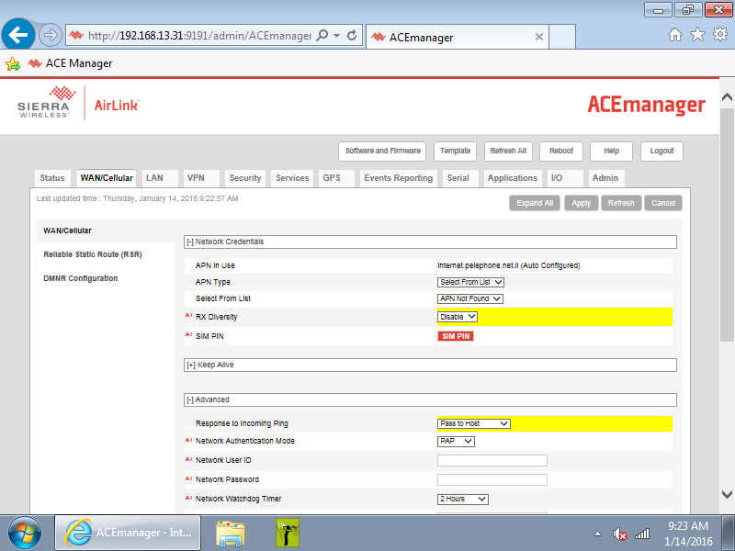

Click Apply.

LAN settings

Click on the LAN tab.

Click on the Ethernet section on the left.

Change the Ending IP to be the same as the starting IP. This ensures IP spoofing is blocked.

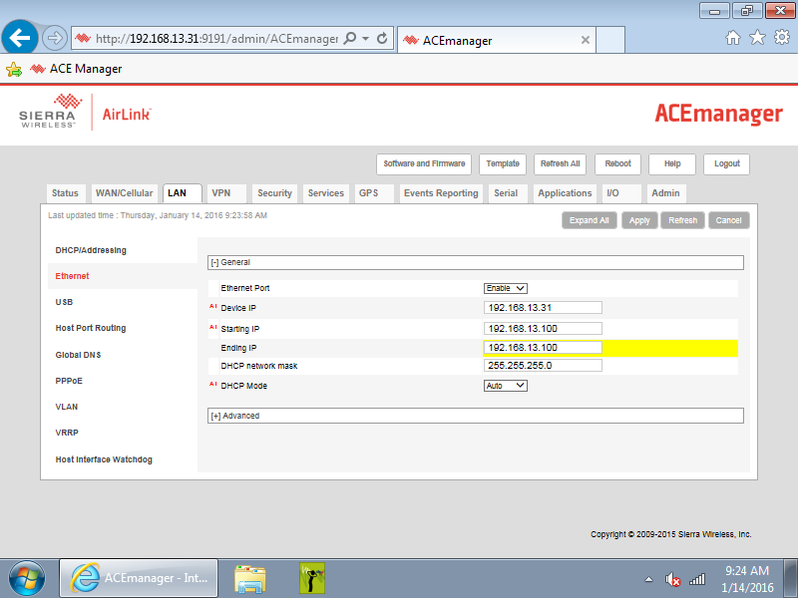

Click Apply.

Services – ACEmanager

Click on the Services tab.

Click on the ACEmanager section in the left pane.

Choose SSL Only for ACEmanager Access - OTA box.

Choose 9449 for the ACEmanager SSL Port box.

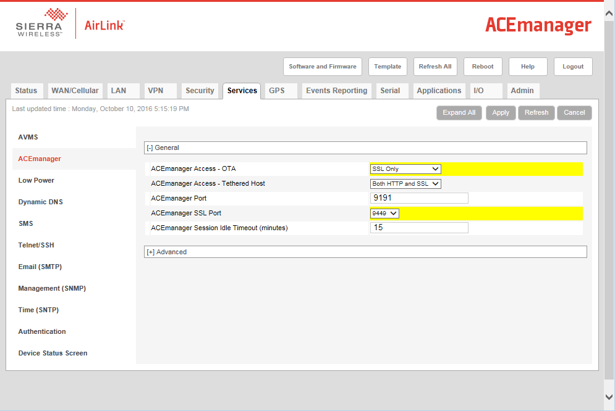

Click Apply.

Services – Low Power

Click on the Low Power section in the left pane.

Choose Low Voltage from the Low Power Mode box.

Enter the desired low voltage shutdown voltage without the decimal point

Click Apply.

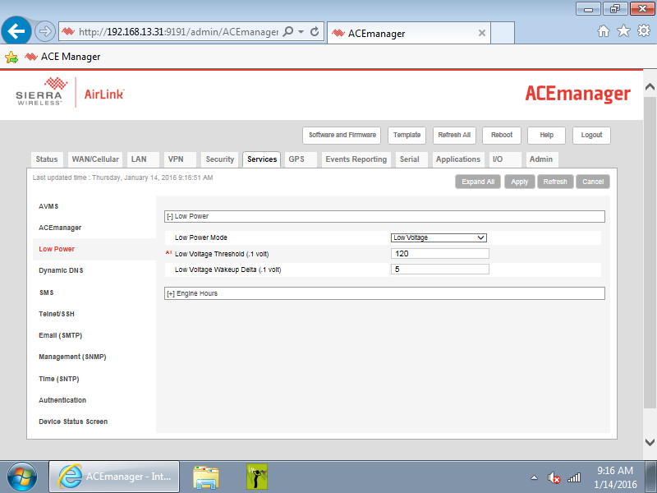
Battery type | Low Voltage Threshold | Entered value (.1 volt)
12.8V LiFePo3 battery | 12.0 V | 120
12V Lead Acid battery | 10.8 V | 108

Services – SMS

Click SMS section in the left pane.

From the SMS Mode box select Gateway Only.

Enter 17341 as the ALEOS Port.

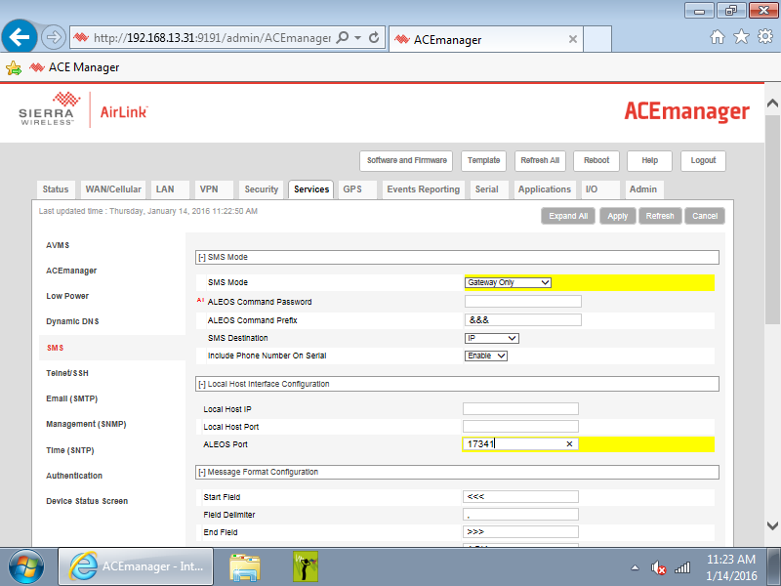

Click Apply.

GPS Settings

Click the GPS tab.

Click Global Settings on the left pane.

In the GPS Service box choose Disable. There is no GPS antenna attached to the gateway. Disabling the GPS service reduces power usage.

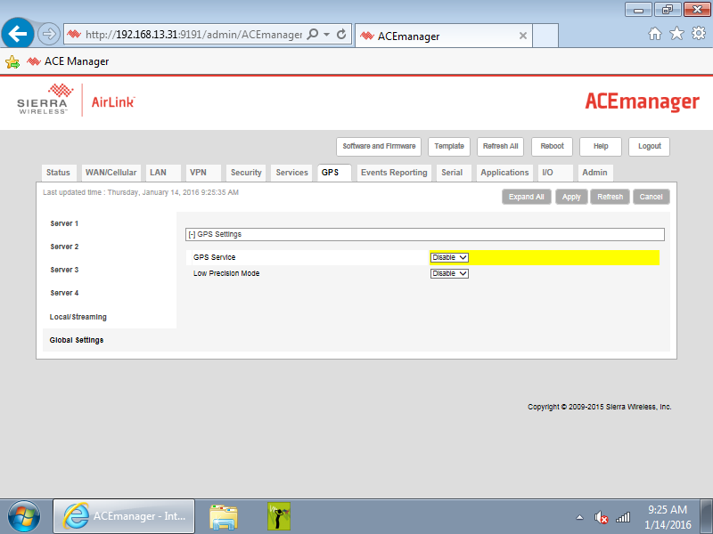

Click Apply

Reboot the gateway

Click the Reboot button.

Allow the gateway to save the applied settings and reboot.

RECORDS

- No records are necessary.

DISTRIBUTION
Instruction is available online in the “NoiseTutor” folder in the “Technician work instruction” folder in Document Control.

REVISION HISTORY
DCO # | REV | DATE | INITIALS | CHANGES MADE
1651 | A | 11 Oct 16 | NR | Initial Release.

