PSA040/PSA043 Battery Charger Work Instructions

PURPOSE AND SCOPE
The purpose of this document is to provide the detail and instruction necessary to build up a PSA040 or PSA043 battery charger.

AFFECTED DEPARTMENTS
- Production

REFERENCE DOCUMENTS
- NA

RESPONSIBILITIES & AUTHORITY
The technician has the following responsibilities and authority:
- Verify compliance of the product under test to specification.
- Troubleshoot and correct product as required.
- Communicate concerns to Supervisor or Quality Assurance.
- Request management review of product concerns.
- Use proper ESD protective equipment.

SAFETY PRECAUTIONS
- Follow general electrical precautions for working with energized, low voltage circuits.

EQUIPMENT & MATERIALS
- Digital volt-ohm meter.
- Soldering iron on a LEAD FREE station.
- Heat gun.
- Engineering ruler with 0.1” increments.
- Safety glasses.
- QTY 1.0, 0195.0061, BATT CHARGER, LD ACID, 12V 3A BARE WIRES. (PSA040)
or QTY 1.0, 0195.0074, BATT CHARGER, LITHIUM, 12V 3A BARE WIRES. (PSA043)
- QTY 1.0, 1212.0022, ANDERSON POWERPOLE RECEP 15A RED.
- QTY 1.0, 1212.0023, ANDERSON POWERPOLE RECEP 15A BLACK.
- QTY 2.0, 1212.0025, ANDERSON POWERPOLE PIN CRIMP 15A.
- QTY 1.0, 1212.0026, ANDERSON POWERPOLE LOCK POST SINGLE.
- 7050.0022, HEAT SHRINK BLK 0.375 ID W/ ADHSV 3:1 (PSA040)
or 7050.0033, HEAT SHRINK, WHT 0.25” ID 2:1 NO ADHSV (PSA043).
- QTY 1.0, 3255.0007, LASER PRINT. SELF LAMIN. LABEL.

INSPECTION
- Inspect battery charger body and cabling to ensure there is no damage to it.
- Ensure that the model number on the charger body is “1205SRJ” for PSA040 or “Li1205SRJ” for PSA043.

Assembly Instructions
- Cut wires so length is 12”
- Strip back the sheath by 2.5” and cut the green wire off at the end of the sheath.
- Strip the wires back 0.25”.
- Add heat shrink (7050.0022 for PSA040 or 7050.0033 for PSA043) as shown in figure 1.
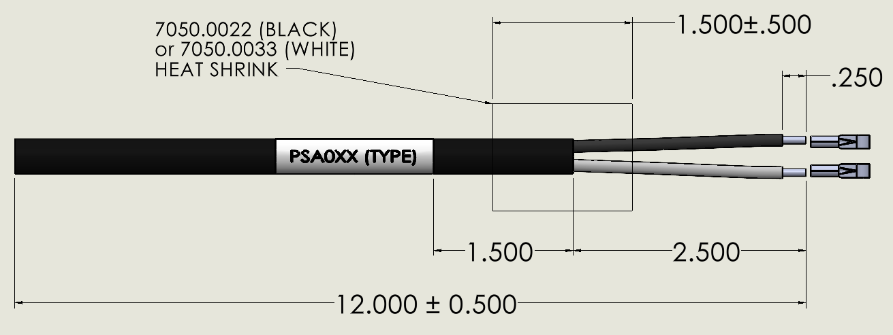
Figure 1: Prep work

- Crimp the pins to the bare wires.
- Assemble the Power Pole housing using the black housing, red housing, pin crimps, and locking post.
- The positive line (white) goes to the red housing; the negative line (black) goes to the black housing.
- Ensure the pin is pushed far enough into the connector to have it click into place.
- Label wire using 3255.0077 with text: “PSA040 (LEAD ACID)” or “PSA043 (LITHIUM)”. See Figure 3.

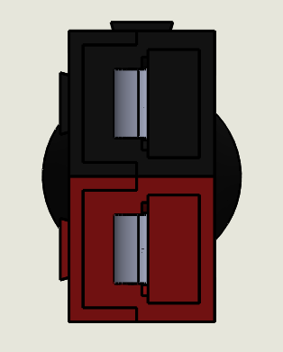
Figure 2: Pin Alignment

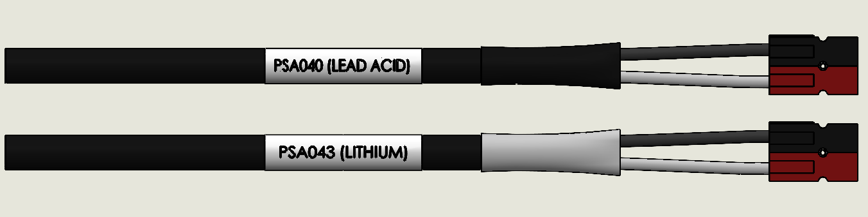Figure 3: Finished Assembly

Electrical Testing
- Power up battery charger.
- With a voltmeter, verify that output polarity is correct and that the output voltage meets the rated volts DC.

Records NA

DISTRIBUTION
Instruction is available online in the “Power Supplies” folder in the “Technician” work instruction folder in Document Control.

REVISION HISTORY
DCO # | REV | DATE | INITIALS | CHANGES MADE
ECO 4568 | A | 5/12/2017 | DWA | Initial Release
ECO 4620 | B | 8/22/2017 | DWA | Changed from 0195.0070 to PSA040
ECO 4629 | C | 10/9/2017 | DWA | Corrected the connector orientation
ECO  4643 | D | 11/2/2017 | DPW | Added length requirement to wires
ECO  4870 | E | 8/12/2019 | DCW | Added PSA043 to instructions

