AEC304 with Attached Preamplifier

- PURPOSE AND SCOPE

- The purpose of this document is to provide the detail and instruction necessary to ensure the compliance of the specified product to established specifications.

- The products covered by this procedure include:
- AEC304 with 377C13 and 426M11 either inside or outside of the AEC206
- AECM304 with 377C13 and 426M15 either inside or outside of the AECM206

- AFFECTED DEPARTMENTS

- Manufacturing

3.0 REFERENCE DOCUMENTS

- D0001.8204 ICP Preamp Test Procedure
- D0001.8400 AEC304 Ear Simulator Final Test

4.0 RESPONSIBILITIES & AUTHORITY

The technician has the following responsibilities and authority:
- Verify compliance of the product under test to specification.
- Troubleshoot and correct product as required.
- Communicate concerns to Supervisor or Quality Assurance.
- Request management review of product concerns.
- Use proper ESD protective equipment.

5.0 DEFINITIONS

6.0 SAFETY PRECAUTIONS

- Safety Glasses are required when soldering, lead clipping, or testing power supplies.
- Follow general electrical precautions for working with energized, low voltage circuits

7.0 EQUIPMENT & MATERIALS

- Computer with TMS 400B76 software

The following items are for reference to determine the sensitivity using the alternate method.
- ICP Power provided by the following or equivalent (e.g. 482C05 with 488A04)
- 2900 test system
- PRA951-L4
- CBL071
- BNC to BNC cables
- BNC Tee connector
- HP / Agilent / Keysight 34401A Multimeter
- CAL250
- ADP019 (outside of AEC206 / AECM206)
- ADP105 (inside of AEC206 / AECM206)

8.0 INSPECTION

9.0 INSTRUCTIONS

- Perform the Sensitivity test from the D0001.8400 test procedure with the AEC304 and certified preamp that will be paired together. (Preferred method; alternate method detailed at end of instructions.)

- Use the sensitivity value from the previous step and program the memory chip in the preamp using the 400B76 program by setting the fields to the appropriate values.

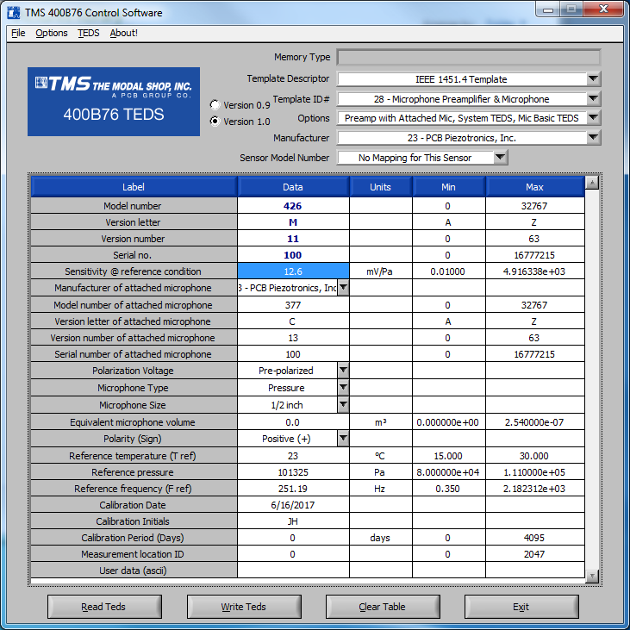

- The following steps are for reference as an alternate method to determine the sensitivity value.

  - Take the finished, certified preamp that will be used and tightly screw the AEC304 with microphone onto it

  - Connect the AEC304 / preamplifier assembly to the test station as shown below.
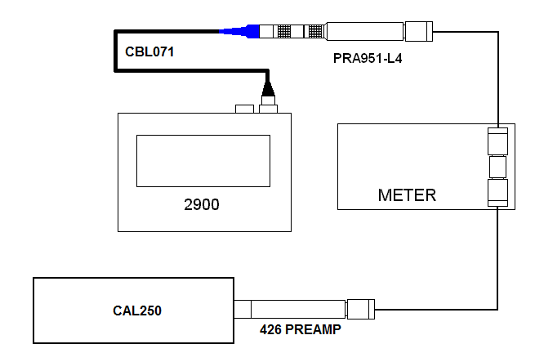

  - Let the setup sit for a few minutes to allow the preamp and microphone to fully stabilize.

  - Calculate the Loaded Circuit Sensitivity using the following steps.
    - You need the ACTUAL reading of your CAL250 that you are going to use in dB SPL.
    - Take that reading and minus 93.98 dB from it.
    - Divide that number by 20. This will be X in the next step.
    - Calculate 10 to the power of X ( 10^{X} ). This will be Pa in step 6.
    - Activate the calibrator and wait for the AC voltage on the Multimeter to stabilize. This value will be V in the next step.
    - Divide V by Pa ( V/Pa ). This will be the sensitivity in Volts per Pascal.
    - Convert to mV/Pa by multiplying by 1000.
    - Multiply by 0.99 to correct for pressure (assuming 85 kPa static pressure). This is the number you will program into the memory chip in the preamp. To calculate the multiplier value do the following.
      - Take 101.3 and subtract the current static pressure in kPa (value shown above uses 85).
      - Times that number by -0.006 (microphone static pressure coefficient).
      - Divide the number by 20. This will be Y in the following step.
      - Calculate 10 to the power of Y ( 10^{Y} ).

- RECORDS

- Include in the database record of the AEC304 (or AECM304) a note with the model and serial number of the microphone and its paired preamplifier.
- Include in the database record of the AEC206 (or AECM206) a note with which AEC304 (or AECM304) preamplifier pair is which channel (left / right).

11.0 DISTRIBUTION

- Manufacturing

12.0 ATTACHMENTS

13.0 REVISION HISTORY

DCO # | REV | DATE | INITIALS | CHANGES MADE
 | A | 6/30/17 | JH | Initial release

