AEC206 ISOLATION TEST

1.0 INTRODUCTION

The purpose of this document is to provide the detail and instruction necessary to ensure the compliance of new and customer service AEC206 units, and ensure that the testing method is in accordance with ISO 4869-3. All instructions contained in this procedure pertain to all models of the AEC206.

2.0 DESCRIPTION

This document outlines the procedure for testing the insertion loss of the AEC206 with isolation cups and it is the responsibility of the individual authorized to assemble and test the AEC206 to follow this procedure.

3.0 LIMITATIONS

The instructions apply to testing all models of the AEC206.

4.0 MATERIALS, TOOLS, & EQUIPMENT

Room with diffuse sound field, per ISO 4869-3
Mackie 824 Mk 2
Isolation Cups with Anechoic Foam
Isolation Test Clamp
2.5 mm Allen Wrench
PC with 5499.0039 RI test Software

5.0 PROCEDURE

5.1 AEC206 units are assembled according to current assembly drawing.

5.2 Test Setup

5.2.1 Turn on the LD2900.

5.2.2 Turn on the PCB Model 482C Series Signal Conditioner.

5.2.3 Insert the isolation cups on each side of the AEC206 head.

5.2.4 Insert the vent screws and tighten until snug.

5.2.5 Inside the testing room, place the assembled AEC206 on the stand, facing the direction indicated by the arrow on the floor.

5.2.7 Attach the LEFT ear BNC connector (labeled with BLUE color) to the BNC cable labeled “Left”. Attach the RIGHT ear BNC connector (labeled with RED color) to the BNC cable labeled “Right”.

5.2.8 Tighten the clamp over the two isolation cups.

5.2.5 Exit the room and shut the door.

5.3 Testing

5.3.1 Open RI Sound Field Program at C:\Dev\RISoundField (Shortcut can be created to desktop.)

5.3.2 Press the Start/Stop button (see below.)

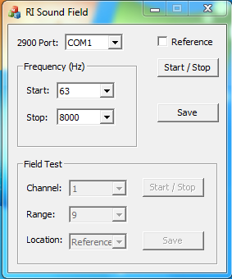

5.3.3 After the testing sweep is completed, enter the testing room, remove the vent screw from the bottom of the head, then remove the clamp and the isolation cups and set them to the side.

5.3.4 Exit the room and shut the door.

5.3.5 Click on the reference box to check it (see below).

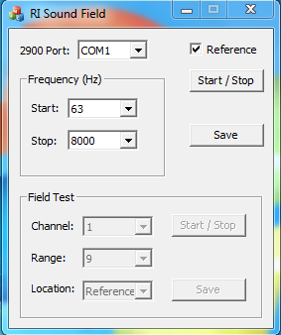

5.3.6 Press the Start/Stop button.

5.3.7 When the reference sweep is finished, press Save, name the file the serial number of the unit, and put the file in the following location:

R:\Provo\Data\CertData\AEC206

5.4 PAPERWORK

5.4.1 Begin the D0001.8375 METCAL procedure.

5.4.1.1 Run the D0001.8426 AEC206 import procedure for the desired serial number.

5.4.1.2 Select the certificate format AEC206_Cert.rpt and save the work order

5.4.1.3 Generate the certificate and save to the order folder in R:\Provo\Logistics\ORDERS\ORDERS

5.4.2 Save both AEC304 certificates to the order folder.

5.4.3 Save both 426M11 certificates to the order folder.

6.0 EVALUATION

This is a test process, no further evaluation required.

7.0 RECORDS

Test data and certificates of compliance are retained per the Quality Records Matrix D0001.1126-1.

8.0 REVISION HISTORY

DCO # | REV | DATE | INITIALS | CHANGES MADE
1721 | A | 7/5/2017 | DPW | INITIAL RELEASE
1749 | B | 9/13/2017 | DPW | AMP REMOVED FOR ROOM CHANGE

