**BAT015 Terminal Assembly**

**1.0 PURPOSE AND SCOPE**

The purpose of this document is to provide the detail and instruction necessary to perform the assembly of the SBAT015.01 and SBAT015.02 terminals for the BAT015.

**2.0 AFFECTED DEPARTMENTS**

Manufacturing

**3.0 REFERENCE DOCUMENTS**

* SDS Sheet for 3695.0001 Silver Epoxy

**4.0 RESPONSIBILITIES & AUTHORITY**

The technician is required to follow all safety precautions while performing this assembly.

**5.0 SAFETY PRECAUTIONS**

* Understand all warnings and requirements documented in the SDS prior to performing this procedure
* Safety glasses, gloves, and an apron are required when assembling the SBAT015.01 and SBAT015.02.
* Assembly must be done in a ventilated location.
* Avoid breathing dust/fume/gas/mist/vapors/spray.
* Eye contact or skin contact must be cared for.
* If eye contact occurs Rinse opened eye for several minutes under running water.
* If skin contact occurs immediately wash with water and soap and rinse thoroughly.
* If skin irritation or rash occurs get medical advice/attention.
* Any unused 3695.0001 Silver Epoxy that remains after assembly must be fully cured before disposal.
* Avoid release into the environment.

**6.0 EQUIPMENT & MATERIALS**

* Proper personal protective equipment
* 3695.0001 Silver Epoxy
* 6130.0024 Ring Terminal
* 5185.0001 Rivet Domed (FOR SBAT015.01 ASSEMBLY)
* 5185.0002 Rivet Flat (FOR SBAT015.02 ASSEMBLY)
* Cardboard
* A 1/8” punch

**7.0 ASSEMBLY**

Prep the cardboard to be able to place the rivets through the hole once assembled using the 1/8” punch.

* Wear all stated protective gear.
* Prepare the 3695.0001 packet by combining the two sides by rolling the packet until the material flows from one side to the other.
* Cut a corner off the packet after it is thoroughly mixed.
* Using a small amount of epoxy make a small bead ring around the ring and then seat the rivet to the ring.

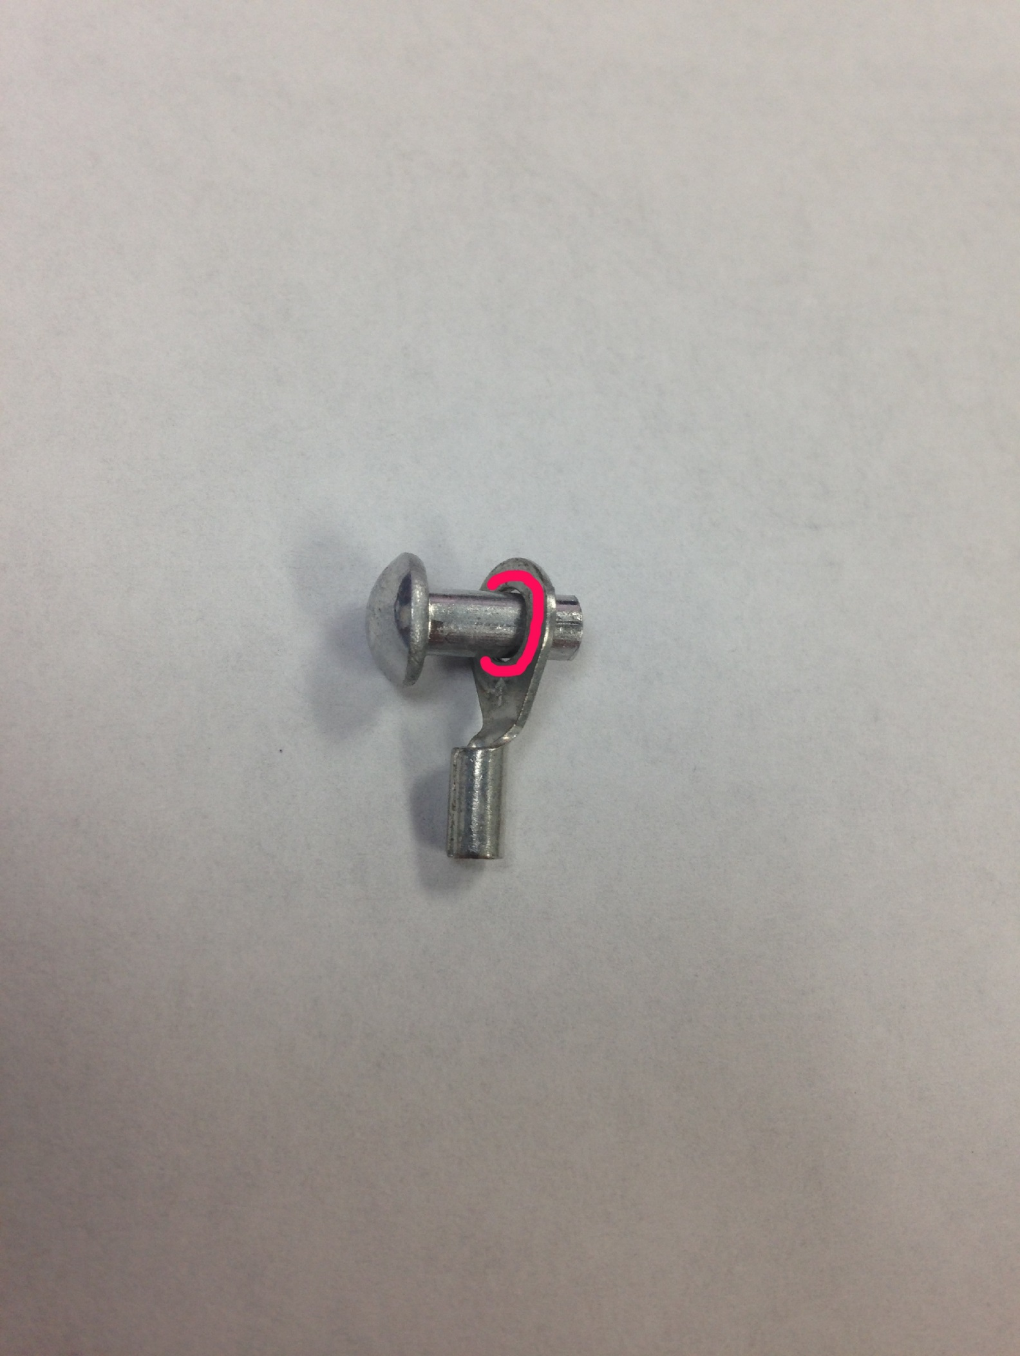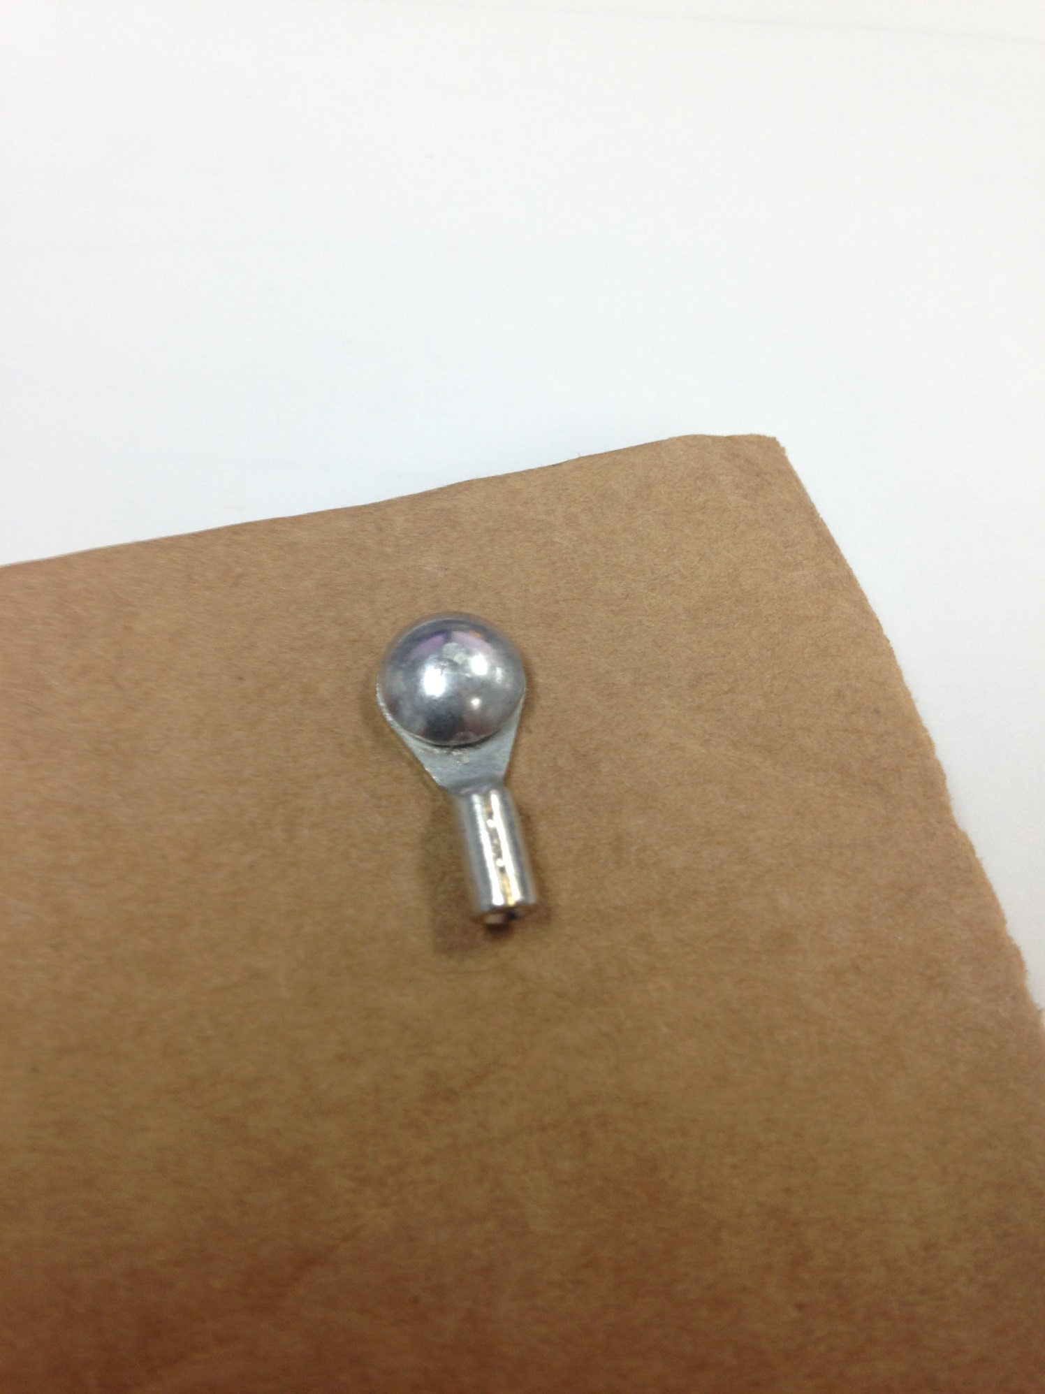

* Cleanup any epoxy that is on the head of the rivet as well on the underside of the ring.
* Push the rivet into the cardboard and leave to cure (24 Hours).

1. **VERIFY ASSEMBLY**

Remove the assembly from the cardboard and inspect the joint is well sealed. Ensure the bottom of the ring does not have any excess epoxy, and if there is, clean up the rivet for assembly into the BAT015.

1. **RECORDS**

There are no records

**10.0 DISTRIBUTION**

These instructions are available to employees electronically via the online Document Control area.

**11.0 REVISION HISTORY**

|  |  |  |  |  |
| --- | --- | --- | --- | --- |
| **DCO #** | **REV** | **DATE** | **INITIALS** | **CHANGES MADE** |
| ECO 4622 | 8/30/2017 | 5/19/05 | DWA | Initial Release |
|  |  |  |  |  |
|  |  |  |  |  |