**A730.01-IS and A730.12-IS CM Board Test Procedure**

# PURPOSE AND SCOPE

These instructions provide the detail necessary to ensure compliance of the Model 730 and Model 730-IS products to established specifications. The A730.01-IS or A730.12-IS board will be referred to hereafter as the “instrument.” The functional test for the A730.01-IS or A730.12-IS is performed using the T730.06 Test Fixture; see 8.0 FIXTURES and TOOLS for a description of the test fixture.

Please become familiar with the entire document before attempting to test the product.

This procedure has been optimized to minimize test time. This functional test when combined with a previous “Flying-Probe” board test provides a reasonable assurance of a fully function board assembly.

# REFERENCE DOCUMENTS

* A730.01-IS Main Board Schematic, Assembly Drawing and Bill of Manufacturing
* A730.12-IS Main IS Board Schematic, Assembly Drawing and Bill of Manufacturing
* A730.06 Test fixture Schematic, Assembly Drawing and Bill of Manufacturing

# EQUIPMENT & MATERIALS

* Multi-Meter with ≥4 ½ digits, 0.1% DC accuracy, 10MΩ input resistance (used to verify fixture’s calibration)
* Frequency counter capable of measuring 32,768.0 Hz and 12MHz with 50ppm accuracy
* Bench Power Supply, 6V & 3A capable
* Any additional cables or adapters that may be needed (i.e. BNC to BNC, leads for voltmeter, etc.)
* Test Fixture Larson-Davis T730.06
* Wireless Charger Pad with AC power adapter and a switchable power strip
* Segger J-Link BASE (PN 8.08.00) with TagConnect debug cable

# INSPECTION

1. Before testing the board, visually inspect and correct component loading, polarity and missing parts. Note and repair obvious solder defects.
2. This test procedure relies on a previous “Flying-Probe” board test to ensure connectivity to connectors and proper component loading.

# INSTRUCTIONS

1. Setup fixture and test equipment
   1. Set the fixture’s POWER switch to OFF.
   2. Setup power supply
      * Adjust output voltage to be 6 volts, ±0.1 V
      * Set current limit to supply 2A
      * Connect power supply to the fixture with Banana plug cable[s] using the proper polarity (Red terminal is positive and Black is negative)
   3. Setup function generator
      * Sine wave output
      * Frequency of 1000 Hz
      * Amplitude of 0.5 Vrms (test fixture provides a 50Ω load)
      * No offset
      * Connect to fixture with BNC to BNC cable
   4. Set the **AMPLITUDE** switch on the fixture to -20dB (down)
   5. Plug in the Wireless Charger Pads’ power adapter to a switched power strip that is turned off
   6. Configure the Bluetooth module programming connection
      * Connect the J-Link to the computer with its USB cable
      * Connect the TagConnect cable to the J-Link
   7. Configure the Bluetooth module programming software
      * Ensure that the three Bluetooth program image files are available (from LD):
        + “ble_softdev.hex”
        + “secure_bootloader_uart_mbr_pca10040.hex”
        + “ble_app.hex”
      * Ensure the **nRFgo Studio** program is installed (available from [NordicSemi.com](https://www.nordicsemi.com/Software-and-Tools/Development-Tools/nRFgo-Studio/Download))
      * Run the program and verify that J-Link is available in the **Device Manager** pane
   8. Periodically as needed, prior to testing a batch of A730.01 panels, verify that the test points on the test fixture are set correctly per this table:

*(Turn on the fixture’s power switch to verify TP voltages)*

Table 1 – Pre-Test Fixture Test Point Verification Voltages

|  |  |  |  |  |
| --- | --- | --- | --- | --- |
| **Test Point** | **Supply Name** | **Nominal (V)\*** | **Low Limit (V)\*** | **High Limit (V)\*** |
| **TP11** | HighLimit_V+1.2 | **1.199** | 1.187 | 1.211 |
| **TP12** | LowLimit_V+1.2 | **1.160** | 1.148 | 1.171 |
| **TP21** | HighLimit_V+1.8 | **1.824** | 1.806 | 1.842 |
| **TP22** | LowLimit_V+1.8 | **1.744** | 1.727 | 1.762 |
| **TP31** | HighLimit_V+5 | **2.596** | 2.570 | 2.622 |
| **TP32** | LowLimit_V+5 | **2.235** | 2.213 | 2.257 |
| **TP41** | HighLimit_V+2.8 | **2.857** | 2.828 | 2.885 |
| **TP42** | LowLimit_V+2.8 | **2.735** | 2.707 | 2.762 |
| **TP51** | HighLimit_Current | **1.596** | 1.588 | 1.604 |
| **TP52** | LowLimit_Current | **0.050** | 0.0498 | 0.0504 |

*\* Table value have been adjusted for 10MΩ loading of the voltmeter.*

1. Attach test boards to the fixture

The images below show the panel insertion and closure:

* 1. Turn off the bench supply

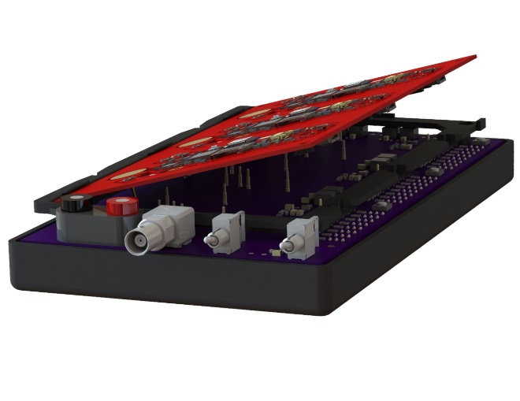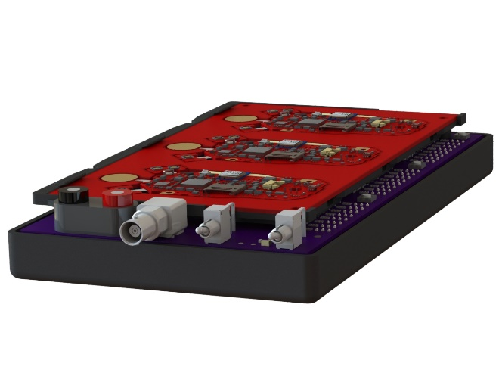

Figure 1 – T730.06 Fixture in the Insertion and Attached Positions

* 1. Put the panel of A730.01 boards with the top edge in the fixture slots at the back and lower onto the male connectors with the proper alignment
  2. Verify that pogo contacts mate with test points between panel and fixture, they are held in contact with the A730.01 with the friction of the board to board connectors

1. Verify instrument’s power supplies in the **Off** state
   1. Turn the fixture’s **POWER** switch to ON
   2. Verify Status LEDs for each board are as shown here:

|  |  |  |  |  |  |  |  |  |
| --- | --- | --- | --- | --- | --- | --- | --- | --- |
|  | **V+2.8_RTC** | **V+2.8_Sys** | **V+2.8** | **V+5ang** | **Va+1.8** | **V+1.2** | **VChg_In** | **Current** |
| **High** | ● | ● | ● | ● | ● | ● | ● | ● |
| **Normal** | ● | ● | ● | ● | ● | ● | ● | ● |
| **Low** | ● | ● | ● | ● | ● | ● | ● | ● |

* 1. If any **High** LED is lit there is an over voltage or over current issue. If any of the **Normal** LEDs that should be off (shown as a grey dot) then a supply is on that should be off. These are failures and need to be resolved before proceeding.

1. Verify instrument’s power in the **On** state
   1. Turn ON each instrument’s power by pressing the **Power Button Actuator** (observe that the tri-color LED DS4 on each board is **GREEN** for a couple of seconds while the version 1.010 and newer MCU firmware boots).
   2. Verify power supply status LEDs for each board per this table:

|  |  |  |  |  |  |  |  |  |
| --- | --- | --- | --- | --- | --- | --- | --- | --- |
|  | **V+2.8_RTC** | **V+2.8_Sys** | **V+2.8** | **V+5ang** | **Va+1.8** | **V+1.2** | **VChg_In** | **Current** |
| **High** | ● | ● | ● | ● | ● | ● | ● | ● |
| **Normal** | ● | ● | ● | ● | ● | ● | ● | ● |
| **Low** | ● | ● | ● | ● | ● | ● | ● | ● |

* 1. If there are faults indicated by High RED LEDs being on, these are the test points and limits that are monitored:

|  |  |  |  |
| --- | --- | --- | --- |
| **Test Point** | **Supply Name** | **Low Limit (V)** | **High Limit (V)** |
| **TP1** | V+5ang | 4.48 | 5.20 |
| **TP3** | V+2.8RTC | 2.74 | 2.86 |
| **TP7** | V+2.8SYS | 2.74 | 2.86 |
| **TP8** | V+2.8 | 2.74 | 2.86 |
| **TP9** | Va+1.8 | 1.76 | 1.84 |
| **TP10** | V+1.2 | 1.18 | 1.22 |

Table 2 – Test Point Voltage Limits for the A730.01

*Caution: Use care while probing test points so that the probe does not short to adjacent circuits.*

1. Verify input signal path
   1. With the **AMPLITUDE** switch in the -20dB (down) position verify that the tri-color LED DS4 on each board is **GREEN** to show a normal signal input

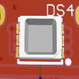

* 1. With the **AMPLITUDE** switch in the 0dB (up) position verify that the tri-color LED DS4 on each board is **ORANGE** to show a high signal input



* 1. If DS4 is **BLUE** then there is no signal detected indicating a problem with the signal path or circuitry



* 1. If DS4 is **flashing RED**, alternately with one of the above colors, then there is a problem with U10 or Y1 operating at an incorrect frequency, therefore:



* + - Verify that TP12 measures a frequency of 32,768 Hz ±2 Hz
    - Verify that TP11 measures a frequency of 12 MHz ±600 Hz
    - Correct this issue before proceeding

*Note: DS4 indicates signal level in a test mode initiated when the Manufacturer’s Date is not set.*

*Note: Firmware version 1.030 or greater is required in 3100.0065 for frequency test functionality.*

1. Verify Wireless Charging
   1. Turn **ON** the power strip to the Wireless Charger
   2. Verify that green LED **DS3** on the A730.01 turns on
   3. Verify that the VChg_In LED status changes such that the LEDs now show:

|  |  |  |  |  |  |  |  |  |
| --- | --- | --- | --- | --- | --- | --- | --- | --- |
|  | **V+2.8_RTC** | **V+2.8_Sys** | **V+2.8** | **V+5ang** | **Va+1.8** | **V+1.2** | **VChg_In** | **Current** |
| **High** | ● | ● | ● | ● | ● | ● | ● | ● |
| **Normal** | ● | ● | ● | ● | ● | ● | ● | ● |
| **Low** | ● | ● | ● | ● | ● | ● | ● | ● |

* 1. Turn **OFF** the power strip to the Wireless Charger

1. Program Bluetooth module using nRFgo Studio (see example image below), repeat for each board on the panel

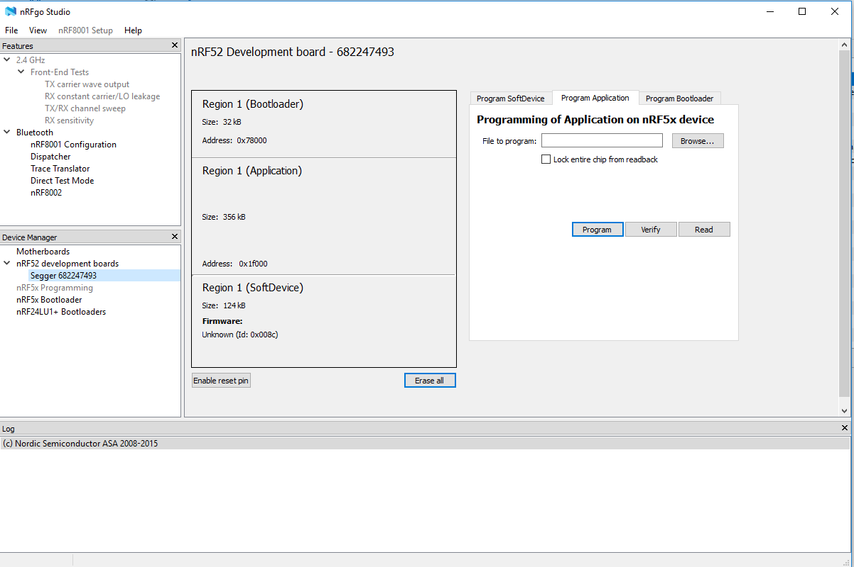

Figure 2 – Bluetooth Module Programmer Dialog

* 1. Connect the TagConnect probe end to J3 of the A730.01 board
  2. Activate the **nRFgo Studio** program
  3. Select the Segger J-Link item from the Device Manager list
  4. Select the “Erase All” button and ensure the log states “Erase completed”
  5. Select the **Program SoftDevice** tab
  6. Click the “Browse” button and select “ble_softdev.hex”
  7. Click the “Program” button and ensure the log says that “SoftDevice … programmed successfully”
  8. Select the **Program Bootloader** tab
  9. Click the “Browse” button and select “secure_bootloader_uart_mbr_pca10040.hex”
  10. Click the “Program” button and ensure that the log states “Bootloader … programmed successfully”
  11. Select the **Program Application** tab
  12. Click the “Browse” button and select the “ble_app.hex” file
  13. Click the “Program” button and ensure that the log states “Application … programmed successfully”;

An example Log output is shown here:

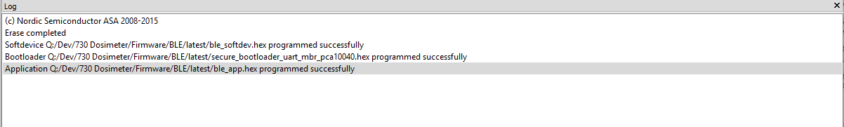

Figure 3 – Bluetooth Module Programmer Log

An example of the programmed regions window is shown here:

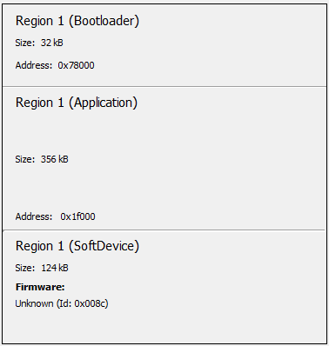

Figure 4 – Bluetooth Module Programmer Example Output

* 1. Repeat for remaining boards

# RECORDS

* Complete and turn in the technician inspection and rework report.

# DISTRIBUTION

* Manufacturing and contract manufacturer.

# FIXTURES and TOOLS

The T730.06 Test Fixture (see Figure 5) is used to perform functional testing of the A730.01. This fixture provides LEDs to output the status of test points found on the A730.01, power and signal inputs, a signal level switch, a power switch and three over-current test buttons. Trim resistors are used to adjust the reference test voltages used for each test point. Detailed schematic and assembly drawings are provided with the test fixture.

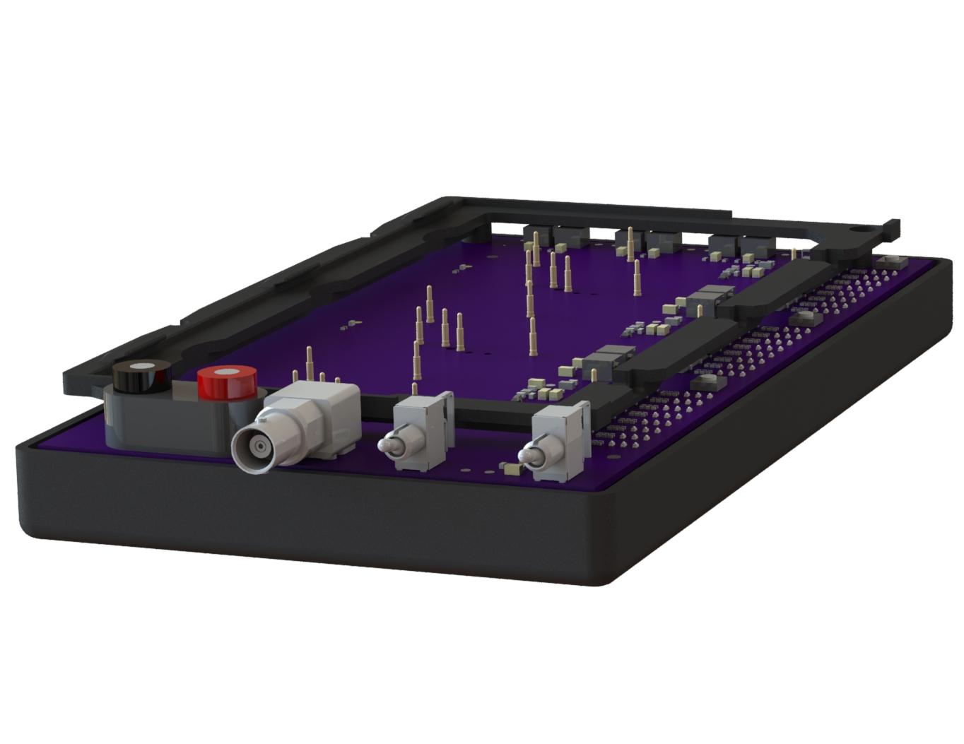

Figure 5 – T730.06 Test Fixture Left View

Caution: Use ESD Safety Procedures when using this test fixture to prevent damage.

Caution: Handle the test fixture carefully to prevent physical damage. Show special consideration to the exposed pogo contacts which can be damaged easily. Store in a protective box when not in use.

## T730.06 Test and Calibration Procedure[1]

***NOTICE: Larson Davis Engineering has calibrated the T730.06. If adjustments are need, please contact Larson Davis Engineering for advice before attempting to recalibrate this test fixture.***

To adjust the trim resistors a digital dc voltage source and a 6-digit precision digital voltmeter are needed to calibrate the T730.06. Refer to the assembly drawing A730.06 for trim resistor location information.

1. Set bench supply to 6.0 volts and current limit to about 100mA
2. Connect bench supply to J1 with Red and Black banana leads (observe proper polarity)
   1. Verify that the current from the bench supply is very low, less than 20mA
   2. Verify voltage at TP3 to be 3.3V (3.2 to 3.4 volts)
   3. Verify voltage at TP2 to be 3.0V (2.97 to 3.02 volts)
3. Connect the digital voltage meter to the digital voltage source and to 3 clip-leads that will be used to contact pogo contacts on the fixture
4. For each line in *Table 3*…
   1. Adjust the voltage source until the voltmeter reads the **Source Voltage** shown

Use a small jeweler’s screwdriver or a tuning tool to adjust trimmer; a recommended tuning tool is LD PN: 6485.0003, Vishay Spectrol PN: ACCTRITOB308

* 1. Connect the voltage source clip-leads to the indicated **Pogo Contacts**
  2. For the “HighLimit” lines turn the designated **Trim Resistor** left until the upper RED LED for that signal turns on for all channels; then turn it to the right until all channels go GREEN
  3. For the “LowLimit” lines turn the designated **Trim Resistor** right until the lower RED LED for that signal turns on for all channels; then turn it to the left until all channels go GREEN

Table 3 – Trimmer Voltage Adjustment

|  |  |  |  |  |
| --- | --- | --- | --- | --- |
| **Pogo Contacts** | **LED Label** | **Source Voltage (V)** | **Trim Resistor** | **Net &**  **Trimmer Name** |
| **EP1A, EP1B, & EP1C** | **V+5ang** | 5.20 | **R32** | HighLimit_V+5 |
| 4.48 | **R33** | LowLimit_V+5 |
| **EP3A, EP3B, & EP3C**  **EP7A, EP7B, & EP7C**  **EP8A, EP8B, & EP8C** | **V+2.8RTC**  **V+2.8SYS**  **V+2.8** | 2.86 | **R42** | HighLimit_V+2.8 |
| 2.74 | **R43** | LowLimit_V+2.8 |
| **EP9A, EP9B, & EP9C** | **Va+1.8** | 1.84 | **R22** | HighLimit_V+1.8 |
| 1.76 | **R23** | LowLimit_V+1.8 |
| **EP10A, EP10B, & EP10C** | **V+1.2** | 1.22 | **R12** | HighLimit_V+1.2 |
| 1.18 | **R13** | LowLimit_V+1.2 |

1. Adjust and verify the thresholds for the **Current** indicators.
   1. Adjust the **Trim Resistor** indicated in Table 4***Error! Reference source not found.*** until the voltage measured at the **Test Point Designation** indicated is as close to the **Test Point Voltage** indicated as possible and must be within the voltage limits shown (the limits have been adjusted to include 10MΩ loading from the voltmeter).

Table 4 – Current Indicator Voltage Adjustment

|  |  |  |  |  |  |  |
| --- | --- | --- | --- | --- | --- | --- |
| **Test Point Designation** | **Trim Resistor** | **Name** | **Test Point Voltage (V)** | **Low Limit (V)** | **High Limit (V)** | **Comment** |
| **TP51** | **R52** | HighLimit_Current | **1.596** | 1.588 | 1.604 |  |
| **TP52** | **R55** | LowLimit_Current | **0.050,00** | 0.049,60 | 0.050,10 | SN 01 & 03 |
| ***0.080,80*** | *0.080,40* | *0.081,20* | ***SN 02 has matched U2x (though non-idea gains at 1mA) that need a higher TP52 voltage; adjust R55 so that the LEDs match with resistors & images below.*** |

* 1. Connect a 110 Ω 1% resistor from P2 pin 3 to GND for all three channels and verify that the Current LEDs are as shown in the table at the right.

|  |  |
| --- | --- |
|  | **Current** |
| **High** | ● |
| **Normal** | ● |
| **Low** | ● |

* 1. Connect a 147 Ω 1% resistor from P2 pin 3 to GND for all three channels and verify that the Current LEDs are as shown in the table at the right.

|  |  |
| --- | --- |
|  | **Current** |
| **High** | ● |
| **Normal** | ● |
| **Low** | ● |

* 1. Connect a 3400 Ω 1% resistor from P2 pin 3 to GND for all three channels and verify that the Current LEDs are as shown in the table at the right.

|  |  |
| --- | --- |
|  | **Current** |
| **High** | ● |
| **Normal** | ● |
| **Low** | ● |

* 1. Connect a 4220 Ω 1% resistor from P2 pin 3 to GND for all three channels and verify that the Current LEDs are as shown in the table at the right.

|  |  |
| --- | --- |
|  | **Current** |
| **High** | ● |
| **Normal** | ● |
| **Low** | ● |

* 1. Re-adjust R52 and R55, or troubleshoot test circuitry[2], to ensure the proper thresholds for this test.

# REVISION HISTORY

|  |  |  |  |  |
| --- | --- | --- | --- | --- |
| DCO # | REV | DATE | INITIALS | CHANGES MADE |
| ECO 4777 | A | 30 Jan 2019 | AJR | Initial version |
| DCO 1891 | B | 03 Jun 2019 | AJR | Added power-on LED status of firmware version 1.010+ to D-1. |
| DCO 1918 | C | 30 Oct 2019 | AJR | ● Added test to verify U10 vs Y1 frequency due to part failures, 3100.0065 firmware revision ≥1.030 provides this test capability.  ● Adjusted the current draw tests to verify OFF current limit, this will catch issues we have had with U10 drawing excessive power (see ECO 4913 for T730.06 test fixture changes). |
| DCO 2002 | D | 21 Oct 2020 | ADB | Removed the crowbar circuitry test as it is unneeded, and added to show procedure is used for A730.12-IS as well as A730.01-IS |
|  |  |  |  |  |

1. The calculations for the trim voltages are found in the engineering spreadsheet: Electrical\A730.06 Test Fixture Information.xlsx
2. Replace U2x as needed for any individual channel until one functions within this specification. The required gain and offset for the INA196AI (U2x) is not guaranteed for the low Vin value needed to test the OFF current of the A730.01-IS, but many devices will work as needed.