**730 Final Assembly and Test**

**1.0 PURPOSE AND SCOPE**

The purpose of this document is to provide the detail and instruction necessary to verify final assembly and test of 730 products. This process also serves as a verification that the product continues to meet the specifications and criteria established by Engineering. Instructions apply to both the **730** and **730IS** models unless specifically noted. References to “meter” apply to all products.

🛈

Instructions for Intrinsic Safe Model **730IS** will be highlighted with this gold shaded background.

**2.0 AFFECTED DEPARTMENTS**

Manufacturing

**3.0 REFERENCE DOCUMENTS**

* D0001.8375 METCAL Procedure Instructions
* D0001.8432 Model 730 Final Test, METCAL
* D0001.8439 Model 730 Board Test Instructions
* D0001.8447 Model 730 Mic Test, METCAL
* D0001.1126-1 Quality Records Matrix
* A730.01-IS Main Board Schematics and Assembly Drawing
* A730.02 Lithium Battery Interface Schematic and Assembly Drawing
* S730.01 Case assembly drawing
* S730.02 Lithium battery assembly drawing
* D0001.8441 Model 730IS Final Checklist
* A730.03-IS NiMH Battery Interface Schematic and Assembly Drawing
* A730.03-IS NiMH Battery Interface Schematics and Assembly Drawing
* A730.12-IS IS Main Board Schematic and Assembly Drawing
* S730.03-IS Intrinsic Safe NiMH battery assembly drawing

**4.0 RESPONSIBILITIES & AUTHORITY**

The technician has the following responsibilities and authority:

* Use proper ESD protective equipment.
* Verify compliance of the product under test to specification.
* Troubleshoot and correct product as required.
* Communicate concerns to Supervisor or Quality Assurance.
* Request management review of product concerns.

**5.0 SAFETY PRECAUTIONS**

* Safety Glasses are required when soldering, lead clipping, or testing power supplies.
* Follow general electrical precautions for working with energized, low voltage circuits.

**6.0 EQUIPMENT & MATERIALS**

* ADP106 ADAPTOR INPUT BNC TO 1/4" MIC 12 pF
* CAL200 Calibrator
* ADP109 1/4" to 1/2" CALIBRATOR ADAPTER
* TMS9917C-LD Microphone Comparison Coupler
* DVX016 BLUETOOTH USB DONGLE
* CBL218 USB cable, A to micro-B (LD PN 0621.0111)
* S730.06 1 to 5 BNC 730 TESTING CABLE
* 831 831 Sound Level Meter
* PRM831 Microphone preamplifier
* Test station With signal generator (SRS DS360) and METCAL test software
* Test fixture 730 Multi-unit wireless charging test fixture
* Miscellaneous Cables, adapters and other miscellaneous test station items

**7.0 INSPECTION**

With the meter fully assembled as documented in the **S730.01** drawing,

* Inspect all meters for functional and cosmetic nonconformities
* Verify all Intrinsically Safe critical parts (A730.12-IS and A730.03-IS), this must be noted on the D0001.8441 form.

1. **INSTRUCTIONS**
2. Perform the **MET/CAL** **Final Test**
3. Connect the **ADP106** to the meter(s) microphone input
4. Configure Test Station and meter power supply
   * 1. **Single unit test configuration**:

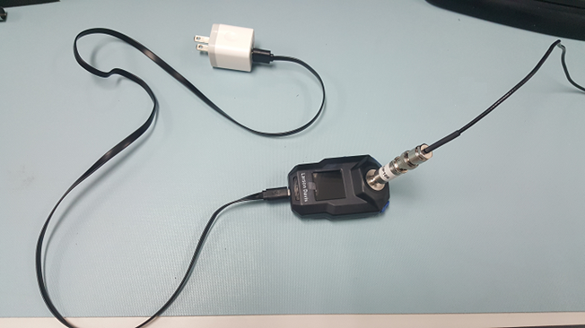

BNC Cable to

Test Station output

Power meter with AC–to–USB Adapter and a USB A to Micro-B cable, or with a Qi compatible wireless charger pad.

Connect ADP106 to the Test Station output with a BNC cable.

* + 1. **Multiple** **unit** **test** **configuration**:

Power meter with Qi compatible wireless multiple charger pad array.

Connect each **ADP106** to the Test Station output using the custom **S730.06** “730 TESTING CABLE”.

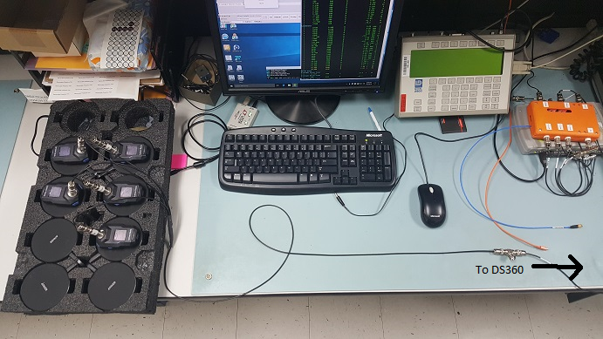

S730.06 Testing Cable to Test Station output

1. Ensure that a USB Bluetooth dongle has been installed in the testing PC.
2. Power on meter(s).
3. Open **MET/CAL** test software.
4. Create asset(s) for the new meter(s).
5. Run **D0001.8432 730 Final Test** from **MET/CAL Run Time**, follow all prompts. For multiple units, each test will execute successively and you will only be required to make these selections for the first unit tested.
6. Review test results and resolve any issues.

Note: The values in the Range test are calculated based on values taken during Overload, LogLin and Noise Floor tests. If any of these four tests have to be rerun, all four should be retested to ensure accuracy.

1. Remove all connections and power off the meter(s).
2. 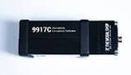Run the **MET/CAL Mic Test** (a.k.a. “Acoustic Test” for this meter (D0001.8375 & D0001.8447)

This test utilizes the **CAL200**, the **TMS9917C-LD** Microphone Comparison Coupler, the **ADP109** 1/4” microphone adapter, the reference microphone provided with the system, the **PRM831** and the **Model 831** Sound Level Meter.

1. Attach the microphone to the meter.
2. Ensure that a USB Bluetooth dongle has been installed in the testing PC.
3. Connect USB power to meter if meter’s battery power is insufficient to complete test.
4. Select **D0001.8447 730 Mic Test** from **MET/CAL Run Time**, follow all prompts.
5. Review test results and resolve any issues.
6. Secure Microphone Attachment
7. Secure the microphone to the meter using a very small amount of Blue Thread-Lock on the threads of the meter’s microphone mount (LD PN 0220.0008, LOCTITE THREADLOCKER BLUE 242).
8. Wipe away any excess LOCTITE to ensure proper conductivity to microphone.
9. Apply Calibration Label
10. Install Calibration Label by placing the printed L730.02 calibration label on the back.
11. 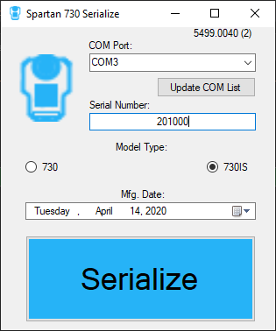Configure Model Number, Serial Number and Manufacture Date
    1. Connect meter to computer via USB
    2. Open **Spartan 730 Serialize** program
       1. Select correct **COM Port**
       2. Select the correct **Model Type** radio button: **730** or **730IS**.
       3. Enter meter’s **Serial Number** (failure to enter correct serial number will overwrite number previously programmed into meter)

The **Serial Number** for the **730IS** is entered with the first two digits representing the year manufactured, e.g. 201000 indicates it was manufactured in 2020 and is sequence number 1000.

* + 1. Select correct **Mfg. Date**
    2. Click “**Serialize**”
  1. Navigate to meter’s **About** view and verify correct model type and serial number information has been programmed into meter

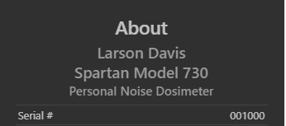 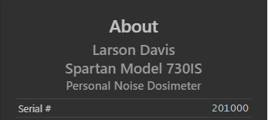

1. **RECORDS**

* Create the D0001.8441 **730IS** Final Checklist
  + Enter Model as **730IS**
  + Enter meter’s serial number
  + Enter microphone’s serial number
  + Enter Tracking Information
* Information entered into the database.
  + Model
  + Serial Number
  + Manufacture Date
  + Certification Date
  + Job Number
  + Firmware Version
  + Software Version
  + Record A730.01-IS and A730.02 board revisions, and mic serial number
* Test data is stored electronically in the 730 database or Metrology database, per the Quality Records Matrix.

1. **INSPECTION**

* Deliver to Logistics

**11.0 DISTRIBUTION**

This instruction is available to employees electronically via the online Document Control area.

**12.0 REVISION HISTORY**

|  |  |  |  |  |
| --- | --- | --- | --- | --- |
| **DCO #** | **REV** | **DATE** | **INITIALS** | **CHANGES MADE** |
| 1876 | A | 13 Mar 2019 | AJR | Initial release |
| 1898 | B | 12 June 2019 | KH & AJR | Moved assembly and board validation info to the S730.01 drawing. Updated instructions for inspection and testing. |
| 1923 | C | 17 Sep 2019 | KH | Added requirement for retesting Range, Overload, LogLin and Noise Floor |
| 1948 | D | 18 Mar 2020 | KH | Added instructions to update manufacture date in meters after certification. |
| 1953 | E | 14 Apr 2020 | AJR | Added 730IS specific items |