**A730.02 Battery Board Test Procedure**

# PURPOSE AND SCOPE

These instructions provide the detail necessary to ensure proper assembly and operation of the A730.02 ASSY DOSIMETER Li-ION BATTERY BOARD. It will be referred to hereafter as the “Battery Board.” Please become familiar with this entire document before attempting to test the product.

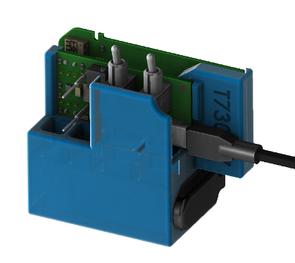

Figure 1 –T730.07 test fixture with battery and USB power connected.

## Description

The T730.07 test fixture (Figure 1) provides a circuit that simulates a battery with a voltage of 3.5 volts and connects to the battery terminals on the Battery Board via pogo pins. The battery voltage is set to 3.5 volts in order for the battery charger on the Battery Board to properly activate and supply current when enabled by the CHARGE switch. The USB adapter provides power for the charger circuit.

For proper operation of the Battery Board’s protection IC, the battery simulator circuit must be isolated from other sections of the test fixture, therefore a 9-volt battery powers it. It can source up to about 100mA, which is sufficient to operate the test fixture’s circuitry. The battery simulator circuit can sink the charger’s output current (up to nearly 500mA) for a short time (see footnote 2).

The POWER switch on the test fixture turns on/off the battery simulator.

The CHARGE switch on the test fixture enables/disables the charger on the Battery Board.

*Caution: Use ESD Safety Procedures when using this test fixture to prevent damage.*

*Caution: Handle the test fixture carefully to prevent physical damage. Show special consideration to the exposed pogo contacts which are damaged or lost easily.*

*Store in a protective box when not in use.*

# REFERENCE DOCUMENTS

* A730.02 Battery Board Schematic, Assembly Drawing and Bill of Manufacturing
* A730.07 Test fixture Schematic, Assembly Drawing and Bill of Manufacturing

# EQUIPMENT & MATERIALS

* Multi-Meter with ≥4 ½ digits, ≤0.1% DC accuracy (used to verify fixture’s calibration)
* Test Fixture Larson-Davis T730.07
* Power Adapter Larson-Davis PSA029 w/ USB mini-B cable
* 9-volt battery (IEC-6LF22 or ANSI-1604A)
* Any additional cables or adapters that may be needed (i.e., leads for voltmeter, etc.)

# INSPECTION

1. Before testing the Battery Board, visually inspect and correct component loading, polarity and missing parts. Note and repair defects.
2. Before using the test fixture, ensure that the voltage of the 9-volt battery is greater than 7 volts.
3. Before performing tests on a batch of Battery Boards, verify the battery simulation voltage is 3.50 as documented in the instructions found in section 8.0, T730.07 Test and Calibration Procedure.

# INSTRUCTIONS

1. Setup fixture and test equipment
   1. Set the fixture’s POWER and CHARGE switches to OFF
   2. Connect power sources to board
      * Connect a 9-volt to battery clip
      * Connect the USB cable between the PSA029 and T730.07
      * Plug the PSA029 into an AC outlet
2. Attach test fixture to the Battery Board to be tested as illustrated in Figure 2

Figure 2 – T730.07 Fixture and A730.02 in the Attached Position

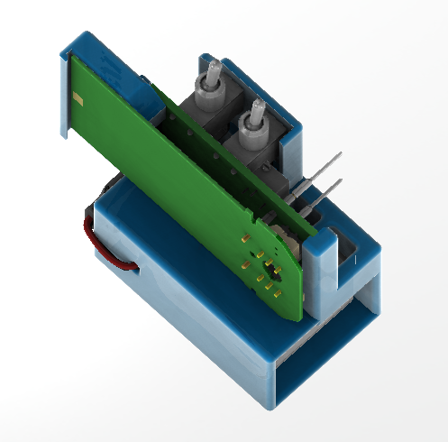

* 1. Place the Battery Board A730.02 onto the Test Fixture T730.07
  2. The end opposite the connectors is held under the lip on the fixture
  3. Align the pins of the Battery Board to the Test Board connectors
  4. Verify that pogo pins contact the battery pads (E1 and E3) on the Battery Board
  5. Press the connectors together to hold the board into its final position

1. Verify the Battery Board’s functionality
   1. Starting with the fixture’s **POWER** and **CHARGE** switches OFF, go through the switch sequence A through E shown in Table 1. Set the POWER and CHARGE switches as indicated in the “Switches” columns and verify that the LEDs are on/off as indicated in the “LED Indicators” columns.

Table 1 – Test Sequence

|  |  |  |  |  |  |
| --- | --- | --- | --- | --- | --- |
|  | ***Switches[1]*** | | ***LED Indicators*** | | **Comment** |
| **Step** | **Power**  **On/Off** | **Charge**  **On/Off** | **Power /**  **Batt OK** | **Current /**  **Charge** |
| **A** | ⭘ Off | ⭘ Off | ⭘ | ⭘ | Battery simulator and Charger are Off, no indicators to be On. |
| ⭘ | ⭘ |
| **B** | 🟓 On | ⭘ Off | 🟓 | ⭘ | Battery simulator is on but the protection IC has not been activated. |
| ⭘ | ⭘ |
| **C** | 🟓 On | 🟓 On [2]  ***10s max.*** | 🟓 | 🟓 | Charger enabled; this activates the protection IC causing Batt Ok to come On. Charge is On, Current LED is On indicating ≈400mA flow. |
| 🟓 | 🟓 |
| **D** | 🟓 On | ⭘ Off | 🟓 | ⭘ | Charger disabled; the Charge and Current indicators go Off. The Batt Ok remains On. |
| 🟓 | ⭘ |
| **E** | ⭘ Off | ⭘ Off | ⭘ | ⭘ | Battery simulator and Charger are Off, no indicators to be On. |
| ⭘ | ⭘ |

*Note: Labels on the test fixture indicate the switch and the LED sequence proceeding from left to right for steps A through E as shown to the right.*

|  |  |  |  |
| --- | --- | --- | --- |
| Switches: |  | LED Indicators: | |
| CHARGE |  | Power | Current |
| ⭘⭘🟓⭘⭘ |  | ⭘🟓🟓🟓⭘ | ⭘⭘🟓⭘⭘ |
| POWER |  | Batt Ok | Charge |
| ⭘🟓🟓🟓⭘ |  | ⭘🟓🟓🟓⭘ | ⭘⭘🟓⭘⭘ |

* 1. If any indicators failed to show as indicated then the board has an issue that must be resolved

1. Remove the Battery Board from the fixture and repeat steps B through D for the remaining Battery Boards to be tested

# RECORDS

Complete and turn in the technician inspection and rework report.

# DISTRIBUTION

Manufacturing and contract manufacturer.

# FIXTURES and TOOLS

The T730.07 Test Fixture (see T730.07 test fixture with battery and USB power connected.) is used to perform functional testing of the A730.02 Battery Board. This fixture provides two control switches and four LEDs that output the status of signals on the Battery Board. A trim resistor adjusts the battery simulator voltage. Detailed schematic and assembly drawings are provided with the test fixture.

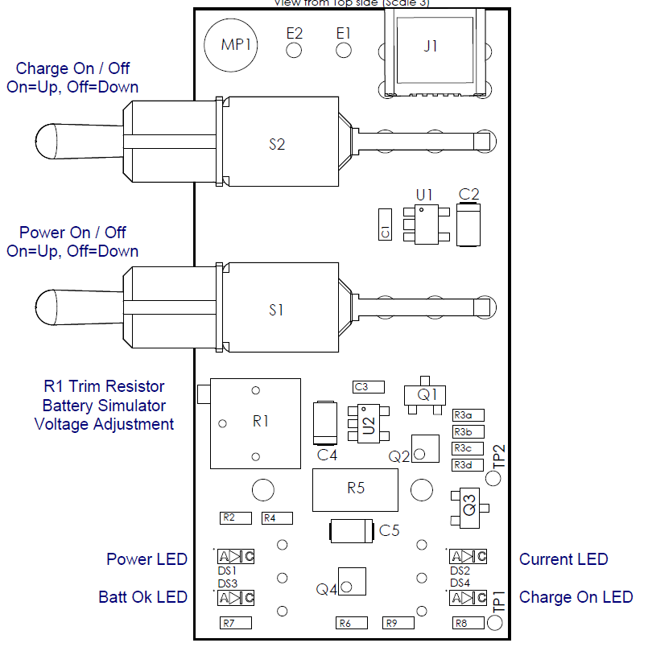

+

**–**

Figure 3 – Test fixture component location

## T730.07 Test and Calibration Procedure

To adjust the trim resistor, a 4½-digit precision digital voltmeter is required. Refer to Figure 3 for voltmeter test points and trim resistor R1 location (see also A730.07 Assembly Drawing).

1. Begin with…
   1. POWER and the CHARGE switches in the OFF position (down)
   2. No Battery Board attached
   3. No connection to the USB connector
2. Connect the voltmeter…
   1. Positive lead [+] to TP2 (or pogo E51 on the back side)
   2. Negative lead [–] to MP1 (or pogo E52 on the back side)
3. Connect the 9-volt battery to the battery clip
4. The voltmeter should read less than 0.1 volts
5. Turn the POWER switch ON
6. Verify that the voltmeter reads between 3.49 and 3.51 volts, if the voltage is within this range then skip to step 8
7. Calibrate the battery simulator by adjusting the 12-turn trim resistor R1 until the voltage reading on the voltmeter is 3.50 volts; turn clockwise to increase or counter clockwise to decrease the voltage

Use a small jeweler’s screwdriver or a tuning tool to adjust trimmer; a recommended tuning tool is LD PN: 6485.0003, Vishay Spectrol PN: ACCTRITOB308

1. Verify fixture functionality using the above procedure on a known good A730.02 board

# REVISION HISTORY

|  |  |  |  |  |
| --- | --- | --- | --- | --- |
| DCO # | REV | DATE | INITIALS | CHANGES MADE |
| ECO 4778 | A | 30 Jan 2019 | AJR | Initial version |
| ECO 4792 | B | 02 Apr 2019 | AJR | Updated to show operation with 3D printed case. |
|  |  |  |  |  |
|  |  |  |  |  |
|  |  |  |  |  |

1. The switch is ON (🟓) when in the UP position, OFF (⭘) when in the DOWN position.
2. **CAUTION**: Do not keep in the CHARGE ON state for more than 10 seconds during a 30 second period to prevent excessive heating of Q2 on the A730.07 fixture.