SoundLink Configuration Work Instruction

#### 1.0 PURPOSE

Instructions to fulfill orders for goods using an internet gateway (like the RV50X) connected to the SoundLink VPN. Section 8.1 provides steps to setup a new SoundLInk Plan; Section 8.2 provides steps to create the configurations needed to connect a gateway to SoundLink; Section 8.3 provides steps configure the gateway using the provided configuration files.

#### 2.0 LIMITATIONS

These instructions were developed using an RV50X and is limited to the RV50 Sierra Wireless cellular gateway and its use in a system configured to have access via the SoundLink VPN service.

#### 3.0 AFFECTED DEPARTMENTS

Manufacturing

#### 4.0 REFERENCE DOCUMENTS

D0001.8422 RV50 Gateway Configuration.docx

#### 5.0 RESPONSIBILITIES & AUTHORITY

The technician has the following responsibilities and authority:

* Configure a Sierra Wireless cellular gateway to be used in a system.
* Connect to and create records on the SoundLink server via the SoundLink Manager software.

#### 6.0 SAFETY PRECAUTIONS

Follow general electrical precautions for working with energized, low voltage circuits.

#### 7.0 EQUIPMENT & MATERIALS

* Access to a PC with SoundLink ver 1.0.1.0 Manager and Microsoft Office installed.
* If an order for new equipment then the RV50s to be configured for the order.
* RV50 template file for SoundLink configuration.

8.0 Procedure

Launch SoundLink Manager and log in.

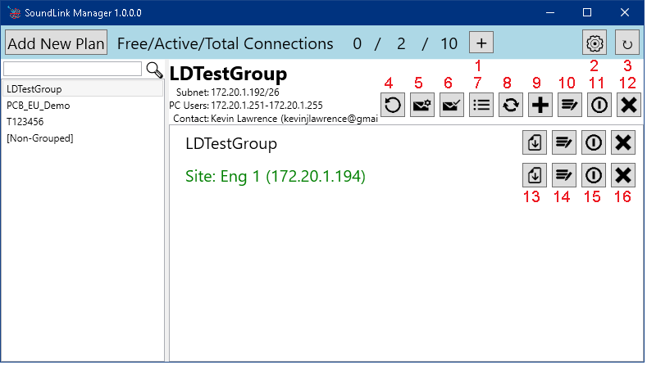Program Layout information

1. Add OpenVPN license
2. Attachment paths
3. Refresh Plans/Sites
4. Renew Sites
5. Send Upgrade Details
6. Send New Equipment Details
7. Generate Label PDF
8. Refresh Sites
9. Add new Site/User
10. Edit Plan Details
11. Disable/Enable Entire Plan
12. Remove Entire Plan
13. Download Site Configurations
14. Edit Site Details
15. Disable/Enable Site
16. Remove Site

For Renewals Skip to Section 8.5

##### 8.1 Setting Up a SoundLink Plan

Using a PC with SoundLink manager installed.

**PRECONDITION:** If the order is for more sites than currently shown as the “Free” license count then an order for more OpenVPN licenses must be made before continuing.

Payable to: “openvpn.net”

Item Description: “OpenVPN Client Device License Business VPN Account, BYOL Azure, for SoundLink production server.”

If an order specifies that it is to be added to an **existing plan** and provides the Plan ID for said plan then Section 8.1 shall be skipped, note the provided Plan ID for later.

Step 1: Click the button.

Step 2: Enter purchase information in the dialog that opens:

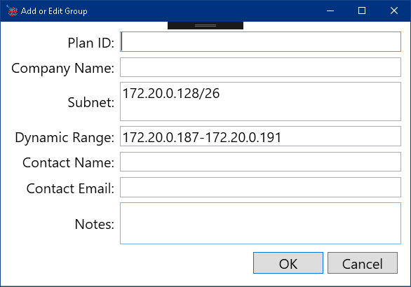

* Plan ID: Use the Order Number, note the Plan ID for later use.
* Company Name: Use the “Ship To” name unless otherwise specified.
* Contact Name: The name of the preferred contact with the customer.
* Contact Email: The email address of the contact given.

Optional Step 3: Enter any notes about the customer, plan, or order.

*Note: The Subnet and Dynamic Range fields are automatically populated and are not editable. They are displayed for convenience only.*

*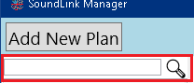Note: The Plan ID, Company Name, Contact Name and Email, and Notes are all searchable using the search/filter field in the main window of SoundLink Manager.*

Step 4: Click the *OK* button, if you missed any fields a warning will appear informing you of any warnings or errors.

Once completed the Plan List on the left side of the main window should refresh.

A PC client is automatically created for each new plan.

##### 8.2 Creating the Configurations for a SoundLink Client

Perform section 8.2 for all SoundLink sites (new or upgrades) on the order being processed before proceeding to the next section.

If the Plan to be configured is not visible in the Plan List you can scroll to find it, or you can enter the Plan ID in the Filter field above the Plan List.

Step 1: If not already selected, select the Plan in Plan List on the left side of the window. The right side should update to show details about the plan.

Step 3: Click the button to add a new client (SoundLink Site or PC User) to the plan. In the dialog that opens, you can make a few changes.

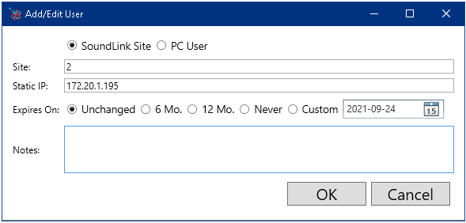

Step 4: Ensure that “Client Type” is set to “SoundLink Site”

Step 5: If site names are provided then change the “Site” field accordingly otherwise leave it with its default value.

Step 6: Set “Expires on” to the duration specified on the order (6 Months or 12 Months)

Step 7: (Optional) Add any notes for the client.

Step 8: Click the *OK* button.

The client list in the currently selected plan will automatically refresh, with the new site being brought into view and added to the current selection. The currently selected items can be used to perform bulk actions (generate labels, update expiration dates, send configuration files)

*Note: The Static IP is not editable and has been automatically populated.*

*Note: If adding an additional PC User is requested, perform steps 1 through 3, then ensure that Client Type is set to “PC User”, then skip to step 7.*

*Note: Static IP and Notes are searchable using the filter feature.*

##### 8.3 Provisioning new Modems as SoundLink Sites

This section is for setting new modems with physical access and is to be done with each new SoundLink Site paired with a new modem on the customer’s order. For upgrading existing equipment to a SoundLink site, see Section 8.4.

Step 1: If not already selected, select the Plan in Plan List on the left side of the window. The right side should update to show details about the plan.

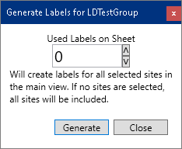Step 2: In SoundLink Manager, select all the SoundLink sites to provision, then click to generate labels for the modems and follow instructions in the dialog, the output is configured to fit on Avery5160 labels.

The “Used Labels on Sheet” is useful for printing labels on a partially used sheet. The label sheet is a 3x10 grid, so setting the value to “5” would generate a PDF with the labels starting on the far right of the second row.

Step 3: For each of the modems included in the order:

1. In SoundLink Manager, click for the site being configured.
2. Select the modem specified by the Model and Serial number found in the name of the folder that opens.
3. Ensure that the modem has been configured according to D0001.8422 RV50 Gateway Configuration.docx
4. If not currently logged in to ACEmanager, log into ACEmanager for the RV50X

Note: Check with Engineering for compatibility if configuring a modem other than the RV50 or RV50X. Changes to this document may be required.

1. In addition to the RV50X template file uploaded, or the configuration changes made, during D0001.8422 upload “R:\Provo\Engineering\Firmware\RV50\FNMS044.02RV50.SOUNDLINK.TEMPLATE.xml” but do not reboot the modem.

If the file is not available, changes made by this file are all under the “VPN” tab as follows.

General Section:

IPsec Implementation: Standard

IPsec Local Termination: Host

IPsec FIPS Mode: Disabled

Out of Band Policies

Incoming Traffic: Allowed

Gateway Generated Outgoing Traffic: Allowed

LAN Host Generated Outgoing Traffic: Allowed

VPN 1 Section:

VPN 1 Type: OpenVPN Tunnel

General (OpenVPN):

Peer Port: 1194

Peer Identity: mnet.pcb.com

Encryption Algorithm: AES-256

Authentication Algorithm: SHA1

Compression: None

Client Certificate: Enable

User Name/Password Retry: Disable

Additional TLS Authentication: Enable

Server Certificate Verification: NS Cert Type

Advanced:

Tunnel-MTU: 1500

MSS Fix: 1400

Fragment: 1400

Allow Peer Dynamic IP: Enable

Re-negotiation (seconds): 604800

Ping Interval (seconds): 10

Tunnel Restart (seconds): 60

NAT: Disable

VPN 2-5:

VPN Type: Tunnel Disabled

1. Go to the “VPN” tab then section “VPN 1” 🡪 General (OpenVPN)

Click “Load Root Certificate”, next drag “**root.crt**” from the Explorer window for this site to the file chooser then click “Upload File to Device”

Click “Load Client Certificate”, next drag “**<ip>.crt**” where <ip> is the IP address assigned to this site, from the Explorer window to the file chooser then click “Upload File to Device”

Click “Load Client Certificate Key”, next drag “**<ip>.key**” where <ip> is the IP address assigned to this site, from the Explorer windows for this site to the file chooser then click “Upload File to Device”

Click “Load Client TLS Key”, next drag “**clientTLS.key**” from Windows Explorer to the file chooser then click “Upload File to Device”

1. Reboot the modem.
2. If SIM cards are provided for the modem verify the modem is on SoundLink, the site’s IP address will turn Green.
3. Attach the appropriate label to the modem.

Step 4: Click to generate an email to send to the customer contact.

Step 5: Verify the recipient address and contents of the attached .zip file.

Step 6: Verify the site list in the body contains all the sites in the Plan.

Step 7: Send the email.

##### 8.4 Generating Upgrade Materials for the Customer

This section is for processing orders to “Upgrade” existing modems to SoundLink Sites.

Step 1: If not already selected, select the Plan in Plan List on the left side of the window. The right side should update to show details about the plan.

Step 2: Click to generate the upgrade materials and email to send to the customer.

Step 3: Verify the recipient address and attached documents:

SoundLink Manual

A zip file containing

Modem Labels.pdf

FNMS044.02RV50.SOUNDLINK.TEMPLATE.xml

User.ovpn

A folder for each selected site in the Plan, or all sites if none are selected.

Step 4: Verify the site list in the body contains all the sites in the Plan with “*” next to sites with attached configurations.

Step 5: Send the email.

##### 8.5 Renewing SoundLink Sites

This section is for processing orders to renew existing SoundLink Sites.

Step 1: If not already selected, select the Plan in Plan List on the left side of the window. The right side should update to show details about the plan.

Step 2: Click to open the Renewal dialog.

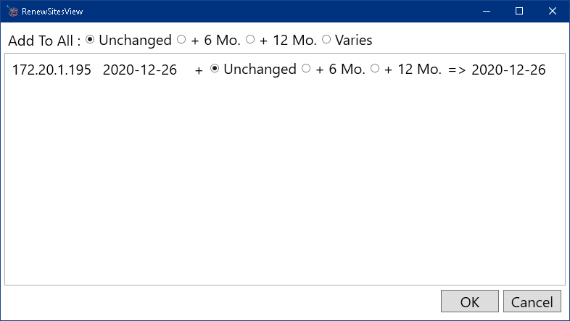

Step 3: For every site included in the renewal select the renewal duration. If all sites on the plan are included, the “Add to All” options can be selected to extend all sites’ subscriptions by the given length.

Step 4: Click “OK” to apply the changes.

Step 5: In the email that opens verify the attached worksheet contains all the sites with updated expiration dates.

##### 8.6 Removing Plans

This section is for processing a termination of service for an entire SoundLink Plan. Once completed, all the sites’ configuration files will be removed from the server and the modems will no longer be able to access the SoundLink service without being reconfigured. This may require the customer to attain physical access to the modem to recover.

Step 1: If not already selected, select the Plan in Plan List on the left side of the window. The right side should update to show details about the plan.

Step 2: Click on the plan controls (not the site controls).

Step 3: Confirm this action. It cannot be undone.

##### 8.6 Removing Sites

This section is for processing a termination of service for a specific SoundLink Site while maintaining service to other sites. Once completed site’s configuration files will be removed from the server and the modem will no longer be able to access the SoundLink service without being reconfigured. This may require the customer to attain physical access to the modem to recover.

Step 1: If not already selected, select the Plan in Plan List on the left side of the window. The right side should update to show details about the plan.

Step 2: Click on the site controls for the specified site.

Step 3: Confirm this action. It cannot be undone.

##### 8.7 Shipment Notification

This section is to be executed by Logistics at time of shipment.

The Director of LD Operations or an individual designated by said Director is to be notified via email when an order containing SoundLink configurations is shipped. Send the order number being shipped in the email.

#### 9.0 RECORDS

The only records generated by this work instruction are VPN user accounts created on the VPN server and associated files uploaded to the RV50(X) and emailed to customers.

An additional record is kept by management

The associated files can be retrieved from the VPN server as long as the user account is still present.

#### 10.0 DISTRIBUTION

This Work Instruction is available online in the work instruction area of Document Control.

#### 11.0 ATTACHMENTS

This document references “R:\Provo\Engineering\Firmware\RV50\FNMS044.02RV50.SOUNDLINK.TEMPLATE.xml”

#### 13.0 REVISION HISTORY

|  |  |  |  |  |
| --- | --- | --- | --- | --- |
| **DCO #** | **REV** | **DATE** | **INITIALS** | **CHANGES MADE** |
| 5049 | A | 24-09-20 | KJL | Creation of D0001.8460 |
| 5094 | B | 05-03-21 | KJL | Replacing “client.*” with “<ip>.*”, adding explanation of <ip> and renaming “FNMS044.02RV50SLTEMPLATE.xml” to “FNMS044.02RV50.SOUNDLINK.TEMPLATE.xml” |
|  |  |  |  |  |
|  |  |  |  |  |
|  |  |  |  |  |
|  |  |  |  |  |
|  |  |  |  |  |
|  |  |  |  |  |
|  |  |  |  |  |
|  |  |  |  |  |
|  |  |  |  |  |