ACC010 NMS044 Pole Work Instructions

PURPOSE AND SCOPE
The purpose of this document is to provide the detail and instruction necessary to tear down and create the ACC010.

AFFECTED DEPARTMENTS
- Production

REFERENCE DOCUMENTS
- NA

RESPONSIBILITIES & AUTHORITY
The technician has the following responsibilities and authority:
- Communicate concerns to Supervisor or Quality Assurance.
- Request management review of product concerns.

SAFETY PRECAUTIONS
- Follow proper safety protocols while working with hand tools

EQUIPMENT & MATERIALS
- Safety glasses.
- QTY 1.0, MEPS044.11 Telescoping Pole
- QTY 1.0, 5335.0010 3/8-16 to ¼-20 thread adapter

INSPECTION
- Verify that there were no scratches caused by the tear down.

Assembly Instructions
- The monopods original use is for holding a camera and has many included items we do not need / use.
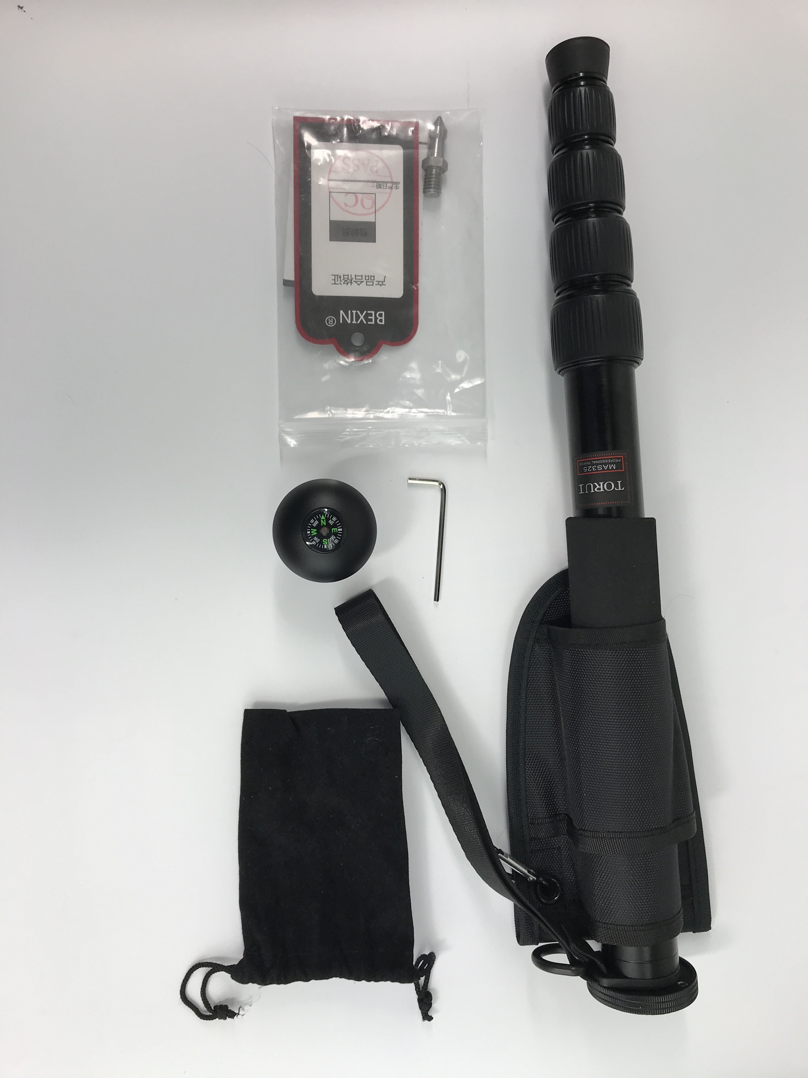
Figure 1: Prep Work

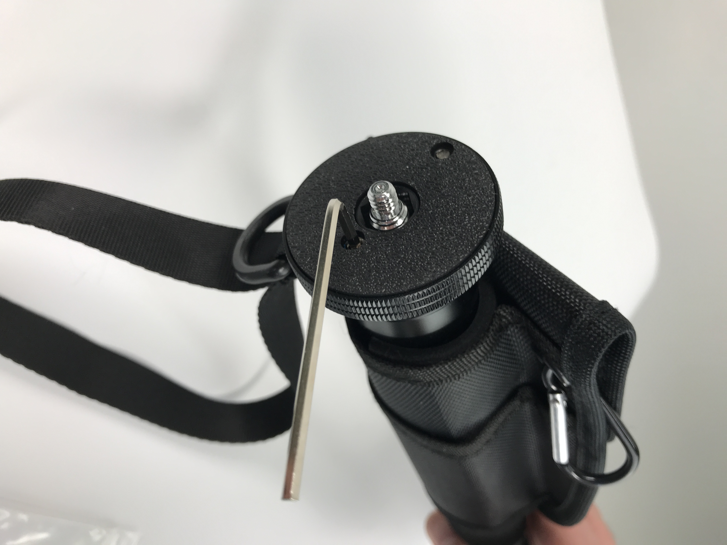
- Use the included HEX 2.5mm key to loosen the set screw on the base ring seen in Figure 2.
Figure 2: Loosen Set Screw.

- Remove the base ring, wrist strap, bag, foam grip, and rubber foot and recycle them.
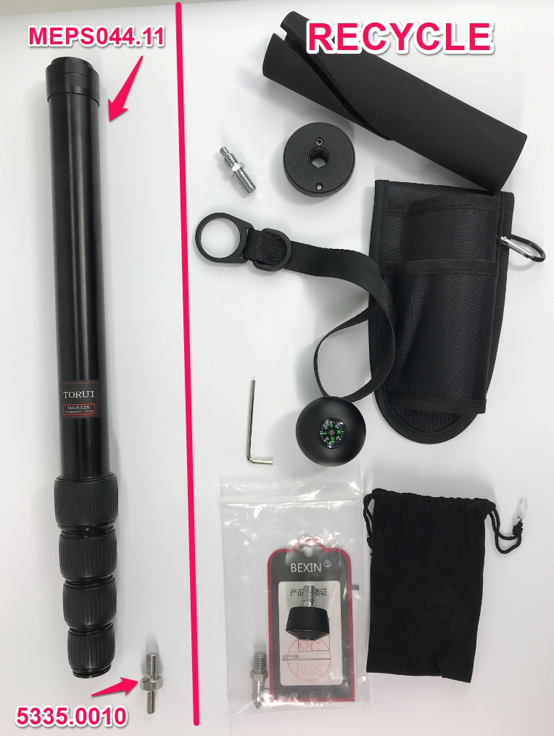
Figure 3: Tear Down

- Use Red Loctite and place the thread insert into the smaller end of the tripod.
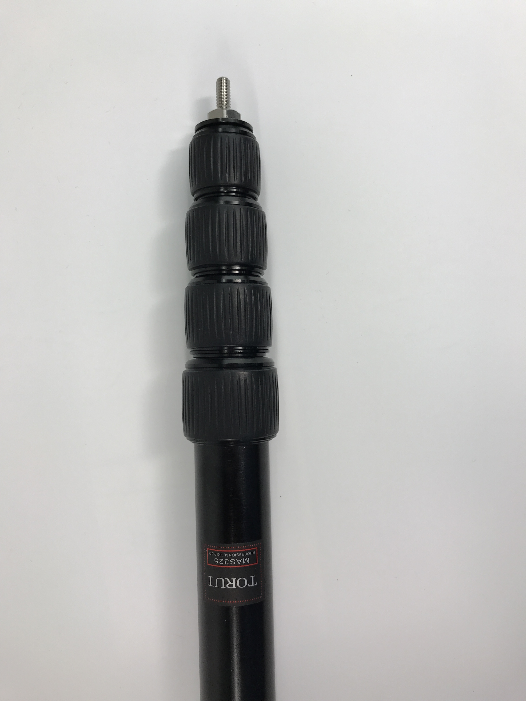
Figure 4: Loosen Set Screw

REVISION HISTORY
DCO # | REV | DATE | INITIALS | CHANGES MADE
ECO 5051 | A | 2/19/2021 | DWA | Initial Release

