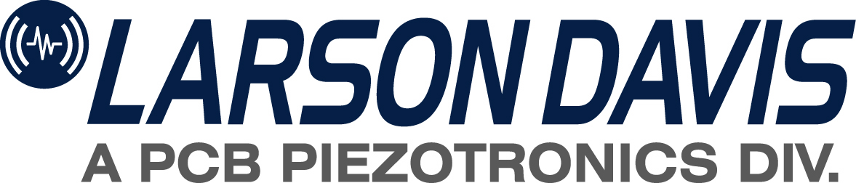
CERTIFICATE OF COMPLIANCE
LD2036(C)
Product #:
Inspected by: W/O#:
This product has been manufactured and tested according to the standards established by Larson Davis. This product has been found to be in compliance with the design specification for its recommended use.
1681 West 820 North
Provo, Utah 84601
CERTIFICATE OF COMPLIANCE
LD2036(C)
Product #:
Inspected by: W/O#:
This product has been manufactured and tested according to the standards established by Larson Davis. This product has been found to be in compliance with the design specification for its recommended use.
1681 West 820 North
Provo, Utah 84601
CERTIFICATE OF COMPLIANCE
LD2036(C)
Product #:
Inspected by: W/O#:
This product has been manufactured and tested according to the standards established by Larson Davis. This product has been found to be in compliance with the design specification for its recommended use.
1681 West 820 North
Provo, Utah 84601
CERTIFICATE OF COMPLIANCE
LD2036(C)
Product #:
Inspected by: W/O#:
This product has been manufactured and tested according to the standards established by Larson Davis. This product has been found to be in compliance with the design specification for its recommended use.
1681 West 820 North
Provo, Utah 84601
CERTIFICATE OF COMPLIANCE
LD2036(C)
Product #:
Inspected by: W/O#:
This product has been manufactured and tested according to the standards established by Larson Davis. This product has been found to be in compliance with the design specification for its recommended use.
1681 West 820 North
Provo, Utah 84601
CERTIFICATE OF COMPLIANCE
LD2036(C)
Product #:
Inspected by: W/O#:
This product has been manufactured and tested according to the standards established by Larson Davis. This product has been found to be in compliance with the design specification for its recommended use.
1681 West 820 North
Provo, Utah 84601
CERTIFICATE OF COMPLIANCE
LD2036(C)
Product #:
Inspected by: W/O#:
This product has been manufactured and tested according to the standards established by Larson Davis. This product has been found to be in compliance with the design specification for its recommended use.
1681 West 820 North
Provo, Utah 84601
CERTIFICATE OF COMPLIANCE
LD2036(C)
Product #:
Inspected by: W/O#:
This product has been manufactured and tested according to the standards established by Larson Davis. This product has been found to be in compliance with the design specification for its recommended use.
1681 West 820 North
Provo, Utah 84601

