ICP PREAMP TEST PROCEDURE

1.0 PURPOSE AND SCOPE

This document describes the test procedure for verifying that an ICP PREAMP is functioning within specified parameters. All employees who have responsibility for testing this instrument are required to follow the instructions detailed in this instruction.

The ICP PREAMPs covered by this instruction include:
(“x” in a model number is generic for the revision letter)
- HT426x01
- 426x01
- 426x03
- 426x10
- 426x11
- PRM422
- PRM426
- N426x01 (negative output)
- GRAS 26CA
- GRAS 26CB
- TMS426x01

2.0 AFFECTED DEPARTMENTS

Production

3.0 REFERENCE DOCUMENTS

For the ICP PREAMP:
- Schematics
- Bill of Materials
- Assembly drawings

4.0 RESPONSIBILITIES & AUTHORITY

The technician has the following responsibilities and authority:
- Verify compliance of the product under test to specifications.
- Troubleshoot and correct connection as required.
- Communicate concerns to the Supervisor of Quality Assurance.
- Request management review of product concerns.
- Follow established ESD standards.

- DEFINITIONS

LD - Larson Davis
ESD- Electro-Static Discharge

6.0 SAFETY PRECAUTIONS

- Use safety glasses when soldering, lead clipping, or testing power supplies.
- Follow general safety precautions for working with energized, low voltage circuits.

7.0 EQUIPMENT & MATERIALS

- BNC to BNC cables
- BNC to Microdot cable if testing 426x03 or PRM422
- BNC Tee connector
- PRA951-L4 preamp
- BNC Mic Adaptor
- ADP005 for use with all preamps except HT426x01
- ADP076 for use with HT426x01
- M2260.06 1/4" TO 1/2" Adapter if testing a 1/4” preamp
- Multimeter HP34401
- RS232 null modem cable (CBL117 or equivalent)
- 2900 Test System with 2209 or 2239
- Computer with Lab.exe Program
- CBL071

8.0 INSTRUCTIONS

  - ICP PREAMP Test.

- Connect the PRA951-L4 to the Preamp Input 1 of the 2900 using a CBL071 cable (See Figure below for an example of connecting a PRM426).
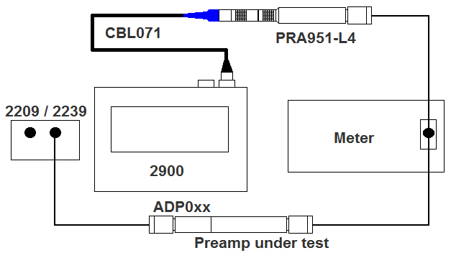

- Using a BNC to BNC cable, connect the PRA951-L4 to the BNC Tee connector and to the HP34401.

- Connect the appropriate mic adaptor to the ICP PREAMP. Use an ADP076 with the HT426x01, use an ADP005 for all others. (use the M2260.06 1/4" to 1/2" Adapter if the preamp is ¼”).

- Using a BNC to BNC cable, connect the input of the mic adaptor to the output of the 2209 / 2239.

- Using a BNC to BNC cable, or a BNC to Microdot cable, connect the output of the ICP PREAMP to the other end of the BNC Tee connector attached to the HP34401.

- Connect the HP34401 to one of the computers COM ports using a RS232 null modem cable.

- Run the Lab.exe program and select the appropriate ICP PREAMP from the Instrument box. Enter the serial number for ICP PREAMP.

- Set Lab to the appropriate adaptor type under the Equipment Setup. Standard for ADP005 and Guarded for ADP076.

- Check the “Sweep Preamp” box and click “Start”.

- After the test has finished, disconnect the ICP PREAMP and check the results. IF THE TEST FAILS, TROUBLESHOOT THE PROBLEM BEFORE CONTINUING.

If the preamp is only being tested to go into inventory at the sub-assembly level, you are finished. The following steps are done when the preamp is being shipped.

  - Prepare for Shipment

- Print the first page (frequency sweep) of the test results.

- Test / program the ICP PREAMP memory (follow procedure D0001.8155).

- Create a ‘Certificate of Calibration and Conformance’ using the old database.

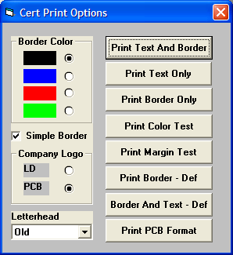
  - If the preamp is a PCB preamp, set the Cert Print Options as shown then select “Print Text And Border”.

  - If the preamp is NOT a PCB preamp, set the Cert Print Options as shown, but select “Print PCB Format”. Yes, I said to select PCB format if it is NOT a PCB preamp.

Note: When you are done creating all the certificates, don’t forget to set the options back to your normal setting.

- Place a black vinyl protective cap on the microphone end of the preamplifier.

- Place the appropriate foam insert into the plastic box. Make sure it is straight.

- Put the preamplifier into the case.

- If the case is dirty or has fingerprints on it, clean it with glass cleaner.

- Create a calibration date sticker and place it on the top of the case in the upper right hand corner. (see picture below for examples)

- Create the appropriate model / serial number sticker and place it on the top of the case, just above the latch, centered side to side. (see picture below for examples)

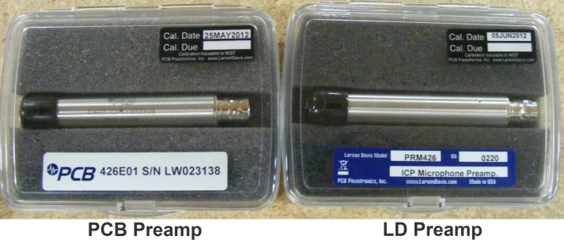

- Put the Certificate of Calibration and the test results in a bag. PCB preamps go in a pink zip-lock bag. Non PCB preamps go in the same sleeves that all LD product go in.

- Enter the preamps information into the database.
Note: If the preamps serial number starts with LW (i.e. LW012345) do not add the LW in the database. Just enter it as 012345. Then add this to the notes field…
************ LIFETIME WARRANTY ************

9.0 INSPECTION

No further inspection of the ICP PREAMP is required.

- RECORDS

Test results are stored electronically and maintained per D0001.1122 Automated Final Test-LD Sig-Gen System.

11.0 DISTRIBUTION

Manufacturing

12.0 ATTACHMENTS

Not applicable to this procedure.

13.0 REVISION HISTORY

DCO # | REV | DATE | INITIALS | CHANGES MADE
 |  | 3/28/02 | RC | Initial Release
401 | B | 3/29/02 | RC | Use CBL071 and PRA951-L4 instead of PRA950-L2
957A | C | 14 July 2006 | LH | Added a list of ICP Preamps that are tested using this instruction. (GRAS 26CA & 26CB, 426x10, 426x11, 426x01, 426x03, N426D01, PRM426, PRM422, TMS426x01)
1060 | D | 18 Feb  2008 | JLD | Added HT426E01 to list of ICP preamps to test.
1068 | E | 14 Apr 2008 | LH | Deleted 8.1 K (return to production). Added purple loctite, torque connector to 17 inch pounds and black vinyl protective cap.
1400 | F | 8 Aug 2012 | JGG | Added pictures, removed loctite and torque steps because this is done by production, and added steps for certs and packaging.

