**Sierra Wireless RV50 Gateway Configuration Instructions**

# PURPOSE AND SCOPE

This document provides the detail and instruction necessary to configure the RV50 Sierra Wireless cellular gateway for use in a system. The preferred method is the use of a template file, but the manual instructions for the process are also provided.

# LIMITATIONS

This instruction is limited to the RV50 Sierra Wireless cellular gateway and its use in a system.

# AFFECTED DEPARTMENTS

Manufacturing

# REFERENCE DOCUMENTS

D0001.6074 Sierra Wireless Bulletin Mirai Malware notice.

# RESPONSIBILITIES & AUTHORITY

The technician has the following responsibilities and authority:

* Configure a Sierra Wireless cellular gateway to be used in a system.

# SAFETY PRECAUTIONS

Follow general electrical precautions for working with energized, low voltage circuits.

# EQUIPMENT & MATERIALS

* A PC with a web browser.
* A Network cable.
* A 12V DC power supply.
* Two cellular antennas.
* RV50 template file.

# PROCEDURES

## Connect the gateway

### Attach an antenna to the Cellular and to the Diversity port on the RV50. The cellular modem can be damaged if operated without an antenna.

### Attach the network cable from the PC to the gateway**.** Alternately, use a Micro USB cable.

### Adjust a DC power supply to 13V and connect the supplied power cable’s red and white wires to positive and the black wire to negative.

### Turn on the power supply and allow the gateway to boot, approx. 1 to 2 minutes.

## Login to the gateway

### Open a web browser.

### Enter <http://192.168.13.31:9191> into the address bar**.** Alternately, if using the Micro USB connection enter <http://192.168.14.31:9191>.

### Login as “user” with default password “12345”, see figure 1.

### 

## Verify current gateway firmware

### Take note of the version of firmware currently on the device under *Status* then the *About* on the left pane.

### 

### Check for the latest firmware version at [http://source.sierrawireless.com/](http://source.sierrawireless.com) select the proper device and follow the link *Firmware Package*.

### If needed, download and update the firmware according to the manufacturer’s instructions and log back in when it has rebooted.

## Set User Password

### Include D0001.6074 Sierra Wireless Bulletin Mirai Malware notice with the system documentation (USB or Printed).

### Click on the *Admin* tab.

### Enter the default “12345” password in *Old Password*.

### Enter “LD_NMSystem16” in both *New Password* and *Retype Password*.

## Click Change Password

## 

### Click *Apply*.

## Template File Loading Process

### Click on the *Template Button* on the top right.

### Select the template file: “R:\Provo\Engineering\Firmware\RV50\FNMS044.01RV50TEMPLATEFILE().xml”.

### 

### Click *Apply and* disconnect from the gateway. Steps 8.6-8.12 are provided to show what is contained in the template file. Skip to 8.13.

## Security - Port Forwarding

### Click on the *Security* tab.

### Click on the *Port Forwarding* section on the left pane.

### Change the screen to match as shown below.

### 

### Click *Apply*.

## Services – ACEmanager

### Click on the *Services* tab.

### Click on the *ACEmanager* section in the left pane.

### Ensure the setting are as shown below.

### 

### Click *Apply*.

## Services – Power Management

### Click on the *Power Management* section in the left pane.

### Choose *Power Saving Mode* box.

### Change the *Processor Power Saving Mode* on the left pane to Enable.

### Click *Apply*.

## Services – Telnet/SSH

### Click on the *Telnet/SSH* section in the left pane.

### Set *Telnet/SSH Echo* on the left pane and set the value to disable.

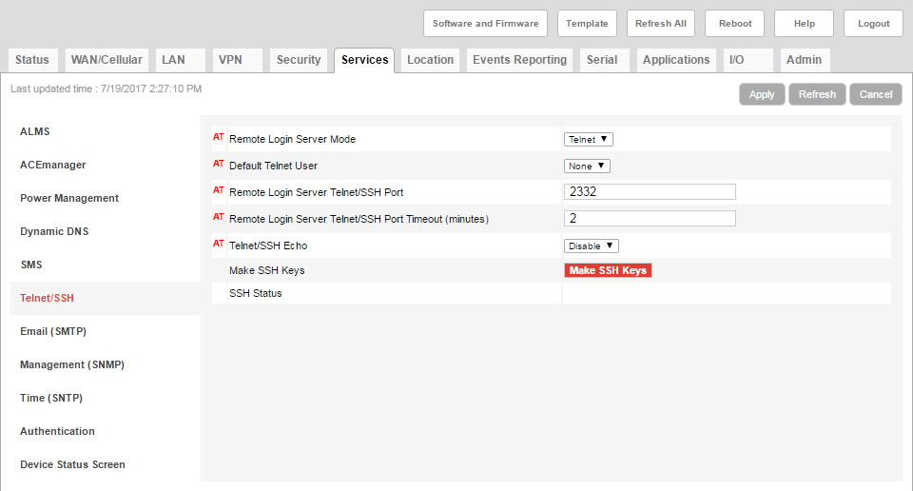

### Click *Apply*.

## Location Settings

### Click the *Location* tab.

### Click *Global Settings* on the left pane.

### Select the *Location Service* dropdown to Enable.

### Set the *TCP Location Port* to 9494.

### 

### Click *Apply.*

## Events Reporting

### Click on the *Add New* tab under Actions.

### Setup the action to match as shown below.

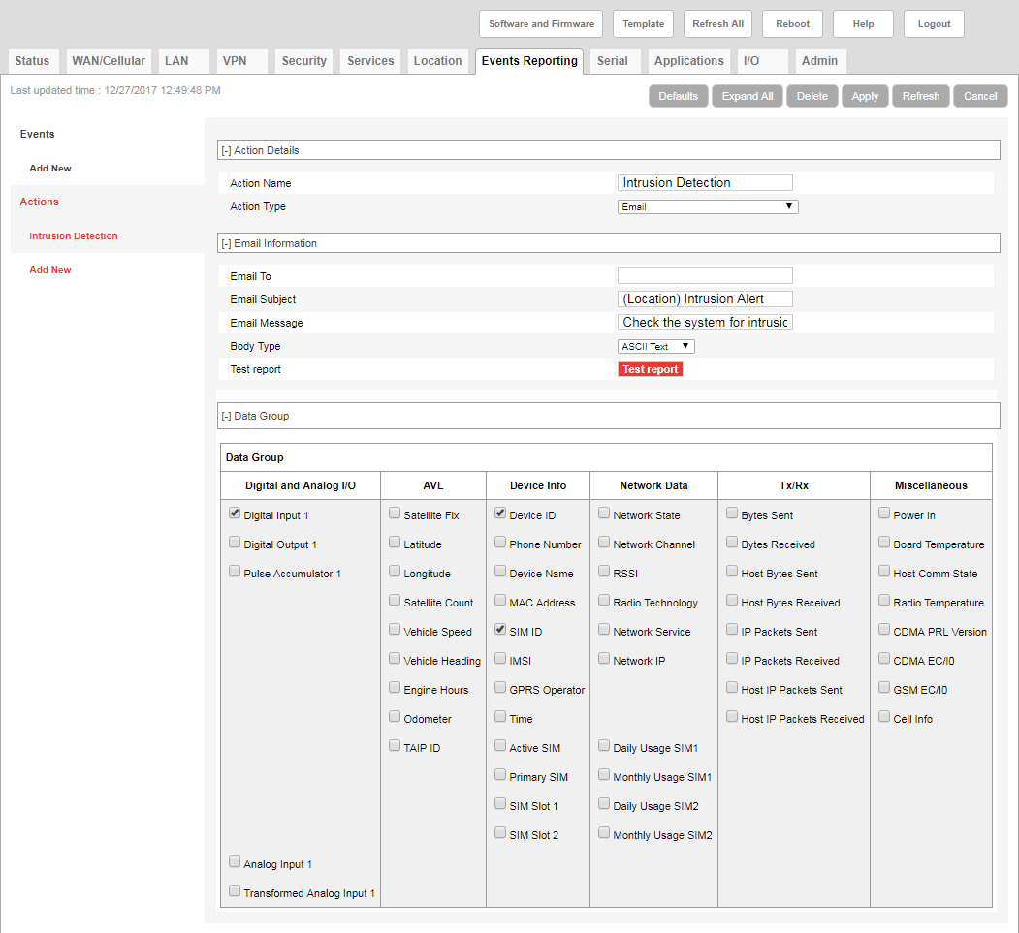

### Click *Apply* to save the action.

### Click on the *Add New* tab under Events.

### Setup the event to match as shown below.

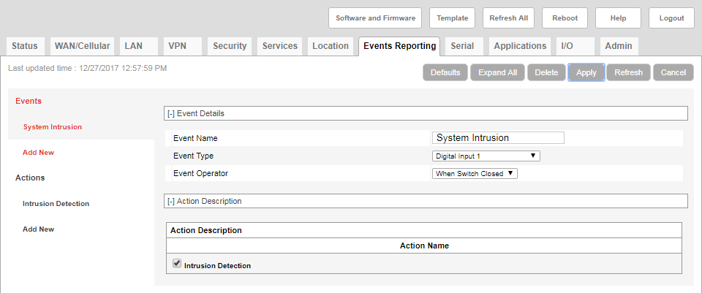

### Click *Apply* to save the action.

## Serial

### Click on the *Serial* tab.

### Change the Serial Port to Disable.

### 

### Click *Apply*.

## I/O

### Click on the *I/O* tab.

### Click on the *Configuration* section on the left pane.

### Verify the settings are as shown below.

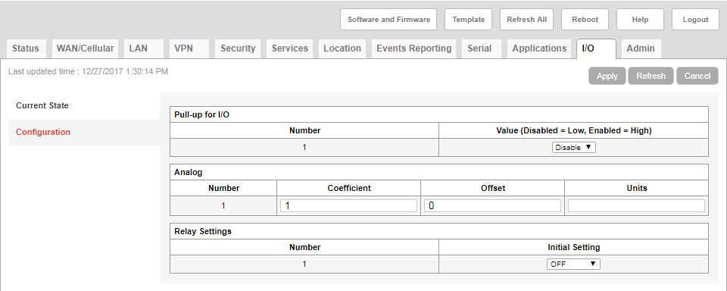

### If there are any changes, apply the changes.

## USB Port

### Click on the *LAN* tab.

### Click on the *USB* section on the left pane.

### Verify the settings are as shown below.

### 

### Click *Apply*.

## LAN settings

### Click on the *LAN* tab.

### Click on the *Ethernet* section on the left pane.

### Change the Ethernet Port to Disable. Note: After this change, you will not be able to connect to the gateway with a wired Ethernet connection. In order to obtain a physical connection again through the Ethernet Port a hard reset must be performed which will reset all items to default settings.

### 

### Click *Apply*.

### Click the *Reboot* button.

### Allow the gateway to save the applied settings and reboot.

## Verify gateway

### You should lose the ability to connect through the wired Ethernet connection at this point.

### Connect to the Gateway with a Micro USB cable and use the following address and password with the process of 8.2: 192.168.14.31:9191, LD_System16. Verify the connection works. You can then verify settings are correct.

### Throw away the quick start guide that was included with the RV50. Deliver to production for inclusion into the NMS044 system this is going with.

# RECORDS

* No records are necessary.

# REVISION HISTORY

|  |  |  |  |  |
| --- | --- | --- | --- | --- |
| **DCO #** | **REV** | **DATE** | **INITIALS** | **CHANGES MADE** |
| ECO 4541 | A | 5/8/2017 | DWA | Initial Release. |
| ECO  4599 | B | 7/20/2017 | DWA | Updated after RV50 Firmware Upgrade |
| ECO 4559 | C | 8/4/2017 | DWA | Updated location information as we switched this to the COM-RV50 instead of the system level |
| 1777 | D | 1/3/2018 | DWA | Included information for intrusion detection |
|  |  |  |  |  |