831 and 831C PRE-SHIPMENT INSPECTION

- PURPOSE AND SCOPE

This document provides the instructions necessary to perform a pre-shipment inspection of the Model 831 and the Model 831C. All references to “Instrument” apply to both instruments unless noted.

- RESPONSIBILITY

Quality Assurance, or designated person, has the responsibility to follow this instruction when inspecting the products listed in section 1.0.

- MATERIALS AND EQUIPMENT

- PRM831, if needed
- ½” LD microphone, if needed
- Calibrator, if needed
- Four “AA” batteries
- CBL203, if needed for PRM2103

- INSTRUCTIONS

Always use the instruments that are being shipped with the product.

Follow the instructions in this procedure concurrent with the D0001.2045 QA Pre-Shipment Inspection Checklist—All instruments instruction.

4.1 Inspection

    - Print a new copy of the Order Verification for new orders.
    - Verify the preamp tube cannot be unscrewed by hand.
    - Plug in the thumbdrive and verify the serial number and model of each product against the calibration certificates. Check the customer name and address against what is listed on the order verification. Verify manuals and software are in the appropriate folders. Verify the firmware loaded on the thumbdrive matches what is loaded on the unit. If the unit is in an AudCal system ensure the Frequency Response file for the instruments are in the appropriate folder.
    - Verify the final checklist has the correct serial numbers and firmware. Final checklist is found on the R drive. R:Provo\Data\CertData.
    - Verify the certification date on the instrument matches the calibration certificate.
    - Verify the certification due sticker/calibration void sticker is inside the battery case over the access screw.
    - Verify a technician has checked the order and included a signed “Technician Final Inspection Slip” (LD2014). This will be placed with the instruments.
4.2 New Product Cosmetic Inspection

1. Verify the presence of screws, feet, and the product jewel.
2. Inspect for gouges, scratches, and dents on the case.
3. Verify the LCD is free of discolorations, scratches, or other blemishes.
4. Verify the mechanical fit of the two halves of the case. Look for non-uniform gaps and misalignments.

  - Service Product Cosmetic Inspection

    - Verify the instrument display is clean and free of fingerprints.

  - Functional Inspection for New Instruments / Brand New Demo Instruments / Demo Sale Instruments

If the instrument will not respond, contact the QA manager. If the QA manager is not available, contact the responsible technician.

    - Assemble the instrument with preamp and microphone.
    - Remove the battery door.
    - Install the four batteries.
    - Verify the battery door fits and clicks in place with the batteries installed.
    - Place the calibrator over the microphone.
    - Turn on the instrument by pressing the power key on the key pad.
    - Press the “TOOLS” key.
    - Using the arrow keys and the “ENTER” key to open the “Calibrate” menu (press “TOOLS” first for the 831C).
    - In the “Calibrate” menu, select the calibrator being used (highlight, then press the “ENTER” key).
    - The instrument is programmed to assume you are using a 377B02. If you are using a different microphone type, do the following:
  - Using the right soft-key, access the “Sensitivity” (831) or “Settings” (831C) menu.
  - Under “Type” (831) or “Microphone” (831C), select the correct microphone.
  - If it is not listed, select “Other”, and enter the microphone’s sensitivity into the “Nominal” field. For more common microphones see the table below.
  - Press the Left soft-key back to the “Calibrate” menu.
    - Instrument will take a few seconds to calibrate.
    - Click “OK” to accept calibration change.
If it says the change is more than 0.5 units, then accept change.
If it says “Out of normal range”, do not accept and get technician.
    - Press right soft-key to the “History” menu.
    - Verify right hand column against following chart – the number must be between the “Min” and “Max” level.

Microphone Model Number | Limits  (dB re. 1 V/Pa) |  | Nominal Sensitivity | Self-Noise
Microphone Model Number | Min | Max | mV/Pa | dB
377B02 | -29.3 | -23.3 | 50.00 | 15.0
377C20 | -29.3 | -23.3 | 50.00 | 14.0
377C01 | -58.2 | -52.2 | 1.80 | 35.0
377C10 | -64.7 | -58.7 | 0.85 | 35.0
377C13 | -41.5 | -35.5 | 12.33 | 18.0
377A15 | -29.7 | -23.6 | 50.00 | 10.0
377A12 | -69.0 | -75.0 | 0.30 | 60.0

    - Record the offset on the QA Pre-shipment log.
    - Right arrow to “Certification” and verify date against calibration date.
    - If 831C is in an AudCal System. Back out to the main menu. Go back into tools, Arrow down to select SLM Mode.
    - Close all menus and return to the opening screen. The reading should be between 113.5 and 114.5 dB with the calibrator on.
(**Note: If the CAL250 is used, verify the Z-weighted level is between 113.5 and 114.5 dB. This can be done by navigating through the live screens by pressing the up arrow key).
    - Push “Run”, then wait five seconds to allow observation of the instrument taking a measurement, record cal level on the QA Pre-shipment Log, then push “Stop” and then “Reset”.
    - If the 831C is in an AUDCAL System go into Tools, arrow back down to select AudCal mode.
    - Go into Tool, using the arrow keys and the “ENTER” key, open the “About” menu.
    - Verify the firmware on the final checklist and the calibration certification.
    - Press the right soft-key 2 times to highlight the “Options” menu.
    - Verify the options with the final checklist and the order. Initial and date the checklist.
    - From the main screen verify the memory on the technician checklist by pressing the up arrow once. Arrow back down once to return to main screen.
    - If the order includes the 831C-PTB option, ensure the preamp is plugged into the unit and verify that the PTB icon is blue on the screen. If the icon is red or missing, return meter to technician. See examples below.

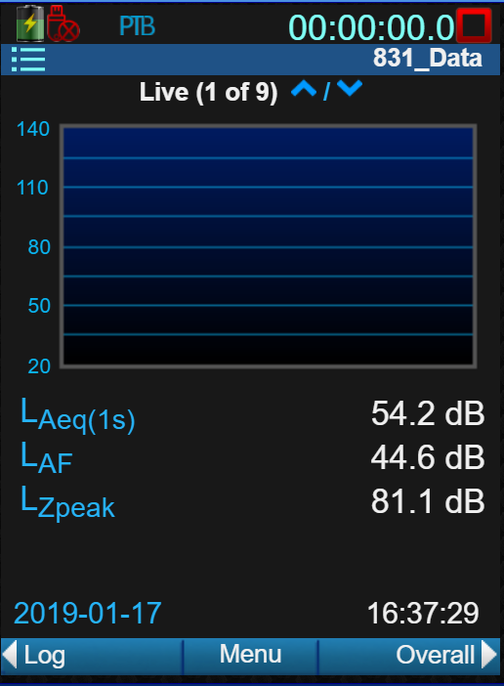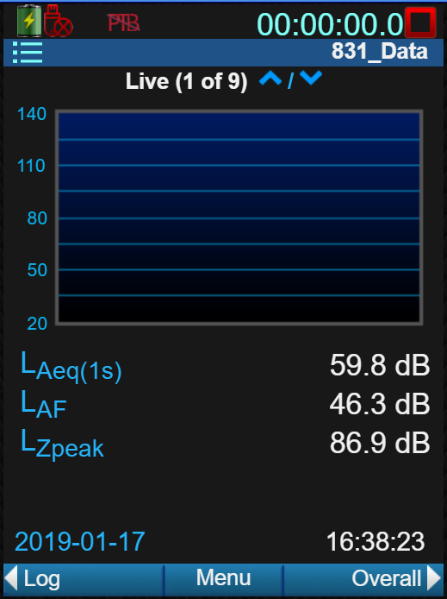
    - Press “On/Off” once, then “Off” using the left soft-key.
    - If it asks if you want to save file, select “No”.
    - Remove the preamp, microphone, and batteries and place in appropriate boxes.
    - Add a red cap (2365.0001) to the top of the instrument.
    - Place the Attention note I831.03 on the instrument so that it is visible when the unit is unpacked by the user (831 only).
    - If the instrument is being shipped on an “Ixxxxxx” order, verify the WEEE symbol is on the back of the instrument, and the bottom of the preamplifier and microphone box. If no symbol is found, add the WEEE sticker to the back of the instrument, and the bottom of the microphone, and preamplifier box.
    - Complete the Final Inspection Form (D2140.0017-1), print, sign, and place the form with the instrument. The form is located in R:\Provo\Quality\Quality Management System\Work Instructions\Quality Assurance.
    - Sign a “QA Final Inspection” (D0002.2003) slip and place with the instrument.

  - Functional Inspection for Service Instruments/Re-calibrated Instruments

Service Return

    - Verify RMA and equipment list match
    - Look at the RMA, to determine what service work was required.
    - Verify, the instrument has had the service work done
    - DO NOT CHANGE CUSTOMER SETTINGS
    - If you find something out of the ordinary, ask for the Technicians help.
    - If the unit is returned “AS IS” do not try to calibrate the unit.
    - Assemble the instrument with preamp and microphone.
    - Remove the battery door.
    - Install the four batteries.
    - Place the calibrator over the microphone.
    - Turn on the instrument by pressing the power key on the key pad.
    - Press the “TOOLS” key.
    - Using the arrow keys and the “ENTER” key, open the “Calibrate” menu.
    - In the “Calibrate” menu, use the customer selected calibrator.
    - The instrument is programmed with the customer settings. If you need to use a different microphone type, do the following: (Do Not Change Customer Settings).
  - Using the right soft-key, access the “Sensitivity” (831) or “Settings” (831C) menu.
  - Under “Type” (831) or “Microphone” (831C), select the correct microphone. If “other” is already selected “USE AS IS”
  - Press the Left soft-key back to the “Calibrate” menu.
    - Instrument will take a few seconds to calibrate.
    - Click “Enter” to accept calibration change.
If it says “Out of normal range”, do not accept and get technician.
    - Press right soft-key to the “History” menu.
    - Verify right hand column against “Limits” in the following chart – the number could be between the “Min” and “Max” level.
However, does not have to be in limits if the customer settings change this. If you have a concern ask the technician for help.

Microphone Model Number | Limits  (dB re. 1 V/Pa) |  | Nominal Sensitivity | Self-Noise
Microphone Model Number | Min | Max | mV/Pa | dB
377B02 | -29.3 | -23.3 | 50.00 | 15.0
377B20, 377C20 | -29.3 | -23.3 | 50.00 | 14.0
377B01, 377C01 | -58.2 | -52.2 | 1.80 | 35.0
377B10, 377C10 | -64.7 | -58.7 | 0.85 | 35.0
377A13, 377B13, 377C13 | -41.5 | -35.5 | 12.33 | 18.0
377A15 | -29.7 | -23.6 | 50.00 | 10.0
377A12 | -69.0 | -75.0 | 0.30 | 60.0

    - Record the offset on the QA Pre-shipment log.
Right arrow to “Certification” and verify date against calibration date.
    - If 831C is in an AudCal System. Back out to the main menu. Go back into tools, Arrow down to select SLM Mode.
Close all menus and return to the opening screen. The reading should be between 113.5 and 114.5 dB. (**Note: If the CAL250 is used, verify the Z-weighted level is between 113.5 and 114.5 dB. This can be done by navigating through the live screens by pressing the up arrow key).
    - Push “Run”, then wait five seconds to allow observation of the instrument taking a measurement, record cal level on the QA Pre-shipment Log, then push “Stop” and then “Reset”, ENTER on “Yes”
    - If the 831C is in an AUDCAL System go into Tools, arrow back down to select AudCal mode.
    - If applicable, verify firmware upgrade. Go into Tools, About and look at the Firmware Rev. Make sure it matches what is listed on the calibration certificate. Close all screens.
    - If the meter is PTB approved, verify that the PTB icon is blue on the screen. If the icon is red or missing, return meter to technician.
    - Press “On/Off” once, then Off button next to screen Off.
    - If it asks if you want to save file, select no.
    - Remove the preamp, microphone, and batteries and place in appropriate boxes.

  - 831/831C-LOWN Calibration
Refer to Figure 831 and Figure 831C below for the following steps.
- Turn on unit and plug in ICP preamplifier 378A04 using the ADP074 and BNC cable.
- Navigate to the Sensitivity tab for the 831, or the Calibrate Settings tab for the 831C in the Calibrate Tool.
- Verify that with the ADP074 and 378A04 connected that the Preamp is ICP in Sensitivity screen for the 831, or in the Calibration Setting screen for the 831C.
- Change the Type to Other for 831 or the Microphone to Other for the 831C.
- Enter Nominal from “System Sensitivity @ 1000Hz” field of the Calibration Report for the 378A04. Hit save.
- Enter Self Noise from “Inherent Noise” field of the Calibration Report. Hit Save.
- Navigate to the Calibrate tab of the Calibrate Tool.
- Select the “LD CAL200, 94.0 dB 1000.0Hz”
- On the CAL200 set the level to 94dB.
- Calibrate as normal. Verify that the Out of Calibration Range error does not appear otherwise get assistance.
- Verify on the Sensitivity tab for the 831 that the Sensitivity is near the published “System Sensitivity @ 1000 Hz” field value. Allowed range for the Sensitivity from 354.81 to 562.34
- Verify on the Calibration Settings tab for the 831C that the Actual is near the published “System Sensitivity @ 1000 Hz” field value. Allowed range for the Sensitivity from 354.81 to 562.34
- Record the Sensitivity level for 831, the Actual level for 831C.
- From the History tab, record the offset.
- From the main screen, record the calibration level.

Figure 831
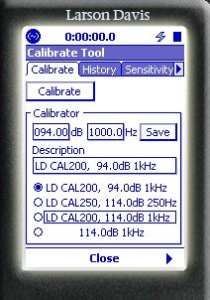
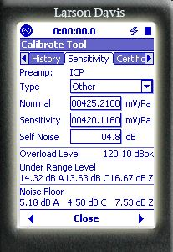
3
4
5
11
8
6

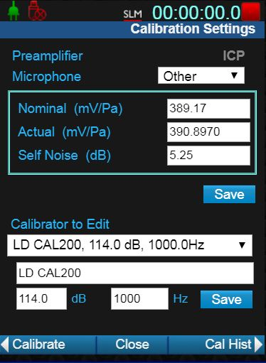
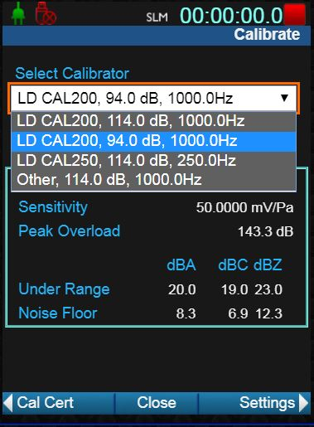
Figure 831C
3

4
5
8
12

6

- PAPERWORK

Record the inspection on the QA Pre-Shipment Inspection Log, D0002.2044.

Initial and date the order. Place the unit on the inspection shelf or notify shipping that the unit is ready.

- REVISION HISTORY

DCO# | REV | DATE | INITIALS | CHANGES MADE
 | A | 8/14/06 | JEB | Initial release
1069 | B | 5/9/08 | MRH | Updated procedure
1346 | C | 5/24/11 | AJR | Added I831.03 Attention note
1345(b) | D | 8/4/11 | MRF | Updated procedure
1376 | E | 4/6/12 | MRF | Updated procedure
1684 | F | 28Mar2017 | AJR | Added 831C to this procedure and updated the limits for ¼” microphones
1798 | G | 4/30/18 | AAC | Updated procedure
1868 | H | 1/23/2019 | DPW | Added PTB and 377A15 Information, Added 831/831C-LOWN
1899 | I | 8/30/19 | AAC | Updated instruction for Audcal systems 4.5 17 &20 , 4.6 15 & 17, section 4.5 step 26 to add PTB units.
1904 | J | 2/26/2020 | AAC | Updated procedure

