**NoiseTutor Outgoing Inspection Procedure**

# PURPOSE AND SCOPE

This document provides the inspection procedure for the NoiseTutor systems (NMS021, NMS022, and EPS041) to ensure compliance of these systems to established specifications.

# LIMITATIONS

This instruction applies to the NMS021, NMS022, and EPS041 NoiseTutor products prior to shipping.

# AFFECTED DEPARTMENTS

Inspection

# REFERENCE DOCUMENTS

* None

# RESPONSIBILITIES & AUTHORITY

The technician has the following responsibilities and authority:

* Print a copy of order verification for new orders.
* Inspecting the NoiseTutor system for manufacturing quality defects, specifically proper cabling/wiring,
* Verifying the software on boot-up and NoiseTutor license file installation
* Verifying 831 connection (if 831 is included)
* Checking charge-status of battery
* Verifying/setting configuration of 831 (if included follow D0001.2047 pre-shipment inspection for 831)
* Filling out NoiseTutor Quick start Guide,
* Add note to outside of case whether this shipment contains a battery or not.
* Delivering system to Shipping

# SAFETY PRECAUTIONS

* Follow general electrical precautions for working with energized, low voltage circuits

# EQUIPMENT & MATERIALS

* completed NoiseTutor system: either NMS021 or EPS041 from Production
* 831 or T021.01, 18-pin voltage measurement tool, if inspecting EPS041

# INSPECTION PROCEDURE

## Inspect the NoiseTutor system for defects

**Step 1:** Visually inspect the NoiseTutor system for scratches, dents, or other obvious defects on the top-cover sheet-metal, the display, or the 831, if applicable.

*Step 1A:* Return system to Production for repair if obvious quality flaws are found.

**Step 2:** Flip the black power switch  to ON (left side down) and press the monitor power button  to turn the system ON. The display should momentarily flash **HDMI** in the upper left-hand side, Figure 1, below, before displaying the PC Desktop, below, along with automatic boot-up of the 831, if applicable.

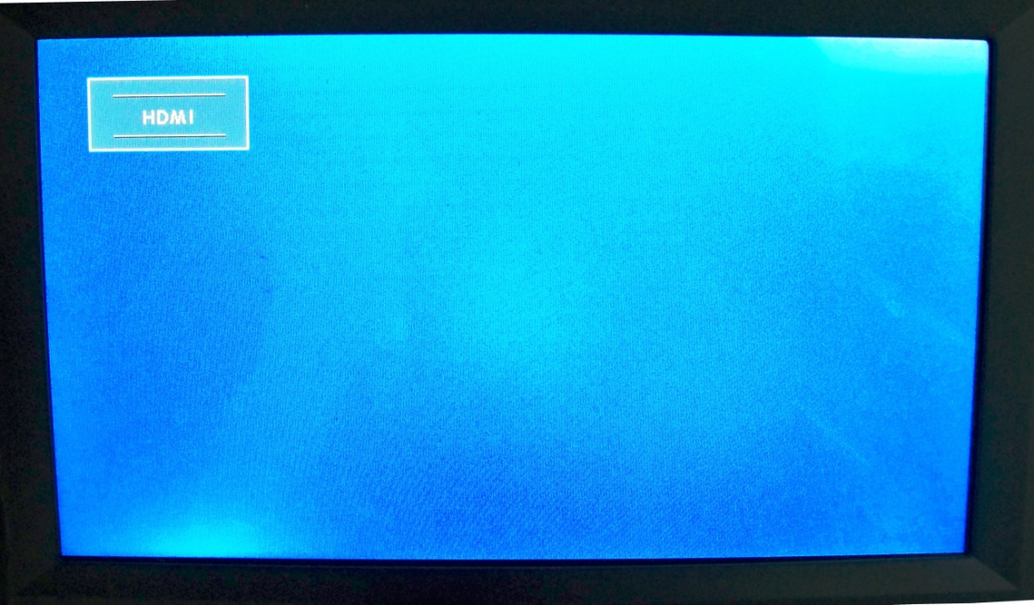

**Figure 1.** HDMI Display showing HDMI input is selected

*Step 2A*: If the system does not power ON (the monitor power button lights-up), attempt to charge the system for 3 hrs.

If the system does not power ON after charging the battery, return the system to Production for diagnostic.

*Step 2B:* If the PC desktop not appear, attempt the following:

*Step2B-1:* With the monitor powered, press the **AV/PC** button  on the display until the display shows **HDMI** in the upper left-hand corner as in Figure 1, above.

If this action does yield the PC desktop, check the HDMI cable connection on both the PC and the monitor.

*Step2B-2:* Check the PC power by verifying that the power lights on the PC are on or flashing as in Figure 3, below.

If the power lights are not ON, press the power button on the PC also shown in Figure 2, below.

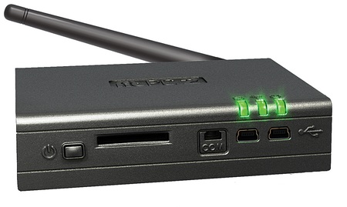

**Power Indication Lights**

**Power Button**

**Figure 2.** PC power button and power indication lights

*Step 2C:* If the above actions do not yield the PC desktop, return the system to Production for further diagnostic.

**Step 3:** If the 831 does not power on automatically, ensure the power switch on the bottom of the 831 is turned to the ON position and the 18 pin connector is connected into the 831.

*Step 3A:* If power switch on the bottom of the 831 is in the ON position and the PC and display are powered, plug the system into an AC source.

If the 831 does not power-up with these changes, return the system to Production.

## Verifying Software Boot-up and License File Installation

**Step 1:** After successfully powering the NoiseTutor station, verify that the PC automatically logs-in to Windows.

If the system does not automatically login-in to Windows, return the system to Production for repair.

**Step 2:** Ensure that the NoiseTutor client pops up along with the Wireless Watcher dialog as in Figure 3, below.

If either of these applications does not automatically load after log-in, return the system to production for repair.

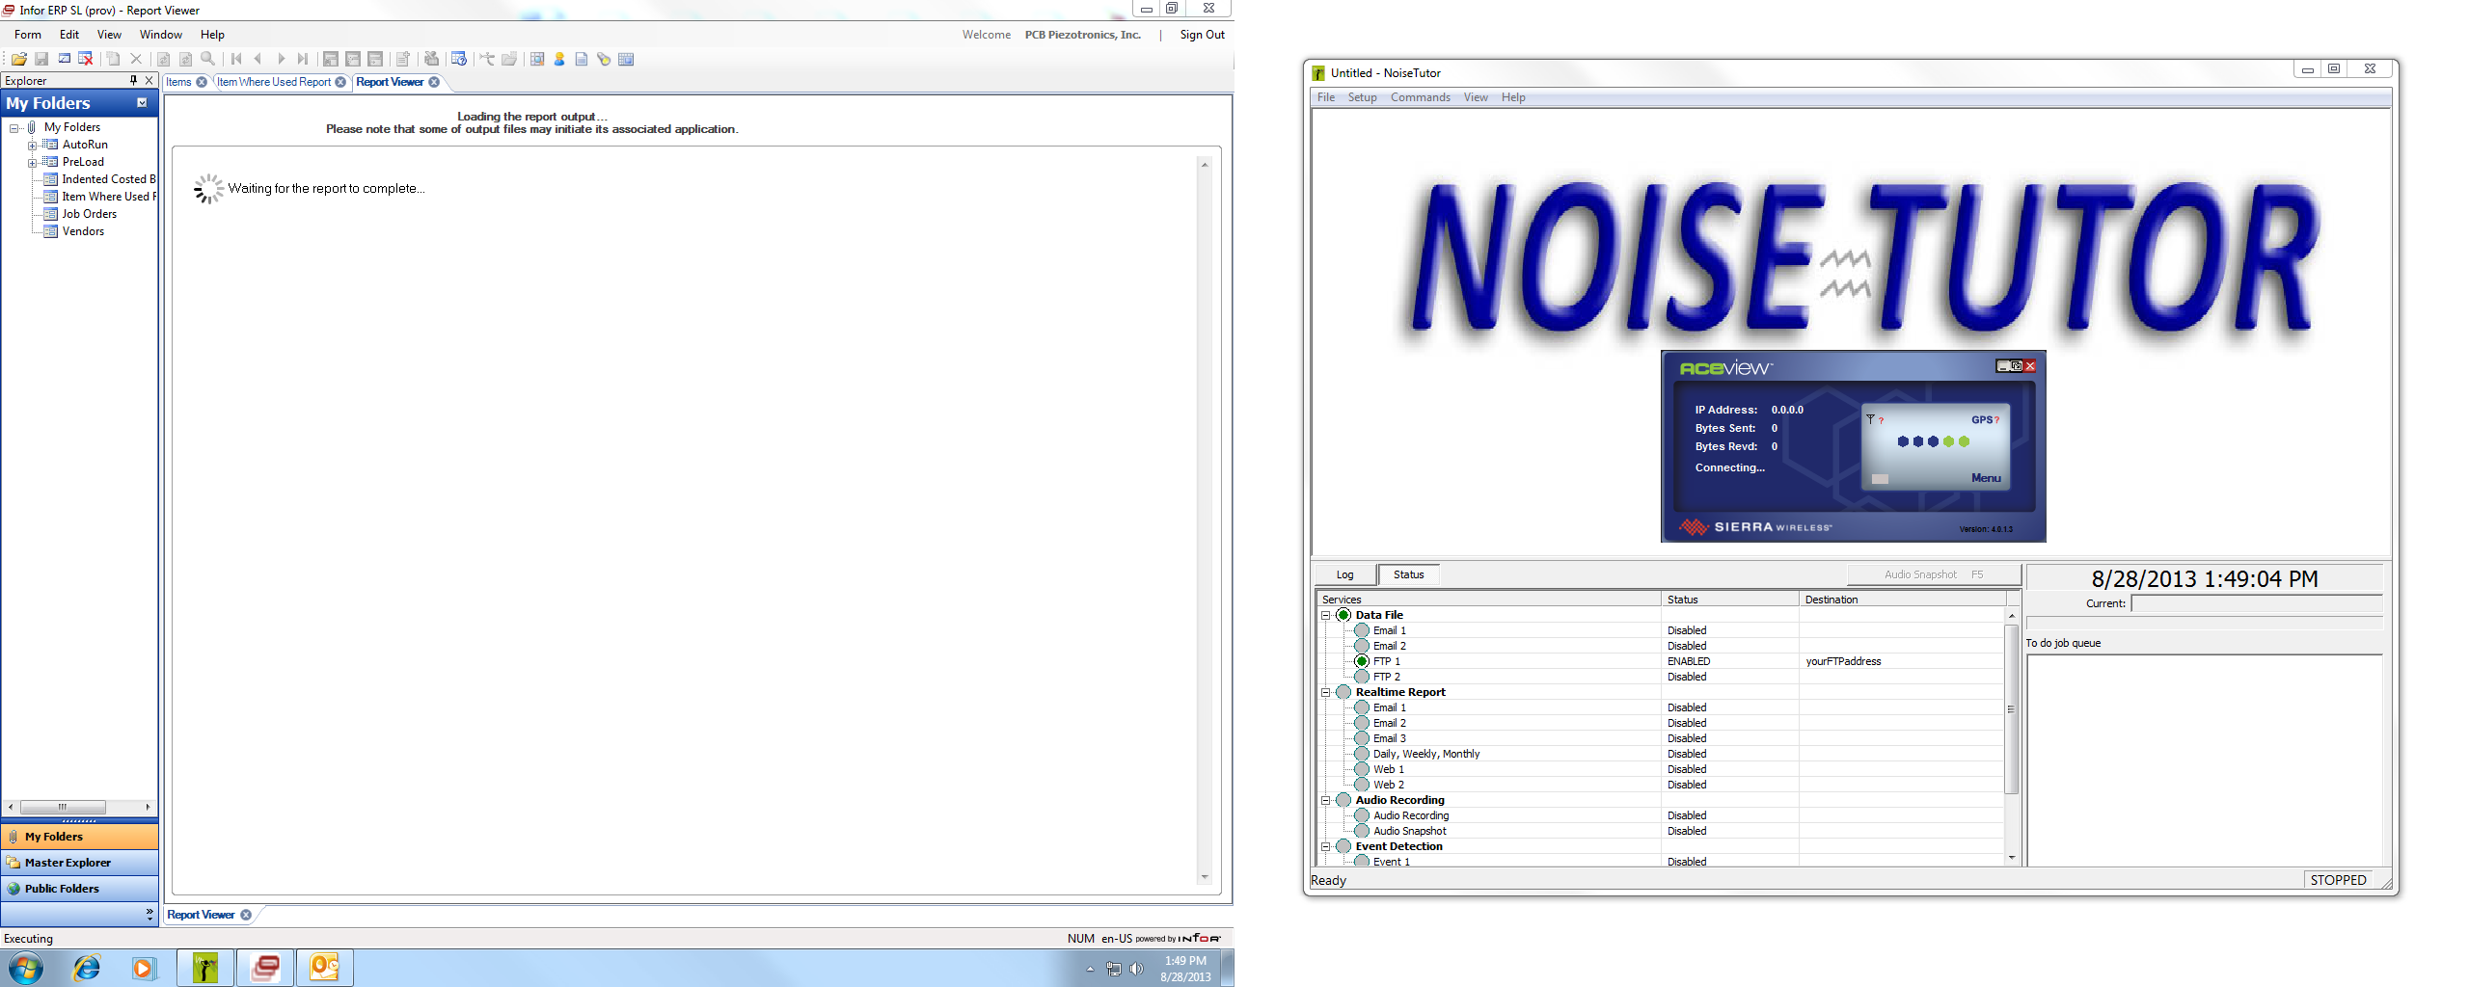

**Figure 3.** NoiseTutor and Wireless Watcher applications upon boot-up

*Step 2A:* If the AceView dialog continually displays “Connecting…”, open the bottom shelf and ensure the Ethernet Cable connections are secure.

If the AceView dialog persists with “Connecting…”, return the system to Production.

*Step 2B:* If the AceView dialog displays that the system is connecting to the network, check the SIM card installed box on the NoiseTutor Quick start guide.

If not the modem displays, “No SIM Inserted”, do not check this box and continue with the inspection.

**Step 3:** Verify system has received proper license file through the following instructions.

*Step 3A:* In the NoiseTutor Toolbar, select **View 🡪 NoiseTutor Folder**

*Step 3B:* Verify that the NoiseTutor Folder contains the file:

“NT_831_LxT_XXX.lc”

where the XXXX is the last 4 digits of the 831 serial number requested on the NoiseTutor order or that of the 831 installed into the station.

## Verifying 831 connection to PC (only applicable systems with an installed 831)

**Step 1:** Verify the 831 is connecting to the PC through the following instructions.

*Step 1A:* In the NoiseTutor Toolbar, select **Commands 🡪 Start**

*Step 1B:* Ignoring any error messages, the NoiseTutor **Log** should state that the 831 is connected as in Figure 4, below.

If the NoiseTutor Client cannot connect to the 831, return the station to Production for repair.

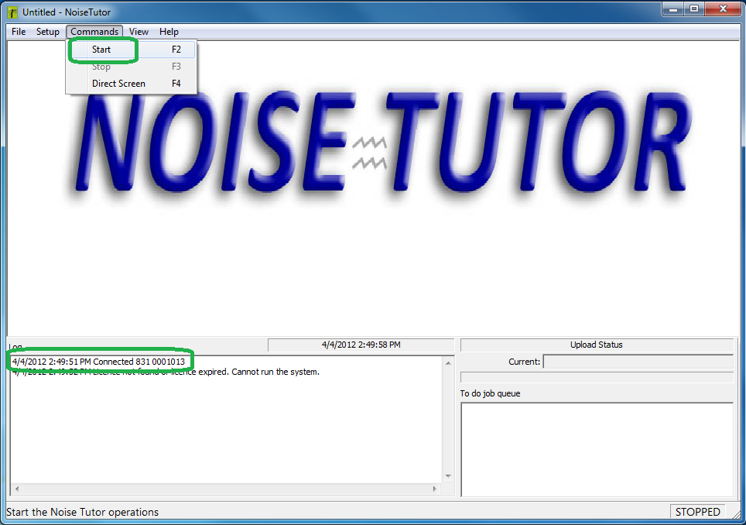

**Figure 4.** Ensure 831 is connecting to PC through NoiseTutor software

**Step 2:** Shut-down PC through the start menu.

## Check battery charge status using 831, for EPS041 (no 831 installed)

**Step 1:** Connect your 831 to the 16-pin connector and power the 831 ON by pressing the **ON/OFF** button on the 831.

**Step 2:** Scroll to the power information screen shown in Figure 15, below, on the **Live** Tab in the 831 (Press up once from default screen).

The system is charged when the **External Powered** value is 14.4V or above as shown in Figure 5, below.

If this value is below 14.4V the system should be charged prior to shipping, 4 hours maximum.

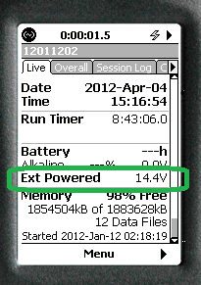

**Figure 5.** Ensure the 831 external power is 14.4V or above

**Step 3:** Power down your 831 and disconnect it from the NoiseTutor system.

## Verifying configuration settings on the 831, for NMS021 (831 installed)

**Step 1:** Scroll to the power information screen on the **Live** Tab in the 831 (Press up once from default screen).

The system is charged when the **External Powered** value is 14.4V or above as in Figure 5, above.

If this value is below 14.4V the system should be charged prior to shipping, 4 hours maximum.

**Step 2:** Scroll to the **Control** screen in the 831 **settings** menu by selecting the **menu** key and selecting **Enter** to pull up the settings menus.

Step 2A: Scroll to the **Control** tab.

Step 2B: Verify or set the **Run Mode** to **Continuous** and the **Auto-store** to **1/day** as in Figure 6, below.

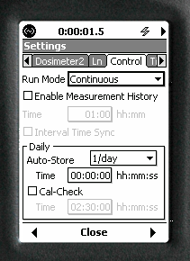

**Figure 6.** Set run-mode in 831 of Auto-store

Step 2C: Select **CLOSE** to exit the settings menu and select **OK** to reset the 831.

**Step 3:** Scroll to the **Power** Tab in the 831 **System Properties** menu by selecting the Tools button, selecting the **System Properties** button, and pressing right twice.

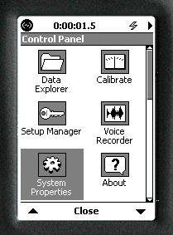

**Figure 7.** Select System Properties in 831 Control Panel

*Step 3A:* Verify or set the **Power-Save Time** to **5 min**.

*Step 3B:* Verify or set the **Ext Shutoff Voltage** to **12.0 V**.

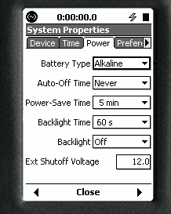

**Figure 8.** Set Power-Save Time and External Shut-off Voltage in 831

*Step 3C:* Select **Close** and **Yes** to apply changes.

**Step 4:** Power down the 831 and turn the black system power button off.

## Filling out Quick start Guide

**Step 1:** Select the “Model 831 installed” box on the NoiseTutor Quick start Guide if the system contains an installed 831.

**Step 2:** Select the “SIM card installed” box on the NoiseTutor Quick start Guide if a SIM card was verified in the system prior. See Section 8.2.

**Step 3:** Select the “License file installed” box on the NoiseTutor Quick start Guide if at least one license file was found in the NoiseTutor folder.

# Paperwork

Record the inspection on the QA Pre-Shipment Inspection Log, D0002.2044. Initial and date the order. Place the unit on the inspection shelf or notify shipping that the unit is ready.

# RECORDS

**Step 1:** Record inspection results in Larson Davis product database for the NoiseTutor system (by serial number).

# DISTRIBUTION

Instruction is available online in the “NoiseTutor” folder in the “Technician work instruction” folder in Document Control.

# REVISION HISTORY

|  |  |  |  |  |
| --- | --- | --- | --- | --- |
| **DCO #** | **REV** | **DATE** | **INITIALS** | **CHANGES MADE** |
| N/A | A | 3/15/12 | KCM | Initial release |
| N/A | B | 9/3/14 | KCM | Removed PC Settings |
| 1625 | C | 5/18/16 | NR | Updated Voltages for K2 LFP battery, updated AceView dialog messages, and fixed formatting |
| 1834 | D | 4/27/18 | NJ | Updated procedure to include printing new copy of order, initial and date the order |