QA PRE-SHIPMENT INSPECTION – 2800

1.0 PURPOSE AND SCOPE

This document provides the instructions necessary to perform a pre-shipment inspection of the 2800.

2.0 RESPONSIBILITY

Quality Assurance, or designated person, has the responsibility to follow this instruction when inspecting the products listed in section 1.0.

3.0 MATERIALS AND EQUIPMENT

Always use the instruments that are being shipped with the product.

- CBL078 or CBL092, if needed
- PRM900B or PRM900C, if needed
- ½” LD Microphone, if needed
- Calibrator, if needed
- 12-volt adaptor

4.0 INSTRUCTIONS

Follow the instructions in this procedure concurrent with the D0001.2045 QA Pre-Shipment Inspection Checklist – All Instruments Instruction.

4.1 Inspection

- Print a new copy of order verification for new orders.
- Verify the serial number and model of each product against the order and calibration certificates.
- Verify the certification due sticker is on the back of the instrument and the calibration void sticker is on the side.
- Verify the certification date on the instrument matches the calibration certificate.
- Verify the calibration due date is the interval the customer requested on order. If there is no request, it is left blank.

4.2 Service Product Cosmetic Inspection

- Verify the display is clean and free of fingerprints.

4.3 Functional Inspection

- Assemble the instrument with preamp, microphone, cables, and calibrator into channel 1.
- Apply power to instrument with 12-volt adaptor.
- Turn instrument on by pressing “ON” button.
- If using a cal250, use the arrow keys to change to filter #24, 250 Hz.
- If using a cal200, use the arrow keys to change to filter #30, 1000 Hz.
- Turn on the calibrator.
- Press “R/S” key.
- If OVER comes on the display, Press “Shift” key, then press “R/S” key.
- If OVER is still on the display, press up arrows until the range is at 120.
- Compare to the graph below.

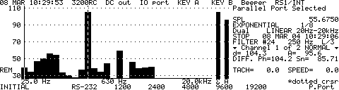

- Press “System” key.
- Press, “Units” key.
- Press “Level” key.
- Press 1, 1, 4, 0 on keypad.
- Press “Exit” key.
- Compare to the graph below. The “D” value should equal 114.0 +/- 0.1

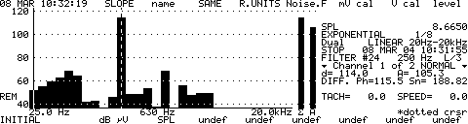

- Connect the microphone extension cable to the channel 2 input of the instrument.
- Press “CH2” key.
- If using a cal250, use the arrow keys to change to filter #24, 250 Hz.
- If using a cal200, use the arrow keys to change to filter #30, 1000 Hz.
- Turn on the calibrator.
- Press “R/S” key.
- If OVER comes on the display, Press “Shift” key, then press “R/S” key.
- If OVER is still on the display, press up arrows until the range is at 120.

- Compare to the graph below.

- Press “System” key.
- Press, “Units” key.
- Press “Level” key.
- Press 1, 1, 4, 0 on keypad.
- Press “Exit” key.
- Compare to the graph below. The “D” value should equal 114.0 +/- 0.1

- Press “Shift” key.
- Press “On/Off” key.
- If the instrument is being shipped on an “Ixxxxxx” order, verify the WEEE symbol is on the back of the instrument and the bottom of the preamplifier and microphone box. If no symbol is found, add the WEEE sticker to the back of the instrument and the bottom of the microphone and preamplifier box.

5.0 PAPERWORK

Record the inspection on the QA Pre-Shipment Inspection Log, D0002.2044.

Initial and date copy of order Place the unit on the inspection shelf or notify shipping that the unit is ready.

6.0 REVISION HISTORY

DCO # | REV | DATE | INITIALS | CHANGES MADE
 | A |  |  | Very old document.
741 | B | 3/1/04 | JEB | Updated the old document to the current format.
1079 | C | 5/09/08 | MRH | Updated procedure
1829 | D | 4/27/18 | NJ | Update to print copy of order verification, initial and date order

