AUDCAL QA INSPECTION PROCEDURE

#### 1.0 PURPOSE

Information about the various components included in AudCal kits needs to be verified in the database inside the kits 831C.

The system also needs to be calibrated with the acoustic coupler, if provided with the kit.

#### 2.0 AFFECTED DEPARTMENTS

Quality Assurance

#### 3.0 REFERENCE DOCUMENTS

**IG4.01** G4 Software Manual

#### 4.0 RESPONSIBILITIES & AUTHORITY

QA personnel will verify that information has been entered into the AudCal database correctly.

#### 5.0 DEFINITIONS

**SYS014, SYS015, SYS016, SYS017, SYS-UPG, SYS-UPG2** – Order numbers for particular configurations of the AudCal Kit.

#### 6.0 SAFETY PRECAUTIONS

No safety precautions indicated for operation of the equipment or performance of this procedure.

#### 7.0 EQUIPMENT & MATERIALS

A desktop PC is required to run the application.

#### 8.0 INSPECTION PROCEDURE

**Step 1: Connect to 831C through G4**

* Connect the 831C to your computer with the USB cable.
* Open G4 application on PC.
* Find the serial number for the meter you are connected to in the meter list and click on it to connect

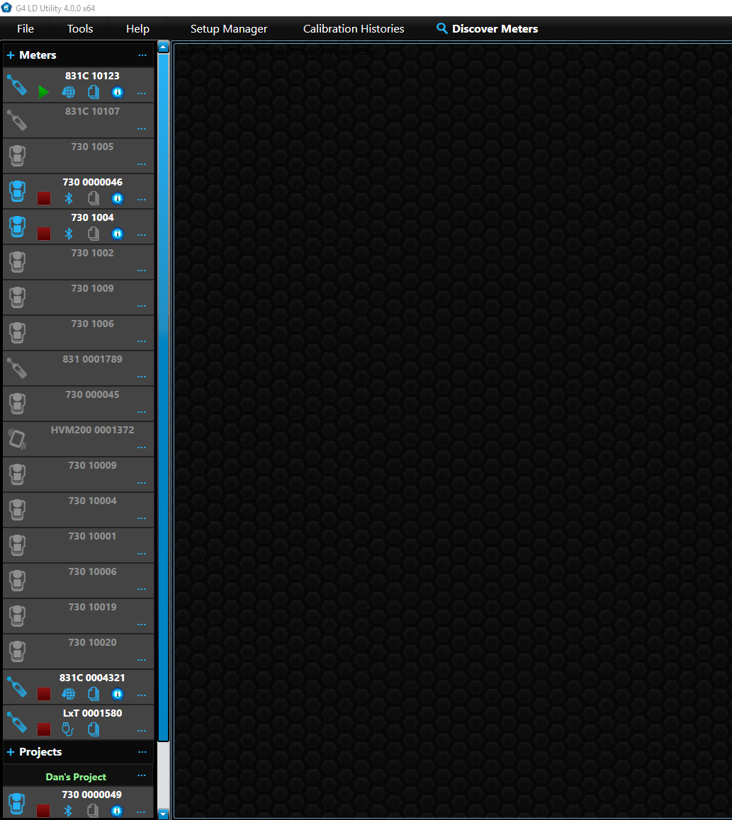

* Select AudCal mode

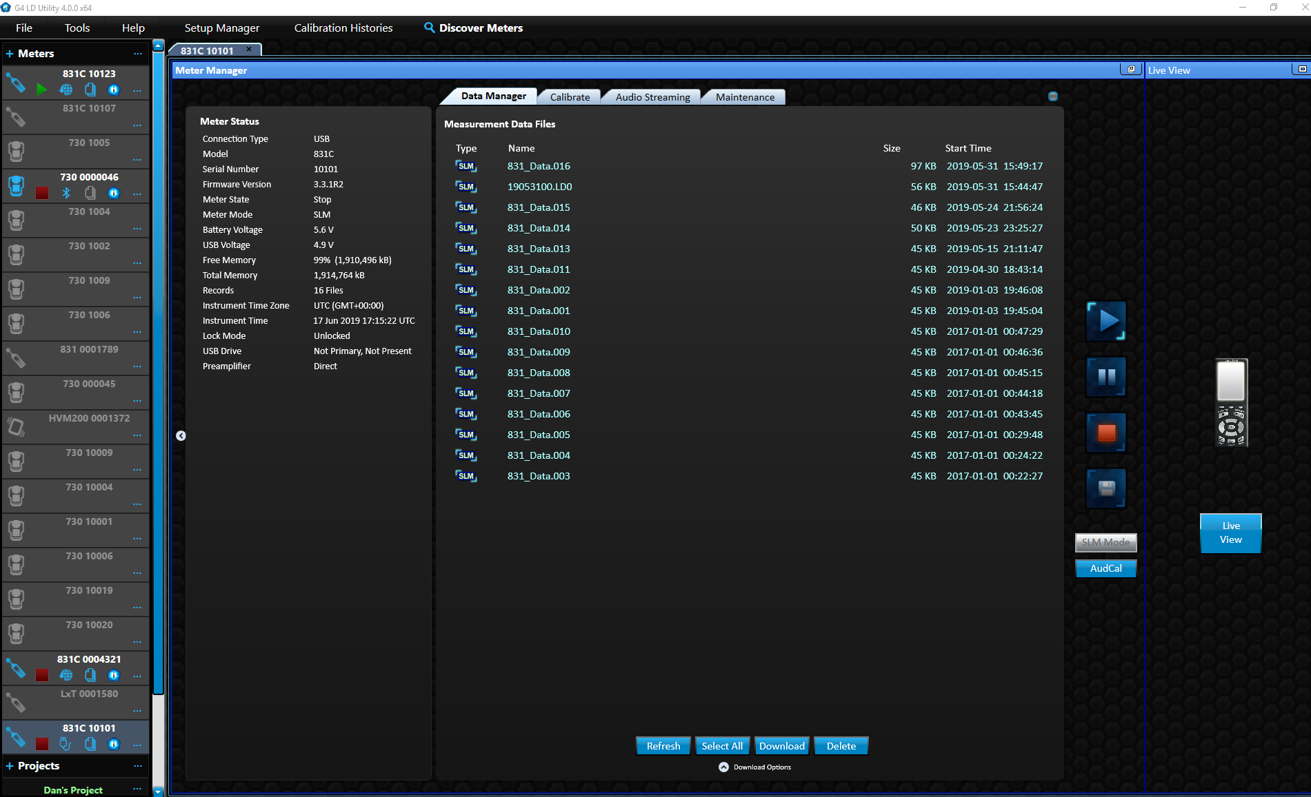

**Step 2: Verify Equipment**

* Click on *My Equipment* to expand the selection.
* Verify that the model, serial numbers, and cal due dates are all correct:

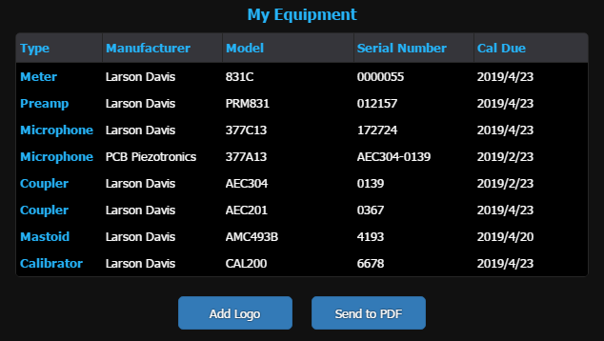

**Step 3: Verify the Microphone Sensitivity and Frequency Response Data (If microphone is included in the order)**

* Expand the microphone folder by clicking *Microphones.*
* Select each microphone in the list (there may only be one). Please note that if an AEC304 coupler is included with the order, one of the microphones listed will be the AEC304 coupler because there is an internal microphone to that system. The frequency response needs to be verified at 2 or 3 points from the calibration certification from the order.

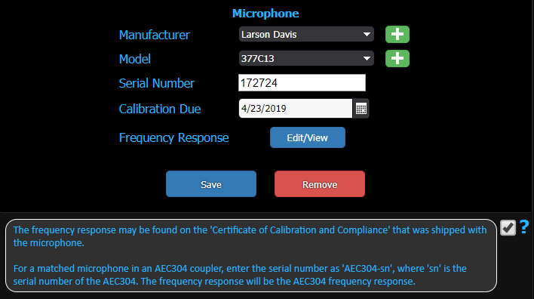

* Select *the Edit/View* button to view the frequency response data.

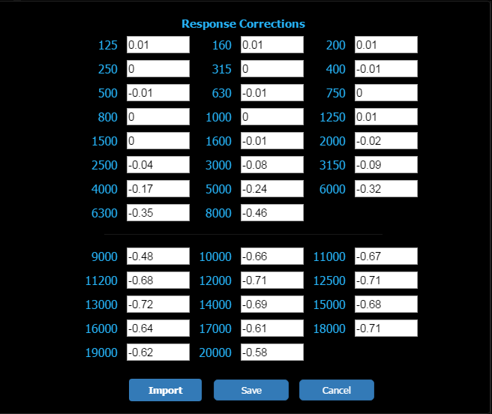

* + 1. Verify that the date in the microphone response file saved on the USB drive is correct for the current calibration certificate.
    2. Verify that the response correction values in AudCal and the values on the USB drive match at 1 kHz and 10 kHz.

**Step 4: Verify the Mastoid Frequency Response Data (If included in the order).**

* Expand the Mastoid folder by clicking *Mastoids.*
* Select the mastoid

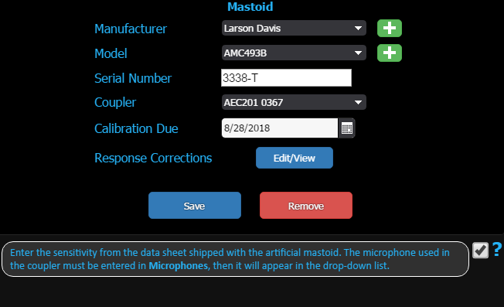

* Select the *Edit/View* button to view the frequency response data

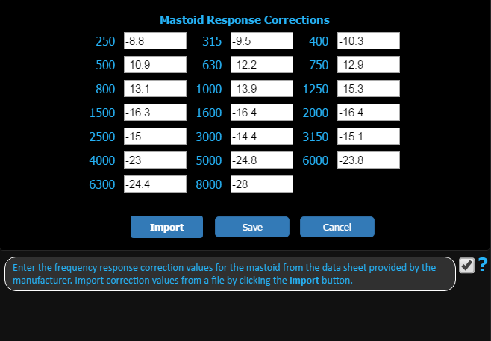

* Open the source file for the frequency response:
  + 1. Verify that the data in the Mastoid response file saved on the USB drive is correct for the current calibration certificate.
    2. Verify that the response correction values in AudCal and values on the USB drive match at 2-3 frequencies.

**Step 5: Assemble the System**

* Install microphone into coupler (377A15 in AEC100, 377C13 in AEC201) (Not applicable for SYS-UPG and SYS-UPG2 orders).
* Install the PRM831 preamp into the coupler (Not applicable for SYS-UPG and SYS-UPG2 orders).
* Connect the EXC006 between the 831C and the coupler. Coil excess cable neatly in upper right pocket in foam. For SYS-UPG and SYS-UPG2 orders, just connect the EXC006 to the 831C and coil the other end in the upper right pocket in foam.
* Insert DVX014 wifi dongle into the meter.
* Plug in 0621.0095 USB cable into meter. Coil excess in main compartment of case.

Case should appear as picture below (SYS017 Shown)



**Step 6: Calibrate the System**

* Follow D0001.2047 for the pre-shipment inspection of the 831C. Using the CAL250, calibrate the 831C with the coupler (either AEC100 or AEC201) connected. For a SYS-UPG, just calibrate with the provided 377A15 outside of the coupler. For a SYS-UPG2, use a mic with a nominal 50 mV/Pa sensitivity (377A15, 377B02, etc…). For SYS-UPG and SYS-UPG2, place PRM831 back into case for shipment.

#### 10.0 RECORDS

The only records generated by this work instruction are the database entries on the 831C.

#### 11.0 DISTRIBUTION

This Work Instruction is available online in the work instruction area of Document Control.

#### 12.0 ATTACHMENTS

No attachments applicable to this process.

#### 13.0 REVISION HISTORY

|  |  |  |  |  |
| --- | --- | --- | --- | --- |
| **DCO #** | **REV** | **DATE** | **INITIALS** | **CHANGES MADE** |
| 1822 | A | 4/16/18 | DPW | Initial release. |
| 1897 | B | 6/12/2019 | DPW | Added instructions for SYS-UPG |
| 1951 | C | 3/27/2020 | TLB | Steps 3 & 4 now include instructions to verify information contained on the USB thumb drive. |
|  |  |  |  |  |
|  |  |  |  |  |
|  |  |  |  |  |
|  |  |  |  |  |
|  |  |  |  |  |
|  |  |  |  |  |
|  |  |  |  |  |
|  |  |  |  |  |
|  |  |  |  |  |
|  |  |  |  |  |
|  |  |  |  |  |