Title: S730.02 Battery Mechanical Inspection Author: Alan Rasmussen

DOC Number: D0002.2068

Revision: A

**Larson Davis S730.02 Battery Mechanical Inspection**

The **S730.02** “BATTERY, LITHIUM FOR BAT022” is inspected using the **T730.12** “TOOL S730.02 GO NO GO” fixture**.**

**BATTERY INSPECTION AND TOOL USAGE**

The T730.12 tool used to verify that the S730.02 battery is in mechanical tolerance as specified on the S730.02 assembly drawing.

1. Place the tool on a flat surface oriented as shown in the photographs below.
2. DO NOT FORCE THE BATTERY INTO THE TOOL, WATCH FOR INTERFERENCE DURING THE EACH STEP.
3. 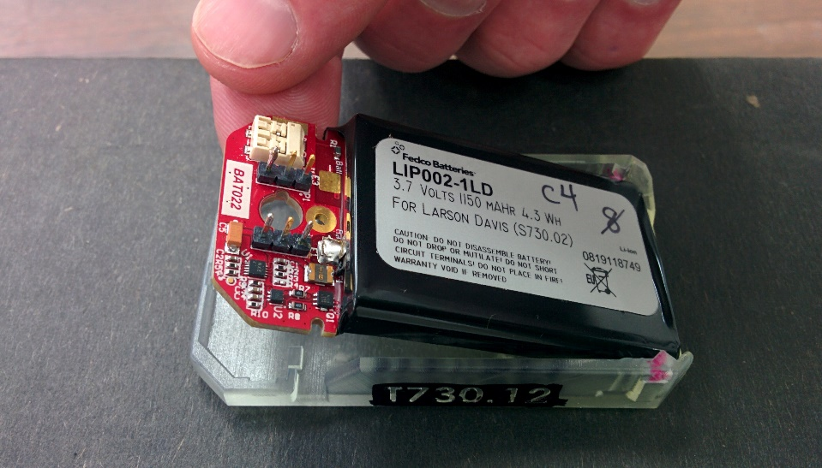Place the finished S730.02 into the tool at an angle, battery end first with the connector pins facing up as shown.
4. Lower the connector end of the battery until the printed circuit board meets the surface of the tool.
5. Verify that there is no interference between any part of the battery and the tool. Pay particular attention to the two red marked areas. No part of the battery to extend above the top wall of the tool.

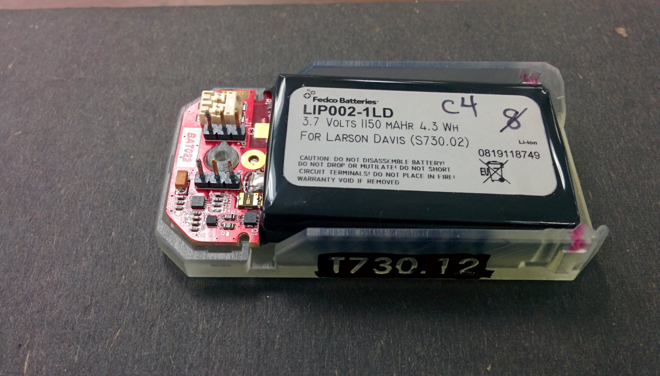

No interference at the two undercut areas marked in red.