**730 Pre-shipment Quality Inspection**

1. **PURPOSE AND SCOPE**

This document provides the instructions necessary to perform a pre-shipment inspection of the Spartan Model 730 and 730IS. All references to “meter” refers to either of the models, **730** or **730IS**. Certain instructions are specific to one of these models and will be clearly identified by model.

🛈

Additional Instructions and Inspection for Intrinsic Safe Model **730IS** will be highlighted with this gold shaded background.

1. **RESPONSIBILITY**

Quality Assurance, or designated person, has the responsibility to follow this instruction when inspecting the products listed in section 1.0.

1. **MATERIALS AND EQUIPMENT**

* Meter to be inspected
* CAL150 or CAL200 calibrator with ADP109 ¼” adapter
* Tablet (Android or iPad) with LD mobile utility app installed

1. **INSTRUCTIONS**

Always use the accessories that are being shipped with the product.

Follow the instructions in this procedure concurrent with the D0001.2045 QA Pre-Shipment Inspection Checklist—All meters instruction.

* 1. **Inspection**
     1. Print a new copy of the Order Verification for new orders.
     2. Verify that the microphone is securely mounted.
     3. Verify the certification date on the meter matches the calibration certificate located on the USB flash drive.
     4. Verify that both attachment clips (AM730.11-IS) are installed.
     5. Verify the final checklist has the Customer name and Sales order number. Ensure appropriate boxes are checked in the Final Inspection Checklists by the technician. Check the items under the inspection section. Verify serial numbers match against units. Type in initial and date at the bottom. Final checklist is found on the R drive. R:\Provo\Data\CertData\730IS Final Checklist
     6. Verify the label on the back of the unit reads SPARTAN Model 730IS.
  2. **New Product Cosmetic Inspection**
     1. Verify the presence of screws and the product labels.
     2. Inspect for gouges, scratches, and dents on the case.
     3. Verify the LCD is free of discolorations, scratches, or other blemishes.
     4. Verify the mechanical fit of the two halves of the case. Look for non-uniform gaps and misalignments.
  3. **Service Product Cosmetic Inspection**
     1. Verify the meter display is clean and free of fingerprints.
  4. **Functional Inspection**

🛈

For **New Meters**, **New Demo Meters**, or **Demo Sale Meters** perform all steps.

🛈

For **Service Meters**, or **Re-calibrated Demo Meters** skip the steps with this blue shaded background.

If at any time there seems to be something wrong with the meter or this procedure, please contact the QA manager. If the QA manager is not available, contact the responsible technician.

1. Calibrate the meter and verify button functionality. [1]
   1. Turn on the meter by pressing the power button.
   2. Place the calibrator over the microphone and turn it on.
   3. Meter will automatically begin a calibration that will take a few seconds to complete.

Follow the prompts on the meter and accept a good calibration with the  button.

*[Refer to the manual for instructions on how to calibrate the meter.]*

If an “Out of normal range” message occurs, do not accept; rather get a technician for assistance.

If the unit fails to auto calibrate follow steps below from the main screen. a. Hold to open menu,

b. twice to Calibration,



c.  once,  to Auto Enable

e. Press to ensure unit is Enabled.

f. If it is Disabled press , if it says Enabled 

h. Press  twice to exit

i. Press ,

j. Press  twice to exit

k.  to return to the main screen.

m. Unit should auto calibrate, if it fails to auto calibrate take it to a technician.

* 1. Remove the calibrator.
  2. Navigate to view the Sensitivity as illustrated below.

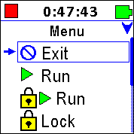 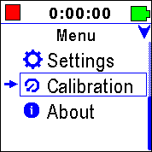 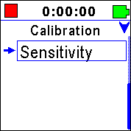 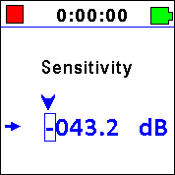

* + 1. From main screen hold the  button until the menu is displayed.
    2. Select **Calibration** using the  or  buttons and then press .
    3. Select **Sensitivity** using the  or  buttons and then press .
  1. Verify **Sensitivity** setting range against following chart.

|  |  |
| --- | --- |
| **Limits (dB re 1/Pa)** | |
| **Min** | **Max** |
| -46.0 | -37.0 |

* 1. Record the **Sensitivity** value on the QA Pre-shipment log.
  2. Exit to the first menu screen by
     1. pressing  five times,
     2. select **Exit** using the  button,
     3. press  one time.

1. Using the LD mobile utility app on a tablet, view the **About** display and verify meter information.
   1. Connect to the specific meter with the LD Mobile app running on the tablet. (The SN shown is specific to each meter.)

 > 

* 1. On the **Tools** > **About** display verify the meter information and the calibration certification:
     1. Model Type
     2. Serial Number,
     3. Certification Date,
     4. Manufactured Date, and
     5. Firmware Version.

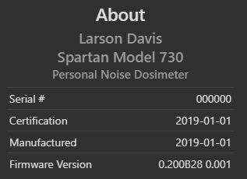

* 1. On the **Tools** > **About** display, swipe up to view the **Options** 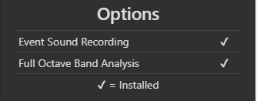
     1. Verify that the options on the sales order are installed.
  2. On the **Live View** scroll the screen to the **Meter Overview**,
     1. Verify that **Total** memory is >7000MB.
     2. Verify that **Battery** level matches the battery icon. 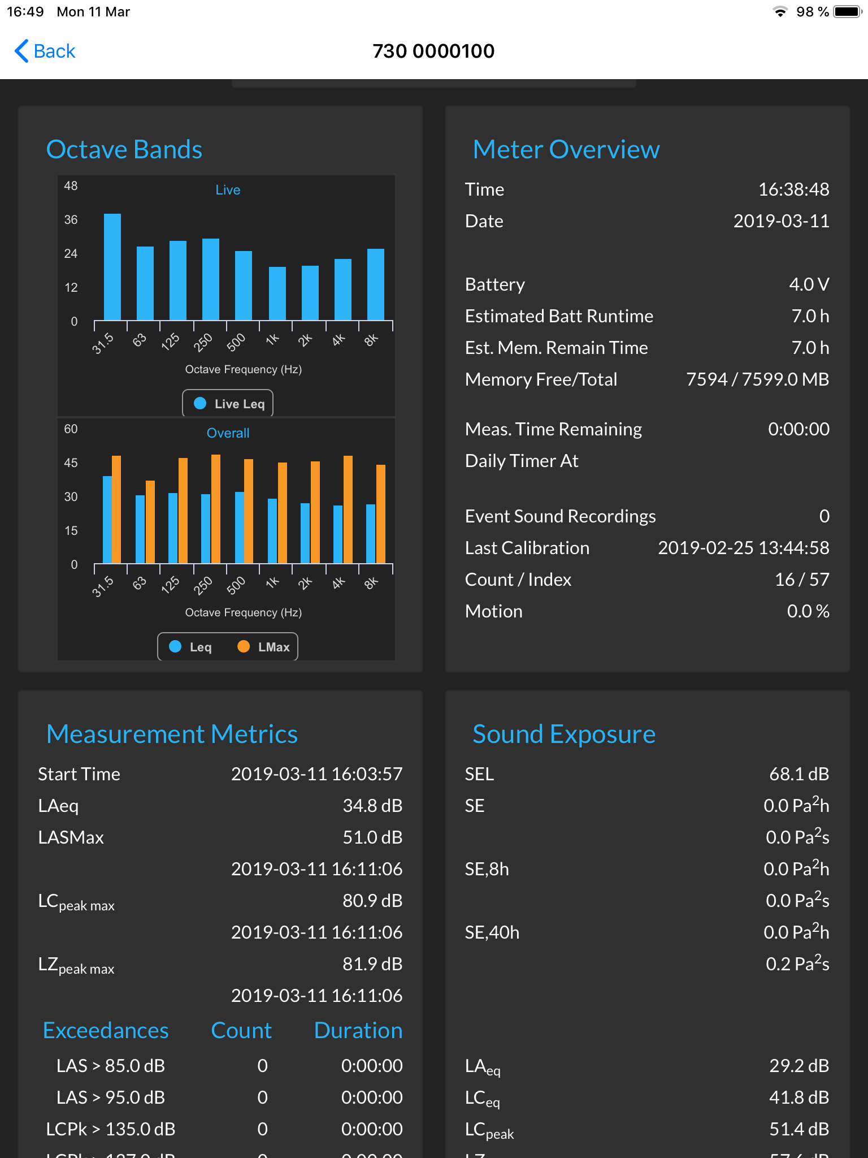

1. Using the LD mobile utility app on a tablet, from the **Tools** menu, press **Format and Restore** to reset data and setting adjustments.

 > 

1. Turn the meter **OFF**

Press and hold the  power button; the display will show a countdown sequence and then turn off. Release the button after the meter turns off.

   

1. Special Accessories Operations
   1. **730IS** meters must ship with the I730.03-IS Safety Instructions booklet and the PS207 EU Declaration of Conformity. (Service Units Excluded unless hardware changed to different revision)
   2. Ensure case has caution ATEX label (3255.0037) and calibrator has Non-ATEX product label (3255.0036) (Service Units Excluded)
   3. When shipping units in a 1, 3, 5 or 10 pack, verify that the wireless charging pads in the cases will charge meters.
      1. Place units into the case over the wireless charging pads.
      2. Plug power into the case supply.
      3. When power is applied, the green charge LED should light in the lower left of the meters status window and the meter should turn on.
      4. Attach the windscreen. Verify that the windscreen and clips are securely attached but can be removed without difficulty.
      5. Units will auto-power-off in 5 minutes. If they are not off then, follow the steps above to turn meters OFF.
   4. When shipping a meter with the KORRVU (0860.0117A) packaging:
      1. Place the protective cap (0680.0026 CAP PROTECTIVE ESD-SAFE 0.3"id 0.56"DEEP) over the microphone.
      2. Press it down until it is secure over the windscreen locks at the base of the stainless steel microphone mount.

This will protect the microphone from damage from the plastic KORRVU film.

* + 1. Place the windscreen with other accessories that ship with this unit.

1. Sign a “QA Final Inspection” (D0002.2003) slip and place inside the envelope containing the calibration certificate.
2. **PAPERWORK**

* Record the inspection on the QA Pre-Shipment Inspection Log, (D0002.2044).
* Initial and date the order.
* Place the unit on the inspection shelf or notify shipping that the unit is ready.

1. **REVISION HISTORY**

|  |  |  |  |  |
| --- | --- | --- | --- | --- |
| **DCO#** | **REV** | **DATE** | **INITIALS** | **CHANGES MADE** |
| 1876 | A | 13 Mar 2019 | AJR | Initial release |
| 1905 | B | 3/16/20 | AAC | Update to current procedures |
| 1953 | C | 09 Apr 2020 | AJR | Added 730IS specific items |
| 1979 | D | 5 Aug 2020 | ADB | Added instructions for 730IS Final Checklist |
| 1987 | E | 1 Sept 2020 | AAC | Added label verification |
| 2010 | F | 27 Jan 2021 | ADB | Excluding DoC and ATEX labels for service units |

1. Calibration can also be done with the mobile app on a tablet; the buttons still need to be tested.