Contents

1 Purpose 1

2 Scope – applies to where & when the Procedure is used 1

3 Definitions and Acronyms (if needed) 1

4 Graphic (if needed) 2

5 Responsibilities 2

6 Operation Procedure 3

7 maintenance Procedure 7

8 Setup Procedure 11

9 Associated Quality Records – as stated in the Quality Records List 14

10 Reference Forms / Templates / Documents 14

11 Current Revision Training Requirements 14

12 Revision History & Approval 14

*Click within the Table of Contents, select* **Update Table > update page numbers**

# Purpose

## The purpose of this document is to define safe operation, inspection, and preventative maintenance for the ADF parts washer in the Paint area

# Scope – applies to where & when the Procedure is used

## This document applies to personnel using, supporting, or maintaining the system

# Definitions and Acronyms (if needed)

## ADF parts washer – A self-contained turntable wash booth manufactured by ADF, model 300

## Rustproof – a rust preventing agent used during the rinse cycle

## Pyrene 1008 – a soap used during the wash cycle

# Graphic (if needed)

N/A

# Responsibilities

## Service providers responsible for performing the maintenance tasks described in this work instruction:

### Production personnel – responsible for the daily operation of the equipment, including (but not limited to):

#### Cleaning of equipment after use

#### Filling out the “ADF parts washer maintenance - Inspection log” form

#### Periodic cleaning and wash tank drain/refill

#### Initiate facility requested as needed for system repair

## Service providers responsible for preventative maintenance tasks outside of the scope of this work instruction:

### MTS Facilities Maintenance – responsible for the inspection, repair, and overall operation of the equipment, including (but not limited to):

#### Compressed air filter replacement as requested

### Metrology – responsible for the calibration of the equipment, including (but not limited to):

#### N/A

# Operation Procedure

## Daily Inspection

### Verify that the Soap and Rust proof 55-gallon drums have enough liquid for the days use(replace as needed)

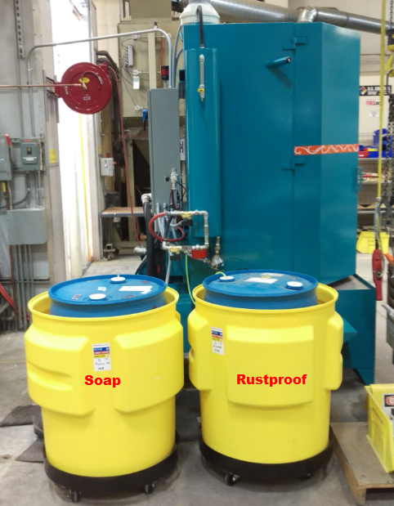

### Inspect Chemical injector lines

#### Soap Chemical Injector

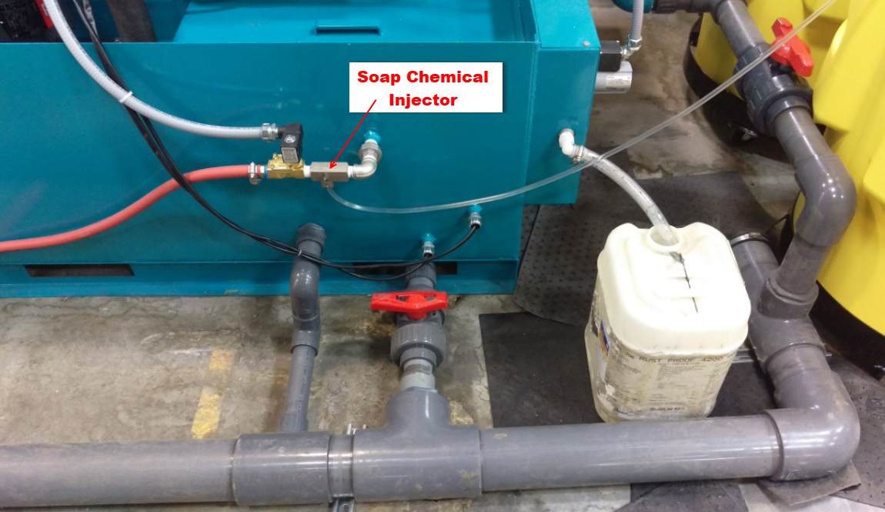

#### Rustproof Chemical Injector

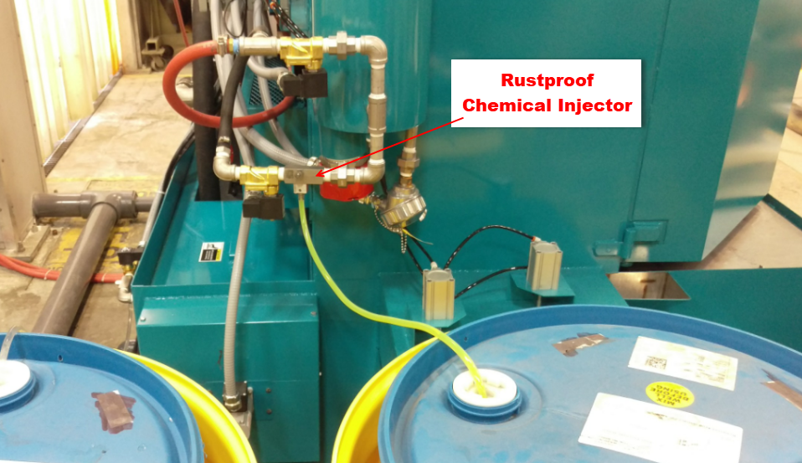

### Check Oil slimmer waste container and empty as needed

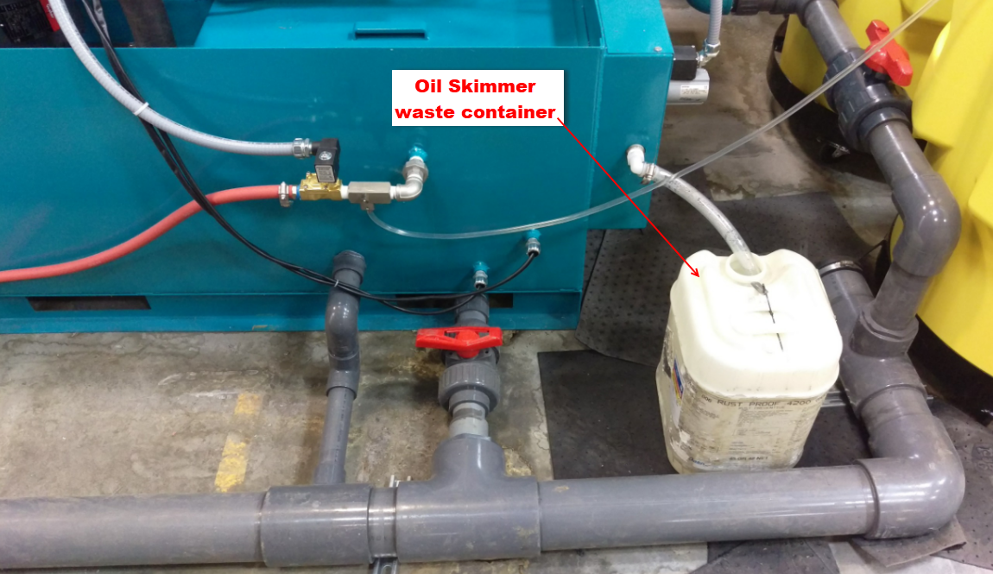

### Visually inspect system for air leaks, water leaks, etc.

### Verify that the filter status indicator is in the green range

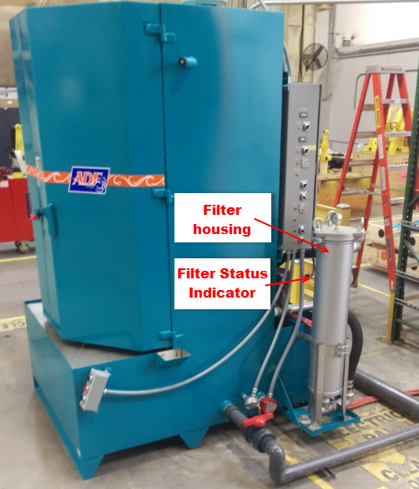 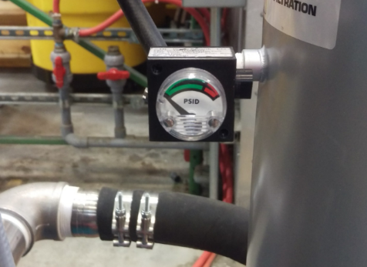

### Verify Air pressure is set to 50 psi

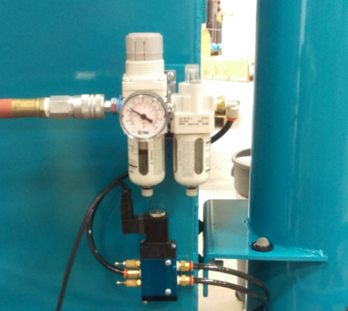

### Complete the daily inspection log

## Daily Start up

### On the main control panel, Turn “ON” the Wash heater, Rinse heater, Rinse cycle, Oil Skimmer and Autofill if not previously turned “ON”

## 

### Verify that the Wash and Rinse temperature are up to temp

### Wash temperature set point -140 degrees F

#### Rinse temperature set point -140 degrees F

### Verify the wash and rinse timer settings

Wash cycle – 3 minutes

Rinse cycle – 1.5 minutes

### Set the Rinse Inhibitor switch

#### For ferrous metal (like Steel) – set to “ON”

#### For non ferrous metal (like Aluminum) – set to “OFF”

### Open the wash doors and load parts into the turn table basket

#### Note: For Pistons requiring Xylon – remove the basket and install the piston rod fixtures into the turn table

### Close the wash doors

### Press “Wash ON” to activate the wash cycle

### 

### Once the wash cycle is complete, Open the wash doors

### Blow any residual moisture off the parts with an air gun as needed and unload the parts

### If the parts are still dirty or have a residual film see the Setup section

## Daily Shut down

### Turn off the Rinse Heater

# maintenance Procedure

## Production personnel

### Monthly or as needed

#### Note: More frequent maintenance may be required based on workload and the cleanliness of incoming parts

### Turn off wash heater, rinse heater, oil skimmer and autofill

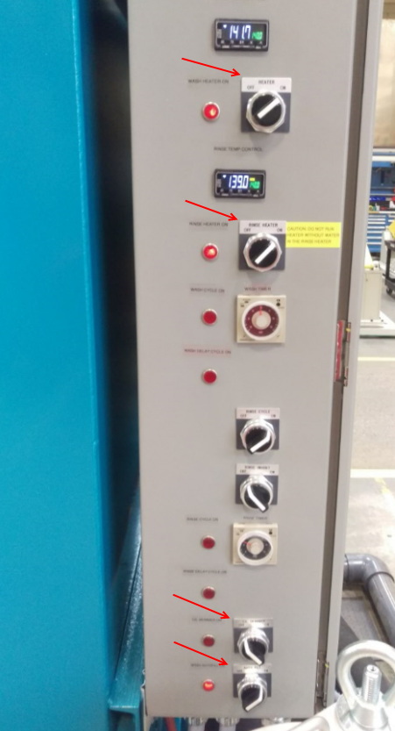

### Open the wash tank drain ball valves #1 & #2 and allow the old soap/water to drain into the floor drain.

#### Note: Drain Valve #3 (rinse water drain) should remain open always

#### Note: Be careful not to flood the floor

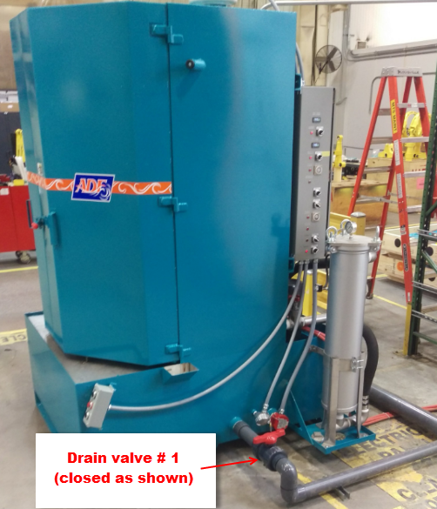 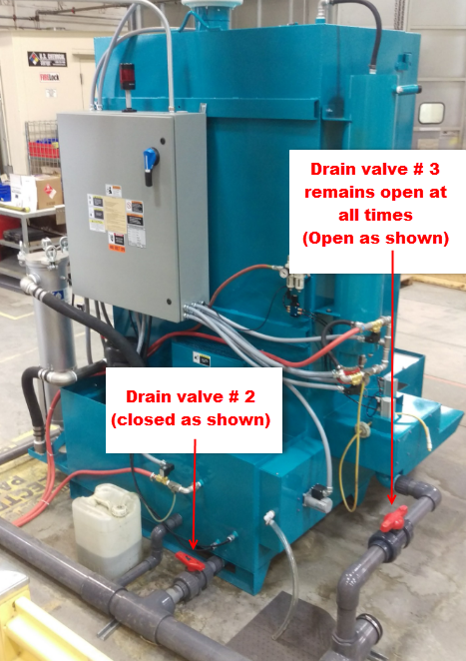

### Locate the filter housing and remove cover

### Use the shop vac to remove any remaining fluid/sediment inside the filter vessel

### Rinse the filter vessel with water until clean water is observed coming out of the spray

### Use the shop vac to remove any remaining fluid/sediment inside the filter vessel

### Wash the filter with soap and water or replace with a new 8” 10 Micron filter

### Rinse the entire wash tank reservoir out with water and use a shop vac to remove and residual water/solids

### Close the wash tank drain ball valves #1 & #2

 

### Contact Facilities maintenance to perform section 7.2 (below) and proceed to the next step once facilities is complete

### Verify the soap level in the 55-gallon drum, replace as needed

### Verify the Rustproof level in the 55-gallon drum, replace as needed

### Turn on the autofill feature to refill the wash tank

### Once the tank water level has covered the heating element turn on the wash tank heater

### Once the wash reservoir reaches “Full” the “autofill” will stop

### Perform soap and rust inhibitor concentration Titration testing per Section 8.5

## MTS Facilities Maintenance

### Pump and Turntable Service

#### With the tank empty, check the pump for any obstructions and lube the pump shaft. Refer to the ADF Manual for instructions on greasing the pressure pump. *Note: Excessive grease not desirable.*

#### Also grease the zerks located on the turntable following the same guidelines from the Manual.

#### Check the drive belts for excessive wear and cracking, as well as the exhaust system.

## Metrology

### N/A

# Setup Procedure

## Set Wash & Rinse temp

### Wash temperature set point -140 degrees F

#### Rinse temperature set point -140 degrees F

## Set Wash & Rinse time

Wash cycle – 3 minutes

Rinse cycle – 1.5 minutes

## Wash tank heater Timer (within the electrical cabinet)

Set to ON between 4 am and 5 pm Monday thru Friday

## Oil skimmer Timer (within the electrical cabinet)

Set to run between 12-4 am Monday thru Friday

## **Titration** – Used to verify Soap and Rustproof concentration levels during setup or when troubleshooting wash performance issues

### **Soap**

#### Cycle the to mix the soap/water

#### After a few minutes pull a sample of the soap/water in a beaker by removing the wash tank cover on the rear of the machine

#### Measure out 10 milliliters and transfer it to a smaller beaker

#### Add 3 drops of Gardotest indicator No.3

#### Zero out the burrette and proceed by adding Gardotest solution No.45 at a controlled rate until the color change occurs. The solution will start at a light brown and change to red. Suggested Titration ranges are as follows:

### Soap Concentration level (gal/100gal)

### 4.4 to 6.6 4-6 gal per 100 gallons water

### 

#### Note: Adding 1 gal of soap to the 160 gal wash tank will approximately raise the titration level by .68 points

#### Note: Gardotest No.3 and Gardotest No.45 both have an expiration date. Refer to the dated materials procedure for instruction on when to dispose of these

#### Notice the fresh clean soap appearance and color. Use this as a guide to determine if service is needed

### **Rustproof**

#### Verify that the Rinse with Inhibitor switch is enabled

#### If enabled skip to step 8.5.2.4

#### If not previously enabled the water heater tank will be free of inhibitor and provided a false low titration reading.

##### Adjust the rinse timer to 5 minutes and cycle the machine to flush the water heater

##### Adjust the rinse timer back to 1.5 minutes

#### To take a sample

##### Open the sample port valve on the side of the water heater and collect 500ml and dump in the wash drain

##### Open the sample port valve on the side of the water heater and collect 100-300 ml sample for Titration

#### Measure out 10 milliliters of the Rustproof/water sample and transfer it to a smaller beaker

#### Add 3 drops of Gardotest indicator No.3

#### Zero out the burrette and proceed by adding Gardotest solution No.45 at a controlled rate until the color change occurs. The solution will start at a light brown and change to red. Suggested Titration ranges are as follows:

### Rustproof Concentration level (gal/100gal)

### 2.2 to 4.4 1-2 gal per 100 gallons water

#### Note: Gardotest No.3 and Gardotest No.45 both have an expiration date. Refer to the dated materials procedure for instruction on when to dispose of these

#### 

## **Chemical Injectors**

### Both the soap and Rustproof lines have chemical injectors used to inject chemical into the system. The chemicals are drawn from the chemical containers and introduced/mixed with the water during “Autofill” for soap and “Rinse” for Rustproof.

### **Injector Specs**

### MFG - Dema

### Model 204BS.2

### Adjustment

#### For coarse adjustment rotate the water bypass screw

Clockwise to increase

Counter clockwise to decrease

#### For Fine adjustment rotate the Fine metering adjustment screw

Clockwise to decrease

Counter clockwise to increase

#### 

# Associated Quality Records – as stated in the Quality Records List

|  |  |
| --- | --- |
| **Required Record** | **QMS Web Location** |
| ADF Parts Washer - Inspection Log | \\mspdata1\Manufacturing\Masters\Paint\ADF Parts Washer - Inspection Log.xlsx |

# Reference Forms / Templates / Documents

|  |  |
| --- | --- |
| **Form / Template / Document Title** | **QMS Web Location** |
| ADF Technical Instruction and Operation Manual | \\mspdata1\Manufacturing\Current\Paint\ADF parts washer 2018\5734 MANUAL4 (3744-042-053-R) MTS SYSTEMS CORP.PDF |
| TDS PYRENE US 1008 | \\mspdata1\Manufacturing\Current\Paint\ADF parts washer 2018\TDS PYRENE US 1008 55 GALLON DRUM (1).pdf |
| TDS RUSTPROOF 4200 | \\mspdata1\Manufacturing\Current\Paint\ADF parts washer 2018\TDS RUSTPROOF 4200 55 GALLON DRUM.pdf |

# Current Revision Training Requirements

|  |  |  |  |  |
| --- | --- | --- | --- | --- |
| **LMS Course Number** | **Read & Acknowledge** | **Read &**  **Test** | **Instructor Evidence** | **Functions or groups that require this training** |
| NA |  |  |  |  |

# Revision History & Approval

|  |  |  |  |
| --- | --- | --- | --- |
| **Revision History** | | | |
| **Rev** | **Description of Change** | **Author** | **Effective Date** |
| A | Creation | Jason Gibson | 12/07/2018 |
|  |  |  |  |
|  |  |  |  |

|  |  |  |
| --- | --- | --- |
| **Required Approvers for Current Revision** | | |
| **Name** | **Function** | **SharePoint Approval** |
| Jason Gibson | Manufacturing Engineer |  |