RoHS Policy
- PURPOSE AND SCOPE
The purpose of the RoHS Policy is to provide a framework for applicable Larson Davis products to be RoHS compliant. Management will determine which products need to meet RoHS compliance.
- AFFECTED DEPARTMENTS
- Engineering
- Logistics-Purchasing
- Production
- Quality
- Sales and Marketing
- REFERENCE DOCUMENTS
3.1 Quality System Procedures
- D0001.1017 Document Control System
- D0001.1024 Item Creation
- D0001.1068 Purchasing
- D0001.1094 Surface Mount Assembly Procedure
- D0001.1108 PCB Fabrication Specification
- D0001.1110 Metal Fabrication Specification
- D0001.1112 Inspection and Test System
- D0001.4012 PCB Work Instruction
3.2 Project Documents and Forms
- D0001.1009-14 Market Release Checklist
- D0001.4012-1 PCB Board Checklist
3.2 Industry Standards and Information
- IPC-A-600: Acceptability of Printed Boards
- IPC/JEDEC J-STD-609: Marking and Labeling of Components
- IPC-A-610: Acceptability of Electronic Assemblies
- IPC-7711: Rework of Electronic Assemblies
- IPC-7721: Repair and Modification of Printed Boards
- Lead-Free Resources:
  - ACI Technologies (www.aciusa.org)
  - CALCE (www.calce.umd.edu)
  - DoD Lead-Free Information (www.leadfreedod.com)
  - iNEMI (www.inemi.org)
  - IPC (www.ipc.org)
  - JEDEC (www.jedec.org)
  - JG-PP (www.jgpp.com)
  - Lead-Free Magazine (www.leadfreemagazine.com)
  - NASA (www.nasa.gov)
- RESPONSIBILITIES & AUTHORITY
Engineering: Engineering has the responsibility for designing, testing and documenting products that are required to be RoHS compliant. Engineering also has the responsibility to authorize any request changes associated with the RoHS status of components or products. A representative from Engineering will monitor the status of RoHS standards and regulations.
Logistics-Purchasing: Logistics has the responsibility for verifying receipt of RoHS compliant parts, while Purchasing is responsible for ordering parts that are specified as RoHS compliant. They are both responsible for quickly communicating concerns associated with violations of RoHS standards.
Production: Production has the responsibility for manufacturing products that are specified as RoHS compliant. They also have the authority to stop production if any concerns arise that would violate RoHS standards.
Quality: Quality has the responsibility for verifying that Larson Davis processes are sufficient to provide RoHS compliant products when specified. Quality also has the authority to conduct audits for determining conformance to this policy.
Sales and Marketing: Sales and Marketing has the responsibility for specifying the need for RoHS compliance of Larson Davis products.
- ACRONYMS AND DEFINITIONS
BOM: Bill of Material (a.k.a. Bill of Manufacturing)
BSD: Business System Database
ECO: Engineering Change Order
PCB: Printed Circuit Board
PRD: Product Requirements Document
PSD: Product Specification Document
RoHS: RoHS (pronounced “Row Hawz”) is the Restriction of Hazardous Substances directive which became effective within the European Union in 2006 (Directive 2002/95/EC). RoHS limits the use of six specific materials:
- Lead (Pb)
- Mercury (Hg)
- Cadmium (Cd)
- Hexavalent Chromium (Cr⁶⁺)
- Polybrominated Biphenyls (PBB)
- Polybrominated Diphenyl Ether (PBDE)

Lead-Free: Of the six materials limited by RoHS, Lead has the most impact to Larson Davis. Lead is one of the primary components within Tin-Lead solder that has been used in the assembly of printed circuit boards (PCBs) for decades. Various solders have been developed without Lead in order to meet RoHS standards. However, these Lead-Free solders typically require a higher temperature (~11% higher) for the reflow soldering process. This means that the components to be soldered onto the PCB need to withstand the higher temperatures. The picture below illustrates what can happen to parts that are not rated for the higher Lead-Free processing temperatures.
Listed below are some of the solder compositions and associated terminology commonly used to describe them.
- SnPb = Eutectic = Tin-Lead Solder (Usually 63% Tin with 37% Lead)
- SAC = SnAgCu = Lead-Free Solder (Tin, Silver and Copper)
- SAC105 = Sn98.5Ag1.0Cu0.5 (Tin, with 1% Silver and 0.5% Copper)
- SAC305 = Sn96.5Ag3.0Cu0.5 (Tin, with 3% Silver and 0.5% Copper)
Solder joints made with Lead-Free solder have very distinct visual characteristics, listed and shown below.
- Grainy, dull, rough appearance
- Higher wetting angle than SnPb solder
- Striation marks are sometimes seen
- Yellowish tint due to flux residue
Tin Whiskers: Solders without Lead are primarily composed of Tin. This can lead to a phenomenon known as Tin Whiskers on the legs of the electrical components which can potentially cause shorts on the PCB assembly. Shown below are a few examples of Tin Whisker growth.
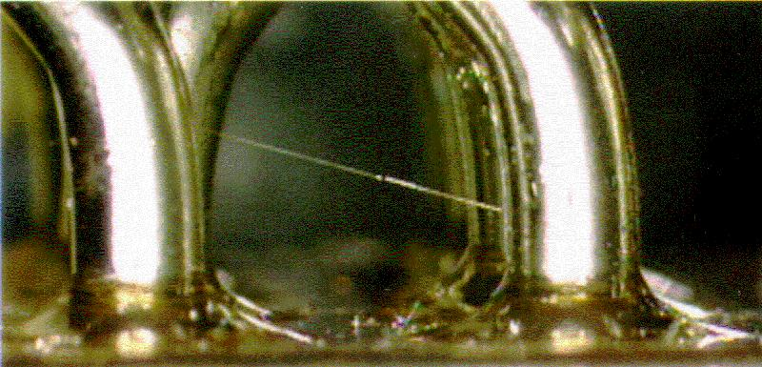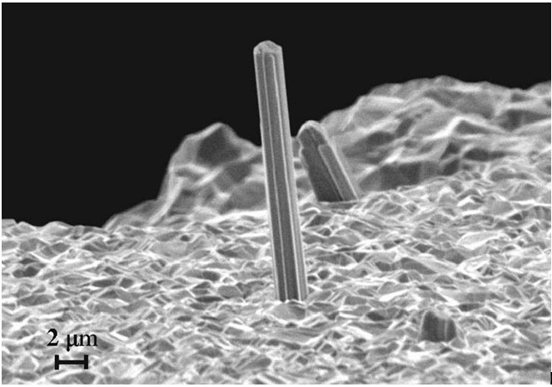
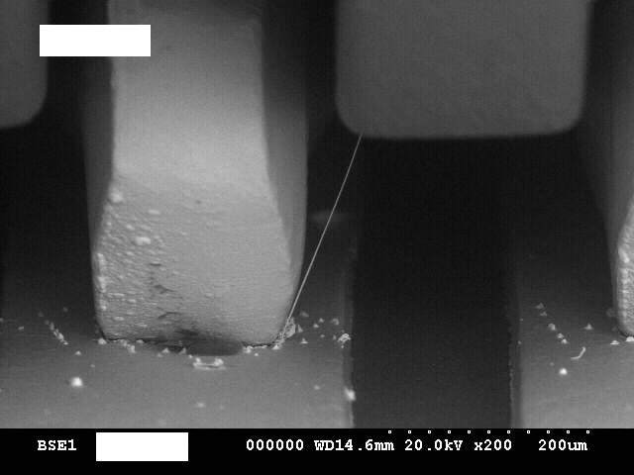
The possible causes for Tin Whiskers include:
- Compressive stress due to intermetallic growth of Cu₆Sn₅
- Residual stress due to recrystallization of the Tin plating on the component lead
- Mechanical stress during component lead fabrication and component assembly
The risk for Tin Whiskers is related to the carbon content and grain size of the Tin plating on the electrical component terminal leads. Bright Tin plating generally has a carbon content between 0.2% and 1.0% with a grain size between 0.5µm and 0.8µm. Matte Tin plating generally has a carbon content between 0.005% and 0.050% with a grain size between 1.0µm and 5.0µm. The following list associates the Tin Whisker risk with the Tin plating.
- Low Risk = 63% Tin – 37% Lead
- Medium Low Risk = Minimum 3% Lead
- Medium Risk = Matte Tin (Nickel Barrier)
- Medium High Risk = Matte Tin
- High Risk = Bright Tin
Cadmium: Cadmium has been used as a corrosion resistant plating material for fasteners. Various Zinc alloys are available as alternatives, along with another process known as Aluminum Ion Vapor Deposition (AIVD). Cadmium is also a key component in NiCad batteries. However, there are many alternative battery chemistries available such as Alkaline, Nickel-Metal-Hydride and Lithium-Ion.
Mercury: Mercury is used in some electrical components as well as light fixtures. Few alternatives are available.
Hexavalent Chromium: Hexavalent Chromium has been used in the Chromate conversion coating process, also known as clear, or yellow, Chromate which is a typical plating process for steel and aluminum. Currently, an alternative process using Trivalent Chromium (Cr³⁺) can be used for Chromate plating with slightly less corrosion resistance.
PBB and PBDE: Polybrominated Biphenyl (PBB) and Polybrominated Diphenyl Ether (PBDE) chemicals have been used as flame retardant materials in the fabrication of printed circuit boards. An alternative PCB flame retardant resin is Tetra-bromobisphenol A (TBBPA).
- RoHS POLICY
The following items are to be considered when developing a product for RoHS compliance.
  - All new products developed by Larson Davis will be designed, tested and documented to meet the RoHS guidelines.
    - Sales and Marketing will decide if an exemption to RoHS compliance is applied for any new product development or customization of an existing product.
    - The requirement for RoHS compliance will be identified in the PRD and PSD as part of the Design Control Procedure.
  - Each new development project will incorporate RoHS compliance into their plans.
    - RoHS compliance of existing products will be determined by management according to customer and market needs.
  - RoHS compliant parts and assemblies will use the existing Larson Davis part numbering scheme (D0001.1017).
  - When RoHS compliance is required for a product, Engineering will select components that are RoHS compliant and will also indicate the RoHS status on the Item Creation Form (D0001.1024).
6.4.1 Larson Davis will keep evidence of RoHS compliance for purchased items by archiving information from the supplier that could include a published spec/data sheet, letter of compliance, listing in a compliance registry, email statement, or other documented proof of conformance.
  - Engineering will verify a minimum of the following items when designing products for RoHS compliance.
6.5.1 PCB materials for high temperature processing as well as RoHS compliant flame retardants.
6.5.2 Electrical components for RoHS compliant levels of Lead, Cadmium and Mercury.
6.5.3 Electrical components for thermal sensitivity and high temperature processing.
6.5.4 Metal parts for RoHS compliant plating materials and processes.
6.5.5 Plastics for RoHS compliant flame retardants and pigments.
  - The use of different soldermask colors indicates the PCB type.
6.6.1 Red = Lead-Free solder
6.6.2 Green = Tin-Lead solder
  - IPC/JEDEC J-STD-609 will be used as the Lead-Free marking standard for PCBs and associated assemblies.
  - All solder connections made to a PCB will be defined on the PCB assembly drawing as either Tin-Lead or Lead-Free.
    - The solder type is to be specified on the PCB assembly drawing, such as SAC305 for Lead-Free or Eutectic 63/37 for Tin-Lead.
6.8.2 Avoid identifying exact supplier specifications in order to maintain flexibility.
  - Listed below are some suggestions for mitigating the risk of tin whiskers:
6.9.1 Choose components with matte tin terminal finishes.
6.9.2 Choose components with a nickel plated barrier between the copper terminal and tin plating.
6.9.3 Increase the spacing between terminals of high risk components.
  - A RoHS compliance check of the BOM will be performed in the BSD as part of the release process.
6.10.1 A BOM that has any component with a RoHS status listed as Not Compliant, Unknown or Requested will not be considered RoHS compliant.
  - Purchasing will confirm RoHS compliance from a supplier when ordering any material that is specified as RoHS compliant (D0001.1068).
  - Incoming inspection will verify that the supplier provided RoHS compliant material (D0001.1112).
  - Any Lead-Free product being manufactured, repaired, serviced, calibrated, upgraded, or otherwise destined to be sent to a customer will be processed at a Lead-Free workstation separated from a Tin-Lead workstation.
    - Tools and material appointed for use at Lead-Free workstations are to remain at the designated workstation.
    - Tools and material will be marked for use at Lead-Free workstations.
- INSPECTION
The Quality organization will determine compliance to this policy.
- RECORDS
Primary record keeping regarding RoHS status of parts will be maintained in the BSD.
- DISTRIBUTION
- Engineering
- Logistics-Purchasing
- Production
- Quality
- Sales and Marketing
- REVISION HISTORY

DCO # | REV | DATE | INITIALS | CHANGES MADE
1361 | A | 03/01/12 | BD | First Release

