Purpose: 1

Related Documents: 1

Responsible: 1

Rules: 1

Instructions:……………………………………………………………………………………………….. 2

Purpose:

Instruct how parts are to be requested from inventory including central inventory, final inspection, Re-Cal and logistics.

Related Documents:

None

Curriculums:

Inventory Control; Final Inspection; Logistics; Planning; Operations; Repairs; Engineering: Quality: Sales.

# Responsible:

# Approve: SC CI Coordinator or PPIC Manager

Maintain: Inventory Control Supervisor

Execute: See Curriculum

# Rules:

1. If the part requested is not held in Central Inventory then put the stockroom location where the parts are to be pulled from (logistics, final inspection, ReCal Shelf#, floor point of use) in the Comment field.
2. Technicians, Leads and Supervisors may use the intranet Parts Request Form directly for items needed for released jobs, MI, QTM (POU replenishment); CON (epoxy), FIX (fixture) or CLU (calibration). Technicians, Leads, Supervisors may not use ENM, ENG, GW or PRO.
3. Planners. Leads and Supervisors will use the intranet Parts Request Form directly for Items being taken from a Recal Shelf to be Re-Cal’d. The planner, lead, supervisor or tech may physically get the part(s) from the Re-cal Shelf.
   1. The Parts Request Form reason will be QTM (Quantity to Move)
   2. The Comments will be
      1. “MOVE or TAKEN from Recal Shelf #______ to XXX –Recal (XXX meaning IMI, SVS, PFT, etc.
         1. Use MOVE if you want IC to get the units and deliver
         2. Use TAKEN if the parts have already been removed from the Re-Cal shelf.
      2. If TAKEN – list the serial numbers of the units taken. (Do not need to include serial numbers if request is to MOVE – IC will collect serial #’s).
      3. If parts were looked for and not found.
4. Final Inspection and Logistics may use the intranet Parts Request Form directly for items needed for CO’s (accessories, etc.). The Job/Issue To code will be QTM, the Comment will be “To Final Inspection” or “To LOG-xx.
   1. If Final Inspection or Logistics wants a part NOT related to a CO or open Job, they will ask a planner to check for availability using the email Parts Request Form, email, phone, etc. (See rule 6 for detail)
5. Repairs may use the intranet Parts Request Form directly to order parts ONCE the planner has released the Repair job.
6. All others (Engineering, Quality, Sales, Marketing, etc)
   1. Complete the Outlook Parts Request Form and send to the planner. In Outlook, Select New Items, More Items, Choose Form, Part Request Form (Note: this Form is not required – information can be shared with planner verbally or through any other vehicle.)
   2. The Planner will determine if parts are available.
   3. If the Planner determines parts are available they will complete the Intranet Request to have the parts delivered per the email.
   4. If parts are already allocated to a CO, Job, etc. the planner will work with the requestor to create a demand signal for the parts to be made / purchased.

# (EMAIL) Part Request Form:

This can be sent to ANY of the planners below, their focus areas are noted:

IMI - Mary Giardini

SVS – Mary E. Carroll, Doug Ackman

Cables & GEP - Joyce Neely

Force & Pressure - Robert Schwarzenholzer

Special Shack / New Products: Aaron Featherman

**Deliver To: (Name):**

**Issue To:** Highlight or put  “X” next to one option below to ensure parts are issued to proper G/L

* ENG   (R&D related use)
* ENM  (Mfg Eng related use)
* FIX     (Fixture)
* Move (must be a Syteline Location)
* GW: (Goodwill) Also check business area below
* PRO: (Promotion) Also check business area below
  + Corporate (000)
  + T&M (010)
  + MICS (020)
  + A&D (40)
  + AUTO (050)
  + Industrial (060)
  + Energy (063)
  + LD (030)
  + LT (070)

If none of the above applies, call planner to discuss.

**Needed:** (Can add additional parts)

**Item Number**

**Quantity**

**Item Number**

**Quantity**

**Reason for Request:** (ex. NPD Model #XX; Special Shack Model #XX; Customer X, containment check, Trade Show _____, etc)

**Comment:**

**Intranet Part Request Form:**

# Instructions: How to get to and use the Parts Request Form

Parts Request Form

# Go to PCB intranet Home page

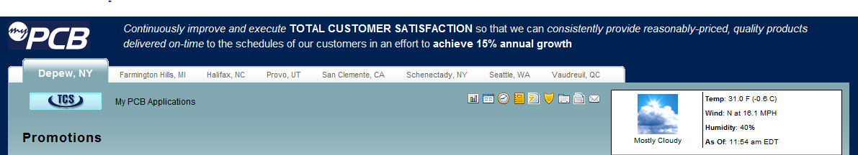

1. Locate Parts Request Form on Intranet
2. Click on Parts request form to open the following screen:

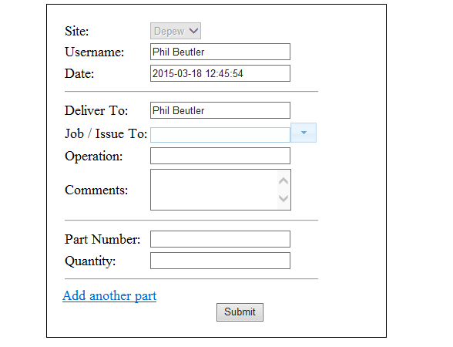

10

7

9

6

12

11

8

5

4

1. Top of Form

4. Your site, username, and Date will auto fill and cannot be overwritten

5. Deliver To will auto fill and can be overwritten as appropriate. (i.e. Planner fills out Part Request Form but sets Deliver To as the Engineer who wants the part)

6. Job/Issue To: For requests related to job #s, scan or enter the Job Number the part(s) are to be issued to. For non-job related requests use the drop down to select the appropriate reason.

* + MI will be used when issuing material to floor ( POU )
  + ENG. –for parts to be used for R&D purpose
  + ENM. –for parts to be used for Manufacturing Engineering purpose
  + GW- Goodwill – for parts to be shipped to customers NOT against a CO and parts to be used for Marketing purposes (tradeshows, demo kits)
  + CON is used for all epoxy requests
  + FIX to be used when a fixture is being issued to the floor or to any Engineer
  + CLU is used for parts to be used in a Calibration function
  + QTM is used for parts that are just moving from one stockroom location to another. Ex: When removing an item from a RECAL Shelf to be recal’d in production; POU replenishment)

1. Operation: If part is requested for a JOB, scan or type in the Operation on the Job Listing that the part is to be used in.
2. Comments:
   1. For QTM requests:
      1. If part is being pulled from Recal Shelf to be re-cal’d the comment would be “From Recal Shelf #___ to XXX-Recal (where XXX equals IMI, SVS, PFT, etc)
      2. If parts is for POU replenishment the comment would be “To POU location XXX (the actual stockroom location parts should be put in)
      3. For Recal request in comments please include serial numbers of the parts that need to be moved.
   2. For all other Job/Issue To Codes use comment to note the reason for the request. (
      1. Production Examples: Not in Job Kit, broke part, unit rework
      2. ENG Examples; NPD Project Model _______; Special Shack Model __________
      3. ENM Examples: CI Project ____________, Containment related to _____________ (model or contained part); Equipment validation ________________(equipment name)
3. Part Number – Scan or Type in Part # Needed. IF the stocking location in IC is known hit the space bar twice and enter the location. (Saves IC person time)
4. Enter Quantity needed
5. If the job requires more than 1 item for the SAME *Job/Issue To*: click on the Add another part link and enter the next part number and quantity needed. You can request up to 10 parts on one Part Request Form BUT all the parts need to be for the SAME Job/Issue To: code. If you need parts for a different Job or Issue To code you must open another Part Request Form.
6. When you have entered all information, select Submit. You will see a green notice saying parts request submitted successfully.
7. IC will pull, label, transact and deliver all parts within 10 minutes.