Contents:
1. Safety: 1
Handling Volatiles 1
Use of Ovens 1
Use of hot plates 1
Heating solvents 2
2. Cleaning Chemicals: 2
2.1. Micro-90 concentrated aqueous detergent (PCB p/n 100-8326-40) 2
2.2. Ammonium Bifluoride, Ammonium hydrogen fluoride, NH₄HF₂ (PCB p/n 100-8613-90) 2
2.3. Methanol (PCB p/n 100-8374-70) 2
2.4. Soda Ash, Sodium Carbonate, Na₂Co₃, (PCB p/n 100-8909-80) 2
2.5. Sodium Phosphate, Sodium Hypophosphite, NaPO₂H₂·H₂O, (PCB p/n 100-8882-40) 3
2.6. Hydrogen Peroxide, H2O2, (PCB p/n 100-11065-60) 3
2.7. Ammonia, Ammonium Hydroxide, H5NO, (PCB p/n 100-8374-40) 3
2.8. Acetone, C3H6O, (PCB p/n 100-11065-60) 3
2.9. Liquinox, H2O2, (PCB p/n 100-11065-60) 3
2.10. Lenium-ES, (PCB p/n 100-8087-40) 4
3. Definitions: 4
4. Cleaning Quartz Wafers of Lapping Compound 4
5. Etching Quartz Wafers 4
6. Tumble Etching Quartz Parts 5
7. Cleaning Quartz Wafers Prior to Plating 5
8. Cleaning Langatate Prior to Plating 6
9. Vapor degrease Cleaning of stacking wax and bite wax from parts/pieces 6
10. Cleaning Of Ceramic Strips Prior To Plating 6
11. Cleaning of Quartz when Blanchard wax is used. 7
12. Cleaning of Ceramic parts (NOT WAFERS) when Blanchard wax is use. 7
13. Mixing Ammonium Bifloride solution 8
14. Operation and use of the Degreaser 8

CAUTION!! Cleaning marked or plated pieces using ultrasonics will erase the markings or damage the plating. In such cases, soak the parts for the prescribed time without turning on the ultrasonics

Safety:

Handling Volatiles
The vapors of volatile solvents such as methanol, ethanol, isopropanol, or acetone should not be inhaled. These solvents must be used in a fume hood. In addition, these solvents are extremely flammable and those flames may not be visible. Splash goggles and nitrile gloves must be worn while working with these solvents.

Use of Ovens
When inserting into or removing anything from an oven that is warmer than 60°C (140°F) use a set of thermal gloves (or mitts) and the appropriate utensils that allow the operator to perform the operation without risk of burns.

Use of hot plates
Use thermal gloves or tongs to remove hot objects from the hot plate to reduce risk of burns.

Heating solvents
Direct heating of solvents, poses a risk of fire and should be avoided. Use a water bath to give more even heat distribution and give more control over the temperature.
Report all spills to the appropriate Production Supervisor.

Cleaning Chemicals:
While performing this maintenance you may be interacting with strong acids, bases, and solvents. Familiarize yourself with the SDS’s for the chemicals listed below. Always wear proper PPE and maintain a safety first mindset.

Micro-90 concentrated aqueous detergent (PCB p/n 100-8326-40)
    - Rubber, nitrile, or latex gloves are recommended.
    - Wear safety goggles with side shields.
    - Wash hands thoroughly after handling.
    - Common sense chemical hygiene practice should be followed.
    - Refer to the SDS for more information.

Ammonium Bifluoride, Ammonium hydrogen fluoride, NH₄HF₂ (PCB p/n 100-8613-90)

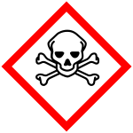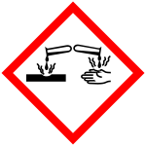
    - Do not breathe dust or mist.
    - Wash skin thoroughly after handling.
    - Do not eat, drink or smoke when using this product.
    - Wear protective gloves/ protective clothing/ eye protection/ face protection.
    - Refer to the SDS for more information.

Methanol (PCB p/n 100-8374-70)
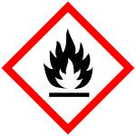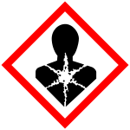
    - Wear protective gloves/protective clothing/eye protection/face protection.
    - Keep away from heat /sparks/open flames/hot surfaces - No smoking.
    - Do not breathe dust/fume/gas/mist/vapors/spray.
    - Wash hands thoroughly after handling.
    - Refer to the SDS for more information.

Soda Ash, Sodium Carbonate, Na₂Co₃, (PCB p/n 100-8909-80)

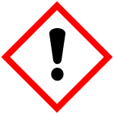
    - Wear eye protection, causes serious eye irritation.
    - Refer to the SDS for more information.

Sodium Phosphate, Sodium Hypophosphite, NaPO₂H₂·H₂O, (PCB p/n 100-8882-40)
    - Handle with nitrile gloves
    - Wear eye protection.
    - Refer to the SDS for more information.

Hydrogen Peroxide, H2O2, (PCB p/n 100-11065-60)
    - Wash skin thoroughly after handling.
    - Do not breathe dust/fume/gas/mist/vapors/spray
    - Wear protective gloves/protective clothing/eye protection/face protection
    - Refer to the SDS for more information

Ammonia, Ammonium Hydroxide, H5NO, (PCB p/n 100-8374-40)
    - Wash face, hands and any exposed skin thoroughly after handling
    - Do not breathe dust/fume/gas/mist/vapors/spray
    - Wear protective gloves/protective clothing/eye protection/face protection
    - Refer to the SDS for more information.

Acetone, C3H6O, (PCB p/n 100-11065-60)
    - Wash face, hands and any exposed skin thoroughly after handling
    - Do not breathe dust/fume/gas/mist/vapors/spray
    - Wear protective gloves/protective clothing/eye protection/face protection
    - Refer to the SDS for more information.

Liquinox, H2O2, (PCB p/n 100-11065-60)
    - Wash skin thoroughly after handling.
    - Wear protective gloves/protective clothing/eye protection/face protection.
    - Refer to the SDS for more information.

Lenium-ES, (PCB p/n 100-8087-40)
    - Avoid breathing vapors or mists
    - Wear eye/face protection
    - Wear protective gloves
    - Refer to the SDS for more information.

Definitions:
PPE - Personal Protection Equipment: nitrile gloves, rubber gloves, safety goggles, face shield, rubber apron, pants, and rubber boots.
DI – Deionized Water, water filtered through deionizing filters to purify it.

Cleaning Quartz Wafers of Lapping Compound
PPE: Use safety glasses and nitrile gloves during operation
  - Fill the ultrasonic cleaners with DI water to about 1/2” below the operating level.
  - Add about 80 mL Micro-90 cleaner and 50 mL dish soap to the first ultrasonic cleaner.
  - Set the temperature of each cleaner to 69°C.
  - Place the loaded etch rack in the first ultra sonic cleaner.
  - Set timer to run for a minimum of 10 minutes and start.
  - Remove the rack after the timer expires.
  - Place the loaded etch rack in the second ultra sonic cleaner.
  - Set timer to run for a minimum of 10 minutes and start.
  - Remove the rack after the timer expires.
  - Place the loaded etch rack in the third ultra-sonic cleaner.
  - Set timer to run for a minimum of 10 minutes and start.
  - Remove and dry the wafers o the hot plate.

Etching Quartz Wafers
PPE: Goggles, nitrile or rubber gloves, and a moisture repellent lab coat or apron must be worn when handling/using acids.
  - Place the empty Teflon etch tank on one hotplate and a stainless pan on the other hot plate.
  - Fill the Teflon etch tank with enough premixed ammonium bifluoride solution to cover the parts.
  - Fill the stainless pan with DI water.
  - Set the temperature of both hot plates to heat the acid and DI water to 105°F to 115°F.
Note: this will take about 1 hour with the knob set to 4.
  - Once temperature is reached, place the loaded etch rack into the acid for 3 minutes.
  - Immediately remove the rack from the acid and place in the stainless pan for rinsing.
  - Repeat 5.5 and 5.6 for all the racks that you have to etch.
  - Fill an empty ultrasonic cleaner with DI water to about 1/2” below the operating level.
  - Insert the perforated tray and turn on the cleaner.
  - Set the temperature to 69°C.
  - Place the etch rack loaded with etched wafers in the ultra-sonic cleaner.
  - Set timer to run for a minimum of 10 minutes.
  - Remove the rack after the timer expires.
  - Blow off with compressed air to remove excess water.
  - Place parts in oven set at 90° - 110°C to dry.
  - Allow the tanks of etching solution and rinse water to cool down.
  - Transfer etching solution back into the jug.

Tumble Etching Quartz Parts
PPE: Goggles, nitrile or rubber gloves, and a moisture repellent lab coat or apron must be worn when handling/using acids.
  - Place one empty Teflon beaker on one hotplate and a Pyrex beaker on the other hot plate.
  - Fill the Teflon beaker with just enough DI water to cover parts.
  - Mix in ammonium bifluoride until saturation at room temperature is achieved.
  - Place the parts in the other Teflon beaker and set it in the tumbler.
  - Set the temperature of the hot plate to heat the acid to 150°F.
  - Once temperature is reached, turn on the tumbler and pour the acid into the beaker with the parts.
  - Tumble the parts for 3 minutes.
  - Remove the beaker from the tumbler and pour off the acid into the other Teflon beaker.
  - Pour the DI water into the beaker and rinse the parts.
  - Pour off the DI water and rinse the parts in methanol.
  - Place the beaker in the oven set at 90°C to 110°C to dry the parts.
  - Allow the beaker of etching solution to cool down.
  - Transfer etching solution back into the jug.

Cleaning Quartz Wafers Prior to Plating
PPE: Use safety glasses during operation, wear nitrile gloves.
  - Fill the ultrasonic cleaners with DI water to about 1/2” below the operating level.
  - Add about 80 ml Micro-90 cleaner and 50 ml dish soap to the first ultrasonic cleaner.
  - Set the temperature of each cleaner to 69°C.
  - Place the loaded etch rack in the first ultra-sonic cleaner.
  - Set timer to run for a minimum of 10 minutes and start.
  - Remove the rack after the timer expires.
  - Place the loaded etch rack in the second ultra-sonic cleaner.
  - Set timer to run for a minimum of 10 minutes and start.
  - Remove the rack after the timer expires.
  - Place the loaded etch rack in the third ultra-sonic cleaner.
  - Set timer to run for a minimum of 10 minutes and start.
  - Place Teflon tank in heated ultrasonic. Fill with enough methanol to cover parts.
NOTE: Do not cover sonic while parts are in methanol.
  - Place cleaning rack filled with parts into tank.
  - Set sonic timer to 10 minutes and start.
Note: Wear gloves/finger cots for all remaining steps. The parts are now clean and will be contaminated by handling.
  - Remove the etch rack from the container. Blow off the excess methanol with an air gun.
  - Place rack in the quartz oven set at 90° - 110°C until dry and ready to go into plater.
Dispose of used methanol into the flammable “Just Rite” waste container. Do not leave any methanol sitting out in beakers or open containers.

Cleaning Langatate Prior to Plating
PPE: Safety glasses, nitrile or rubber gloves.
  - Add 3-5 grams of soda ash and 3-5 grams of sodium phosphate for every 100 ml DI water.
  - Heat solution to 40°- 60° C and stir until dissolved.
  - Ultrasonic wash in solution for 20-30 minutes.
  - Ultrasonic rinse in DI water at 60°- 80°C for 20-30 minutes.
  - Add 3-5 grams of citric acid for every 100 ml DI water.
  - Heat solution to 40°- 60°C and stir until dissolved.
  - Ultrasonic wash in solution for 20-30 minutes.
  - Ultrasonic rinse in DI water at 60°- 80°C for 20-30 minutes.
  - Mix 1 part hydrogen peroxide 30%, 1 part ammonia 25%, and 5 parts DI water.
  - Heat solution to 60°- 80°C.
  - Ultrasonic wash in solution for 20-30 minutes.
  - Ultrasonic wash in methanol at 60°- 80°C for 5 minutes.
  - Dry in oven at 80°- 90°C for 30 minutes minimum.

Vapor degrease Cleaning of stacking wax and bite wax from parts/pieces
PPE: Safety glasses, nitrile or rubber gloves.
  - Check that the degreaser is ready per section 14.2 below.
  - Place waxed pieces in a wire basket.
  - Lower the basket into the vapor degreaser.
  - Allow the pieces to sit in the vapors until all wax is removed. Switch sides to soak in clean Lenium for a minimum of one hour.
  - Pull the basket and check the pieces for cleanliness.
  - If the pieces are not clean of wax, repeat steps until all of the wax is cleaned from the pieces.
  - If the machine is not going to be used again that day turn it off per section 14.3

Note: some pieces may need to be separated between cleanings.

*Note: Strips thicker than .025” do not require the sieving screen

Cleaning Of Ceramic Strips Prior To Plating
  - Materials:
    - (.190mm X .100mm) glass dish(es)
    - Micro-90 solution
    - D.I. Water
    - Acetone
    - Methanol
    - Drying oven
  - Procedure
PPE: Safety glasses, nitrile or rubber gloves.
NOTE: Use enough dishes so that the bottom of the dish is no more than half covered in parts.
    - Acetone
      - Lay the strips flat in a clean glass dish.
      - Use enough dishes so that the bottom of the dish is no more than half covered in parts.
      - Fill the glass dish with aproximetly one inch of Acetone.
      - Label dish with chemical and job number.
      - Place the glass dish in the ultrasonic cleaner.
      - Set timer to run for a minimum of 30 minutes and start.
      - Check on the parts every few minutes and stir them around gently, making sure that all parts are in a single layer.
      - Remove parts and dump the used Acetone in the proper container.
    - Micro-90:
      - Lay the strips flat in a clean glass dish.
      - Use enough dishes so that the bottom of the dish is no more than half covered in parts.
      - Fill the glass dish with one inch of Micro-90 soap solution.
      - Label dish with chemical and job number.
      - Place the glass dish in the ultrasonic cleaner.
      - Set timer to run for a minimum of 30 minutes and start.
      - Check on the parts every few minutes and stir them around gently, making sure that all parts are in a single layer.
      - Dump the soap solution in proper container.
    - Water Rinse:
      - Lay the strips flat in a clean glass dish,
      - Use enough dishes so that the bottom of the dish is no more than half covered in parts.
      - Fill the glass with one inch of Dl water.
      - Label dish with chemical and job number.
      - Place the glass dish in the ultrasonic cleaner.
      - Set timer to run for a minimum of 15 minutes and start.
      - Check on the parts every few minutes and stir them around gently, making sure that all parts are in a single layer.
      - Pour off the Dl water
      - Repeat the Dl rinse two more times.
    - Methanol Rinse:
      - Lay the strips flat in a clean glass dish.
      - Use enough dishes so that the bottom of the dish is no more than half covered in parts.
      - Fill the glass with one inch of Methanol so that parts are fully submerged.
      - Label dish with chemical and job number.
      - Place the glass dish in the ultrasonic cleaner.
      - Set timer to run for a minimum of 10 minutes and start.
      - Check on the parts every few minutes and stir them around gently, making sure that all parts are in a single layer.
      - Dump the Methanol in the proper container.
    - Drying:
      - Lay the strips flat in a clean glass petri-dish.
      - Dry in oven at 80- 90°C for 30 minutes minimum.
      - Proceed to the next operation.

Cleaning of Quartz when Blanchard wax is used.
PPE: Safety glasses, nitrile or rubber gloves.
  - Soak in Acetone until visually clean.
  - Check that the degreaser is ready per section 14.2 below.
  - Place waxed pieces in a wire basket.
  - Lower the basket into the vapor degreaser.
  - Allow the pieces to sit in the vapors until all wax is removed. Switch sides to soak in clean Lenium for a minimum of one hour.
  - Pull the basket and check the pieces for cleanliness. If the pieces are not clean of wax, repeat steps until all of the wax is cleaned from the pieces.
  - If the machine is not going to be used again that day turn it off per section 14.3

Note: some pieces may need to be separated between cleanings.

Cleaning of Ceramic parts (NOT WAFERS) when Blanchard wax is use.
PPE: Safety glasses, nitrile or rubber gloves.
  - Soak in acetone until visually clean.
  - Empty acetone from dish and properly dispose of used acetone.
  - Refill with fresh acetone.
  - Transfer covered dish labeled with job number to the lab with paperwork for secondary cleaning in the plating lab.
Secondary cleaning in plating lab
  - Empty and properly dispose of acetone in the dish that parts were transferred in.
  - Fill to cover parts with fresh acetone and place in ultrasonics for ½ hr.
  - Empty and properly dispose of acetone in the dish again with fresh acetone and repeat ½ hr. in ultrasonics.
  - Empty and properly dispose of acetone in the dish and replace with methanol.
  - Place methanol filled dish in ultrasonics for ½ hr.
  - Empty and properly dispose of used methanol.
  - Place parts in drying oven.
*Note*: Make sure the dishes are properly labeled with the job # and the chemicals that are in them.

Mixing Ammonium Bifloride solution
PPE: Goggles, nitrile or rubber gloves, and a moisture repellent lab coat or apron must be worn when handling/using acids.
  - Inset a Teflon coated stirring bar into a 2L Beaker
  - Add 1L of DI water to the beaker.
  - Place the beaker on a stirring hot plate and heat the water to 105°F to 115°F
  - Slowly add ammonium bifloride powder to the DI water, mixing between each addition.
  - Continue adding powder until it stops dissolving, at which point saturation is complete.
  - Store the mixed solution in the pre-mixed ammonium bifloride jug and label with the mixed date.
Note: Pre-mixed ammonium bifloride is considered stable, but should be disposed of and made fresh in 5-year intervals.

Operation and use of the Degreaser
  - GENERAL PRACTICE.

Some of the parts of the degreaser that should be familiar to the operator are shown in Figure 1 below.
Sub Zero: This is the top row of cooling coils that keep Lenium from escaping the degreaser. They will often have a frosted appearance, and will be defrosted automatically by the machine.
Primary Refrig: This is the bottom row of cooling coils that keep Lenium from escaping the degreaser, when the Lenium is hot in the boiling side Lenium will be seen condensing off these pipes continuously. Sometimes small amounts of water will be seen floating in the tray beneath one or both sets of cooling coils.
Boiling Side: This is sometimes referred to as the dirty side or hot side of the degreaser. Most of the dirt that is brought in with parts should be captured in this part of the degreaser.
Cold side: Sometimes referred to as the clean side, or non-boiling side. The Lenium in this bath can be quite hot, but will always be below the boiling temperature. Lenium that condenses on the cooling coils will flow into here and then this “clean” Lenium will overflow into the boiling side to clean out the contamination that does make its way into this side.

PPE: Use safety glasses during operation

  - Daily Start-Up/checks:
    - Check around the machine for any evidence of leaks or chemical spills.
    - Check the surface of the cold side of the Lenium, alert supervisor/engineer if there is any visible amount of water on the surface.
    - Check that the solvent level on left side, “boiling side” is not low enough such that the rack over the heating coils is exposed. When needed, add Lenium-ES from new drum to the non-boiling side to bring up to proper level. When adding Lenium, the fresh Lenium should be added to the clean side and allowed to overflow into the dirty side until the desired level is reached, that is at least 3” below the devider between clean and dirty sides. Lenium expands a lot when boiling so additions should be made when the system is hot.
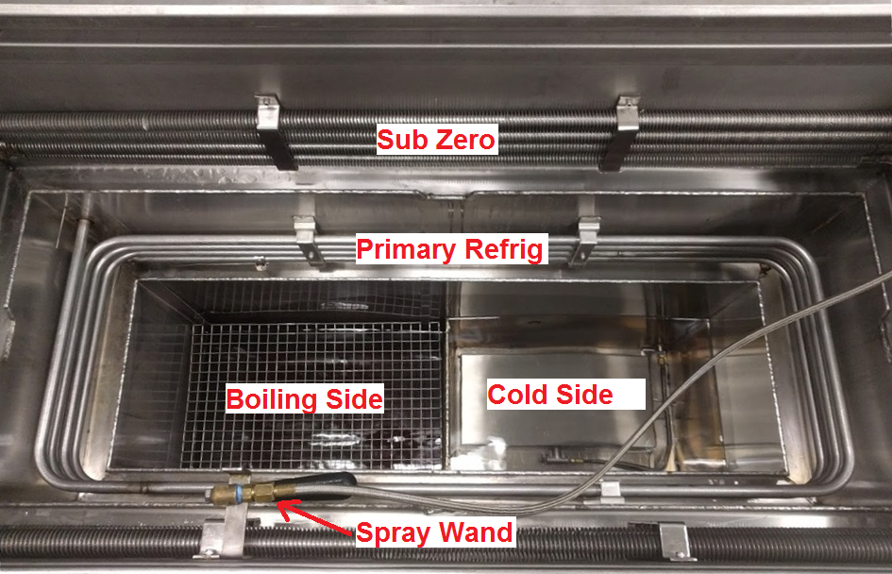
Figure 1: The interior of the vapor degreaser.

    - Check that “MAIN”, “PRIMARY REFRIG”, “SUB ZERO”, “HEAT” and “RECIRC PUMP” switches are on. See the photo of the control panel, figure 2.
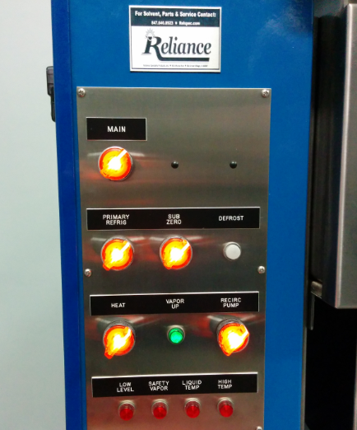
Figure 2: Degreaser Controls, shown with all settings on, the “vapor up” ready, and ready to be used.

    - Check that the cooling coils are cooling. Condensation should be visible on the lower coils when they are functioning.
    - The equipment is ready for use when the “boiling” side is boiling, AND the “VAPOR UP” light is on (green).
  - Long Break Shut Down:
Typically the machine is left on so that it can clean itself out more overnight. If the machine is not going to be used for an extended period such as a holiday weekend:
    - Replace cover completely, if necessary.
    - Turn the “HEAT” switch off and the recirculation swich off.
NOTE: TURNING OFF RECIRCULATION REDUCES LENIUM LOSS TO EVAPORATION BY UP TO 90%.
  - For complete shutdown: Such as when the machine is going to be cleaned out, turn the switches off in the following order:
    - “HEAT” (if not already done)
    - “RECIRC PUMP”
    - “SUB ZERO”
    - “PRIMARY REFRIG”
    - “MAIN” power

