**Contents**

1.0 SAFETY FIRST 1

2.0 Process 1

3.0 Maintenance Procedures 2

3.1. Chamber Vacuum Decay Test 3

3.2. Testing for Defective Control Cards (for Maintenance Use Only) 3

3.3. Testing for Defective Solid State Relay (SSR) (for Maintenance Use Only) 4

# SAFETY FIRST

Before attempting to work on equipment, review and understand all posted PCB safety instructions as well as safety information provided by the equipment’s original equipment manufacturer (OEM), then carefully follow the instructions while troubleshooting the equipment.

# Process

The following table provides information for troubleshooting the equipment. In general, follow the table from top to bottom because the most likely probable causes are listed first. NOTE: Always perform the wafer plating verification procedure in CR1017 after repairing or cleaning the plater.

| **Problem** | **Cause** | **Suggested Action** |
| --- | --- | --- |
| Takes too long to reach vacuum setpoint (process setpoint indicator changes from red to green) | Chamber leaks | Run Chamber Vacuum Decay Test |
| Use Helium leak detector to locate leak |
| Note: 15 minutes is OK; 15–30 minutes is a concern but does not | Door left open a long time (12+ hrs.) | Allow full pumpdown & resume |
| require immediate action; >30 | Lack of liquid Nitrogen | Check supply in tank |
| minutes needs immediate action. |  | Look for obstructions in funnel |
|  | Door seal leak | Run Chamber Vacuum Decay Test |
|  |  | Check door seal for debris |
| Remove seal and clean or replace |
|  | Shutter rotary feedthru leak | Actuate shutter manually while running vac pump and check for spikes in PSI |
| Remove seal and clean or replace |
|  | Stage rotary feedthru seal leak | Run Chamber Vacuum Decay Test |
| Run stage while running vac pump and check for spikes in PSI |
| Remove seal and clean or replace |
|  | Electrode feedthru leak | Run Chamber Vacuum Decay Test |
| Tighten nut under suspect electrode |
| Remove seal and clean or replace |
|  | Monitor Crystal feedthru leak | Run Chamber Vacuum Decay Test |
| Gently wiggle feedthrough while running vac pump and check for spikes in PSI |
| Remove seal and clean or replace |
|  | Window seal leak | Run Chamber Vacuum Decay Test |
| Remove seal and clean or replace |
|  | Pirani vacuum gage leak/faulty Pirani vacuum gage | Pump down test; if 10-4, gage is faulty |
|  | Hi-Vac gate valve leak | Run Chamber Vacuum Decay Test |
| Open and close valve while running vac pump and check for spikes in PSI |
|  | Roughing valve leak | Run Chamber Vacuum Decay Test |
| Open and close valve while running vac pump and check for spikes in PSI |
|  | Backing valve leak | Run Chamber Vacuum Decay Test |
| Contact Denton for instructions |
|  | Vent valve leak | Run Chamber Vacuum Decay Test |
| Use Helium leak detector to locate leak |
| Contact Denton for replacement |
|  | Piping joint leak | Run Chamber Vacuum Decay Test |
| Use Helium leak detector to locate leak |
| Contact Denton for replacement |
|  | Conflange gasket leak | Run Chamber Vacuum Decay Test |
| Use Helium leak detector to locate leak |
| Replace gasket. Never re-use |
| Filament Max Power fault | Filament burned out | Contain job and reference CR1017 for further job actions; replace filament |
|  | Fuse blown | Contain job; replace fuse |
| Check electrodes for shorting |
|  | Not enough wire in filament (gold) | Contain job |
| Stage does not rotate | Chain fell off | If plating occurred, contain job; reattach chain |
|  | Chain broken | If plating occurred, contain job; contact Maintenance |
| Bad solid state relay (SSR) | If plating occurred, contain job; contact Maintenance* |
| Stage rotates at max speed regardless of settings | Bad control card | If plating occurred, contain job; contact Maintenance** |
| Bad solid state relay (SSR) | If plating occurred, contain job; contact Maintenance* |
| Roughing pump inoperable | Pump failure due to bad seals, motor burnout, etc. | Replace roughing pump and send pump to Maintenance for diagnosis |
| NiCr plating layer too thin | See Filament Max Power fault above | Contain job |
| Au plating layer too thin | See Filament Max Power fault above | Contain job; add wire or replace filament |
| Crystal failed message displayed | Measuring crystal is worn out (excessive plating) | Replace measuring crystal |
| Unexpected shutdown of high vac pump | Pump overheating (thermal protection) | Check cooling water flow to pump |
| Emergency Stop button pressed | Twist button until it pops out to reset |
| *Maintenance personnel (only) refer to Testing for Defective Solid State Relay (SSR) (for Maintenance Use Only) | | |
| **Maintenance personnel (only) refer to Testing for Defective Control Cards (for Maintenance Use Only) | | |

# Maintenance Procedures

The maintenance procedures in this section pertain to PCB’s usage of the equipment and supplement the equipment’s OEM documentation. Always refer to the OEM documentation when performing maintenance. If the procedures in this section conflict with the OEM documentation, use the information as presented in the OEM documentation.

## Chamber Vacuum Decay Test

The Chamber Vacuum Decay test consists of drawing a vacuum on the chamber, isolating it, and monitoring the pressure (vacuum). Depending on what pressure is achieved; any loss to the next scale e.g. 1 x 10-5 Torr to 1 x 10-4 Torr within 5 minutes indicates a leak in the chamber.

1. Turn on machine.
2. Press the auto pump button on the touch screen.
3. Allow the chamber to pump down to the 10-6 scale or as low as possible within 30 minutes.
4. Isolate the chamber by pressing the hi-vac button on the touch screen. The button will turn red indicating the valve is closed.
5. Monitor the pressure (vacuum) as described above.
6. If the chamber fails the test, a leak will have to be found following the above table.

## Testing for Defective Control Cards (for Maintenance Use Only)

NOTE: Refer to Figure 1 for this test.

* 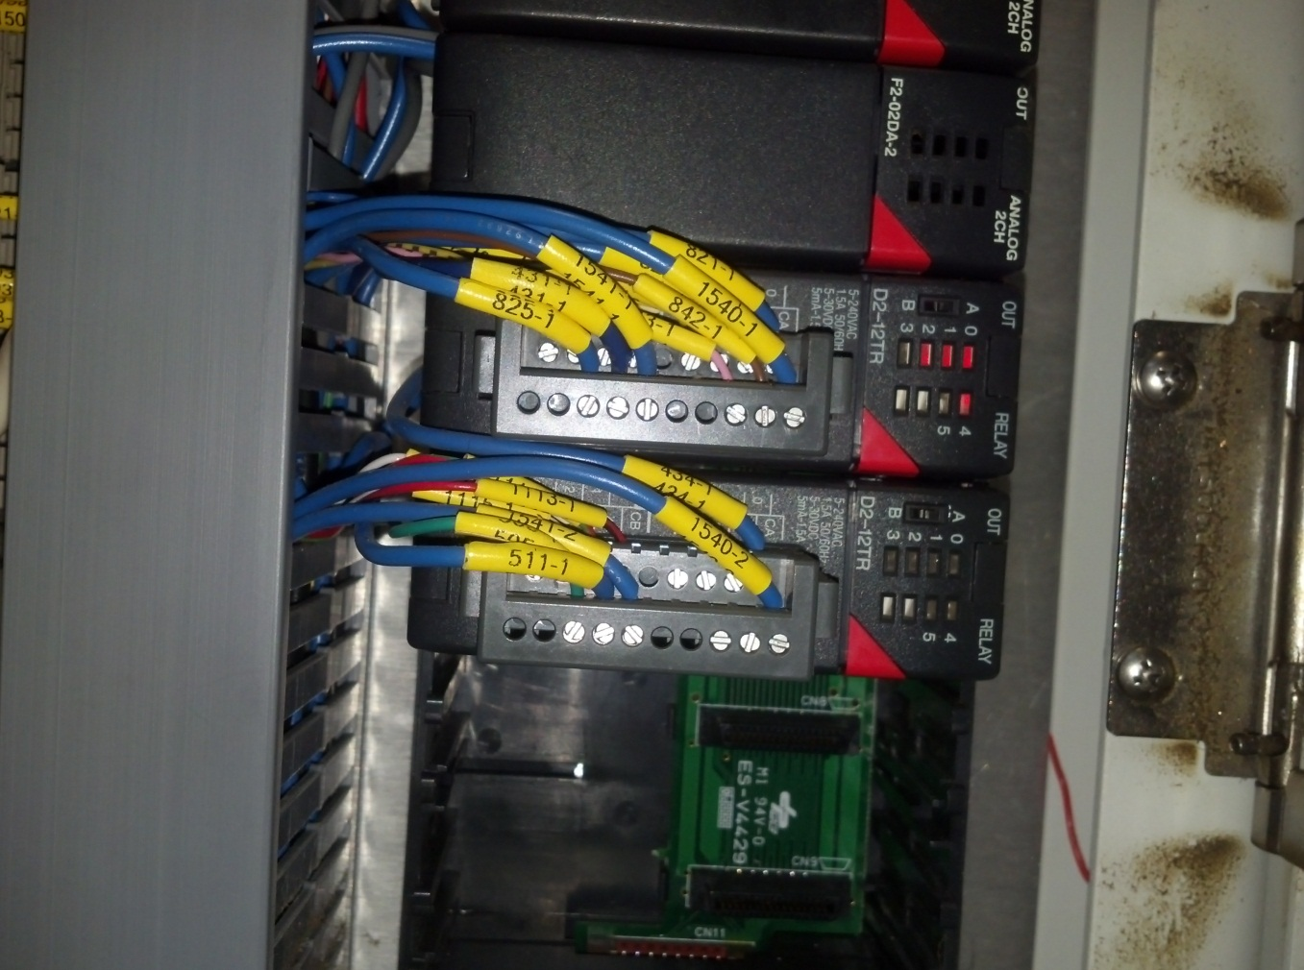

Terminal Blocks

Make sure model numbers match before swapping cards

Terminal Blocks

Figure Control Cards

1. Turn off the plater and perform the Lock-out/Tag-out procedure.
2. Reference the machine’s schematics to locate the suspect control card.
3. Reference the machine’s schematics to locate another control card of the same type.
4. Pull the terminal block from the suspect control card. ***Do not remove any wires from the terminal block!!***
5. Pull the suspect card from the bus bar.
6. Pull the terminal block from the other control card. ***Do not remove any wires from the terminal block!!***
7. Pull the other card from the bus bar.
8. Insert the other control card into the suspect card’s slot.
9. Insert the suspect card’s terminal block into the other control card.
10. Insert the suspect control card into the other card’s slot.
11. Insert the other card’s terminal block into the suspect control card.
12. Restart the machine.
13. If the function works properly, then the suspect card is defective and needs to be replaced. If the machine’s function is still not working properly, the suspect control card is good and another component will have to be tested. Control cards do not need to be swapped again.

## Testing for Defective Solid State Relay (SSR) (for Maintenance Use Only)

NOTE: Refer to Figure 2 for this test.

* 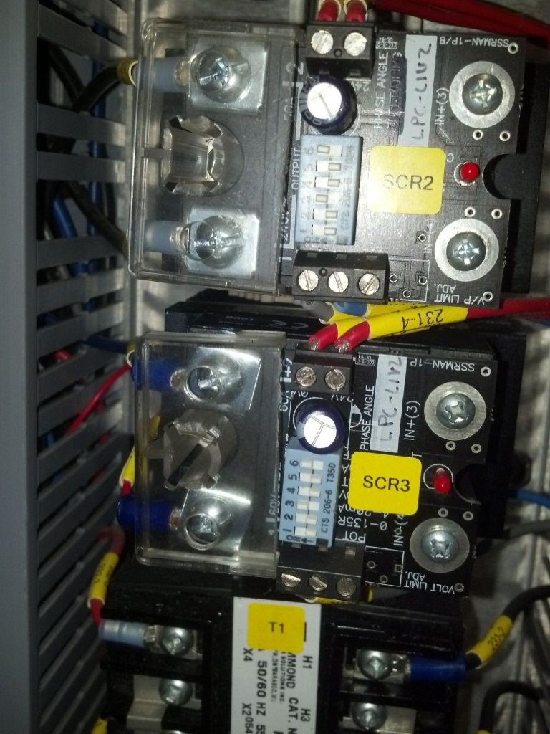

Output side of SSR should measure 0-24 V depending on setting

Output side of SSR should measure 0-24 V depending on setting

Input side of SSR should measure 0-10 V depending on setting

Input side of SSR should measure 0-10 V depending on setting

Figure Solid State Relay

1. Reference the machine’s schematics to locate the suspect SSR.
2. Using a voltmeter, check the input voltage on the SSR. The voltage should vary 0-10 V proportional to the setting on the touch screen 0-100%. If this is not the case, another component is defective and further action will need to be taken as prescribed by the manufacturer.
3. Using a voltmeter, check the output voltage on the SSR. The voltage should vary 0-24 V proportional to the setting on the touch screen 0-100%. If this is not the case, the SSR is defective and needs to be replaced.